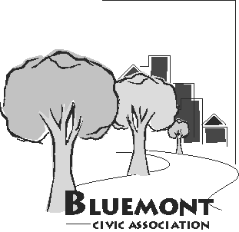
Bluemont Civic Association
Representing Neighborhoods in and around Key school/Escuela Key, Lacey Woods Park, Bon Air, Fields Park, Balls Crossing, West Ballston, and all along the former Bluemont Division of the Washington and Old Dominion Railroad

P.O. Box 5134 Arlington, Virginia 22205
www.bluemontcivic.org

Executive Board Meeting Minutes
at the Lubber Run Community Center and on Zoom
June 25, 2025; 7:00 PM
- First Vice President Laura Kirkconnell acting in the absence of the President began the meeting at 7 PM and established that a quorum was present.
- Minutes of the May meeting were approved without changes.
- Summary Reports and Follow up Discussion
- President's Report (delivered by the First Vice-President)- New Pay Pal system has boosted our dues. Civic Federation election is upcoming. Important zoning resolution will be reviewed. David Smith was elected Civ Fed Board Chair for another year.
- Treasurer's Report - BCA has a total of 121 members. BCA filed to be a tax-exempt, unincorporated civic association. Each year, BCA Secretary must e-file an annual return. BCA cannot have income of more than $49,999.

- Nominating Committee report - Election procedures reviewed and confirmed for 7:30 General Meeting. Members attending on-line will vote via a Zoom poll.
- ArNAC report - Our N. Carlin Springs project will be voted on by the County Board in September.
- Meeting adjourned at 7:28 PM.

