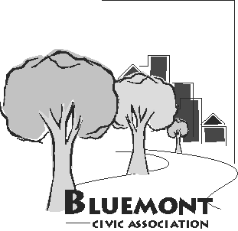
Bluemont Civic Association
Representing Neighborhoods in and around Arlington Traditional School, Lacey Woods Park, Bon Air, Fields Park, Balls Crossing, West Ballston, and all along the former Bluemont Division of the Washington and Old Dominion Railroad

P.O. Box 5134 Arlington, Virginia 22205
www.bluemontcivic.org

Minutes: October 26, 2022 General Membership Meeting

Via Zoom and in Key School Library
7:30 PM

1. The president announced that a quorum was present.

2. Members approved the minutes September General Membership meeting by unanimous consent.

3. Josh Serck, Landscape Architect for Renovations to Upper Bluemont Park, led a presentation by the County team planning the Parks Maintenance Capital project is to replace the tennis court complex, lighting, restroom/storage, shelter, parking lot, site circulation, section of Four Mile Run Trail, site furnishing, drainage and landscaping, and bring the area up to 2010 ADA Standards for Accessible Design. The slides presented can be found on the project page, https://www.arlingtonva.us/Government/Projects/Project-Types/Parks-Projects/Upper-Bluemont-Project

The team presented the two conceptual designs being considered. Both seek to improve all the tennis courts, bringing them up to tennis standards with some reaching the quality needed to host tennis competitions. The project will raise the courts to reduce damage from flooding from the heavy stormwater flows through Upper Bluemont Park to adjacent Four Mile Run. In response to public and County feedback, the plans seek to: minimize the footprint and impervious surfaces in the Resource Protection Area for Four Mile Run; increase picnic opportunities and spectator space for the tennis courts; preserve as many existing trees as possible; improve the safety of access to the parking lot from Wilson Blvd; increase space between the tennis courts; move the courts toward Manchester Street and away from Four Mile Run; have a separate practice court and moving that court away from Manchester Street; improve the pinch point along the Four Mile Run multi-use trail by the tennis courts; and avoid affecting the Safe Routes to School path through Upper Bluemont Park. The number of courts is being kept to nine, which is the maximum that can be fit into the area.

The team reviewed the differences between Concept Design 1 and 2. Those differences are summarized in the slide below. Additional information is on the project page. https://www.arlingtonva.us/Government/Projects/Project-Types/Parks-Projects/Upper-Bluemont-Project

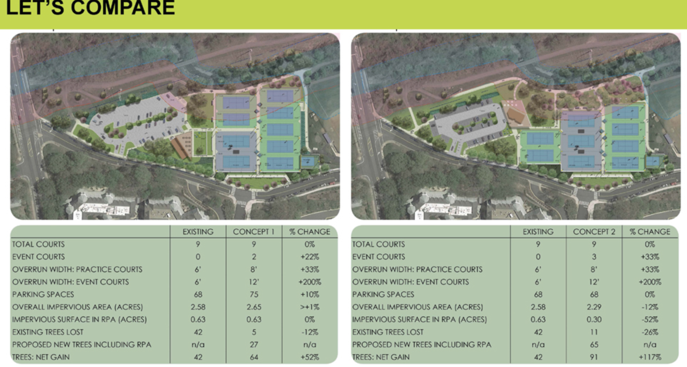

Differences noted during the presentation include:

Concept 1 has two full size courts capable of hosting a tournament with the other courts are at the minimum standard, does not make major changes to the parking lot, adds seven spaces to the parking lot, and removes five trees, some of which are dead.

Concept 2 has three full size tennis courts capable of hosting a tournament, a different parking lot configuration that reduces impervious surface, keeps the existing 68 parking spots, occupies less of the Resource Protection Area, has more space for reforesting that will act like a sponge to soak up storm water and protect the courts and Four Mile Run, removes six more trees to re-do the parking area, and has a greater net gain in trees than does Concept 1.

In response to questions/comments from BCA members, the County team said: they need to: coordinate with the Northern Virginia Parks Authority (NOVA) on its plans to widen the W&OD Trail along Upper Bluemont Park; that the courts in Upper Bluemont Park cannot be lined for pickleball because they are meant to be Arlington’s premier tennis facility, but they would get back to BCA about whether pickleball could be done at a Bon Air Park court on the other side of Wilson Blvd; they are looking to see if things like a green roof, solar lights, and electric vehicle charging stations would be cost effective. BCA members recommended construction be kept out the Resource Protection Area, noting flooding problems faced by homes in Bluemont on the other side of Four Mile Run from Upper Bluemont Park, including some being placed into a 500-year flood plain by FEMA.

4. Summary Reports of Executive Board Officers, Civic Federation Delegates, BCA Committees.

The President said the November 16 General Membership meeting with the Arlington County Police will focus on how the County Police and the Department of Human Services deal with emotionally disturbed and possibly homeless people who are reported to be threatening to residents and employees of local businesses, and he is working to invite the Department of Human Services to join the discussion. He reported on his walk through of Bluemont parks with Parks Liaison Hugh Robinson and the latter’s suggestion an area on Harrison Street and 9th Road be made a County park. He described discussions between civic association presidents and County Board members about the Missing Middle Housing Study phase 2 recommendations. He reviewed his exchanges with Department of Environmental Services Transportation Division public engagement specialist about the disruptions caused by DES’ failure to inform BCA, metrobus, and others about extensive work done at the intersection of Wilson Blvd and N. George Mason Drive. The County cited staffing shortages, and said it would try to keep BCA better informed. The President said he would be following up with the County on the following day and would update BCA members. The President noted that the long delayed Site Plan Review Committee meeting for the grocery store and multi-family building at the Ballston Macy’s will be held on November 7.

The Treasurer reported that the balance in BCA’s bank account was $1763.28.

The Neighborhood Conservation Advisory Committee (NCAC) Representative discussed the delay in the BCA previous priority project for 6th Street N and Emerson, which was supposed to start this fall, but is delayed by the need for a homeowner to notarize some paperwork. He said BCA’s new first priority project (Wilson Blvd and N. Lexington Street) and second priority project (safety improvements to N. Carlin Springs Road) are probably five to ten years from construction given the County’s process for funding and planning, and that he would like to invite the County officials in charge of NCAC projects to do a presentation to BCA in January and February.

BCA’s Civic Federation delegates reported on the October meeting of the Arlington County Civic Federation, which was all about the Missing Middle Housing Study. Presentations made and other information about the meeting are at https://www.civfed.org

Regarding BCA’s N. Carlin Springs Road Task Force, the President said he had sent County Board member Takis Karantonis the questions on N. Carlin Springs Road from the BCA General Membership meeting with him, and was awaiting a response.

5. Discussion of the 4600 Fairfax Drive site plan. BCA’s representative to the Site Plan Review Committee David Smith reported on the first Committee meeting, which was well-attended by a lot of nearby residents. He said BCA’s dropping off fliers to homes near the site had helped get nearby neighbors involved, which will be important over the next couple of years as the planning and construction proceed. The Site Plan Review Committee meeting was more of an information briefing about the revised layout for the project in response to concerns raised by the County and community. Changes are shown on this County web page. https://www.arlingtonva.us/Government/Projects/Project-Types/Site-Plan/4600-Fairfax-Drive Changes include eliminating the road connecting N. Fairfax Drive with Wakefield Street, and the road connecting N. Woodrow and Wakefield Streets, as well as moving the multi-use path away from N. Abingdon Street to between the multi-family building and a group of triplexes. The County webpage includes the full presentation of the revised layout, and a recording of the Site Plan Committee meeting. Here is a slide showing the concept design of the revised layout. https://www.arlingtonva.us/files/sharedassets/public/projects/documents/site-plan-projects/ballston-holiday-inn/1083-_ha_draft-revised-site-plan-concept-final.pdf There will be two more Site Plan Review Committee meetings, the first of which is expected after the new year.

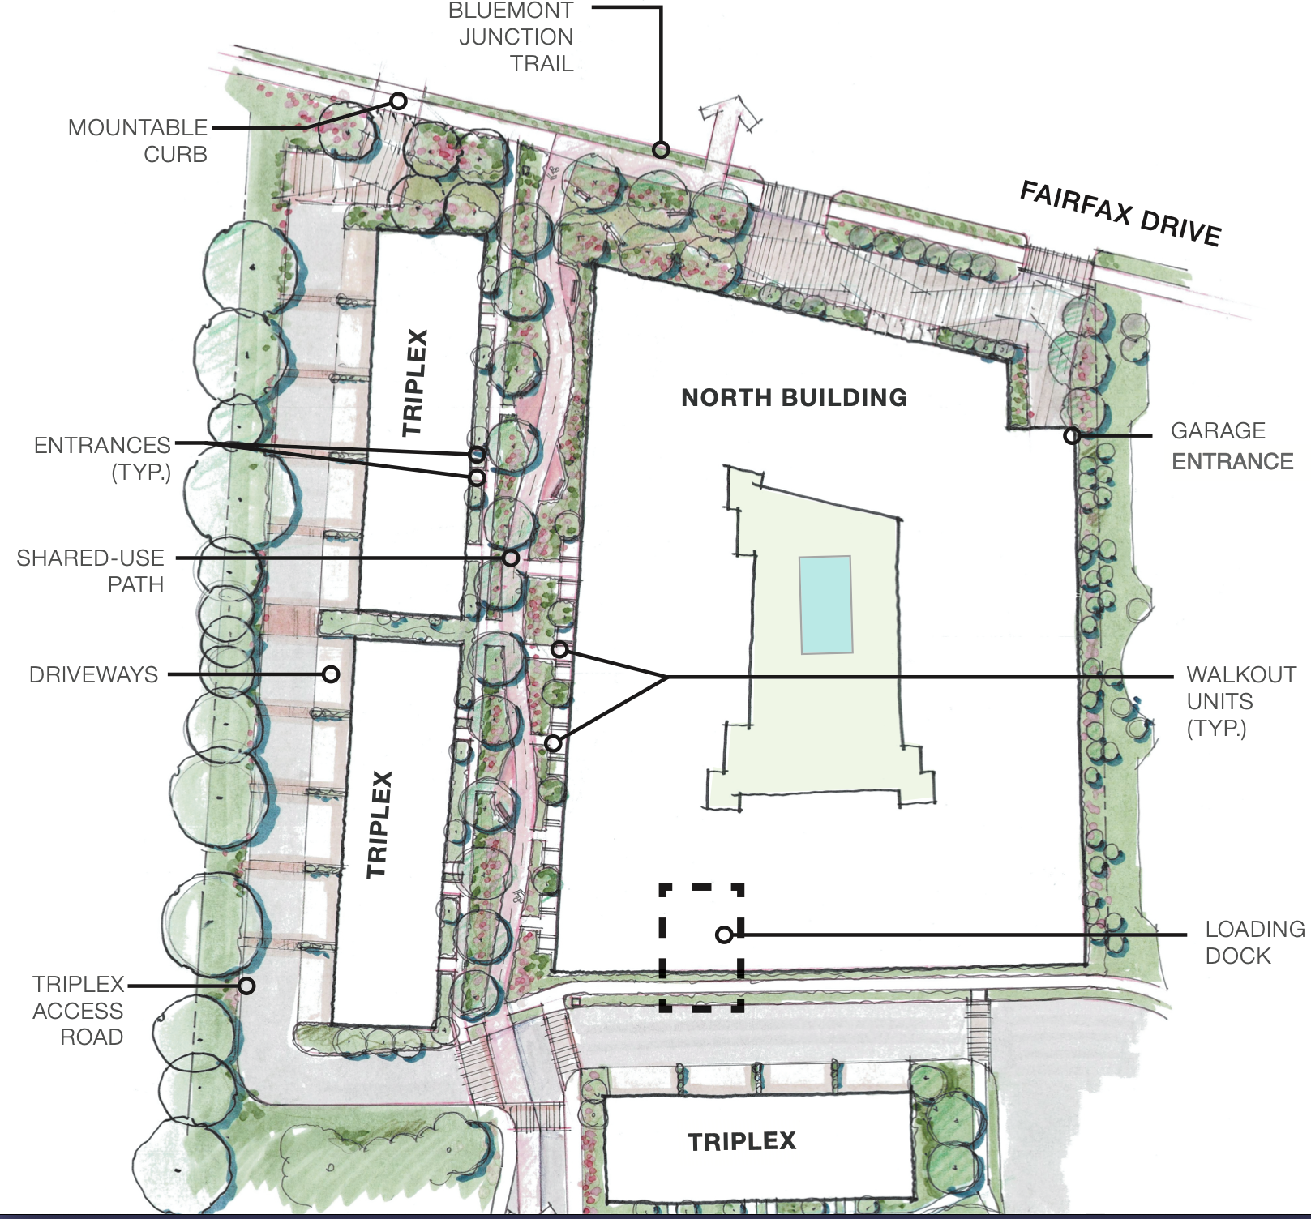

6. Any Other Business

The Executive Board and members discussed getting a BCA zoom account, noting that having hybrid meetings increases engagement with the community. The Executive Board expects to vote on this next month, after learning more about the cost and other details.

The president discussed the Halloween parade that will begin at 5:15 pm on Monday, October 31. The president asked for volunteers to staff the BCA table at the parade.

Members discussed the disruption from the unannounced DES work on N. George Mason and Wilson Blvd, including the disruption to stores across from the Safeway. The owner of one store could not even get to work, and the Metrobus could not get down the street.

7. Adjourned at 8:30 pm

Minutes prepared by Secretary Laura Kirkconnell

