Bluemont Civic Association
Representing Neighborhoods in and around Arlington Traditional School, Lacey Woods Park, Bon Air, Fields Park, Balls Crossing, West Ballston, and all along the former Bluemont Division of the Washington and Old Dominion Railroad

P.O. Box 5134 Arlington, Virginia 22205
www.bluemontcivic.org

General Membership Meeting Minutes

Virtual Meeting via Zoom
June 30, 2021; 7:30 PM

The President established that a quorum was present. Those present and voting approved the minutes of the May 2021 General Membership meeting.

Annual Elections

The President repeated the rules applicable to the election. The President announced the candidates whose nominations had been received by the Nominating Committee before the May 26 deadline for nominations:

For President (current incumbent Laura Kirkconnell)
For 1st Vice President (current incumbent Henry McFarland);
For 2nd Vice President (current incumbent Kate Mattos);
For Treasurer (David Smith).
For Secretary: The President explained to the membership that the Nominating Committee had received the nomination of David Hughes for Secretary prior to the May 26 deadline. During the May 26 General Membership meeting, the President had misread the nominations presented for approval by members, leaving off Dave Hughes’ name. The President asked that the membership ratify Dave Hughes as the nominee for Secretary. The membership did so by unanimous consent.
For Neighborhood Conservation Advisory Committee Representative: (current incumbent Nick Pastore);
For Alternate Neighborhood Conservation Advisory Committee Representative: (current incumbent Christopher George);
For Delegates to the Arlington County Civic Federation (four positions available: two current incumbents were nominated, Allen Norton and David Hughes). Chris George and Shakti Shukla were nominated from the floor;
For Alternate Delegates to the Arlington County Civic Federation (four available: one current incumbent was nominated, Mark Haynes). Bruce Leighton, David Smith, and Nick Pastore were nominated from the floor.

The membership voted on all nominees through the medium of a Zoom poll. The membership voted in favor of all nominees.

Roadway Improvements to Wilson Blvd Between N. George Mason Drive and N. Frederick Street

Thereafter, the General Membership heard an update on the County’s Concept Plan for Roadway Improvements to Wilson Blvd between N. George Mason Drive and N. Frederick Street, including on how to provide feedback. The presenter was Erin Potter Public Engagement Specialist, Transportation Division, Arlington County. Ms Potter reviewed the Concept Design that can be found at this link: https://transportation.arlingtonva.us/wp-content/uploads/sites/19/2021/06/Wilson-Blvd-Concept-Design-FINAL.pdf?fbclid=IwAR1JXirdxXmSu5V8y3DoAUKl01osmwyaN9gm00YgDQMo3ff1OiA-S7zxQSA. Ms Potter welcomed feedback to help the County design a final Concept Plan. The direct link to the feedback form is here: https://www.surveymonkey.com/r/K2X882S

The project page (https://projects.arlingtonva.us/projects/resurfacing-projects-for-complete-streets-2021-season/) has links to the Concept Design, a recording of the June 21 Community Meeting where the Concept Design was presented, presentation slides from that meeting, background information, the link to provide feedback by July 7, and other information.

Arlington County Police Department Community Outreach Team

Thereafter, the General Membership heard an update on recent crime statistics and crime prevention tips from the Arlington County Police Department (ACPD) Community Engagement Team. Officer Guenther made a presentation and attempted to answer questions from the membership. Several slides related to her presentation.

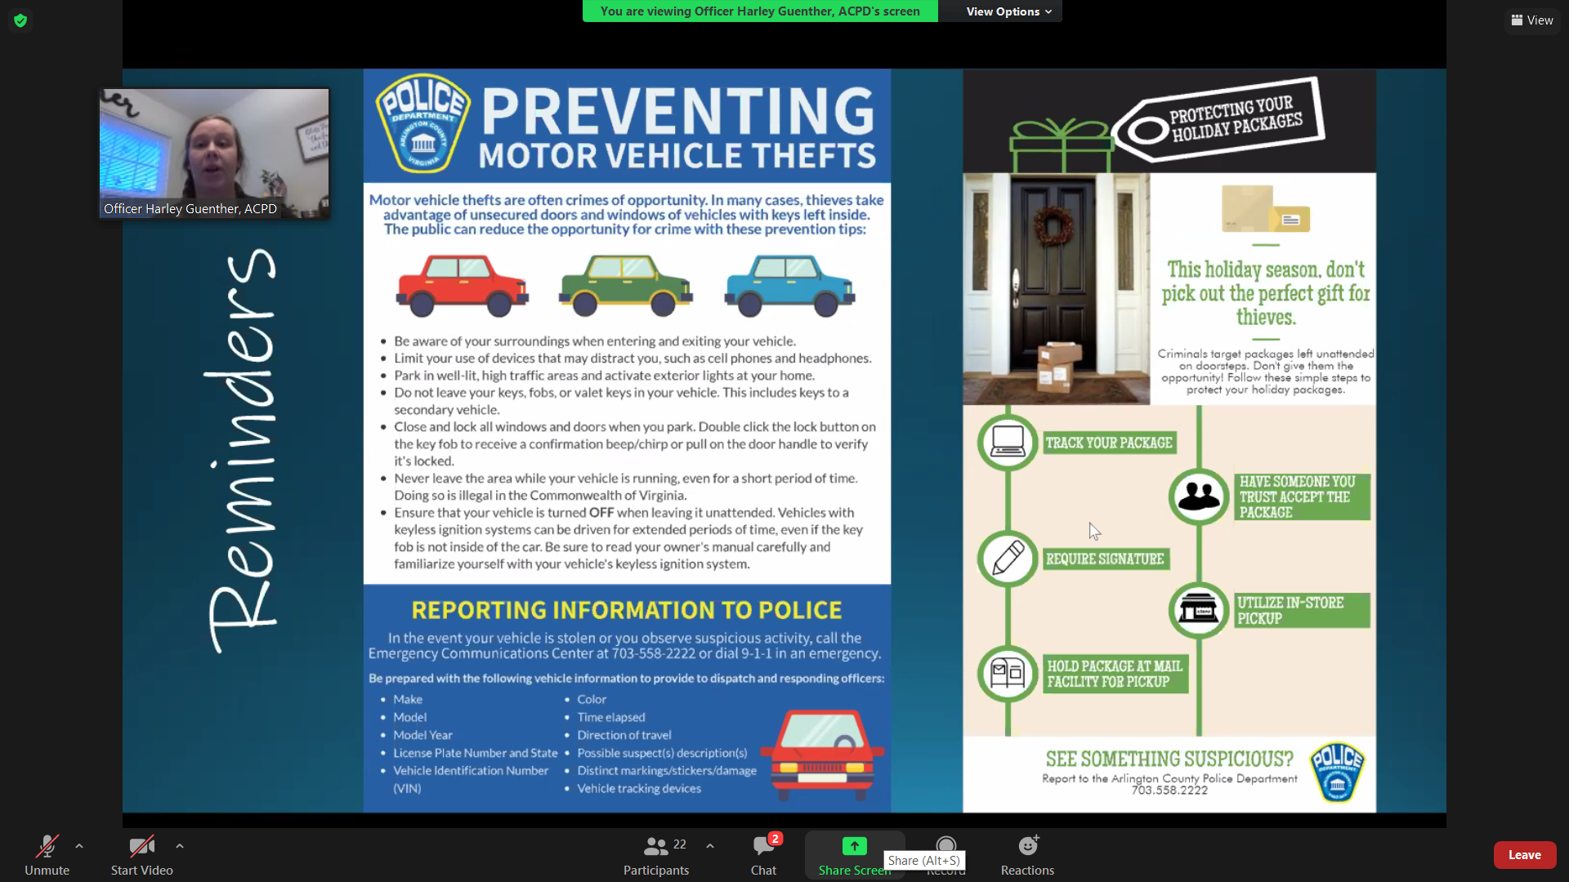

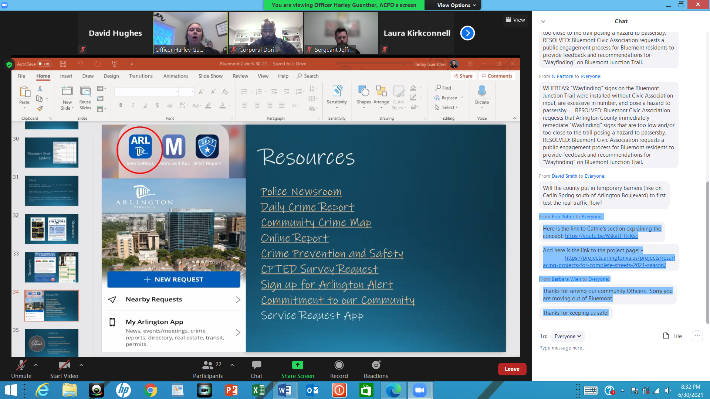

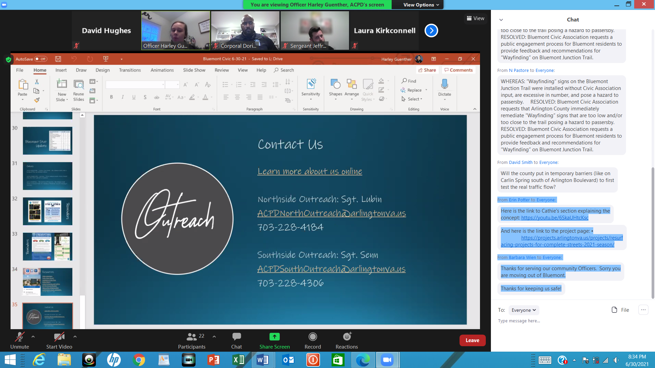

A link to the ACPD annual report can be found in this media release:
https://newsroom.arlingtonva.us/release/police-department-publishes-2020-annual-report/. Sgt. Lubin and Cpl. Brooks announced that they will be leaving the team for new assignments.

Reports from Officers, Civic Federation Delegates and Committee Chairs:

Thereafter, there were brief reports from BCA officers. The First Vice President reported that the County’s report on the initial public input regarding the Missing Middle Housing Study (MMHS) was expected in the near future. The MMHS Working Group has continued to review the BCA Neighborhood Conservation Plan, as well as zoning and parking restrictions applicable to Bluemont.

The First Vice President reported also reported that there are no new developments with regard to Metro’s capacity studies. The CIP currently indicates that the Ballston-MU west entrance may be built in the period 2024-2026, at the cost of $130 million.

The Second Vice President reported that neighbors were concerned with the proposed changes to the striping at the intersection of Wilson Boulevard and George Mason Drive, as well as further west on Wilson Boulevard from George Mason to N. Frederick Street.

The Civic Federation delegates reported on the last meeting featuring a Q & A with County staff concerning the upcoming CIP, as well as Civ. Fed. elections and awards presentations.

The N. Carlin Springs Road Task Force leader reported that it had closed out the neighborhood survey having received 92 responses, a neighborhood survey that includes both Bluemont and Arlington Forest. The Task Force has since had one follow-up meeting.

The Treasurer indicated that the balance in BCA’s checking account is $1,756.

MOTION of support for the Neighborhood Conservation Program

Thereafter, there was discussion of a motion that had been previously presented and discussed at the May Zoom meeting interrupted by power failure. Neighborhood Conservation Advisory Committee Representative Nick Pastore had proposed it and gave a general explanation of the program and its importance to our neighborhood. The motion reads:

WHEREAS Arlington residents have limited options to improve and enhance Arlington neighborhoods based on community driven priorities for the installation of sidewalks, curbs and gutters, streetlights, signs, park improvements, neighborhood art and beautification;

RESOLVED, that the Bluemont Civic Association supports the Neighborhood Conservation Program and provides thanks to the Arlington County Board for funding Bluemont’s project for improvements to the intersection of 6th St N and N Edison St.

RESOLVED, that the Arlington County Board should continue funding and resourcing the Neighborhood Conservation Program at equal or greater levels into the future to ensure community driven neighborhood conservation priorities are exercised.

The motion passed.

Flooding Risk Along the Lubber Run Open Channel in Bluemont

There was a brief discussion of the President’s follow-up with the County with regard to the concerns of the residents of the west side of the 500-700 blocks of N. Abingdon Street, bordering the east bank of Lubber Run. The County has not responded to the President’s letter pertaining to erosion and stream maintenance, and the work that the County intends to do at Ballston Pond. The County has proposed dates for a community meeting to discuss these concerns, and David Smith is coordinating with the County to establish an appropriate date.

Truck Traffic Along Tazewell and Nearby Residential Streets

Waycroft Building: The President reported on e-mail exchanges between a representative of Saul Centers Inc and members of the community regarding delivery truck traffic on Tazewell Street and other smaller residential streets from the Waycroft building, which houses the Target store. The Saul Centers Inc. representative wrote that she had spoken to Target to reiterate to them that Tazewell is not to be used for waiting for entrance to the loading dock, nor for travel to/from the dock, and that Target will inform their delivery companies on these provisions. She also said she would work with our LD management vendor to ensure that the dock managers understand the rules.

A representative of the Townes of Ballston HOA reported that he had raised the potential for increased truck traffic on Tazewell with the opening of the Silver Diner. The Saul Centers representative had agreed that the arrival of the Silver Diner will definitely increase truck traffic, as they will be assigned to the loading dock on Tazewell Street. The BCA Secretary noted that, to minimize truck traffic on Tazewell Street, in the Site Plan discussions for the Waycroft building the stated design was for delivery trucks using the Tazewell Street loading dock to go to Glebe, N. 7th Street, then to Tazwell, then turn to the loading dock, so there should not be a problem with Saul Centers directing Silver Diner delivery trucks to do so. It was also noted that the Tazewell loading dock is much smaller than the main loading dock for the Waycroft building, it should be receiving smaller delivery vehicles, not 18-wheeler trucks.

Members discussed proposing a formal resolution at the next BCA General Membership meeting calling for the truck traffic using the Tazewell Street loading dock to follow the traffic pattern presented during the Site Plan discussions for the Waycroft building in order to minimize track traffic on Tazewell Street.

600 N. Glebe (Harris Teeter site): The President reported that the construction manager for the Harris Teeter project had requested she call him, but agreed to do a Zoom call in order to include those Board members and neighbors available on short notice. The President, some other members of the Executive Board, and two nearby neighbors were able to join the call about dump trucks and other construction vehicles using Tazewell and other small residential streets in Bluemont. The President noted that the construction traffic using Tazwell Street was contrary to commitments made by Harris Tetter and the construction company to the neighborhood and County staff during the Site Plan review for the 600 N. Glebe project. Neighbors provided practical advice based on what has worked, and not worked, with past construction projects along Glebe. The construction manager agreed to implement those measures, which included giving fliers to truck drivers every day to ensure every driver knew to follow the rules to avoid Tazewell and small residential streets, and ensuring heavy vehicles such as cement trucks and dump trucks had sufficient space to stage and wait on the construction site to keep them off Tazewell and other residential streets. The construction manager had already followed up by sharing the contact information of the site manager neighbors and the civic association should contact about problems, and making sure the site manager knew he or she was to respond to such contacts; and placing a sign indicating that no construction traffic was allowed on Tazewell.

Discussion of Signage Along the Bluemont Junction Trail

There was extended discussion of the amount and placement of signage along Bluemont Junction Trail. In some instances, the location of the signage creates a safety issue. The matter was tabled until September, but in the meantime, BCA will propose that the County staff and community members do a “walk-through” along the trail to discuss problematically located and/or superfluous signage, and as part of that proposal will identify some signs that seem to be problematically located.

Food Waste Collection Program

The Second Vice President gave a short recap of the June 10 County public meeting on the subject of the Food Waste Collection Program.

Silver Diner Use Permit and Minor Site Plan Amendment Requests

The President reported that, in accordance with procedures agreed by the General Membership for responding to County requests for the BCA position on permit requests going before the County Board, she had submitted the BCA position regarding the User Permit and Minor Site Plan Requests for the Silver Diner, which was, “The position of the Bluemont Civic Association is that County staff should immediately inform implicated neighbors of a use permit request rather than waiting until a proposal is ready to go to the County Board. The Bluemont Civic Association cannot take a position on a permit without knowing the views of neighbors, so it is critical that the County inform them soonest. As an organization with only monthly meetings and the need to provide one-month’s notice to our members of a potential resolution and/or vote, there is a potential for as much as a two-month lag between when we are informed by the County staff and when we might be able to take a position on a specific issue such as this. This time lag is unfair to both the applicant and to the affected neighbors.”
The County project manager then contacted the BCA President, which led to the President helping the planner identify points of contact for nearby residents, and providing the planner a list of BCA members and other Bluemont residents who requested their contact information be provided to County project manager. The discussion also led to a community meeting hosted by the County planner and the lawyer representing the Silver Diner permit requests.
The BCA First Vice President reported he had attended this community meeting to discuss Silver Diner’s request for a Use Permit for Outdoor Seating and Minor Site Plan Amendment for Administrative Approval of Changes to Façade Lighting. The outdoor café (planned to operate year-round) would encompass 900 square feet and involve changes in architectural lighting. The restaurant is planned for spring 2022.

National Night Out Event

The President indicated that the Executive Committee had decided that BCA should not sponsor or host a neighborhood National Night Out event, but if such an event were held, would be willing to be present with a table, but would encourage the neighborhood to attend such an event, if one is held, and would be willing to have a table to share information about the civic association if invited to do so.

Whether BCA Should Weigh in Regarding the Neighborhood Complete Streets Commission’s Letter to the County Board on Enforcement of the Street Width Provision of the Virginia Statewide Fire Prevention
The President described the request from a BCA member that BCA weigh in regarding County Board Enforcement of the Street Width Provision of the Virginia Fire Prevention Code, and explained why BCA could not intervene unless its members take a position on the issue. No members proposed that BCA take a position on this issue.

The meeting adjourned at 9:35.

