BLUEMONT NEIGHBORHOOD CONSERVATION PLAN

ACKNOWLEDGEMENTS

Bluemont residents owe their deep thanks to the following neighbors who worked so hard to produce this report: Jeff Bartos, Laura Brothers, William Brothers, Carla dal Cais, Lisa Everhart, Caroline Haynes, David Hughes, Sandy Munnell, Nancy O’Doherty, Maura Quinn, Suzanne Sundburg, David Van Wagner and Lisa Van Wagner.

Table of Contents

- Introduction 4
- Executive Summary of Bluemont Survey… 6
- History 11
- Land Use and Zoning 16
- Street Conditions 19
- Traffic Management and Transportation 27
- Housing 46
- Public Facilities and Services 55
- Commercial and Business Areas 65
- Urban Forestry 72
- Recommendations… 74
- Appendices A – J
Appendix A – BCA NCP Survey 2010 79
Appendix B – BCA NCP Survey 2010 (Narrative Responses) 96
Appendix C – Illustrated List of Street Condition Issues 125
Appendix D – Illustrated List of Traffic Management/Transportation Issues 181
Appendix E – Illustrations of Representative Housing Stock 191
Appendix F – Comments on Early Draft Versions and Responsive Revisions 206
Appendix G – Bluemont Area Map… 213
Appendix H – Bluemont General Land Use Planning Map 214
Appendix I – Bluemont Zoning Map 215
Appendix J – Bluemont Parks Map 216
Appendix K - Arlington County Staff Comments on Draft Plan 217

Introduction

- Drafting Process Overview

The effort to draft this Neighborhood Conservation Plan (NCP) began in the spring of 2010 with a survey that was distributed to the door of each of more than 2,000 Bluemont residences. More than 350 survey responses were submitted either through hard copy or an online version of the survey made available through www.surveymonkey.com. Based upon the results of the 2010 survey and independent research, including various walking tours of the Bluemont neighborhood, individual chapters of this NCP were drafted and serially posted for comment on the Bluemont Civic Association’s (BCA) website (www.bluemontcivic.org) and on a separate website maintained by the drafters of the NCP (www.bluemontncp.wordpress.com). All comments received in response to those postings were evaluated and responsive revisions were made to the NCP when determined appropriate. Bluemont residents present at a May 22, 2013, meeting of the BCA voted to adopt this NCP by unanimous voice vote.
The May 22nd meeting had been advertised in the BCA’s April 2013 newsletter (distributed to all Bluemont residences) and draft copies of the plan were previously made available at the BCA April 24, 2013 general membership meeting.

Background and Demographic Information Relating to Bluemont

Bluemont is a vibrant, friendly community of nearly 6,000 people in west central Arlington County, Virginia. The neighborhood’s special attractions include prize-winning flower gardens, a wetlands refuge and beaver pond, streams, stands of heritage trees, noted schools, historic sites, the satellite campuses of two major universities, unique shops, and some of the finest bicycle trails in the Eastern U.S. When the BCA polled residents about what they liked most about the neighborhood, the most common responses were the neighborhood’s convenience to Washington, DC., its closeness to public transportation, and its closeness to parks and recreational areas.¹

Although most aspects of Bluemont’s demographics have remained relatively stable since the 2000 census, some elements have changed substantially.² The total number of households in Bluemont declined slightly from the year 2000 (2,316) to 2010 (2,300), while the total number of housing units (2,392) barely increased (from 2,373) during the decade. In addition, the number of non-family households marginally increased over the decade (from 1,084 in 2000 to 1,107 in 2010), while the number of family households decreased slightly (1,232 to 1,193) during that period. There were 92

¹ Bluemont Neighborhood Conservation (NCP) Survey 2010, responses to Question I.1 and II.1.
² Compare http://www.arlingtonva.us/Departments/CPHD/planning/data_maps/Census/civic/CensusCivicBluemont.aspx (last visited January 9, 2012) and http://www.arlingtonva.us/departments/CPHD/planning/data_maps/Census/2010Census/civic/file82922.pdf (last visited January 9, 2012).

vacant housing units in the neighborhood in 2010, compared with 57 in 2000. As it has since 1990, Bluemont remains a community with a significant share of owner-occupied housing (1,444, or 60.4%) compared to the County as a whole (40.3%).³

Following accelerated growth in the 1990s (18.4%), the total population in Bluemont increased from the year 2000 to 2010 by 6.24% to 5,850. Starting with an “under-18” count of 745 in 1990, there has been a continuing increase in that population cohort within the neighborhood. During the decade ending in 2010, Bluemont’s population under the age of 18 rose from 928 to 1,083, a net change of 155 (16.7%) compared with 2000, and an increase of 45% in the past twenty years.⁴ Despite this dramatic increase in the youth population, Bluemont does not contain within its borders a public elementary school dedicated to serve the neighborhood. Arlington Traditional School (ATS) is located within Bluemont but serves a County-wide population.

Meanwhile, the number of single-person households within Bluemont’s borders dropped from 668 in 2000 to 583 in 2010, a decline of 12.7%. At the same time, the number of households with four or more people jumped significantly (413 to 565 or 36.8%) from 2000 to 2010.⁵

³ Id.
⁴ Id.
⁵ Id.

Executive Summary of Bluemont Survey

In the spring of 2010, the BCA conducted a survey of residents within the Bluemont neighborhood, and received more than 350 responses to all or portions of the survey. The following paragraphs present a summary of the survey’s results.

In contrast to neighboring Ballston, a substantial amount of Bluemont’s land is devoted to low-density residential development, low-density commercial development, and parks. Survey responses indicate that neighborhood residents want this land use pattern to continue.⁶ Detached homes of varying ages and styles continue to give Bluemont its predominant character. While survey responses indicated some concern about the extent of non-owner-occupied housing within the neighborhood (35.8%), the largest concern associated with new construction or additions within the neighborhood relates to the disproportionate size of such construction when compared to surrounding homes.⁷

Like many traditional urban neighborhoods, Bluemont has its own commercial district of small shops and stores (Bluemont’s second commercial area, part of the Rosslyn-Ballston corridor, contains higher-density development). Bluemont’s primary commercial district along Wilson Blvd. is aging, with much of its basic configuration unchanged in the last 30 years. In the Bluemont NCP Survey, nearly seven in ten respondents indicated that a village center concept is desirable for Bluemont’s primary commercial corridor (defined as Wilson Blvd. between N. George Mason Drive and N. Greenbrier St.).⁸ When asked to identify the importance of various potential elements of a village center, the highest priority was given to a grocery store, with clear majorities also identifying retail/restaurants, pedestrian access, green space/open space, onsite parking, cultural/community space, and a pharmacy as being of very high, high, or medium importance.⁹ Asked more specifically to identify the kinds of businesses that respondents would most like to see in Bluemont’s commercial area, a majority of respondents named a grocery store, an independently owned restaurant, and a coffee shop.¹⁰ More than a quarter of respondents also specified a gas station, a specialty bakery, a general merchandise/hardware store, a pharmacy, and a bookstore as desirable elements.¹¹

A clear majority of respondents to the survey would support a village center redevelopment concept if the developers were required to include modest multi-story buildings combined with street-level retail space and upper-story office and/or residential space.¹² A slightly smaller majority indicated that they would prefer that such upper story space be used for residential purposes, with a significant plurality of respondents indicating that they would prefer office use, and other respondents indicating additional

⁶ Bluemont NCP Survey 2010, responses to Questions 2 and 4.
⁷ Bluemont NCP Survey 2010, responses to Questions 3 and 5.
⁸ Bluemont NCP Survey 2010, response to Question 6.
⁹ Bluemont NCP Survey 2010, response to Question 7.
¹⁰ Bluemont NCP Survey 2010, response to Question 8.
¹¹ Id.
¹² Bluemont NCP Survey 2010, response to Question 9.

retail or service as a preference.¹³ More than half of respondents to the survey indicated that three or four stories would be the maximum height acceptable within any village center design.¹⁴

Regardless of building height preferences within any village center development, more than three-quarters of those responding indicated that they preferred that the project incorporate either street parking combined with at-grade or below-ground parking, or below-ground parking.¹⁵ Almost seven out of ten of those responding indicated that retention of some or all of the corridor’s existing businesses was important to them.¹⁶

In general, Bluemont is a great place to live. Nonetheless, the survey results indicate that the community faces several challenges. According to the survey’s respondents, the most pressing problems are the County’s below average performance with regard to snow removal, the unsatisfactory, unfriendly nature of the neighborhood’s sidewalks, and certain aspects of vehicular traffic within and through the neighborhood.¹⁷

¹³ Bluemont NCP Survey 2010, response to Question 10.
¹⁴ Bluemont NCP Survey 2010, response to Question 11. Notably, at an April 24, 2013, general membership meeting, the BCA adopted the following position statement in response to the proposed redevelopment of the Safeway site at 5101 Wilson Boulevard by Silverwood Companies:
The Bluemont neighborhood is overwhelmingly comprised of single-family and other low-density housing. The residents of Bluemont highly value this community characteristic and the lifestyle associated with it. The residents of Bluemont have enjoyed and benefited from the location of the Safeway grocery store on Wilson Blvd and strongly support the modernization of that store and the possible addition of additional retail and services to the location. We recognize that a redevelopment of the Safeway property could bring with it additional community benefits such as a coffee shop, new green space or gathering locations, wider and more convenient sidewalks, undergrounded utilities, street trees and/or additional parking.
Further, the Bluemont Civic Association (BCA) supports the concept of a Westover-like “village center” that is small scale, pedestrian friendly and has a variety of local businesses and restaurants, and for which a re-developed Safeway could be a centerpiece. In this regard, the BCA also supports its existing local businesses.
With the exception of the edge development along Glebe Road in Ballston, there are currently no commercial buildings above two stories in the Bluemont neighborhood. We believe that a tall commercial building would be out of character in Bluemont, particularly when it is immediately adjacent to single-family residential homes. This point has been emphasized on two recent surveys of Bluemont residents.
Absent very careful planning, limits and safeguards, a redeveloped Safeway property would bring with it increased density, traffic, parking issues in adjacent residential streets, noise, large trucks on adjoining streets accessing the loading dock and potentially serious traffic and safety concerns with the Arlington Traditional School. These impacts would negatively impact the quality of life in the Bluemont neighborhood.
Therefore, the BCA objects to redevelopment beyond the existing C-1 zoning classification. The BCA and Bluemont residents look forward to addressing these important issues with Safeway and its chosen developer throughout the redevelopment process.
The position statement was adopted by voice vote after members voted in favor of the statement over two other proposed Safeway development position statements. In that initial three-way vote, 98 member voted for the eventual position statement, 43 members voted for a position statement that supported development consistent with the C-2 zoning classification and 32 members voted for a position statement generally supporting the level of development proposed by Silverwood Companies (i.e., C-0-1.0 zoning classification).

¹⁵ Bluemont NCP Survey 2010, response to Question 12.
¹⁶ Bluemont NCP Survey 2010, response to Question 13.
¹⁷ Bluemont NCP Survey 2010, response to Question 14.

While the snow removal issue may reflect the unusual circumstances of the last several winters,¹⁸ the sidewalk and traffic concerns are problems that have occupied neighborhood residents for many years. The unfriendly sidewalks existing in several portions of the neighborhood are out of character for a progressive and affluent municipality like Arlington. More than three respondents in ten rated Bluemont’s sidewalks as poor or very poor. Slightly more than one in twenty respondents rated Bluemont’s streets as excellent, while slightly more than one in six respondents rated the streets as poor or very poor.¹⁹

More than three out of four respondents either agreed or strongly agreed that there should be a continuous sidewalk on at least one side of each street in the neighborhood.²⁰ Opinion was split among the respondents on the question of whether there should be a continuous sidewalk on both sides of each street in the neighborhood, with a plurality indicating that they were relatively neutral on the issue.²¹ Opinion among the respondents was also split on the question of whether there are circumstances where sidewalks should not be required, such as cul-de-sacs and dead end streets.²²

Nearly three out of four respondents either agreed or strongly agreed that the utility lines along Wilson Blvd. should be placed underground (removing the poles) to make the sidewalks more easily passable for pedestrians and the disabled, and almost four out of five respondents indicated that developers should bear the costs of burying utility lines.²³ Nearly seven of ten respondents indicated that Dominion Virginia Power should bear the costs of burying utility lines, with just over half of respondents indicating that Arlington County taxpayers should bear the costs.²⁴

With reference to traffic conditions within and through the neighborhood, a majority of respondents indicated some concern or high concern about vehicles exceeding speed limits in the neighborhood. A plurality of respondents indicated some concern or high concern about cut through traffic in the neighborhood and the general volume of traffic on arterial streets (Wilson Blvd., George Mason Drive, Washington Blvd., and Carlin Springs Road).²⁵

When it comes to methods to control vehicle speed and improve pedestrian safety, a majority of respondents favored two options: aggressive enforcement of traffic laws and restrictions on truck traffic in the neighborhood.²⁶ A plurality of respondents either favored or strongly favored raised crosswalks as another method to control speed.²⁷

¹⁸ The survey was distributed to Bluemont residents in April 2010, approximately two months after the February 5–6, 2010 North American blizzard, also known as "Snowmaggedon," left 20-35 inches of snowfall throughout northern Virginia.
¹⁹ Id.
²⁰ Bluemont NCP Survey 2010, response to Question 15.
²¹ Id.
²² Id.
²³ Bluemont NCP Survey 2010, responses to Questions 15 and 16.
²⁴ Bluemont NCP Survey 2010, response to Question 16.
²⁵ Bluemont NCP Survey 2010, response to Question 17.
²⁶ Bluemont NCP Survey 2010, response to Question 18.
²⁷ Id.

Conversely, a majority of respondents opposed four of the options: road “diet”/lane or lane-width reduction; one way streets in the neighborhood; nubs/curb extensions; and lower speed limits.²⁸ A substantial plurality of respondents opposed speed bumps and similar pluralities opposed traffic circles and restricted turns during rush hour.²⁹ Opinion was split among respondents on increased fines for speeding and four-way stops as traffic control methods.³⁰

As noted earlier, two of the most attractive aspects of living in Bluemont are its convenience to Washington, D.C., and its closeness to public transportation. Nonetheless, a slim plurality of respondents to the 2010 survey indicated that they would not be more likely to use public transportation (including Metrorail) if bus service along Bluemont’s major arteries (Wilson Blvd., Washington Blvd., George Mason Drive, and Carlin Springs Road) operated on a more frequent basis. Likewise, a similar proportion of respondents indicated that they would not be more likely to ride a bike to work or to run errands if Bluemont’s major arteries included a dedicated bike lane.³¹

Two parking issues that may be related generated concern for a majority of survey respondents: the availability of on-street parking for guests and the existence of multicar households that use street parking. Respondents expressed a lower degree of concern about the availability of on-street parking for their own vehicles, blocked fire hydrants, the effectiveness of parking enforcement, the adequacy of zoned-parking or time restrictions, or commercial and apartment overflow onto residential streets. ³² A clear majority of survey respondents support zoned parking. ³³

Survey respondents generally enjoy the use of the seven neighborhood parks within the community,³⁴ especially for activities such as walking/jogging, biking, and simple enjoyment of open space.³⁵ Were public funds on hand, more than two-thirds of survey respondents support Arlington County’s purchase of properties (as they might become available) adjacent to Bluemont’s parks and streams in order to enlarge the neighborhood’s amount of park or open space.³⁶ Although Bluemont residents currently have no dedicated community meeting space, just less than half of survey respondents support the County’s purchase of property (as it might become available) to be used for that purpose.³⁷

Perhaps reflecting the substantial increase of the under-18 population of Bluemont during the past twenty years, a clear majority of survey respondents support finding ways for more children from the neighborhood to attend ATS.³⁸

²⁸ Id.
²⁹ Id.
³⁰ Id.
³¹ Bluemont NCP Survey 2010, responses to Questions 19 and 20.
³² Bluemont NCP Survey 2010, response to Question 21.
³³ Bluemont NCP Survey 2010, response to Question 22.
³⁴ Bluemont NCP Survey 2010, response to Question 24.
³⁵ Bluemont NCP Survey 2010, response to Question 25.
³⁶ Bluemont NCP Survey 2010, response to Question 26.
³⁷ Bluemont NCP Survey 2010, response to Question 27.
³⁸ Bluemont NCP Survey 2010, response to Question 28.

A primary purpose of this Neighborhood Conservation Plan is to help us, the residents of Bluemont, to improve our pedestrian access and safety within the neighborhood. In recognition that economic activity often generates change, Bluemont residents hope that this plan might help to encourage rational rejuvenation of our commercial area, and make traffic on our streets safer. Bluemont residents request the County’s support in building the infrastructure of a true urban village, featuring fluid but slower-moving traffic and a network of sidewalks that encourages people of all ages to walk anywhere in the neighborhood. This plan lays out the specifics of such a program in the discussion and recommendations that follow.

The residents of Bluemont ask that the County generally maintain local land use and zoning designations so that for generations to come Bluemont will remain a residential neighborhood of primarily detached homes.³⁹ Land use and zoning patterns are especially important to the many of us who are carefully watching the Ballston development as it enters its final, high-density phases.

³⁹ Bluemont NCP Survey 2010, response to Question 2.

History of Bluemont

- Prehistoric Through 1700 AD

The area's first settlers arrived some 10,000 years ago at the close of the Ice Age. Their descendants saw the effects of global warming as conifer forests were replaced by oak, hickory and chestnut trees, and as the sea level rose and flooded river valleys to form the Chesapeake Bay. By 1600, the area that would become Arlington was a crossroads between trading routes that followed the Fall Line north and south and those that followed the Potomac River east and west. In addition, the Potomac was an important food resource, especially during spring migrations when fish collected at Little Falls.⁴⁰

The written record of Native American settlements in our area is limited to the observations of early English explorers and traders sailing up the Potomac. Archaeolo- gists have identified Native American village sites near Long Branch Nature Center, East Falls Church, and a quarry along Four Mile Run. The spread of English settlements up the Potomac River was stalled around Stafford County by conflict with the Native Americans during the late 1600s. By 1700 the area was vacant due to the effects of disease, warfare and migration on the original residents.⁴¹

Colonial Period: 1700-1780

The dawn of the 18th century saw the advance of English settlement as waves of woodsmen, speculators, squatters and tobacco planters spread across the land. At the time, Arlington was part of the Northern Neck Proprietorship owned by Lord Fairfax in England. In 1739, the Bluemont area was included in the second largest land grant made within the confines of today's County. The new owner was a tobacco planter named John Colville, who named his 1,321 acre parcel “The Lubber Tract” after its location next to Lubber Run. Colville was born into a merchant family, and after arriving in the area on his own ship in 1733, decided to settle on Great Hunting Creek near Alexandria in an estate called Cleesh. He promptly entered into the elite ranks of local society, holding offices in the County court, militia, Truro Parish Vestry, and House of Burgesses. Colville bought and sold land tracts of tens of thousands of acres in his dealings with William Fairfax, Lord Fairfax's brother and land agent in Virginia. By 1749, Colville was the third largest slaveowner in Fairfax County.⁴²

The extent to which Colville planted the Lubber Tract is uncertain. In 1754 he received permission from the Fairfax County Court to build a mill on Lubber Run.
Meanwhile, the crossroads of the Road from Falls Church to Awbrey's Ferry near present day Rosslyn (Wilson Blvd.) and the Road from Alexandria to Little Falls (Glebe Road) had been developed with a tavern. Colville died in 1755 and his last will

⁴⁰ Allen, O. and S.R. Flack, Potomac Gorge Site Conservation Plan (Natural Park Service and Nature Conservancy, 2001), pp.3-5 to 3-10.
⁴¹ Netherton, Nan and Ross, Arlington County in Virginia: A Pictorial History (Donning, 1987), p. 12.
⁴² Id. at pp. 18-27.

left the tract to a cousin's husband, the Earl of Tankerville. After the American Revolution, the Earl of Tankerville had the Lubber Tract divided into lots and sold at auction in 1789. Some of the lot lines survive today as Carlin Springs Road, Wilson Blvd., 11th St. N., and N. 16th St.⁴³

Antebellum: 1780-1860

Tobacco cultivation depleted the land, and by the time of Colville's death, planters in the area were seeking alternate ways to maintain their incomes. The buyers of the Lubber Tract lots faced the obstacles of worn-out fields and an unstable national economy. The early 1800s saw a collapse of agricultural land values in Virginia.
Between 1817 and 1829 the assessed value of land in the state fell from $207 million to
$90 million. Squeezed by poor prices, shrinking assets and tight credit, many farmers lost their land to foreclosure. About 1 million Virginians left for new lands in the West. Those families that held on survived by growing grain or planting orchards and through improved agricultural practices like crop rotation and the use of fertilizers.

By the 1850s, the prospects for area farmers were improving as the growth of Washington, DC and the construction of the Alexandria, Loudoun and Hampshire (AL&H) Railroad opened up new markets for their produce. By the eve of the Civil War, local families included the Wilkinsons, Cathcarts, O'Reilleys and Schneiders. North of the Falls Church Road (today’s Wilson Blvd.), William R. Birch farmed the inheritance of his wife Julia Shreve, a descendant of an original Lubber Tract lot owner. West of the Birch farm (beyond the line of N. Edison St.), Julia's uncle Samuel Shreve had sold his portion to Richard and Frances Southern. Richard Southern was a British immigrant and horticulturist who had once managed the gardens of the John Mason estate on Mason Island (today’s Roosevelt Island). Southern called his farm Poplar Grove and became known for being one of the first to popularize the use of the tomato as a food. The memory of both farms persists in the form of family cemeteries within Bluemont’s borders. The Birch cemetery is now an empty lot on N. Abingdon St. south of Fairfax Drive, and the Southern Shreve cemetery is marked today near St. Ann Church, between N. Frederick St. and N. Harrison St. off of N. 10th St.

Civil War: 1860-1865

After the citizens of Virginia voted to secede from the Union on May 23, 1861, Union army units immediately crossed the Potomac River from Washington, D.C., and occupied the shoreline of what is now Arlington County. Late on the afternoon of May 24, Company B of the Second United States Cavalry advanced along the Georgetown Wagon Road (today’s Wilson Blvd.), to the AL&H Railroad line, which in 1861 reached from Fairfax St., Alexandria, to Leesburg. The cavalry unit stopped an Alexandria-bound passenger train in the area of present day Bluemont Park and arrested everyone on board as secessionists, including two Confederate soldiers. In August and September, 1861, after the First Battle of Manassas / Bull Run, the Bluemont area became a no-man's land

⁴³ United States Department of the Interior – National Park Service, National Register of Historic Places Registration Form for Buckingham Historic District (2003), p 18.

between frontlines. Units of the two armies scouted and skirmished between frontlines from Hall's Hill to Baileys Crossroads. For the remainder of the war, the County was a staging area and occasional home for the Army of the Potomac.⁴⁴

By the Second Battle of Manassas / Bull Run in August, 1862, medical conditions for soldiers were much improved, but there were so many casualties that the wounded had to be transported closer to Washington, D.C., for treatment. Brought by train through Alexandria, the number of wounded was so high and the facilities so few that there was often a backlog. From the train cars, the soldiers were transported by wagons to makeshift hospitals. One such hospital existed in Bluemont at the intersection of N. Harrison St. and 5th St. N. .

Maps of this era show that the area was dotted with dozens of encampments, hospitals and forts, vestiges of which can still be found in the berms (hills) in our local parks. Specifically, one bermed site located in Bon Air Park appears on a Civil War-era battle map from 1865. Several batteries and forts also were situated near Veitch Road (today’s N. Harrison St.).

Bluemont, like the rest of Arlington, was transformed by the presence of thousands of soldiers, living and foraging on the land. Crops were trampled and destroyed. Fence rails were used for firewood. Livestock was confiscated by the military or sold for a fraction of its value and driven away on hoof to feed the troops. Most of the standing timber was cut to supply building materials or facilitate the firing of artillery.
Rifle trenches and ammunition bunkers were dug and berms created along the ridges and high ground. Barns, outbuildings, and private homes were occupied, damaged, or destroyed to accommodate the more than 100,000 Union troops who were stationed in Arlington. By the end of the war, the supply of wood and timber had so dwindled, that the Union army imported them from Loudoun. Many residents of Bluemont left the area during the war, and the area was effectively re-settled after the war by army veterans, camp followers, and former slaves.⁴⁵

Reconstruction: 1865-1890

A mix of old and new families helped rebuild the area after the war. North of today's 11th St. N., a Union Army officer from Ohio named Robert S. Lacey stayed to settle. The heirs of Thomas J. Cathcart occupied the summer home their father had bought in 1859 southwest of Ball's Crossroads (today’s intersection of Wilson Blvd. and Glebe Road). The Cathcarts were descendants of American diplomat James Leander Cathcart, who during the early 1800s negotiated treaties with the Barbary Coast “pirates” of Algiers, Tripoli, and Tunis. Along the south side of the Georgetown Wagon Road, from Lubber Run to Four Mile, the family of George and Mary Adams bought a large farm at a foreclosure auction.

⁴⁴ Price, William H., “Civil War Military Operations in Northern Virginia in May-June 1861.” Arlington Historical Magazine, vol. 2, no. 2, 1961, pp. 43-57.
⁴⁵ Netherton, pp. 60-77.

The Maria O'Reilley, Richard Southern, and William Birch families held on to their farms between today's Wilson Blvd. and 11th St. N. Over time, the lands were divided among the different family members. Margaret Birch married Confederate veteran George Veitch and the couple resided west of Veitch Road. The Bluemont area's first landowner of African descent was Joshua DeVaughn, who in 1884 was given land along Four Mile Run in return for taking care of an aging Mary Carlin.⁴⁶

The growth of the community around the intersection of Wilson Blvd. and Glebe Road prompted construction of the first church in our area. The First Presbyterian congregation dedicated a building in 1876 on the northwest corner of Ball's Crossroads. William Birch served as a trustee for the Walker School in Ballston, established in 1870. In 1881, neighborhood resident George R. Adams became the first school superintendent dedicated solely to Alexandria County. His predecessor Richard Carne had divided his services between both Alexandria City and the County. (Note that Alexandria originally referred to the combined area of what is now Arlington County and the City of Alexandria.)

Streetcar Suburb: 1890-1945

During the 1890s, Arlington’s prominence as a Washington suburb continued to grow and new transportation ties enabled residents to make easy trips into the District for work and pleasure. During this decade, the Washington, Arlington & Falls Church Electric Railway constructed a trolley line that originated in Rosslyn and continued on through the Bluemont area with stops at Lacey (Glebe Road), Sunnyside (N. Edison St.), Mulhall (N. Frederick St.) and Veitch Summit (N. Harrison St.).

In 1912, the Washington & Old Dominion (W&OD) Rail Road completed the connection between Georgetown and its older line along Four Mile Run. At the junction, passengers could catch a train to the railroad’s terminus at the town of Bluemont in Loudoun County. This tiny town on the Blue Ridge gave its name to a division of the rail line, the railroad junction, and eventually to a street, park, bicycle trail and, of course, our neighborhood and civic association.

Postwar Urbanization: 1946 to the Present

The Bluemont neighborhood filled up quickly after World War II and was essentially built out by 1960. The area’s new residents participated in establishing institutions such as Saint Ann church, Saint Michael's church, and the Arlington Forest Club. In 1951, the First Presbyterian congregation moved into their new building on Carlin Springs Road.

The new community became dependent on the automobile after the trolley, and then the W&OD discontinued passenger service. Across Glebe Road, the Parkington Shopping Center featured a Hecht's department store and the “world's largest parking

⁴⁶ Charles Lane Property Purchases (1905-1935), Arlington County Central Library Virginia Room.

garage.” Other merchants followed their customers as a commercial strip developed along Wilson Blvd.

The 1950s and 60s saw a great deal of civic action as residents dealt with issues such as school improvement, integration, civil rights, and a proposal to build an interstate highway through the neighborhood. By 1980, the Bluemont area had become a relatively affordable, family-oriented community convenient to nearby parks, schools and shopping. As the baby boom grew up and moved out, Stonewall Jackson School (today’s ATS) was closed, and most neighborhood children were reassigned to Ashlawn or McKinley Elementary Schools. These two public elementary schools continue to serve Bluemont children to the present day, although neither are located within the boundaries of the BCA.

On December 1, 1979, the Metro Orange Line was opened between Rosslyn and Ballston. The Ballston station remained the western terminus of the Orange Line until June 7, 1986, when the line was extended to Vienna. The Ballston station remains the final underground station for westbound Orange Line travelers.http://en.wikipedia.org/wiki/Ballston%E2%80%93MU_%28WMATA_station% 29 - cite_note-November_29.2C_1979-4

In 1982, the Custis Memorial Parkway (Interstate 66) was opened along the former trolley and railroad right-of-ways. The subsequent redevelopment of the whole Rosslyn-Ballston corridor, and Ballston’s particular growth as a major employment center, has affected the Bluemont area. Parking space has grown tighter and traffic more congested. Property values have risen. Apartment and townhouse development has spread westward across Glebe Road. Throughout the neighborhood, many older houses on large lots have been redeveloped with infill housing.

The most recent major commercial development within BCA’s borders began in 2005 with the development of the Peck-Staples-Jordan Manor sites by JBG Companies. The development at the northwest corner of Wilson Blvd. and Glebe Road consists of two large office buildings at the sites of the former Staples and Bob Peck Chevrolet buildings, and an adjacent 90-unit Arlington Housing Corp. apartment building along Wilson Blvd. with an entrance on N. Wakefield St. The Peck-Staples-Jordan Manor development exceeded the various zoning and the County’s General Land Use Plan (GLUP) limitations applicable to the site and mobilized significant portions of the BCA membership in opposition. Ultimately, the BCA gained some concessions, but the Civic Association found that many of its arguments were discounted by County officials because the 1999 BCA Neighborhood Conservation Plan was out of date and out of step with current development and land use realities. It contained little written policy that could be used to help shape the project.

Land Use, Zoning, and Local Ordinances

- Land Use and Zoning

Arlington County has designated approximately 70% of the area within Bluemont as a low-density residential neighborhood, while parks and other public or semi-public places make up about 20%. Commercial and mixed-use areas make up the remaining 10% of Bluemont’s land.⁴⁷

The great majority of Bluemont’s residential areas are classified as Low Residential in the GLUP, with a corresponding density of 1 to 10 units per acre and a zoning classification of R-5 or R-6. Most of the dwellings in these Low Residential areas are single-family detached homes, with a lesser number of duplexes and townhouses. A few areas in the neighborhood contain low-rise apartment buildings, classified as Low- Medium Residential in the GLUP with a corresponding density of 16-36 units per acre.⁴⁸

Bluemont also hosts a number of high-rise apartment complexes near the intersection of Glebe Road and Washington Blvd. This area is classified as a mixture of High-Medium Residential (up to 3.24 floor-area ratio) and Medium Office-Apartment- Hotel (up to 115 units per acre for apartment density).⁴⁹

Bluemont’s public areas include County parks and off-road trails. The neighborhood’s two sizable semi-public areas are the St. Ann's Church property and the Arlington Forest Club property.⁵⁰

Bluemont has two distinct business districts – the Glebe Road business district and the Wilson Boulevard business district.

The Glebe Road business district runs along the west side of Glebe Road. The portion of this area between Fairfax Drive and Wilson Blvd. is classified as Medium Office-Apartment-Hotel (up to 2.5 floor-area ratio for office density), while the area south of Wilson Blvd. to Carlin Springs Road is classified as a Coordinated Mixed-Use Development District (permitted density based upon site size up to 6.0 floor-area ratio). The density of these uses tapers off within a few blocks west of Glebe Road to the low- density residential designation most prevalent in our neighborhood.⁵¹

The Wilson Boulevard business district runs along Wilson between N. George Mason Drive and N. Greenbrier St. and is designated as a Service Commercial area with C-1 zoning. It is abutted again by low-density residential parts of our neighborhood.

⁴⁷ Zoning Map accompanying Arlington County General Land Use Plan (adopted August 12, 1961 with amendments through December 10, 2011.
⁴⁸ Id.
⁴⁹ Id.
⁵⁰ See Section VIII. Public Facilities and Services for further discussion.
⁵¹ Id.

Unlike some areas of Arlington, there is no special development or zoning district developed for Bluemont, which thus falls within the general policies of the GLUP and the Zoning Ordinances. Of particular note to Bluemont residents are the following “Development and Growth Goals” which the Arlington County Board has adopted in connection with the GLUP:

  - Concentrate high-density residential, commercial and office development within designated Metro Station Areas in the Rosslyn-Ballston and Jefferson Davis Metrorail Transit Corridors.

* * * * * *

- Preserve and enhance existing single-family and apartment neighborhoods. . . Throughout the County, the Neighborhood Conservation Program … help[s] preserve and enhance older residential areas and help[s] provide housing at a range of price levels and densities.

* * * * * *

- Preserve and enhance neighborhood retail areas. The County encourages the preservation and revitalization of neighborhood retail areas that serve everyday shopping and service needs and are consistent with adopted County plans.⁵²

Also significant to Bluemont residents and businesses is the County’s “recogni[tion] that development at increased density levels has an increased impact on the community. Therefore, development at the high end of the density range on the [GLUP] may not necessarily represent the vision for a specific location or may not be desirable under all the circumstances.” Thus, when the County is asked to approve density at or above the high end allowed by current zoning, it should consider, among other things, whether the adverse “impacts of increased density are mitigated in a manner consistent with the County goals, policies and plans, and good zoning practice.”⁵³

A current issue of considerable interest for Bluemont residents is the prospect of additional development at the Safeway grocery store site located at 5101 Wilson Blvd. In this regard, we note that Arlington County has adopted an express “Policy for Grocery Stores,” which states that “It shall be the policy of Arlington County, Virginia, to support the retention and expansion of existing grocery facilities, and to support the construction of new grocery facilities where feasible, appropriate, and in accordance the County’s general land use policies…. The Arlington County Board … will seriously consider any reasonable proposal whose purpose is consistent with this policy,” including “to weigh, as part of any land use, zoning, or site plan decision, the impact of that decision on the community’s grocery shopping needs.”⁵⁴

⁵² Id., at 11.
⁵³ Id., at 31.
⁵⁴ Id., Appendix 1.

Bluemont residents particularly note that in other Arlington neighborhoods which have faced or are facing new commercial development projects in immediate proximity to well-established single-family residential neighborhoods, the County has stated policies of giving heightened regard to the impact of such development on adjoining residential areas. Amongst other considerations, the County has stated the goals of preserving the integrity of the residential areas and mitigating development’s impact on traffic. Bluemont residents seek the same treatment in the County’s consideration of any commercial development in our neighborhood.⁵⁵
Recommendation IV-1: In order to preserve Bluemont as a predominantly residential neighborhood of detached homes, the County should work with the BCA to broadly maintain the prevailing land use and zoning patterns of the neighborhood. Bluemont residents particularly recommend that their views be given due consideration in adjudicating any rezoning request or zoning variance request that would allow additional commercial development or higher density development in the neighborhood.
Recommendation IV-2: The County should work closely with the BCA in actively soliciting the opinions of Bluemont residents on prospective modifications to the Ballston Sector Plan that include any part of the Bluemont neighborhood.

Local Ordinances

Many Bluemont residents responding to the NCP Survey expressed concerns about violations of various County ordinances within the area of the BCA. These include violations of ordinances that address abandoned cars, care of premises, improper residence occupancy, and improper parking.
Recommendation IV-3: Working with the BCA as appropriate, the County should be responsive to requests for enforcement of County ordinances on residential use, residential care, parking, noise, and other health and quality of life issues. In acting on such requests, the County should balance potential risks to health, safety, and welfare with the privacy rights of local residents.

⁵⁵ In Cherrydale, which has a special “Revitalization District,” the County has set the goal of “preserv[ing] the integrity of residential neighborhoods by not allowing expansion of commercial uses into residential areas and by visually and functionally improving transitions between both uses.” Id. at 26. And in East Falls Church, where the County now plans significant mixed-use development close to the Metro, the County’s policy still calls for “[e]nsur[ing] that new buildings are appropriate and transition appropriately to adjacent single-family neighborhoods, and mitigat[ing] potential traffic impacts and expand[ing] travel choice.” Id., at 27.

STREET CONDITIONS

- General Conditions

Bluemont residents responding to the 2010 neighborhood survey seemed generally satisfied with the condition of the neighborhood infrastructure, including streets, curbs, gutters and sidewalks. More than 75% of survey respondents graded the conditions of Bluemont’s streets, street lighting, curbs and gutter/drainage as average or better.⁵⁶ A slightly smaller number of survey respondents (69.3%) rated Bluemont’s sidewalks as average or better.⁵⁷

When they were asked whether there should be continuous sidewalks along Bluemont streets, 82.4% of respondents believed that sidewalks are needed on at least one side of all streets.⁵⁸ Respondents were more ambivalent, however, on the question of whether there should be continuous sidewalks on both sides of all streets within Bluemont: 37.3% of respondents felt that sidewalks were not needed on both sides of each street, 32.5% favored having sidewalks on both sides, and 30.2% had no opinion.⁵⁹ There was a similar split of opinion on the question of whether or not sidewalks should be required for dead end streets and cul-de-sacs: 36.5% of respondents felt that sidewalks should not be required in those circumstances, 42% felt that they should be required and 21.4% had no opinion.⁶⁰

Needed Infrastructure Improvements

  - Overview

The Bluemont area varies widely in the amount of curb, gutter, and sidewalk on each street. The quality of drainage and street lighting also differs from one street to another. This plan comprehensively identifies locations that warrant capital improvements, based upon over 100 survey responses,⁶¹ informal questioning of community residents, and walking tours of Bluemont streets by NCP drafters. Appendix C - Illustrated List of Street Condition Issues to this report lists each one of those

⁵⁶ Bluemont NCP Survey 2010, responses to Question 14. The Survey asked residents to rate various components of Bluemont’s infrastructure on a scale of 1 to 5, with 1 representing very poor and 5 representing excellent. For the purposes of the discussion of this survey question, a rating of 2 is equated with poor, a rating of 3 is equated with average and a rating of 4 is equated with above average.
⁵⁷ Id.
⁵⁸ Bluemont NCP Survey 2010, responses to Question 15. The Survey asked residents to scale their opinions on various statements regarding infrastructure, with 1 representing strongly disagree and 5 representing strongly agree. For the purposes of the discussion of this survey question, a response of 2 is equated with disagree, a response of 3 is equated with no opinion and a response of 4 is equated with agree.
⁵⁹ Id.
⁶⁰ Id.
⁶¹ Bluemont NCP Survey 2010 (Narrative Responses), response to Question IV.12.

locations with a description of the problem, the approximate corresponding street address and an illustrative photograph.

Bluemont residents believe that there are three infrastructure problems that are particularly egregious and deserve priority as the County considers capital improvements within BCA’s boundaries: the Wilson Blvd. sidewalks, the George Mason Drive sidewalks and the Kensington/Lexington/Jefferson Streets area sidewalks. Those priority problems are described below and illustrated by Illustrations 1 through 26 in Appendix C. Illustrations 27 through 132 of Appendix C reflect the remainder of Bluemont’s infrastructure issues. Those issues are not listed in any order of priority.

Needed Sidewalk Improvements

    - Wilson Boulevard⁶²

Wilson Blvd. is the Bluemont neighborhood’s “Main Street.” Serving as Bluemont’s main commercial corridor, it provides pedestrians with the most direct access to bus stops and the Metrorail station in Ballston, the western gateway of the Rosslyn- Ballston corridor. In the 2010 Bluemont NCP survey, nearly 90% of respondents indicated that pedestrian access to Bluemont’s commercial corridor on Wilson Blvd. was important to them, with nearly 70% further characterizing pedestrian access as very important for its entire length through the neighborhood.⁶³

Currently, however, most of the sidewalks along Wilson Blvd. are narrow, obstructed by utility and sign poles, and unbuffered so that pedestrians are forced to walk within inches of often-heavy, high-speed traffic. Most of Wilson Blvd.’s sidewalks fail to meet either current County design standards or those associated with the Americans with Disabilities Act (ADA), particularly for width.⁶⁴ There are over 100 utility poles, signs, fire hydrants, or other obstructions in the middle of these sidewalks. In most sections of Wilson Blvd. within Bluemont, other than the section between George Mason Drive and
N. Frederick St., there currently are no landscaping strips, bike lanes, on-street parking lanes, or other buffers that would shelter pedestrians on the sidewalk from the flow of vehicular traffic.

The narrow sidewalks along Wilson Blvd. tend to decline or dip sharply whenever they cross a driveway because there is not enough available space to engineer a gentler slope. Landscaping strips would provide space in which to relocate signs, utility poles, fire hydrants, and other roadside fixtures, while also providing a buffer for pedestrians from traffic.

⁶² The sidewalk conditions described in this section are illustrated by Illustrations 1 through 14 in Appendix C.
⁶³ Bluemont NCP Survey 2010, responses to Question 12.
⁶⁴ The ADA requirement for sidewalk width is four feet. We understand from Arlington County staff that the County’s sidewalk standard is an even wider. Notably, it appears that Wilson Boulevard’s various intersections all have ADA- compliant curb cuts. The proliferation of sidewalk obstructions along Wilson Boulevard substantially diminishes the usefulness of these curb cuts.

As part of the Arterial Transportation Management (ATM) pilot program, Arlington County made improvements to Wilson Blvd. sidewalks and crosswalks between N. George Mason Drive and N. Frederick St., for which Bluemont residents are very grateful. Nonetheless, the BCA has repeatedly noted to both County staff and County Board members that essential safety improvements have yet to be made to Wilson Blvd.’s sidewalks east of N. George Mason Drive and west of N. Frederick St., and that many areas are not ADA-compliant.

Unsafe walking conditions are particularly egregious in two three-block areas of Wilson Blvd. On the south side of Wilson Blvd. between N. George Mason Drive and N. Abingdon St., there are ten utility poles obstructing an already non-ADA-compliant sidewalk. Similarly, on the north side of Wilson Blvd. between N. Wakefield and N. Buchanan Streets, the non-ADA-compliant sidewalk is obstructed by fifteen utility poles, with the pathway constricted down to eighteen inches at one point.⁶⁵ Notably, both these sections of Wilson Blvd. are major pedestrian thoroughfares for reaching the Ballston Metro station and Ballston’s commercial district. Therefore, broadening the available pavement and reducing sidewalk obstructions to enable safe pedestrian access should be a top priority.⁶⁶

Listed below are some of the repeated instances in which the BCA and its members have formally expressed their long-standing desire for sidewalk improvements along Wilson Blvd.:

- 1999: Bluemont’s Neighborhood Conservation Plan recommended the construction of wider sidewalks for the length of Wilson Blvd. in the Bluemont neighborhood.
- 2001: The BCA asked the County to consider reconfiguring Wilson Blvd. in an effort to improve pedestrian safety and reduce speeding while maintaining traffic flow.
- 2004: BCA members voted to support the improvements to Wilson Blvd. outlined in the County’s Wilson Boulevard Corridor Design Study that was part of the ATM Study.
- 2007: The BCA hosted Arlington County Board members for a Walking Town Meeting (WTM) that was attended by all Board members, the County Manager, and over 150 BCA members. During the WTM, Bluemont residents expressed

⁶⁵ These two sidewalk portions overlap, but do not entirely parallel each other as there are no “through” streets intersecting Wilson Boulevard in this area.

⁶⁶ Pedestrians seeking alternative routes to Ballston from Bluemont might follow the Bluemont Junction Trail and Fairfax Drive. The Bluemont Junction Trail is neither lighted at night nor plowed of snow, thus restricting the hours and times of the year when many Bluemont residents might find it a viable alternative. Of course the availability of alternative routes to reach the Ballston Metro station and the Rosslyn-Ballston Corridor does not mitigate the fact that Wilson Boulevard in this area is non-ADA compliant.

concerns regarding the Wilson Blvd. sidewalk situation. The WTM included a walking tour of the most pedestrian-unfriendly portions of Wilson Blvd. between
N. George Mason Drive and N. Abingdon St. Sidewalk conditions there are so dangerous that Arlington County Police blocked off the outer eastbound traffic lane of Wilson and directed WTM participants to use the sidewalk on the south side in order to ensure everyone’s safety during the walk.
- 2011: BCA members passed a resolution that: (1) reaffirmed their request for County investments to improve Wilson Blvd.’s sidewalks so that they meet Arlington County and ADA design standards throughout the Bluemont neighborhood and (2) requested that County officials work in consultation with BCA representatives, neighborhood residents, and local businesses as these improvements are designed and implemented.
- January 2012: BCA formed an Arterial Roads Sidewalks and Pedestrian Safety Task Force (Arterial Roads Task Force) to identify and investigate options to improve Bluemont’s arterial roads in a way that would:

  - make them safer and more accessible for pedestrians;
  - help achieve the BCA goal of ensuring that arterial sidewalks meet Arlington and ADA design guidelines; and,
  - allow for the safe, orderly flow of bicyclists, motor vehicles, pedestrians, and transit.

- October 2012: BCA adopted a resolution based upon the recommendations of its Sidewalk Safety Task Force that calls for a phased reconfiguration of Wilson Blvd. west of George Mason Drive. The proposed changes would bring better sidewalks and new bicycle lanes, while ensuring the continued flow of motor vehicles. The Task Force made its recommendations based upon considerable outreach to Bluemont residents and businesses, County transportation officials and neighboring civic associations. The Task Force is currently undertaking a series of meetings with County officials to identify program and funding options for implementation of the BCA-requested improvements.⁶⁷

Notably, the goal of safe and convenient pedestrian access to Wilson Blvd.’s sidewalks is consistent with the pedestrian component of the County’s MTP.⁶⁸ That plan endorses the goal of constructing and managing arterial roads, such as Wilson Blvd., to be “Complete Streets” that are safe and comfortable for pedestrians, bicyclists, transit riders, motorists, and other users and the goal that transportation facilities, including sidewalks, meet the ADA guidelines.⁶⁹

⁶⁷ BCA Resolution on Wilson Boulevard Reconfiguration (Passed on October 24, 2012), available at: http://bluemontroads.files.wordpress.com/2012/02/oct-24th-bca-resolution-on-wilson-boulevard-reconfiguration.pdf. ⁶⁸ Arlington County Master Transportation Plan – Pedestrian Element (adopted July 19, 2008)
⁶⁹ Id.

Recommendation V-1: Improve sidewalks on both sides of Wilson Blvd. throughout the Bluemont neighborhood so that they meet Arlington County and ADA design standards and generally manage Wilson Blvd. so that it is safe and comfortable for pedestrians, bicyclists, transit riders, motorists, and other users. County officials should work closely with the BCA’s Sidewalk Safety Task Force in undertaking these efforts to ensure that any work is responsive to the particular needs of Bluemont residents.

Recommendation V-2: In the near term, implement the recommendations made in the BCA’s October 24, 2012 Resolution to reconfigure Wilson Boulevard west of George Mason Drive to make it safer and more accessible for all modes of transportation, with implementation in two phases: (1) Conversion of the existing four lanes to two through lanes and a two-way center turn lane (with dedicated turn lanes at intersections), and two bicycle lanes by restriping the pavement; and (2) Widening of sidewalks and planting/utility strips so as to meet ADA requirements and Arlington County design guidelines.

North George Mason Drive⁷⁰

George Mason Drive is the main north-south arterial road traversing the Bluemont neighborhood. The portion of George Mason Drive between Carlin Springs Road and Wilson Blvd. is flanked by single-family homes on both sides. Accordingly, pedestrians bound for Wilson Blvd. use this route either to access the commercial establishments west of George Mason Drive or to walk eastward to Ballston. The sidewalks along this portion of George Mason Drive, however, are largely non-ADA-compliant, lack planting strips or other buffers, and are obstructed by numerous utility poles.⁷¹ As with Wilson Blvd.’s sidewalks, this situation is unsafe for pedestrians and discourages walking within Bluemont. Sidewalk conditions along the northbound lanes of George Mason Drive in this area are particularly dangerous. Unlike the sidewalks along the southbound lanes, which are bordered by an on-street parking lane, pedestrians using the sidewalk next to the northbound lanes must step off the sidewalk and into a very busy street in order to avoid the sidewalk’s many obstructions.

Notably, the goal of safe and convenient pedestrian access to George Mason Drive sidewalks is consistent with the pedestrian component of the County’s Master Transportation Plan (MTP).⁷² That plan endorses the goal of constructing and managing arterial roads, such as George Mason Drive, to be “Complete Streets” that are safe and comfortable for pedestrians, bicyclists, transit riders, motorists, and other users and the goal that transportation facilities, including sidewalks, meet the ADA guidelines.⁷³
Recommendation V-3: Improve sidewalks on both sides of N. George Mason Drive throughout the Bluemont neighborhood so that they meet Arlington County and ADA design standards and generally manage N. George Mason Drive so that it is safe and comfortable for pedestrians, bicyclists, transit riders, motorists, and other users.

Kensington/Lexington/Jefferson Streets⁷⁴

The area approximately bounded by N. Kensington and N. Lexington Streets to the west, 5th St. N. to the south, N. Jefferson St. to the east and 8th Road N. to the north, has numerous streets without sidewalks. The lack of sidewalks, combined with the usage of many of these streets as cut-throughs, creates very hazardous conditions for pedestrians in this neighborhood. The risk level is raised still further by the fact that the area has a number of school and Arlington Transit (ART) bus stops and is adjacent to frequently used Bluemont Park.⁷⁵

⁷⁰ The sidewalk conditions described in this section are illustrated by Illustrations 15 through 22 in the NCP’s Street Conditions Appendix.
⁷¹ A small segment of no longer than 100 feet of sidewalk along the southbound lanes of N. George Mason Drive (immediately south of the Wilson Boulevard intersection) appears to be ADA-compliant and has a landscaping strip. ⁷² Arlington County Master Transportation Plan – Pedestrian Element (adopted July 19, 2008)
⁷³ Id.
⁷⁴ The sidewalk conditions described in this section are illustrated by Illustrations 23 through 26 in Appendix C.
⁷⁵ See Jefferson/Lexington-Kensington Cut-Through section of the NCP’s Traffic Management/Transportation Chapter.

Streets that are missing sidewalks in this area are:

      - N. Jefferson St. (no sidewalk on one side of the street);
      - N. Kensington St. (no sidewalks on one side of the street);
      - N. Lexington St. (no sidewalks on either side of the street);
      - 5th St. N. (no sidewalks on either side of the street);
      - 6th St. N. (no sidewalks on either side of the street);
      - 8th St. N.⁷⁶ (no sidewalks on either side of the street); and,
      - 8th Road N. (no sidewalks on either side of the street)

Bluemont residents recommend the installation of sidewalks on at least one side of the street for each road in this area. Notably, the area’s numbered streets are already quite wide and the installation of sidewalks into the roadway would have the additional benefit of slowing traffic and deterring the usage of these streets as cut-through routes.
Recommendation V-4: Install sidewalks on at least one side of the street on N. Jefferson St., N. Kensington St., N. Lexington St., 5th St. N., 6th St. N., 8th St. N., and 8th Road N..

3. Wilson Boulevard Utility Lines

The Bluemont NCP 2010 Survey included two questions regarding the utility lines that run along Wilson Blvd.⁷⁷ Residents were asked how they felt about the statement: “The utility poles along Wilson Blvd. should be placed underground (removing the poles) to make the sidewalks more easily passable for pedestrians and the disabled.”⁷⁸ Of the 350 people who responded to this question, 73.4% strongly agreed or agreed with the statement.⁷⁹ Only 11.1% of respondents strongly disagreed or disagreed with the statement and 15.4% had no opinion.⁸⁰

The survey also asked who should generally bear the cost of burying utilities lines, and permitted respondents to choose multiple parties to bear such costs.⁸¹ In response, 78.4% of respondents stated that developers should bear the costs, followed by 68.2% selecting Dominion Virginia Power and 51.6% selecting Arlington County taxpayers.⁸² There were 37 separate narrative answers to the question of who should bear

⁷⁶ Reportedly, the residents of 8th Street N. currently have outstanding before the County a petition to install sidewalks on 8th Street N. between N. Jefferson and N. Kensington Streets.
⁷⁷ Bluemont NCP Survey 2010, Questions 15 and 16. See Wilson Boulevard Sidewalks section for a discussion of the difficulties that utility poles, located along Wilson Boulevard, impose upon pedestrians. Illustrations 1 through 14 in Appendix C depict some of these utility poles.
⁷⁸ Bluemont NCP Survey 2010, Question 15.
⁷⁹ Bluemont NCP Survey 2010, responses to Question 15. The Survey asked residents to scale their opinions on this statement from 1 to 5, with 1 representing strongly disagree and 5 representing strongly agree. For the purposes of the discussion of this survey question, a response of 2 is equated with disagree, a response of 3 is equated with no opinion and a response of 4 is equated with agree.
⁸⁰ Id.
⁸¹ Bluemont NCP Survey 2010, Question 16. Notably, this question addressed the undergrounding of utility lines generally, but immediately followed the Wilson Boulevard utility line question.
⁸² Bluemont NCP Survey 2010, responses to Question 16.

the costs of burying utility lines.⁸³ What seemed most notable in those narrative answers was that a very small number of respondents believed that utility line burial was a bad idea or thought that the cost burden should be placed exclusively on property owners located near the utility lines. A number of respondents pointed out that utility line burial should be done in concert with the movement of other sidewalk obstacles such as parking and street signs, as sidewalks would otherwise still be significantly obstructed. From these responses, it appears that Bluemont residents broadly support the undergrounding of utility lines along Wilson Blvd. and generally believe that the cost of undergrounding should be broadly shared, with a preference for developers and Dominion Virginia Power to bear the costs and an acceptance that Arlington County taxpayers may have to help defray the costs as well.
Recommendation V-5: The utility lines along Wilson Blvd. should be placed underground and the costs of this undergrounding should be primarily borne by developers and Dominion Virginia Power, along with Arlington County taxpayers if necessary.

⁸³ Bluemont NCP Survey 2010 (Narrative Responses), response to Question IV.3.

Traffic Management and Transportation

A. Traffic Management

Bluemont residents responding to the 2010 neighborhood survey indicated concern about speeding on neighborhood streets and their use as “cut-throughs” by vehicles attempting to avoid Bluemont’s congested arterial roads. Of the survey respondents who expressed an opinion, 62.3% were concerned about cut-through traffic and 83.3% were concerned about excessive speed in the neighborhood.⁸⁴ This theme continued in the discrete comments written by survey respondents. Of the survey’s 112 narrative comments on traffic concerns, there were 26 complaints about speeding vehicles and 28 complaints about cut-through traffic.⁸⁵ In addition, there were 12 complaints about unsafe or problematic intersections.⁸⁶ Generally, the comments represent the community’s collective desire for neighborhood streets that favor the needs of residents, not the convenience of through traffic.

Inappropriate Use of Neighborhood Streets (“Cut-Throughs”)

There are five principal types of roads within Bluemont: (1) Controlled Access Roads (a single road - Interstate 66); (2) Other Principal Arterial Roads (five roads - Carlin Springs Road between N. Kensington St. and N. George Mason Drive; Wilson Blvd.; Washington Blvd.; N. George Mason Drive; and N. Glebe Road); (3) Minor Arterial Roads (a single road – Carlin Springs Road between N. George Mason Drive and
N. Glebe Road; (4) Neighborhood Principal Roads (three roads – N. Kensington St. from Carlin Springs Road to 8th Road N., continuing to N. Lexington St. and onto Wilson Blvd.; N. Jefferson St. onto 8th Road N. to N. Kensington onto Carlin Springs; and N. Harrison St. from Wilson Blvd. to 10th St. N.); and (5) Neighborhood Minor Roads (37 roads – all or portions of the remaining streets within Bluemont).

As many residents noted in the neighborhood survey, when drivers are not able to move with ease along arterial roads, many will instead use neighborhood streets.⁸⁷ Drivers who use Bluemont’s minor streets to avoid arterial roads have a profound effect on the neighborhood’s quality of life. Cut-through traffic makes neighborhood streets more hazardous, as users of cut-throughs often speed to “beat” traffic on the arterial roads. In addition to putting neighborhood residents at risk of being hit by vehicles, such traffic brings excessive noise, vibrations, and emissions to residential areas.

Survey respondents particularly identified three Bluemont neighborhood cut- through routes that warrant traffic-calming measures to slow down traffic and to deter

⁸⁴ Bluemont NCP Survey 2010, responses to Question 17. The Survey asked residents to rate their concern regarding various Bluemont traffic concerns on a scale of 1 to 5, with 1 representing not at all concerned and 5 representing very concerned. For the purposes of the discussion of this survey question, this narrative equates a rating of 2 with slightly concerned, a rating of 3 with no opinion and a rating of 4 with concerned.
⁸⁵ Bluemont NCP Survey 2010 (Narrative Responses), response to Question IV.12.
⁸⁶ Id.
⁸⁷ Id.

their usage by drivers seeking alternative routes to arterial roads.⁸⁸ Notably, these routes all intersect the Bluemont Junction Trail and thus pose a heightened hazard to the Trail’s pedestrian and bicycle users.

Before presenting the particular traffic concerns of Bluemont residents and recommending responsive traffic calming measures, it should be noted that the NCP Survey asked one question as to what types of methods were favored to control vehicle speed and improve pedestrian safety.⁸⁹ Survey respondents expressed a strong preference for reliance on law enforcement measures, with 78% of those expressing an opinion favoring aggressive enforcement of traffic laws and 72% calling for increased fines for speeding.⁹⁰ A majority of the respondents who expressed an opinion supported only three other traffic calming measures: 59.3% of such respondents favored four-way stop signs; 60.2% supported raised crosswalks; and 73.8% favored restrictions on truck traffic.⁹¹ Respondents who expressed an opinion particularly disfavored three traffic calming measures: road "diets" (i.e., lane or lane-width reduction) were opposed by 76.8% of such respondents, lower speed limits were opposed by 70.8%, and conversions to one-way streets were opposed by 81.6%.⁹²

In arriving at the measures recommended below, the drafters acknowledge the preferences expressed by Bluemont residents through the NCP Survey. Bluemont residents request that the County do the same in addressing the traffic concerns raised here. If the general preferences of Bluemont residents conflict with measures necessary to alleviate particular traffic hazards, Bluemont residents request that the County select traffic calming measures that give priority to the personal safety of pedestrians and motorists.

Jefferson/Lexington-Kensington Cut-Through⁹³

The Bluemont neighborhood known as Bon Air, located between Wilson Blvd. and Carlin Springs Road, has various streets that are used as cut-throughs by commuters and others. Drivers leave Wilson Blvd. to take southbound N. Jefferson Street, follow westward any one of the broad connecting side streets such as 8th Road N., 8th Street N., 7th Street N., 6th Street N. or 5th Street N., and then turn left onto southbound N. Kensington Street that continues to Carlin Springs. Alternatively, drivers turn off of Wilson Blvd. onto southbound N. Lexington Street, to 8th Road N. for one block and then onto N. Kensington until Carlin Springs. Each of these cut-through routes is utilized in the opposite direction as well. Vehicular traffic moves through these streets as if they were right-of-ways for them, and not neighborhood streets. In addition, a high percentage

⁸⁸ Id.
⁸⁹ Bluemont NCP Survey 2010, Question 18. The survey questions listed 12 different traffic calming measures and asked residents to rate their support for each on a scale of 1 to 5 -- 1 represented strongly opposed and 5 represented strongly in favor. For the purposes of the discussion of this survey question, a rating of 2 is equated with opposed, a rating of 3 is equated with no opinion and a rating of 4 is equated with in favor. The Survey did not associate the listed measures with any particular Bluemont traffic issue.
⁹⁰ Id.
⁹¹ Id.
⁹² Id.
⁹³ The traffic conditions described in this section are illustrated by Illustrations 1 through 5 in Appendix.

of the neighborhood’s streets lack sidewalks, and that leads to heightened risks for pedestrians.

While certain traffic-calming measures have been installed along these routes, they have not proved altogether satisfactory. There are two speed humps on N. Kensington, but the distance between them allows drivers to accelerate rather than maintain a safer 25 miles per hour. There are stamped walkways at N. Jefferson and N. Kensington on 8th Road N. that have been torn up for water line repairs, and a raised crosswalk for the Bluemont Junction Trail to cross N. Kensington that is in serious need of repainting.

The intersection of N. Kensington and 7th St. N. is a particular concern because it is a bus stop for the #75 ART bus and the Washington-Lee school bus. There is neither signage nor a crosswalk (paved or raised) at this corner.

We recommend the installation of a four-way stop sign at the intersection of N. Kensington St. and 7th St. N. ; the creation of a crosswalk with stamped asphalt or a raised and stamped crosswalk; and the provision of signage along N. Kensington to inform motorists to yield to pedestrians. If necessary, other alternatives to consider could include the installation of traffic circles at several points along N. Kensington or restrictions on the usage of the street by non-residents during rush hours.⁹⁴
Recommendation VI-1: Install a four-way stop sign at the intersection of N. Kensington St. and 7th St. N. ; create a crosswalk with stamped asphalt or a raised and stamped crosswalk; and provide signage along N. Kensington informing motorists to yield to pedestrians. If necessary, the County could consider the installation of traffic circles at several points along N. Kensington St. or restrictions on the usage of the street by non- residents during rush hours.

Emerson-Bluemont-Greenbrier-5th-Harrison Cut-Through⁹⁵

Traffic travelling north and south within Arlington often seeks to avoid the congestion of the main north-south arterials of George Mason Drive and Glebe Road by leaving Wilson Blvd. and following N. Emerson St. to Bluemont Drive to N. Greenbrier St. to 5th St. N. to N. Harrison St. in order to reach Carlin Springs Road (and vice versa). In order to deter this inappropriate usage of neighborhood streets, Bluemont residents recommend traffic calming measures along this route, including: (1) a raised crosswalk at
N. Emerson and the Bluemont Junction Trail, (2) a three-way stop sign at the intersection of Bluemont Drive and N. Greenbrier St., and (3) a three-way stop sign at the intersection of N. Greenbrier and 5th St. N. .
Recommendation VI-2: Institute traffic calming measures along the Emerson- Bluemont-Greenbrier-5th-Harrison Cut-Through, including a raised crosswalk at N.

⁹⁴ Notably, the County took similar measures in connection with the usage of N. Edison Street between Yorktown Boulevard and Little Falls Road.
⁹⁵ The traffic conditions described in this section are illustrated by Illustrations 6 through 9 in Appendix D.

Emerson and Bluemont Junction Trail and appropriate stop signs at the Bluemont Drive-
N. Greenbrier and N. Greenbrier-5th intersections.

Buchanan-Fairfax Cut-Through⁹⁶

Traffic seeking to travel west on Wilson Blvd. and then north on George Mason Drive often confronts congestion at the Wilson-George Mason intersection, including the intersection’s right turn prohibition. In order to avoid the intersection, traffic oftentimes turns off Wilson onto northbound N. Buchanan St. to westbound Fairfax Drive in order to reach George Mason Drive. To deter this inappropriate usage of neighborhood streets, it is recommended that traffic calming measures be taken along this route, including a raised crosswalk at Buchanan and the Bluemont Junction Trail.
Recommendation VI-3: Institute traffic calming measures along the Buchanan-Fairfax Cut-Through, including a raised crosswalk at N. Buchanan and Bluemont Junction Trail and appropriate stop signs along N. Buchanan.

6th St. – Edison St. Cut-Through⁹⁷

Many private vehicles try to avoid using the elevated on-ramp from southbound George Mason Drive to westbound Carlin Springs Road due to the on-ramp’s frequent congestion. Instead these vehicles use a cut-through by turning right from southbound George Mason onto westbound 6th St. N., proceed through the neighborhood to the intersection of N. Edison and 6th St. N. (there is no stop sign for 6th St. N. traffic at this intersection), turn left onto southbound N. Edison St., and finally turn right onto westbound Carlin Springs at the Edison St.-Carlin Springs intersection. Both 6th St. N. and N. Edison St. are fairly wide in this area, which enables vehicles to accelerate rapidly through this passage and pose an increased hazard to pedestrians and other vehicles.
Bluemont residents believe that some traffic-calming measures are warranted along this cut-through route, including possible stop signs for 6th St. N. traffic and/or a traffic circle at the 6th St. N.–N. Edison St. intersection. Notably, the County plans in the near future to undertake various improvements to the nearby Carlin Springs Road Bridge (which passes over George Mason Drive).⁹⁸ In connection with work on the Carlin Springs Road Bridge, Bluemont residents request that the County particularly study measures to ensure a smooth flow of traffic over the on-ramp from George Mason to westbound Carlin

⁹⁶ The traffic conditions described in this section are illustrated by Illustrations10 through 12 in Appendix D.
⁹⁷ The traffic conditions described in this section are illustrated by Illustrations 13 and 14 in Appendix D.

⁹⁸ Carlin Springs Road Bridge Improvement Plan, prepared by Arlington County Department of Environmental Services, available at: https://www.arlingtonva.us/departments/EnvironmentalServices/ProjectsAndPlanning/capprojects/page80347.aspx (last visited May 22, 2012).

Springs and, accordingly, reduce the incentives to use the 6th Street – Edison Street cut through.⁹⁹
Recommendation VI-4: Institute traffic calming measures along the 6th St.-Edison St. Cut-Through, including either a stop sign or traffic circle at the Edison-6th intersection. In addition, take steps to ensure a smooth flow of traffic over the on-ramp from George Mason to westbound Carlin Springs in order to reduce the incentives to use the 6th Street
– Edison Street cut through.

Bluemont Junction Trail and Various Bluemont Streets

Notably, three of the above-listed “cut-through” situations involve cut-through routes which cross over portions of the Bluemont Junction Trail.¹⁰⁰ The combination of increased pedestrian/bicyclist crossings and hasty cut-through drivers at each of these points creates a heightened potential for dangerous accidents. Bluemont residents request that the County consider traffic calming measures at these three intersections, including raised crosswalks, warning signs, and/or stop signs.
Recommendation VI-5: Institute traffic-calming measures at the intersections of the Bluemont Junction Trail and N. Buchanan, N. Emerson and N. Kensington Streets, such as raised crosswalks and/or stop signs.

Hazardous and Congested Traffic Conditions

In addition to neighborhood cut-throughs, the NCP Neighborhood Survey revealed several discrete traffic-related concerns among Bluemont residents – eleven problematic intersections and one stretch of roadway proximate to a pedestrian and bicycle pathway. These items are set forth below in the order in which the conditions should be addressed. Priority amongst these conditions is generally based upon the level of hazard that the particular condition poses to pedestrians, bicyclists, and motorists.

George Mason Drive and 6th Street N, Intersection¹⁰¹

The intersection of George Mason Drive and 6th St. N. is very prone to accidents.
Southbound George Mason traffic tends to be accelerating as it approaches the intersection and frequently has problems navigating the blind curve preceding the intersection. (Notably a heavy guard rail is in place along the southwest corner of the intersection to prevent vehicles from running off the road into the yards of George Mason-fronting homes.) Likewise, northbound George Mason traffic turning onto 6th St.

⁹⁹ This recommendation was prompted by multiple comments made on the first draft of the Traffic Management/Transportation chapter via the NCP Task Force’s website.

¹⁰⁰ The Bluemont Junction Trail crosses the Jefferson/Lexington-Kensington Cut-Through on N. Kensington Street, the Emerson-Bluemont-Greenbrier-5th-Harrison Cut-Through on N. Emerson Street and the Buchanan-Fairfax Cut- Through on N. Buchanan Street.

¹⁰¹ The traffic conditions described in this section are illustrated by Illustration 15 in Appendix D.

N. and 6th St. N. traffic turning onto northbound George Mason are blind to southbound George Mason traffic, which often results in vehicular collisions and close calls. In order to reduce speeding by southbound George Mason traffic in this area, measures should be taken to reinforce the importance of obeying the speed limit, such as the installation of speeding fine notice signs and/or speed display units on southbound George Mason as it approaches the intersection with 6th St. N.
Recommendation VI-6: Institute speed-reduction measures on southbound George Mason Drive as it approaches the intersection with 6th St. N., including the installation of speeding fine notice signs and/or speed display units.

Wilson Boulevard and N. Edison Street Intersection¹⁰²

The traffic light at Wilson Blvd. and N. Edison St. is frequently run by both eastbound and westbound Wilson Blvd. traffic. Red light running is problematic wherever it occurs, but is a particularly hazardous at this intersection because vehicles and pedestrians going toward the nearby ATS use N. Edison St. It is not clear why there are numerous instances of red light running at this intersection, but possible reasons include that it is a three-way intersection (N. Edison St. is not a through street), drivers are distracted by the nearby heavily-congested Wilson Blvd.-George Mason Drive intersection, and that sun blindness can occur during morning and evening rush hours. Bluemont residents recommend that the County install a warning strobe or flashing light, in conjunction with the traffic light and periodic police presence, in order to sensitize Wilson Blvd. traffic to the presence of the light at this intersection.
Recommendation VI-7: Institute measures to sensitize Wilson Blvd. traffic to the presence of a traffic light at the Wilson Blvd.-N. Edison St. intersection, including the installation of a warning strobe or flashing light and periodic police presence.

Carlin Springs Road and N. Edison Street Intersection¹⁰³

A high number of Bluemont residents cross Carlin Springs Road at N. Edison St. as pedestrians on their way to and from Lubber Run Park, particularly during the summer for performances at the Lubber Run Amphitheater. Currently, the intersection poses a heightened risk to pedestrians due to the lack of a crosswalk and the high rates of speed on Carlin Springs. Pedestrian safety enhancements should be installed at this intersection such as a prominently painted crosswalk. (Notably there is already a painted crosswalk several blocks west of this intersection at Carlin Springs and N. Harrison that facilitates pedestrians crossing Carlin Springs to reach the Arlington Forest Club pool during summer months.) We understand that the County is undertaking various improvements to the nearby Carlin Springs Road Bridge as well as enhancements to the flow of pedestrian and bicycle traffic between Ballston and the Bluemont, Arlington Forest and Buckingham

¹⁰² The traffic conditions described in this section are illustrated by Illustration 16 in Appendix D.
¹⁰³ The traffic intersection conditions described in this section are illustrated by Illustration 17 in Appendix D.

neighborhoods.¹⁰⁴ In connection with that project, the County should also consider pedestrian safety measures at the Carlin Springs-N. Edison intersection.
Recommendation VI-8: Make pedestrian safety enhancements at the intersection of Carlin Springs Road and N. Edison St., such as the installation of a prominently painted crosswalk.

Fairfax Drive (5400-5700 blocks)¹⁰⁵

Fairfax Drive between N. Harrison and N. Kennebec Streets is a straight road segment without any sort of stop sign, thus leading to higher traffic speeds. The Custis Trail runs parallel to and immediately south of Fairfax Drive, separated by a line of trees and thick vegetation. The separate Custis Trail exits/entrances off of Fairfax Drive are not clearly marked for Fairfax Drive vehicular traffic. In addition, the lack of a sidewalk along the south side of Fairfax Drive results in Custis Trail users exiting the Trail immediately onto the roadway. Bluemont residents recommend that the County make the Custis Trail exits/entrances and/or warning signs along Fairfax Drive more prominent to improve drivers’ awareness of the possibility of pedestrians and bicyclists exiting the Custis Trail onto Fairfax Drive.
Recommendation VI-9: Make the Custis Trail exits/entrances and/or warning signs along Fairfax Drive more prominent.

Wilson Boulevard and N. Emerson Street Intersection¹⁰⁶

The intersection of Wilson Blvd. and N. Emerson St. poses a number of hazards for both pedestrians and vehicles that may warrant a traffic light. While technically a three-way intersection with N. Emerson St. being the non-through street, the intersection is more like a four-way intersection as it also serves as the main entrance/exit to the Safeway parking lot. The intersection also has a crosswalk that is well used by pedestrians crossing Wilson Blvd. to reach Safeway. Northbound vehicles on N. Emerson are frequently backed up waiting to turn onto westbound Wilson Blvd. due to the high volume of traffic on Wilson. Drivers exiting the Safeway parking lot compound this situation. Because they are not on the actual street grid, they are frequently less mindful of right-of-way priorities. An additional complication is presented by vehicles turning onto N. Emerson St. from Wilson Blvd. in order to access the 7-11 convenience store. rather than turning into the 7-11 parking lot directly from Wilson. The County should consider the need for a traffic light at this intersection. It is also recommended that if the

¹⁰⁴ Carlin Springs Road Bridge Improvement Plan, prepared by Arlington County Department of Environmental Services, available at: https://www.arlingtonva.us/departments/EnvironmentalServices/ProjectsAndPlanning/capprojects/page80347.aspx (last visited May 22, 2012).

¹⁰⁵ The traffic conditions described in this section are illustrated by Illustration 18 in Appendix D.
¹⁰⁶ The traffic conditions described in this section are illustrated by Illustration 19 in Appendix D.

Safeway lot is redeveloped, the County should require that the main entrance/exit to the site have a traffic light.
Recommendation VI-10: Consider the installation of a traffic light at the Wilson Blvd. and N. Emerson St. intersection, particularly in the event that the Safeway parcel is re- developed.

Wilson Boulevard and George Mason Drive Intersection (Pedestrian Median) ¹⁰⁷

The leading (southernmost) edge of the pedestrian median in George Mason Drive at the north side of its intersection with Wilson Blvd. is frequently hit by traffic turning from eastbound Wilson onto northbound George Mason, especially in darker conditions. This situation poses a hazard both to vehicles and to pedestrians waiting on the median. Bluemont residents recommend the installation of reflective markings along the southern most edge of the median to reduce these risks.
Recommendation VI-11: Install reflective markings on the leading edge of the pedestrian median in George Mason Drive at the north side of its intersection with Wilson Blvd.

Wilson Boulevard and George Mason Drive Intersection¹⁰⁸

Congestion at the Wilson Blvd.-George Mason Drive intersection makes it difficult for traffic to turn from eastbound Wilson onto northbound George Mason and from westbound Wilson onto southbound George Mason. We believe that left-hand turning lights would be appropriate for both of these flows of traffic. Left-hand turning lanes are already in place on Wilson Blvd. in each direction, and there is a precedent for such a light as a left-hand turning light has already been installed for northbound George Mason Dr. traffic turning onto westbound Wilson Blvd. Any such changes to the intersection should not compromise the safety of pedestrians and bicyclists since this intersection is a crucial part of the Bluemont Junction Trail connecting the neighborhood to Ballston.
Recommendation VI-12: Evaluate intersection of Wilson Blvd. and George Mason Drive for left-hand turning lights for eastbound and westbound Wilson Blvd. traffic, ensuring that there will still be enough time for pedestrians and bicyclists to use the crossing.

Emerson Street and 6th Street N. Corner Curve¹⁰⁹

The corner of 6th St. N. and N. Emerson St. is hazardous for a number of reasons.
These include limited visibility for motorists travelling southbound on N. Emerson curving onto eastbound 6th St. N., as well as for motorists travelling over the opposite

¹⁰⁷ The traffic conditions described in this section are illustrated by Illustration 20 in Appendix D. ¹⁰⁸ The traffic conditions described in this section are illustrated by Illustration 21 in Appendix D. ¹⁰⁹ The traffic conditions described in this section are illustrated by Illustration 22 in Appendix D.

route, due to narrowing of the road at its junction with N. Emerson St. and unrestricted parking along the intersection. Other problems include the high rates of speed encouraged by the 36-foot width on 6th St. N., and that pedestrians are forced to walk in the street due to the absence of a sidewalk along the north side of 6th St. N. as it approaches N. Emerson.
Recommendation VI-13: Evaluate the intersection of N. Emerson St. and 6th St. N. for hazard-reducing measures, including installation of a corner mirror to correct limited visibility, and installation of a sidewalk along the north side of 6th St. N.

N. Frederick Street and 5th Street N. Intersection¹¹⁰

The intersection of N. Frederick St. and 5th St. N. is a simple two-way, ninety degree intersection without any parking restrictions along the inner or outer edge of the road as 5th St. N. turns and becomes N. Frederick St. Cars routinely park at the inner edge of the intersection and obstruct the view for vehicles turning from 5th St. N. onto N. Frederick St. and vice versa. Parking restrictions should be instituted along the inner edge of this intersection to enhance visibility.
Recommendation VI-14: Establish parking restrictions along the inner edge of the intersection of N. Frederick St. and 5th St. N..

N. Emerson Street and Bluemont Drive Intersection¹¹¹

The intersection of N. Emerson St. and Bluemont Drive is a three-way intersection, with Bluemont Drive as the non-through street. N. Emerson St. is a narrower two-way street with two-sided parking. Vehicles making a right hand turn from eastbound Bluemont onto southbound N. Emerson have their views obstructed by legal parking on the west side of N. Emerson. Parking restrictions should be instituted at this intersection to enhance visibility down N. Emerson St..
Recommendation VI-15: Establish parking restrictions along N. Emerson St. near the intersection of N. Emerson St. and Bluemont Drive.

Wilson Boulevard and N. Vermont Street Intersection¹¹²

The intersection of Wilson Blvd. and N. Vermont St. is a three-way intersection, with N. Vermont as the non-through street. The intersection is the first intersection immediately west of the major intersection of Wilson Blvd. and Glebe Road. The Wilson-Vermont intersection has no traffic light, so drivers turning from N. Vermont onto westbound Wilson have to wait for rare gaps in traffic to complete their turns. This situation is exacerbated by eastbound Wilson traffic that frequently ignores the stop line at the intersection and blocks traffic entering and exiting Vermont during the morning

¹¹⁰ The traffic conditions described in this section are illustrated by Illustration 23 in Appendix D. ¹¹¹ The traffic conditions described in this section are illustrated by Illustration 24 in Appendix D. ¹¹² The traffic conditions described in this section are illustrated by Illustration 25 in Appendix D.

rush hour. With the recent work on Wilson in this area, the stop line is even more frequently disregarded because it no longer extends across all three lanes of eastbound Wilson. The County should repaint the stop line at this intersection and install prominent signage warning eastbound Wilson traffic to not block the intersection.
Recommendation VI-16: Re-paint the stop line at the intersection of Wilson Blvd. and
N. Vermont St. and have prominent signage warning eastbound Wilson traffic to not block the intersection.

Glebe Road and Wilson Boulevard Intersection¹¹³

The intersection of Glebe Road and Wilson Boulevard is heavily congested, especially during morning and afternoon rush hours. Bluemont residents are particularly concerned about the extreme back-ups that occur during the morning rush hour on eastbound Wilson due to traffic turning left onto northbound Glebe. The residents of Bluemont expect that the volume of traffic flowing through this intersection will only increase as Ballston’s development continues. Bluemont residents want to ensure a reasonably smooth flow of traffic through this intersection not only for those residents who use these roads, but also to ensure that frustrated drivers don’t abandon these arterial roads and resort to Bluemont neighborhood streets as cut-throughs. The County should diligently monitor the congestion situation at this intersection and take all necessary steps to ensure the smooth flow of traffic without compromising the safety of pedestrians who use the intersection on their way to and from Metro and Ballston buildings.
Recommendation VI-17: The County should diligently monitor the congestion situation at the intersection of Glebe Road and Wilson Blvd. and take all necessary steps to ensure the smooth flow of traffic without compromising the safety of pedestrians who use the intersection on their way to and from Metro and Ballston buildings.

B. Parking

Bluemont residents do not seem overwhelmingly disturbed about any single parking issue. The NCP Survey asked residents to rate on a scale of 1 to 5 whether they were not at all concerned (equivalent to a rating of 1) or very concerned (equivalent to a rating of 5) about seven different parking conditions.¹¹⁴ For six of the seven conditions, there were a higher percentage of respondents who indicated that they were not at all concerned about the specified condition than were very concerned.¹¹⁵

One condition that did seem of particular concern to Bluemont residents was “multicar households using street parking”, a situation that 24.1% of respondents found

¹¹³ The traffic conditions described in this section are illustrated by Illustration 26 in Appendix D.
¹¹⁴ Bluemont NCP Survey 2010 Question 21.
¹¹⁵ Bluemont NCP Survey 2010, responses to Question 21. The six conditions were: (1) availability of on-street parking for my own vehicles (35.8% not at all concerned v. 19.4% very concerned); (2) availability of on-street parking for guests (24.4% v. 18.8%); (3) blocked fire hydrants (36.8% v. 13.4%); (4) effectiveness of parking enforcement (27.7%
- 14.5%); (5) adequacy of zoned-parking or time restrictions (30.8% v. 7.3%); and (6) restaurant, retail, or apartment building parking overflow onto residential streets (25.5% v. 15.8%).

very concerning (v. 16.5% who were not at all concerned).¹¹⁶ Residents’ heightened sensitivity to parking by multicar households was also reflected in narrative comments regarding parking conditions that troubled Bluemont residents.¹¹⁷ Generally, those comments indicated a concern regarding multi-family, multi-tenant dwellings¹¹⁸ where the number of vehicles of those tenants exceeds two or more vehicles.¹¹⁹

A sampling of those narrative comments follows:

  - Overcrowding on street due to multi-family, multi-tenant dwellings

  - Rental properties with multiple renters parking on street and people on Wilson parking on side streets, such as N. Harrison
  - Multiple resident (group house) parking where vehicles outnumber driveway parking spaces two to one
  - Parking issues because of rental houses with more cars than owner-occupants

  - Limit the number of cars per household, especially in the case of renters

  - More than one family in a home with 3-4 cars; during snow, multiple cars from one home parked on street when they had driveway available
  - Multi-family and multi-single rentals with 4+ autos using street parking

  - Single family houses rented to multiple individuals, resulting in 3-5 vehicles per house
  - Renters tend to abuse on-street parking and should be limited to number of cars that can eat up on-street parking. No County stickers – no legal on-street parking: if enforced that would solve MD and D.C. renter on-street parking issue
  - Multiple “boarding” style dwellings with 4+ cars

  - Multi-family in single family zoned houses – boarding houses and houses chopped into apartments¹²⁰
Given the wide range of parking situations within Bluemont, we do not believe it would be appropriate to advocate any one parking problem solution in the NCP. Notably, Arlington County’s Residential Permit Parking Program may be helpful in discouraging residents from parking a large number of their vehicles on Bluemont streets. Arlington County instituted the Residential Permit Parking Program to provide residents in

116 Id.
¹¹⁷ Bluemont NCP Survey 2010 Question IV.10.
¹¹⁸ We interpret such comments as addressing rental properties that appear to be group homes.
¹¹⁹ Bluemont NCP Survey 2010 (Narrative Responses), response to Question IV.10.
120 Id.

residential areas relief from heavy daytime commuter parking. As an additional effect, the annual per vehicle fee for securing a permit may create a disincentive for residents to park an excess of vehicles in neighborhoods that participate in the program.

The basic requirements for instituting residential permit parking in a neighborhood are the following:

- 60% of the residents of a block (i.e., a numbered block (e.g., 1400 block)) must sign a petition in favor of having permit parking restrictions instituted:
- at least 75% of the total spaces per block must be occupied; and,
- at least 25% of the available on-street parking on the block must be occupied by out-of-area vehicles such as commuters, shoppers, students, etc., who do not live within the residential area.¹²¹

The Arlington County webpage describing the Residential Permit Parking Program states “[t]he County recognizes that in some neighborhoods, zoned parking participants may wish to set the limit for Vehicle-Specific Permits at more or fewer than three cars per household and has set up a resident-initiated procedure for making such a change. This change can take place if 60 percent of the households in a particular zone sign a citizen-initiated petition, specifying a different limit.”¹²²

The permit parking program restricts streets on a block-by-block basis (numbered block). Certain physical blocks (bounded by two streets) contain more than one numbered block, in which case part of the street may be designated for permit parking.
There is a fee of $20 for each of the first two vehicle-specific permits and the fee for the third vehicle-specific permit is $50. Bluemont residents who are interested in participating in the Residential Parking Permit Program should contact the Department of Environmental Services at 703-228-3344.

Since the NCP survey was administered, Bluemont residents have learned of possible development at the Safeway located at 5101 Wilson Blvd. which could impact the large parking lot located on that site. Currently, patrons of nearby popular restaurants and parents attending functions at Arlington Traditional School often use the Safeway parking lot on a short-term basis, and Safeway has graciously allowed them to do so.
Should that development go forward and the lot become unavailable due to construction and structures, it is likely that Bluemont residents in the immediate area will want to further explore the Residential Permit Parking Program or other remedies for spillover parking.

¹²¹ Section 14.2-98 of the Code of the County of Arlington, Virginia, 1957. After residents petition the County to institute residential permit parking for a particular block, the County conducts its own study of the block to evaluate whether it meets the criteria of Section 14.2-98.

122 See http://www.arlingtonva.us/departments/EnvironmentalServices/dot/traffic/parking/EnvironmentalServicesZone.aspx ((last accessed June 13, 2012).

C. Transportation

- Western Entrance to Ballston-MU Metro Station

Bluemont residents have long advocated, and County leaders have long recognized, that there should be a western entrance to the Ballston-MU Metro station. At a regular meeting of the Arlington County Board on January 21, 2006, Board member Chris Zimmerman reportedly stated that “[o]pening a western entrance to the Ballston Metro station is a long-standing goal for Arlington. The new entrance will improve accessibility to the Metro for many residents, workers, and visitors.”¹²³

Soon after that date, the JBG Companies committed to construct a substantial part of the new western entrance to the Ballston-MU Metro station in connection with a proposed project in the area known as Arlington Gateway. The developer recognized that the positioning of the new entrance would make Metro more accessible to neighborhoods to the west of Ballston, particularly Bluemont. The mixed-use venture was to be a 23- story condominium building with 237 units and ground-floor retail. JBG never constructed the condominium project.

Since 2006, the density of building in and around the intersections of Glebe Road and Wilson Boulevard, and Glebe Road and Fairfax Drive, has continued substantially unabated. This has created continuing challenges to manage increased automobile traffic and pedestrian usage in and around these intersections. The general vicinity of the Arlington Gateway structures, as well as the development of the Peck-Staples site at 800- 900 N. Glebe Road, has exacerbated the traffic management difficulties in this area.

In the meantime, Arlington County has shifted its priorities away from the existing problems in and around the Ballston-MU station to address other transportation projects. At a County Board meeting on July 13, 2010, the Board reallocated $5.6 million in funds that were designated for the Ballston improvements to help pay for the $35.9 million upgrade at the Rosslyn Metro station. The source of these funds was apparently the Federal Government, and County staff expressed concern at that time that the unused funding might be lost if not applied to an ongoing project such as the Rosslyn upgrade.
The County had not used the funds because of the failure of the development of the originally planned Arlington Gateway condominium project. Nonetheless, at that same meeting, County Board member Zimmerman, referring to needed upgrades to the Ballston station, was quoted as stating “[w]e can’t dither on this thing. The buildings are coming [to the western edge of Ballston], and we don’t have a plan for moving forward.”¹²⁴

At a public meeting in January, 2011, the matter arose again. This time, County Board member Zimmerman was quoted as stating “It has not been abandoned. We have

¹²³ See http://www.jbg.com/news?NewsID=25 (last accessed August 6, 2012).

¹²⁴ See http://www.sungazette.net/arlington/news/ballston-metro-upgrade-funding-shifted-to-rosslyn/article_3e095ef6-
1f03-537d-b9f4-18b6fc0055a1.html (last accessed August 6, 2012).

made a number of steps forward.”¹²⁵ It appears that Zimmerman was referring to what had become the County’s Capital Improvement Program (CIP) Fiscal Years 2007 – 2012.¹²⁶ In that plan, there was no funding projected for a western entrance to Ballston- MU Metro. County staff included the West Entrance project in a section headed “Alternative Funding Needed,” describing the project as follows:

The Ballston-MU Station West Entrance Project involves the design and construction of a complete new entrance with fare gates and kiosk at the west end of the Ballston- MU Station. A tunnel will be constructed over several phases, connecting the already built street escalator wellway to the western end of the Ballston Metro platform. Four elevators will also be con[s]tructed for improved accessibility.

The first phase of the new tunnel is recommended in the High Priority bond. The remainder of the project will require alternative funding. The total project cost is estimated to be $55 million.¹²⁷

The plan recognized the obvious justification for the project.

A west entrance will be closer and more convenient to the rapidly growing high-density, mixed-land use development occurring around the intersection of N. Glebe Road and N. Fairfax Drive as well as adjacent neighborhoods west of Ballston. The County’s 1998 Ballston Metro Access Study projected an increase in patronage from approximately 21,300 to 36,500 by 2010 due to planned development in the area and assuming a west entrance. An estimated 38%, or roughly 14,160 weekday entries and exits, of the projected daily patronage will use the west entrance. Today the current entrance located at the east end of the station handles an average of about 24,000 entries and exits per weekday.¹²⁸ (Emphasis supplied.)

Although the County recognized the need, the County has taken no action since 2007 as development and density in the Ballston area has increased.

¹²⁵ See http://www.sungazette.net/arlington/news/officials-plan-for-new-ballston-metro-entrance-isn-t-
dormant/article_b89cf644-daeb-534c-9c5b-ba4bd15049e1.html (last accessed August 6, 2012).
¹²⁶ See http://www.arlingtonva.us/Departments/ManagementAndFinance/CIP07Proposed/9AlternativeFunding.pdf (last accessed August 6, 2012).
127 Id.
128 Id.

The County’s CIP FY 2013-FY 2022 describes the project in terms substantially identical to the 2007-2012 document.¹²⁹

The access improvement plan for the Ballston-MU station includes a new entrance at the west end of the station to provide easier access from the Glebe Road area and growing development in the western part of Ballston. This new entrance will be located at the intersection of N. Fairfax Drive and N. Vermont Street and will include two street level elevators and escalators connecting to an underground passageway and new mezzanine with stairs and elevators to the train platform. The new entrance will have fare gates, fare vending machines, and an attended kiosk. The proposed CIP includes funding in the out-years of the CIP including anticipated developer contributions tied to an approved redevelopment project that has been on indefinite hold due to market conditions.¹³⁰ (Emphasis supplied.)

Likewise, the justification for the project remains essentially the same, with one significant addition.

A west entrance will be closer and more convenient to the rapidly growing high-density, mixed-land use development occurring around the intersection of N. Glebe Road and N. Fairfax Drive as well as adjacent neighborhoods west of Ballston. The County’s 1998 Ballston Metro Access Study projected an increase in patronage from approximately 21,300 to 36,500 due to planned development in the area and assuming a west entrance. An estimated 38 percent, or roughly 14,160 weekday entries and exits, of the projected daily patronage will use the west entrance. The additional entrance will also improve emergency egress in the event of a fire or other unsafe incident requiring emergency evacuation from the station and train platforms.¹³¹ (Emphasis supplied.)

So considerations of public safety, as well as patrons’ convenience, also justify this project in no uncertain terms.

Unfortunately, the County’s current CIP identifies the apparent stumbling block here as cost and financing, eight to ten years into the future. The CIP, as currently in

¹²⁹ See http://www.arlingtonva.us/departments/ManagementAndFinance/CapitalImprovementProgram/file86291.pdf
(last accessed August 6, 2012).
¹³⁰ Id at E-20.

effect, acknowledges this at a time when the County is attempting to finance streetcar lines within Crystal City and along Columbia Pike at an estimated cost in excess of $200 million (some of which is contemplated to come from State and federal sources), as well as other projects north of Ronald Reagan-Washington National Airport.

The cost to design and construct the West Entrance is currently estimated at $67.7 million and $72.4 million in total costs; however, the project is not expected to begin in the next several years so the cost will continue to increase due to inflation. A large portion of the construction for this project will extend beyond the FY 2022 horizon. A developer contribution of $10.5 million was set by the original approved site plan conditions. All new operating and maintenance costs that result from the opening and use of the West Entrance will be covered by the Metrorail regionally allocated operating subsidy.¹³²

It is undeniable that, notwithstanding the failure of the Arlington Gateway condominium project and the 2008 financial crisis, density west and southeast of Ballston-MU Metro has increased dramatically since 2006. More requests to construct high density development west of Ballston, such as the area behind the “Blue Goose” building (along the 1000 block of N. Glebe Road), as well as portions of the 600-700 blocks of the west side of N. Glebe Road (north of the Exxon station and south of the Mazda dealership), are likely within the next few years. With the high density
development of the parcel east of Ballston Common Mall (south of Wilson Blvd. between N, Quincy St. and N. Randolph St.), commuter traffic in the area surrounding the Ballston Metro station on a daily basis will only increase in the immediate future.
Nonetheless, the thousands using the Metro system will continue to have but one way in and one way out, with a choke point of 12-14 fare gates through which to move.

While the County Board Chairman described a western entrance to Ballston Metro eight years ago as “a long-standing goal for Arlington [to] improve accessibility to the Metro for many residents, workers, and visitors,” only recently has come a glimmer of hope. At its recess meeting on September 24, 2013, the County Board took action to allocate local Northern Virginia Transportation Authority (NVTA) funds to restart the planning and design process for construction of the Ballston-MU Metrorail Station West entrance. According to staff reports, it was likely that NVTA would issue an official call for projects for its Fiscal Year 2015 Six-Year Program (SYP) this Fall/Winter 2013-2014. In anticipation, the County Manager’s staff indicated its commitment to prepare a list of transportation priorities for NVTA Fiscal Years 2015 – 2017 funding. Staff requested that the Board allocate a portion of the Local Share of Fiscal Year 2014 revenues to this project (as well as other projects). Staff plans to discuss and integrate the full plan into the next iteration of the CIP.

For FY 2014, the Board authorized $500,000 for preliminary project work such as planning and design. In addition, the Board recommended allocation of $56,000,000 of regional funding in FY 2015 – FY 2017 towards completion of this project. The access improvement plan for the Ballston-MU station includes a new entrance at the west end of the station to provide easier access from the Glebe Road area and growing development in the western part of Ballston. This new entrance will be located at the intersection of North Fairfax Drive and North Vermont Street and will include escalators, elevators, a new mezzanine and an attended kiosk.

It is important to note that the allocation of funding for this project continues to rest upon some uncertainties and contingencies. The CIP includes funding in the out- years for design and an anticipated developer contribution of $10,866,000 tied to an approved redevelopment project that has been on indefinite hold due to market conditions. Staff currently maintains that the proposed $56,000,000 will provide an estimated 75 percent of the total funding required to implement this project, which is currently estimated to cost $75,000,000. The funds will accelerate the design and construction of the project. The remaining funds will come from local and state sources to be identified in the upcoming iteration of the CIP.

Further high density development west of Ballston, in areas such as Bluemont, will only contribute to an already worsening transportation situation in the intersections in and around the area of the Ballston-MU Metro station, and west on Wilson Blvd. past
N. George Mason Drive. Adoption of the following recommendation would be consistent with the County’s stated goals to reduce vehicular traffic, and it would further the objective to make Metro more convenient, accessible, and safer for people who live and work in the Ballston area.
Recommendation VI-18: The County should give priority treatment to the completion of a western entrance to the Ballston-MU Metro station and any future development west of N. Glebe Road between N. Carlin Springs Road and Washington Blvd. should be contingent upon acceleration of the timetable for such entrance.

Bus Transportation

Bluemont residents highly value public transportation services and generally seem satisfied with the level of service within Bluemont’s borders. When residents were asked to choose the top advantages of living in Bluemont, proximity to public transportation was ranked second behind only convenience to Washington, D.C.,a choice that likely is partially influenced by the availability of public transportation between Bluemont and Washington.¹³³

Undoubtedly residents’ choice of public transportation is chiefly attributable to Bluemont’s proximity to the Ballston-MU Metro station, as the vast majority of Bluemont residents are within a one-mile radius of the station. However, Bluemont is

¹³³ Bluemont NCP Survey 2010, responses to Question 1.

also directly serviced by a significant number of public bus routes. For example, numerous Washington Metropolitan Area Transit Authority (WMATA) bus routes travel along Carlin Springs Road, Wilson Blvd., Washington Blvd. and Glebe Road on Bluemont’s eastern border. (Notably, no WMATA bus routes use George Mason Drive within the confines of Bluemont.) In addition, Bluemont is serviced by three ART bus routes – the ART #75 bus travels between Ballston-Virginia Square and Shirlington and follows N. Kensington St., 7th St. N., N. Jefferson St. and Wilson Blvd. within Bluemont. The ART #51 and #52 buses both travel between the Ballston Metro station and the Virginia Hospital Center, following Washington Blvd. within Bluemont.

The Bluemont NCP Survey included two questions related to bus service in Bluemont. One question asked what residents thought of the general condition of bus service within Bluemont.¹³⁴ Of the respondents who expressed an opinion on the subject, 88% thought that bus service was good or excellent.¹³⁵ The survey also asked whether residents would be more likely to use public transportation if bus service along Bluemont’s major arterials (i.e., Wilson Blvd., Washington Blvd., George Mason Drive and Carlin Springs Road) ran on a more frequent basis.¹³⁶ Of the 356 persons who responded to the question, 27.2% indicated that they would be more likely to use public transportation if there was more frequent bus service and 31.2% indicated that they would not.¹³⁷ The survey also showed 29.5% of the respondents having no opinion on the question and 12.1% indicating that more frequent bus service would make no difference to them as they already use buses and would continue to do so.¹³⁸
Recommendation VI-19: The County should maintain at least the current level of bus service enjoyed by Bluemont through both ART and WMATA buses.

Bicycling

After the NCP Survey was conducted, Capital Bikeshare installed two bike- sharing stations within Bluemont – one along the Bluemont Junction Trail near the intersection of Wilson Blvd. and N. George Mason Drive and the other near the intersection of Glebe Road and 11th Street N.¹³⁹ Many Bluemont residents appear to take advantage of Capital Bikeshare to bicycle to work, schools and Metro. The County should work with Capital Bikeshare to maintain the two bike-sharing stations already within Bluemont and consider additional Bluemont locations for stations, such as Bluemont and Bon Air Parks.

¹³⁴ Bluemont NCP Survey 2010, Question 14.
¹³⁵ Id. The survey question asked residents to rate their reaction on a scale of 1 to 5 -- 1 represented very poor and 5 represented excellent. For the purposes of the discussion of this survey question, a rating of 2 is equated with poor, a rating of 3 is equated with no opinion and a rating of 4 is equated with good.
¹³⁶ Bluemont NCP Survey 2010, Question 19.
¹³⁷ Bluemont NCP Survey 2010, responses to Question 19.
138 Id.
¹³⁹ Capital Bikeshare is a bicycle sharing system that serves Washington DC, Arlington County and the city of Alexandria. The stations and bicycles are owned by the participating local governments and operated in a public- private partnership with Alta Bicycle Share. See http://www.capitalbikeshare.com/news/2012/10/02/capital- bikeshares-2nd-year-in-arlington (last accessed on February 24, 2013).

Recommendation VI-20: The County should work with Capital Bikeshare to maintain the two bike-sharing stations already within Bluemont and consider additional Bluemont locations for stations, such as Bluemont and Bon Air Parks.

Housing

A. Historical Homes

From 1880 to the early 1900s, most of Bluemont and the surrounding land were occupied by a handful of families who set up small farms. They enjoyed being close to the city but liked having the extra space to grow a garden or raise livestock. Samuel Shreve, a Revolutionary War officer who settled in Virginia in 1780, was deeded 260 acres by Colonel John Colville of Newcastle Upon Tyne, of the Kingdom of Britain.
Present-day N. Jefferson St. is in the middle of the original land owned by Samuel Shreve. Of these original families and their children, the Veitch-Thomas house is all that remains. Information is unclear about the exact location of the original house on N. Jefferson St. One document lists 920 N. Jefferson as the original home site. Another names 864 as the original and current site address. It is possible there were two homes at both of these addresses, and the current one at 864 is the only one standing. Arlington County Tax records show the house at 864 N. Jefferson St. was built in 1894.¹⁴⁰
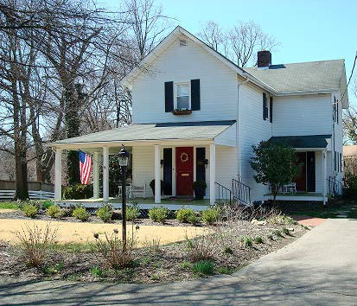
Historic Farmhouse—864 N. Jefferson St., built 1894

Several other houses in the Bluemont area were built in the early part of the 20th century. A cluster of homes on N. Frederick St. was built in 1900. An old farmhouse on
N. Edison was built in 1908 and another old farmhouse on 9th St. N. was built in 1910. Several homes on N. Buchanan St. and 8th Road N. were built in 1920 and 1925.¹⁴¹ A Sears Catalog Home built in 1928 stands on N. Jefferson St. between 8th St. N. and 7th St. N.¹⁴² The Bluemont neighborhood grew rapidly in the post-World War II era. Scores

¹⁴⁰ http://www.arlingtonva.us/departments/realestate/reassessments/scripts/dreadefault.asp
141 Id.
¹⁴² Interview with Katherine Holt Springston, February 12, 2012.

of brick Cape Cod and Colonial-style homes were built to house the returning troops and their families. Representative photos of these types of homes (circa 1948) appear in Appendix E.
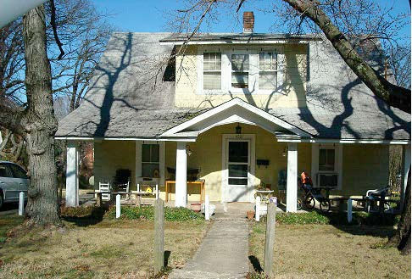
1021 N. Edison St., one story with attic, built 1908

Type & Ownership

The 2010 Census Bureau data for the Bluemont neighborhood reflects a total of 2,392 housing units. Of those,2,300 (96.2%) are occupied.¹⁴³ Owner-occupied units (1,444) comprised 60.4% of total units; renter-occupied units (856) accounted for the remaining 35.8%. Only a small number of housing units (92 or 3.8%) were vacant.¹⁴⁴ Bluemont’s 60.4% of owner-occupied units compares favorably to the corresponding Countywide figure of 40.3%. Moreover, Bluemont’s 3.8% vacancy rate is just slightly over half the corresponding 7% County-wide rate.

Bluemont’s housing stock comprises various types, including townhomes, garden apartments, low-rise apartment buildings, and condominiums. However, detached single- family homes of various ages and styles predominate. Thirty-five percent of respondents to the Neighborhood Survey identified the “character of neighborhood as primarily single-family homes” as a significant advantage to living in Bluemont.¹⁴⁵ Consistent with

¹⁴³ 2010 Census (Summary File 1), prepared by CPHD—Planning Division: Planning Research and Analysis Team, available at http://www.arlingtonva.us/departments/CPHD/planning/data_maps/Census/2010Census/civic/file82922.pdf (last visited March 7, 2012).
¹⁴⁴ Id. The Census Bureau defines “vacant housing units” in pertinent parts as follows: “A housing unit is vacant if no one is living in it at the time of the interview, unless its occupants are only temporarily absent. In addition, a vacant unit may be one which is entirely occupied by persons who have a usual residence elsewhere.” http://www.census.gov/hhes/www/housing/hvs/annual97/ann97def.html (last visited March 7, 2012).
¹⁴⁵ Bluemont NCP Survey 2010, responses to Question I.1.

that view, 83.1% of respondents advocated maintaining Bluemont primarily as a neighborhood of single-family detached homes.¹⁴⁶ Nevertheless, a limited number of survey responses (19) expressed support for the development of townhomes and condominium units along Wilson Blvd. Such development, they observed, would build the tax base, increase demand for public and private services, and be served by public transportation.¹⁴⁷

A significant percentage of respondents (35.8%) registered concern about the extent of non-owner-occupied (i.e., rental) housing within the neighborhood,¹⁴⁸ which those respondents believe has exacerbated parking shortages and created maintenance issues.¹⁴⁹ For example, a number of narrative comments contended that on-street parking has become overcrowded due to illegal multi-family and multi-tenant units (specifically, rental properties with more cars than owner-occupants).¹⁵⁰ Narrative suggestions to address on-street parking shortages included limiting the number of cars per household (especially for renters) and imposing parking permit restrictions. One respondent recommended requiring apartment buildings to provide at least one parking spot for each unit.¹⁵¹

New home construction and additions disproportionate in size to surrounding residences proved far more concerning to more than half (54.5%) of survey respondents.¹⁵² Respondents also associated adverse environmental impacts with expansive new home construction and additions, including loss of green space/mature tree canopy (41.2%), street damage (21.8%), and drainage/runoff/flooding (21.5%).¹⁵³

Condition

Arlington County’s Neighborhood Conservation Program Handbook (May 2009) indicates that this section of an NCP should present and assess the overall condition of housing, distinguishing between the structure and the property, i.e., peeling paint, disrepair, and overgrown vegetation, trash, etc. The Handbook suggests identification of specific houses/apartments requiring attention and/or model neighborhood stock.

An objective measure of property condition would be the number of complaints filed with Arlington Code Enforcement, a part of Arlington’s Inspection Services Division (ISD),, http://building.arlingtonva.us/resource/code-enforcement/. Arlington Code Enforcement, however, files complaints by individual address, making this information inaccessible other than by a targeted address search. As a result, it is not

¹⁴⁶ Bluemont NCP Survey 2010, responses to Question II.1.
¹⁴⁷ Bluemont NCP Survey 2010 (Narrative Responses), response to Question II.1.
¹⁴⁸ Bluemont NCP Survey 2010, responses to Question II.2.
¹⁴⁹ See Bluemont NCP Survey 2010 (Narrative Responses), response to Question IV.10.
150 Id.
¹⁵¹ Id. See also NCP, sec. 6, Transportation/Traffic Management, at 12-15.
¹⁵² Bluemont NCP Survey 2010, responses to Question II.4.
153 Id.

possible to evaluate the extent to which residents have pursued formal complaints against poorly maintained and/or illegal rental properties in their neighborhoods.

Survey Question VII asked respondents to address any concerns not specifically covered in the survey. Responses that implicated housing stock conditions arose several times in the narrative responses to Question VII. Unkempt conditions of rental properties that could contribute to the lowering of property values of surrounding homes, drew repeated criticism. One of the narrative survey comments indicated that the respondent had witnessed no code enforcement despite formal complaints about unkempt condition of property; boarding houses, etc.¹⁵⁴ Another charged that homes with four or more renters are frequently not well maintained and are regularly the scene of loud, late-night parties. This respondent was reluctant to call police, however, stating that documented police activity creates an undesirable record for resale.¹⁵⁵
Recommendation VII-1: The BCA should remind Bluemont residents through its website and/or newsletter of the process for filing code-related complaints with the County and encourage them to do so, when appropriate.

Residents’ efforts to adopt more environmentally friendly landscaping practices also implicate property conditions in Bluemont. For example, removing turf and replacing areas with native plants attract beneficial insects that support native bird populations. In addition, native plants are low-maintenance and require less watering than exotic alternatives. Adding rain barrels to slow down and capture storm runoff improves water quality. Some Bluemont residents have transformed traditional lawns into small meadows to attract native butterflies and birds.¹⁵⁶
Recommendation VII-2: The BCA should educate residents about the sustainable landscape movement, encourage residents to adopt environmentally friendly gardening techniques, and remind residents of the differences between “neglected” yards and those that are intended to create havens for native plants.

Trends

  - Assessed Property Values

¹⁵⁴ Bluemont NCP Survey 2010, narrative response to question VII., commenter’s address: 5600 block of 6th St. N. ¹⁵⁵ Bluemont NCP Survey 2010, narrative response to question VII, commenter’s address: 700 block of N. Buchanan St.
¹⁵⁶ Good Neighbor Handbook: Tips and Tools for River-Friendly Living in the Middle Potomac Region, Potomac Conservancy & The Nature Conservancy (2005), available at http://pocahontaschapter- vnps.org/otherevents/neighbor.pdf.

In January 2012, the Arlington County Department of Real Estate Assessments reported “modest increases” in the value of the County’s residential properties for the second year in a row.¹⁵⁷ According to County-generated data, “[t]he average value of existing single-family properties, including condominiums, townhouses, and detached homes, increased approximately 1.8% from $510,200 in Calendar Year (CY) 2011 to
$519,400 in CY 2012.”¹⁵⁸ Overall, 32% of individual properties increased in value; 46% remained unchanged; and 22% declined.¹⁵⁹

Tear-Downs & New Home Construction

Survey question II.4 asked respondents to identify ways in which new home construction or additions currently occurring in Bluemont neighborhoods create concerns. In addition to the aesthetic and environmental concerns noted earlier, 35 narrative responses detailed the following concerns: large dwellings used illegally as multi-family units (five respondents), damage to character of neighborhoods (five respondents), and increases in traffic congestion. Three respondents noted that large new home constructions and additions have decreased the availability of affordable housing for middle-income families.¹⁶⁰
Bluemont residents’ concerns over burgeoning house sizes are shared across Arlington, as tear-downs and infill construction proliferate with rising land prices and homeowners’ desire for more living space.¹⁶¹ Arlington County data on single-family home demolition permits and home starts by civic association show that “[s]ince 2000, local builders have demolished more than 1,000 single-family homes and started construction of 1,581 new ones.”¹⁶² Over the past decade, 67 demolitions and 102 new home construction starts have occurred in Bluemont, making it one of the most active civic associations for such actions, surpassed only by the Arlington—East Falls Church and Williamsburg Civic Associations.¹⁶³

¹⁵⁷ About Your Real Estate Assessment publication, Arlington County Dept. of Real Estate Assessments (Jan. 2012), accompanying Notices of 2012 Real Estate Assessments.
158 Id.
159 Id.
¹⁶⁰ See also Bluemont NCP Survey 2010 (Narrative Responses), response to Question III.2 (observing that a portion of any village center development should be made affordable because loss of single-family homes is forcing younger families to relocate).
¹⁶¹As reported in Arlington Magazine, “[t]he average new house built in 2010 is significantly bigger than the houses of the 1950s that still populate many Arlington neighborhoods.” Alison Rice, “Sizing Up,” Arlington Magazine, Mar./Apr. 2012, at 39. In 1950, the average home was 1,000 square feet; that average more than doubled to 2,392 square feet in 2010. Id.
¹⁶² Rice, Sizing Up, supra note 10, at 44.
¹⁶³ Id. The source for the reported data is Arlington County single-family home demolition permits and home starts by civic association, Jan. 1, 2000, to Sept. 30, 2011. Graphic reproduced by permission of the publisher, Arlington Magazine.

Arlington Single-Family Home Demolition Permits and Home Starts by Civic Association

Civic Association | Demolitions | Starts
ARLINGTON—EAST FALLS  CHURCH | 67 | 104
BALLSTON—VIRGINIA  SQUARE | 42 | 38
BLUEMONT | 67 | 102
CHERRYDALE | 64 | 92
DONALDSON RUN | 37 | 64
LEEWAY OVERLEE | 39 | 82
LYON PARK | 57 | 66
LYON VILLAGE | 51 | 58
NAUCK | 26 | 62
ROCK SPRING | 53 | 66
WILLIAMSBURG | 109 | 120
YORKTOWN | 38 | 66
Source: Arlington County single-family home demolition permits and home starts by civic association, Jan. 1, 2000, to Sept. 30, 2011.

Home Sales
Despite the negative economic climate over the past five years, homes sale numbers and amounts for Arlington County, in general, and within Bluemont’s zip code 22203, in particular, have declined less dramatically than in other areas in the metropolitan region. The most recent sales figures (January 2012) in the 22203 zip code reflected nine sales, up from six the prior month. The average $329,800 sales price was down 34% from that of the prior month; the median sales price of $295,000 posted a 32.2% decline from December 2011. However, the length of time homes spent on the

market declined from 139 days to 59 days, on average.¹⁶⁴ The chart below depicts year- over-year home sale numbers (2008-2012) for the 22203 zip code.¹⁶⁵
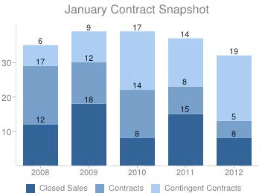
Source: Real Estate Business Intelligence.

Foreclosures and Real Estate-Owned Properties

Double-digit declines in property values over the last five years have resulted in waves of foreclosures and related bank sales of distressed properties nationwide.
Arlington County has fared substantially better than other neighboring jurisdictions, having the lowest foreclosure rate in the Washington, D.C., region.¹⁶⁶ According to Arlington County Real Estate Assessments, foreclosures for Arlington County totaled 28 in 2006, 139 in 2007, 305 in 2008, 300 in 2009, 192 in 2010, and 80 from January to June 2011.¹⁶⁷ The County reports that the majority of Arlington foreclosures have been in zip code 22204.¹⁶⁸

To date, efforts to obtain specific foreclosure numbers for the Bluemont zip codes have been unsuccessful. However, data obtained from the commercial database, Zillow, suggest that Bluemont’s foreclosure rate from January 2006 through December 2011 was slightly higher than Arlington County’s overall foreclosure rate, with an average monthly

¹⁶⁴ Scott McCaffrey, “Home Sales Decline in January, But Average Prices Head Higher,” Arlington Sun Gazette, Feb. 16, 2012, at 7. The article’s data were reported by Real Estate Business Intelligence, http://www.rbintel.com/.
¹⁶⁵ Real Estate Business Intelligence, http://www.rbintel.com/statistics/zip-code-report?zip=22203 (last visited Mar. 7, 2012). The underlying data break out sales prices by detached homes (by number of bedrooms) and condominiums.
¹⁶⁶ Dept. of County Planning, Housing & Dev., Meeting the Affordable Housing Challenge: Annual Affordable Housing Targets Report for FY 2011, at 4, available at http://www.arlingtonva.us/departments/CPHD/housing/pdf/file85030.pdf (last visited Mar. 7, 2012).
167 Id.
168 Id.

foreclosure rate of 8.8 homes per 10,000 during the period, compared to the overall monthly rate for Arlington of 3.88 per 10,000.¹⁶⁹

Affordable Housing

Survey respondents were split on the value of providing affordable housing (including housing for the elderly/disabled). One-third of respondents identified affordable housing as “not at all important”; whereas 27.1% of respondents valued it as somewhat important and 12.4% valued it as “very important,” on a scale of 1-5.¹⁷⁰
One affordable housing project opened within Bluemont boundaries in October 2011: The Jordan, located at 801 N. Wakefield St., 1/4 mile from the Ballston shopping district and metro.¹⁷¹ This apartment complex provides 90 affordable apartments, a landscaped courtyard with a waterplay area, and underground parking for residents.¹⁷²
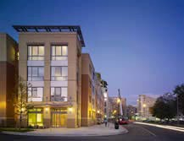

¹⁶⁹ See http://www.zillow.com/local-info/VA-Arlington-home- value/r_30258/#metric=mt%3D49%26dt%3D1%26tp%3D5%26rt%3D8%26r%3D30258%252C276216%26el%3D0
Zillow defines a “foreclosure” as occurring when “a homeowner loses their home to their lending institution or it is sold to a third party at an auction.”]

¹⁷⁰ Bluemont NCP Survey 2010, responses to Question III.2.i. These responses considered affordable housing in the context of a possible village center concept, in which development might include residences located above retail space. See also Bluemont NCP Survey 2010, responses to Question III.5 (indicating that 59.5% of respondents would prefer residential use on upper stories of multi-story village center-style development; 41.1% of respondents would prefer office space).
¹⁷¹ See http://www.ahcinc.org/JordanManor.html (last visited Mar. 7, 2012). The Jordan was developed by the nonprofit organization AHC Inc., in partnership with Arlington County, Bonstra Haresign Architects, Capital One Bank, Hudson Housing, LLC, The JBG Companies, and the Virginia Housing Development Authority. According to the AHC Inc. website, “The four-story building replaces the 28-unit Jordan Manor. The Jordan is part of a 4.8 acre multi-use project that will also include a 10-story office building, an eight-story Virginia Tech complex, and 27 market- rate townhomes.”
172 Id.

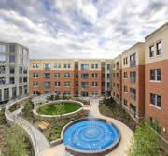
Source for images: http://www.ahcinc.org/JordanManor.html Respondents’ ambivalence to providing affordable housing contrasts with
Arlington County Board initiatives to make affordable housing a priority. The affordable housing goals adopted by the Board in 2011 include “distribut[ing] committed affordable housing within projects, within neighborhoods and throughout the County.”¹⁷³
Recommendation VII-3: Bluemont should work with the County to contribute to the realization of affordable housing targets as part of any future development of mixed-use space in the Wilson Blvd. commercial corridor.

¹⁷³ Dept. of County Planning, Housing & Dev., Meeting the Affordable Housing Challenge: Annual Affordable Housing Targets Report for FY 2011, at i, available at http://www.arlingtonva.us/departments/CPHD/housing/pdf/file85030.pdf (last visited Mar. 7, 2012).

Public Facilities and Services

- Educational Facilities

Bluemont is home to ATS at 855 N. Edison St., near the intersection of N. George Mason Drive and Wilson Blvd. The ATS school grounds are classified as neighborhood open space. On the large lot surrounding the school are playgrounds, a basketball court, and an athletic field with a backstop that is used for ball games, including baseball and soccer. ATS has been a County-wide elementary alternative school since 1978, and has been in its current location since 1995. It serves preschool through grade 5 students from all Arlington neighborhoods. Families follow specific application procedures and students are selected by random double-blind lottery to be admitted into the school.
Admission to ATS is also limited by the small number of slots available each year, since many slots are already filled as a result of sibling preference and the automatic eligibility of Virginia Preschool Initiative (VPI) students already in the pre-school program.¹⁷⁴ Free bus transportation is provided for students living more than one mile from school, although some children who live less than one mile away receive free bus transportation so they do not have to cross Wilson Boulevard. The school is noted for its adherence to a traditional philosophy of education and consistently ranks as one of the top performing elementary schools in Arlington. Fifty-seven percent of Bluemont residents responding to the survey support efforts to enable neighborhood children to attend ATS.¹⁷⁵

St. Ann’s Catholic School, located at 980 N. Frederick St., is a private parochial school and accepts students from pre-school through 8th grade.

A wide range of institutions of higher education have a growing presence in Bluemont, including satellite campuses for Marymount University, Northern Virginia Community College, George Washington University and Virginia Tech, all located along Glebe Road and the eastern edge of Bluemont within walking distance of the Ballston Metro.

The Virginia Tech facility, located at 900 N. Glebe. Road is home to Virginia Tech's Advanced Research Institute (VT-ARI, formerly the Alexandria Research Institute), and is focused primarily on engineering and computer science. The George Washington University Graduate Education facility is located at 950 N. Glebe Road and offers a range of advanced degree programs.
Recommendation VIII-1: ATS is currently slated for construction improvements to add classrooms and capacity to the school in the near future. When this capacity is added, Bluemont recommends that the School Board change the ATS lottery process so that preference is given to Bluemont children who apply for the ATS lottery. Such a policy will allow children who live closest to ATS to attend the school if they prefer and will help to alleviate overcrowding at Ashlawn and McKinley elementary schools.

¹⁷⁴ http://www.apsva.us, ATS admission procedures, site last visited on March 12, 2012.
¹⁷⁵ Bluemont NCP Survey 2010, responses to Question 29.

Parks, Open Space, Recreation, and Beautification Projects

  - Overview

Despite increasing urbanization in the area, Bluemont enjoys a relative abundance of parks and other open space. Within this small urban neighborhood are: Bluemont Junction Park, Fields Park, Lacey Woods Park, half of Bluemont Park, half of Bon Air Park, part of Lubber Run Park, a wetlands preserve known as Ballston Pond (formerly known as Beaver Pond), historic Southern-Shreve Cemetery, and Arlington Constitutional Garden and Bicentennial Bell. Passing through the neighborhood are two streams, Four Mile Run and Lubber Run, as well as three of the region’s premier bike trails, the Custis Trail, the Washington & Old Dominion Trail, and the Bluemont Junction Trail. Together, these parks and other open spaces offer a wide range of recreational and nature-oriented activities, from running, bicycling, soccer, and tennis to walking, bird- watching, and botanizing.

Bluemont’s parks and open spaces encompass a surprising number of significant natural resources considering that they are in the heart of an urban community. The recently completed Natural Resources Management Plan identified these resources and created a geographic information system map of each park, marking champion trees, natural geologic features, and significant native plants and other natural resources which is supposed to be reviewed before construction on any trail or park enhancement.¹⁷⁶ Knowing what we have is the first step in preserving our treasures.

The citizens of Bluemont cherish these open spaces. When asked which park facilities are used most by individuals and families, respondents to the survey reported using the parks and open spaces for walking and jogging, (93.3%); biking (65.3%) and enjoyment of open space (69.7%). Respondents reported using the more developed facilities such as playing fields (25.4%), tennis courts (19.2%), and basketball courts (10.8%) at significantly lower levels.¹⁷⁷

Bluemont residents put a high value on parks and open space. Over two-thirds of respondents (68.9%) support the purchase of properties as they become available in order to enlarge the amount of park and open space.¹⁷⁸
Recommendation VIII-2: As population density and development continues to increase, Bluemont residents urge the County to seek additional opportunities for land acquisition and easements to expand existing parks and open space.

¹⁷⁶ The Natural Resources Management Plan, adopted by the County Board on November 13, 2010: http://www.arlingtonva.us/departments/parksrecreation/documents/file76445.pdf (last visited Mar. 10, 2012).
¹⁷⁷ Bluemont NCP Survey 2010, responses to Question 25
¹⁷⁸ Bluemont NCP Survey 2010, responses to Question 26.

Streams and Wetlands

Four Mile Run passes through the center of Bon Air Park and Bluemont Park on its way to the Potomac River. Mature trees used to line both stream banks. Those trees shaded the stream and its wildlife and helped protect the stream banks from erosion.
However, these riparian zones are now largely overrun by non-native invasive plants that are strangling out native plant populations, killing mature trees and becoming a vector for spreading non-native invasive species into areas previously clear of them.¹⁷⁹

Further, like other Northern Virginia streams, the health of Four Mile Run is threatened by pollutants. Impermeable surfaces, such as sidewalks, structures, and roads, cover more than 40% of Arlington as a whole, and almost 47% in the Lubber Run watershed. As impermeable surfaces have replaced vegetation in much of the stream’s watershed unfiltered, rushing storm runoff collects pollutants from our buildings, streets and yards and causes serious erosion. Four Mile Run does not currently meet Federal or State water quality standards.¹⁸⁰

As part of the Storm Water Master Plan update and in anticipation of more stringent clean water ordinances for the Chesapeake Bay, the County has been studying potential sites for storm water retrofits. There are a number of potential projects within the Lubber Run watershed and also within the BCA’s borders, including a bio-retention project at ATS. The objectives of the bio-retention projects are to improve the quality of water in our streams by slowing down and temporarily storing storm water runoff, and cleaning and filtering pollutants in the process.¹⁸¹

Likewise, resident are encouraged to take steps on their own properties to collect or slow down storm water, and allow it to soak into the ground, keeping pollutants out of Arlington’s streams. Using rain barrels, reducing permeable surfaces, reducing turf grass and replacing it with rain gardens, and native plant gardens are all steps that residents can take individually to improve water quality. Additionally, any future traffic-calming projects, such as a traffic bump out, should incorporate storm water management techniques.¹⁸²

Lubber Run flows south-southeast through the eastern edge of the neighborhood. The northern edge of Lubber Run Park is within the Bluemont neighborhood. The stream joins Four Mile Run in Arlington Forest, one-half mile south of the neighborhood.

Ballston Pond (formerly known as Beaver Pond Park), classified as Natural Resource Open Space, is a wetland area built as a storm water retention area for Interstate 66 between Washington Blvd. and Fairfax Drive. The pond overflows into Lubber Run.

¹⁷⁹ Natural Resource Management Plan, pp. 20-22.
¹⁸⁰ E-mail exchanges and telephone conversations with Aileen Winquist, Watershed Outreach Program Coordinator, Arlington County Department of Environmental Services, Dec. 2011 - Feb. 2012. awinquist@arlingtonva.us
¹⁸¹ http://www.arlingtonva.us/departments/EnvironmentalServices/epo/page83243.aspx
¹⁸² E-mail exchanges and telephone conversations with Aileen Winquist. Dec. 2011 - Feb. 2012. awinquist@arlingtonva.us

A major restoration of the pond, including a boardwalk for public viewing, is currently in the planning stages.¹⁸³

Bike Trails

Bluemont hosts three paved off-road trails, each of which is an important part of the exemplary Northern Virginia multi-use trail network. Bluemont’s trails are often filled with walkers, runners, people pushing baby carriages, children playing, in-line skaters, and recreational and commuter bicyclists. But the very popularity of the trails presents challenges. Heavy usage becomes even more of a problem when some trail-users speed or otherwise ignore trail guidelines.

The Washington and Old Dominion (W&OD) Trail, located on the site of the former railroad bed, runs continuously from Purcellville, Virginia to the Potomac River. The trail passes on the western edge of the Bluemont neighborhood, running along Four Mile Run through Bon Air Park and Bluemont Park. The W&OD trail is up to 12 feet wide and is maintained by the County and the Northern Virginia Regional Park Authority (NVRPA). The riparian area, between the trail and Four Mile Run, is blanketed with non- native invasive species which have choked out native vegetation and toppled mature trees. This area has become a vector for the spread of non-native invasive species along the W&OD corridor.
Recommendation VIII-3: The County should work with NVRPA and Dominion Power to implement an invasive species control plan to remove the existing infestation of invasive species in the power line right of way, to stop the rampant spread of new and existing invasive species, and to slow the destruction of the trees and the riparian vegetation.¹⁸⁴

At the Northern end of Bon Air Park, the W&OD trail connects to the starting point of the Custis Trail, a County-maintained pathway running through the Bluemont neighborhood along the north side of Interstate 66 on its way to Washington, D.C. The trail is lighted and about nine feet wide. Mature oaks and other large trees line parts of the trail, especially in the western portion between N. Harrison St. and Bon Air Park. The County has planted additional trees in the area near N. George Mason Drive. However, non-native invasive plants threaten many newly planted and mature trees.

Bluemont Junction Trail runs 1.3 miles from the W&OD trail in Bluemont Park to Fairfax Drive in Ballston. Many residents use this section of the trail as a neighborhood gathering area, and strollers, tricycles and casual dog walkers are common sights. More and more people are using the trail both for recreation and to walk or bike to the booming commercial district of Ballston. Regrettably, this commute is made more difficult and dangerous because of the trail’s crossing at the intersections of N. Kensington St., N. Emerson St., Wilson Blvd. and N. George Mason Drive, and again at

¹⁸³ http://ballstonpond.us/
¹⁸⁴ Natural Resource Management Plan, recommendation #13.

N. Abingdon St. These intersection crossings are dangerous for pedestrians and bicyclists.

Pedestrians and bicyclists face additional hazards where the trail ends near Fairfax Drive. The trail is constricted by a guardrail near N. Abingdon St., and then gives way to a narrow, unbuffered, obstructed sidewalk in front of the Holiday Inn at 4610 Fairfax Drive. A bicycle lane was added between the right turn lane and the major flow of traffic on Fairfax Drive, beginning in front of the Holiday Inn. However, motorists often cross the bike lane, increasing the danger for bicyclists. The flow of bicyclists through this area has likely increased recently as users of the recently-installed Capital BikeShare rack at George Mason Drive and Wilson Blvd. frequently ride these bicycles to and from the Ballston Metro station.
Recommendation VIII-4: The County should take steps to reduce the potential for motorist-bicyclist accidents at the I-66 eastbound exit ramp/Fairfax Drive near the Holiday Inn at 4610 Fairfax Drive.

Parks

Bluemont Park, classified by the County as community open space, is located between Wilson Blvd., Carlin Springs Road and N. Manchester St. This large park has a number of recreational, natural, and historical attractions that are popular with neighborhood residents and visitors. On the Bluemont NCP survey, 60.2% of residents reported using Bluemont Park frequently, or more than two or three times a month.¹⁸⁵

The northwest portion of Bluemont Park includes lighted tennis courts and a parking lot. A well-worn dirt path crosses from the southeastern corner of the parking lot to the Four Mile Run Trail. The northeast portion of Bluemont Park includes an athletic field, and a train caboose and a small exhibit commemorating the site of the former Bluemont rail junction. Arlington County youth soccer leagues as well as a private school lacrosse team often use the field. The western central portion of the park is a large open area that includes three baseball diamonds. Often on the weekends, the fields are used all day, with several simultaneous games of the same or various sports. The fields below the Reevesland Farm house are often used for informal soccer and ultimate Frisbee games.

The southwest portion of the park contains a lighted basketball court, a newly refurbished children’s playground, a Disc Golf Course, picnic tables, barbecue pits, and another parking lot entered from N. Manchester St. This portion of the park is populated with mature trees, and features severely compacted soil from an abundance of park users. The southeast portion of the park is predominately an open athletic field surrounded by a forest of mature trees, and includes a picnic pavilion and a tree-covered picnic area. The area is accessed by a low concrete footbridge that fords Four Mile Run and is designed to allow water from the stream to overflow the bridge during heavy rain. The facilities and

surrounding trees are suffering from significant erosion and soil compaction. The area is a popular spot for group picnics with over 50 picnic tables and eight barbecue grills.

Tucked into pockets along the edges of the park are significant natural resources: a piedmont mountain swamp forest behind the railroad car, an acidic oak hickory forest on the edges, a tulip poplar spicebush forest along N. Manchester St., and an oak heath forest near the Arlington Forest Swim Club. The County Champion Swamp white oak and a notable Blackhaw viburnum are located next to the picnic pavilion near the stream and a significant specimen American hornbeam tree is near the playground.
Unfortunately, during the reconstruction of the Bluemont playground, the footprint of the playground was significantly increased and over half of the playground is now in a Resource Protection Area.
Recommendation VIII-5: The County should complete the exhibit commemorating the site of the former Bluemont rail junction. The completed exhibit should illustrate the history of the County’s railroads and trolleys, should explain the significance of the junction to the development of the County and the Bluemont neighborhood, should fully expose the portion of the railroad‘s electrical substation that remains outside of the athletic field’s fence, and should interpret the historical features that remain on the site. The completed exhibit should contain maps, pictures and signage that are both outdoors and inside the caboose.
Recommendation VIII-6: Prior to embarking on any future renovations or construction projects, the County should work to ensure that sensitive natural resources are not further damaged or compromised.¹⁸⁶

Bluemont Junction Park, while the Bluemont Junction Trail (see above) is the highlight of this narrow park, there are also grassy areas wide enough to host informal athletic activities. Much of the park has been planted with trees, which is giving the park a more wooded appearance. The “Rocks,” an area with a number of large boulders placed near N. Illinois St., is a popular natural playground for neighborhood children and has become the destination for the annual Halloween parade along the bike trail. Likewise, the placement of large boulders along the trail provides natural seating and rest areas for trail users. Over 59% of respondents report using this park frequently or at least two to three times a month.¹⁸⁷

Bon Air Park’s 23.9 acres are classified by Arlington County as community open space. The park is bounded by Wilson Blvd., Arlington Mill Drive, Interstate 66, and N. Lexington St. Bon Air is a popular location for group picnics as well as family gatherings and individual respites. In addition to Four Mile Run and the W&OD Trail, the park contains two tennis courts, a basketball court, a baseball diamond, a volleyball court, playgrounds, and picnic tables and grills.

¹⁸⁶ Natural Resource Management Plan, recommendation # 3

Bon Air Park embodies the diversity of Arlingtonians’ views on what a public park should provide. From a natural resources point of view, the park is important for its educational exhibits of the volunteer Master Gardeners. The Quarry/Shade Garden is in a historic quarry, with examples of plants that do well in our area in semi-sun and shade; the Sunny Garden demonstrates how a flower garden can be both beautiful and sustainable. Not all of the plants in the gardens are native to this area, but a significant number abound with butterflies, birds, and other creatures that use these gardens as an important source of food. The emphasis on water-wise and sustainable low maintenance plants provides a contrast to the formal Rose Garden which requires a great deal more pesticides and labor to weed, prune, debug, and maintain. Some residents feel the Rose Garden is well worth the extra cost and consider it a masterpiece. However, in contrast to the high usage of other parks, 57.2% of respondents reported using Bon Air park infrequently or never.¹⁸⁸ The recent addition of the lot adjacent to the Sunny Garden on
N. Lexington St. also shows a wide diversity of public opinion. Tree lovers want a mini- forest, butterfly lovers a prairie garden, deep thinkers a meditation garden, volleyball enthusiasts a sand court, and some have suggested a community vegetable garden! For now, the land is fallow with planted grass to prevent erosion and any future plans will be presented to the neighborhood association for comments.

Fields Park, classified as neighborhood open space, is located near the intersection of George Mason Drive and Wilson Blvd. next to the Bluemont Junction Trail and the Constitutional Garden and Bicentennial Bell. A stone marker in the park is inscribed, “In memory of Maryanna Fields 1922-1985.” The park consists primarily of a Bermuda-grass athletic field used mostly for youth soccer. The park was recently refurbished and, in addition to the existing picnic tables, now has bleachers and an ADA- accessible sidewalk. The park is also the location of a Capital Bikeshare rack. (A second Capital Bikeshare rack within Bluemont is located near N. Wakefield St. and N. Glebe Road.) Trees line the park on its east, west, and north sides. Adjacent private property is separated from the park by a chain-link fence with lock and gate entrances for each property owner. Fields Park had by far the lowest usage of respondents, with 84.1% reporting that they use the park infrequently or never.¹⁸⁹

Lacey Woods Park, classified as community open space, is regarded by residents and visitors as a small treasure of urban forestry. The park is located southwest of N. George Mason Drive and Washington Blvd. While only about 13 acres, Lacey Woods Park contains one of the largest and most important concentrations of woods in the neighborhood and County. Lacey Woods Park contains a heavily used basketball court and an athletic field. The park also has a popular children’s playground and numerous benches. The park has two picnic shelters and a fire ring. Parking is available on adjacent streets. Residents have noted that some dog owners fail to leash their pets or to clean up after them while in the park.¹⁹⁰

¹⁸⁸ Bluemont NCP Survey 2010, responses to Question 24.
¹⁸⁹ Bluemont NCP Survey 2010, responses to Question 24.

Although the open areas of soccer field, basketball court, and playground are classified as “modified urban landscape,” the remainder of Lacey Woods is an acidic oak hickory forest with a towering canopy. The park boasts two National Champion trees.
Near the playground is a natural wetlands seep, making it home to many salamanders, Turks’ Cap lilies, Solomon’s seal, and Strawberry bush. Beautiful caterpillars and salamanders have been discovered during the regular volunteer work days,the second Saturday of each month.

Other Open Spaces

Arlington Constitutional Garden and the Constitutional Bicentennial Bell, classified by the County as neighborhood open space, are located at the corner of Wilson Blvd. and George Mason Drive. The garden and bell commemorate the bicentennial of the U.S. Constitution. They were established in 1987 as a joint effort of the Arlington Beautification Project and Arlington County. The project received a certificate of official recognition from the Commonwealth of Virginia under the Living Legacy program. The bronze Bicentennial Bell weighs 250 pounds and has a 30 pound clapper that is inserted to ring the bell on ceremonial occasions such as Independence Day and other federal holidays, and at midnight on New Year’s Eve.

Private Neighborhood Services

Arlington Forest Club, classified by the County as semi-public land, lies south of Bluemont Junction Park at the corner of N. Harrison St. and Carlin Springs Road. This private recreation association offers its members pool and lighted tennis facilities.
Because the club’s mature trees and landscaping make such a contribution to the neighborhood, the BCA has encouraged the club to maintain its greenery and to consider adding trees or other landscaping along N. Harrison St.¹⁹¹

The Arlington Metaphysical Chapel, is located on Wilson Blvd. near N. Jefferson St. The church building originally housed the Bon Air Baptist Church. In 1949 it was sold to the Odd Fellows Lodge which sold the building to the AMC Congregation in 1981. The building was restored to its original interior design, removing dropped ceilings, restoring the chandelier ceiling in the main sanctuary, as well as adding central air conditioning and lighting. The quaint white frame building blends in with the surrounding residences.

Bon Air Baptist Church, established in the early 1900s, is an attractive, well- maintained facility located at 800 N. Illinois St., in the middle of a residential block. The front of the church is landscaped, while the back area has been converted into a parking lot extending to N. Jefferson St.

First Presbyterian Church, The First Presbyterian congregation, started in 1872, moved to its present location at the corner of Carlin Springs Road and N. Vermont St. in 1950. The tall white-spired church, parking lot, and playground sit on a three-acre site,

¹⁹¹ 1999 Bluemont Neighborhood Conservation Plan, p. 28.

one of the largest remaining green spaces in the Ballston area. The church also serves the wider community during the weekdays as the meeting and distribution location for the non-profit Meals on Wheels food delivery service to shut-in residents of Arlington.

Saint Ann Catholic Church and School celebrated its 60th anniversary in 2007.
Its large lot, bounded by N. 10th St., Custis Trail, N. Frederick St. and N. Harrison St., contains the church and various school buildings. Most of the lot not covered by buildings is paved over for parking. The church lot also contains two basketball courts and a children’s playground.

Saint Michael’s Episcopal Church, built in 1948 of native Virginia stone, is located at N. Ivanhoe St. and N. 11th Road. The church’s chimes can be heard across the northern portion of the neighborhood. The attractively landscaped grounds include an education building, outdoor altar, memorial garden, labyrinth, and children’s playground.

Southern-Shreve Cemetery, classified by the County as a Historic Resource, is located, along with an accompanying marker, south of Saint Ann Church at Fairfax Drive and N. Harrison St. (See Historic Section notes on the Shreve and Southern families, early settlers in the area.)

Neighborhood Beautification

Streets are the most visible and important public spaces in neighborhoods.
Unfortunately, Bluemont’s attractive parks stand in stark contrast to its streets, where concrete and power lines are far more visible than vegetation. As redevelopment takes place, we encourage efforts by Arlington County Government and private developers to build more attractive, landscaped streetscapes, particularly along arterial roads.

Bluemont neighborhood’s above-ground utilities are an impediment to improved street landscaping. Utility lines and poles are not only unattractive, but are especially unkind to trees. Regrettably, burying utilities throughout the neighborhood is prohibitively expensive at this time. However, as with other Arlington neighborhoods, a partnership between the County and local businesses could conceivably produce sufficient funding to bury utilities along Wilson Blvd.¹⁹²

There are minimal buffer and transition areas between commercial facilities and adjacent residential neighborhoods in much of the neighborhood. In many cases, commercial activities take place directly adjacent to or across from residential dwellings with minimal or no benefit from landscaping or other forms of screening.
Recommendation VIII-7: Local businesses are encouraged to develop and maintain attractive landscaping, especially in commercial areas adjacent to residential areas.
County business development offices should encourage such practices even if not specifically required by County ordinance.

192 See Section V.B.3. for a further discussion and recommendations regarding the utility lines along Wilson Blvd.

Residents oppose the prospective construction of any telecommunication towers or facilities on County parks or other land. Commercial buildings in Ballston are at a higher elevation than any neighborhood location and could accommodate such towers or facilities more efficiently than any stand-alone structure in Bluemont neighborhood.¹⁹³
Recommendation VIII-8: The County should not permit the installation of telecommunications towers or facilities in the neighborhood.

Public Safety - Fire, Ambulance, Police

Ballston Fire Station, also known as Fire Station 2, is located within the BCA’s borders at 4805 Wilson Blvd., near the intersection of George Mason Drive. This relatively centrally located fire station allows for a rapid response time to incidents involving Bluemont homes and residents. The fire station also hosts an occasional open house and the firefighters have allowed tours of the trucks during neighborhood events including in recent years the BCA-sponsored Neighborhood Day picnic. Likewise, though not located within Bluemont, the Virginia Hospital Center is just a short drive away for most residents.

Approximately four times a year a member of the First District Team of the Arlington County Police Department attends BCA general membership meetings and provides updates and listens to community concerns. While safety along the bike trails was raised as a concern in the last Bluemont Neighborhood Conservation Plan,¹⁹⁴ in 2011 there were only four reports of graffiti and one report of a stolen cell phone. The Arlington Police Department has police officers and auxiliary officers that conduct bicycle patrols on the bike path and throughout the neighborhoods. Officers also patrol the bike paths and neighborhoods on Segways. Motor officers also patrol the bike paths as time permits. The bike trails within the civic association are considered to be very safe.¹⁹⁵ However, crime along the path is not unheard of, and reports of a sexual assault on the bike trail have increased concern among residents about the safety of the trail.

¹⁹³ 1999 Bluemont Neighborhood Conservation Plan, p. 29.
¹⁹⁴ 1999 Bluemont Neighborhood Conservation Plan, p. 25
¹⁹⁵ Interview and e-mail exchange with Corporal Beth Lennon, #908, Arlington County Police Department, and C. Haynes, March 3, 2012.

Commercial and Business Areas

A. Overview

This section of the NCP presents a description and inventory of the business and commercial establishments within the boundaries of the BCA and identifies areas of concerns about and by those establishments. In assembling its findings, the drafters of the NCP drew information from the Bluemont NCP Survey and from a more informal polling of Bluemont business owners.

The section includes (1) an inventory of the types of business and commercial establishments within Bluemont; (2) conditions affecting those establishments; and (3) the relationship between Bluemont’s residential and business areas.

Inventory of Business and Commercial Establishments

Businesses in Bluemont are concentrated in two basic areas: the Glebe Road Business Corridor consisting of the western side of N. Glebe Road between Carlin Springs Road and Washington Blvd. and the Wilson Boulevard Business Corridor consisting of both sides of Wilson Blvd. between N. George Mason Drive and N. Jefferson St. These two business areas are quite different in character.

The Glebe Road Business Corridor is a bustling urban center close to the Ballston Metro stop, and principally contains large, multi-story, mixed-use buildings, with some street-level retail establishments. The composition of these buildings is commercial office space with a growing influx of university satellite campuses. Some of the retail establishments provide support to surrounding office buildings, or to nearby Washington,
D.C. (e.g., Holiday Inn), or are largely devoted to serving the lunchtime office crowd (e.g,, Booeymongers). Other establishments are destination retail (e.g., Rosenthal Mazda, The Melting Pot). There is very little along this corridor that can be classified as neighborhood-facing, although all of the retail does serve the BCA community (e.g., Dry Clean Pro, Greene Turtle Bar and Grille). Many of these businesses are situated in buildings that have been constructed in the last twenty to thirty years.

The Wilson Boulevard Business Corridor contains almost exclusively single-story businesses, nearly all of which are owner-operated. In addition to being predominantly neighborhood-serving retail, this area is home to a number of unique businesses such as a gift shop, clock and watch repair shop, used-book store, animal hospital, second-hand store, and Neapolitan wood-fired pizza restaurant, among others. Most of these businesses occupy small buildings that are over fifty years old.

While there is a significant amount of high-rise commercial development within Bluemont along Glebe Road, that development generally follows the County’s previously-established GLUP for the Rosslyn-Ballston Corridor with concentrated dense, mixed-use development around Metro stations. Accordingly, the analysis and related

discussion presented below focus solely on the Bluemont’s Wilson Boulevard Business Corridor; data related to the Glebe Road corridor is excluded to provide a clearer picture of the business district opportunities within Bluemont.

First, the Wilson Boulevard businesses can be delineated according to their ownership structures:¹⁹⁶

- Closed (2%) – currently for lease
- Local Chain (2%) – outpost of multi-site chain operating strictly in the Washington, D.C. metropolitan region
- Non-profit (2%) – not for profit organization
- Franchise (12%) – includes national chains that are in our neighborhood; these include grocery stores, restaurants, and gas stations
- Owner Operated (82%) – single establishment businesses that are owned and operated in this location; they include beauty and health services, law and medical offices, restaurants and specialty stores

BCA Commercial - Wilson Boulevard Corridor - By Size of Business

Closed 2%

Local Chain 2%
Non-Profit 2%

Franchis e 12%

Owner Operated 82%

¹⁹⁶ This and the following data are derived from an inventory and survey of the neighborhood businesses.

Second, Wilson Boulevard businesses can be categorized by the types of goods or services provided:

- Closed (2%) – currently for lease
- Auto (5%) – gas stations
- Beauty (7%) – includes hair and nail salons
- Fitness (7%) – includes fitness center and soccer club administrative office
- Grocery (7%) – includes convenience store as well as full-service grocery store
- Health Care (12%) – includes office space for counselors, a pharmacy, and a veterinary hospital
- Legal (14%) – includes law offices and title companies
- Restaurant (23%) – includes chains (both local and national) but is mostly made up of owner-operated, single location restaurants
- Specialty (23%) – includes a funeral parlor, gift shop, second hand store, laundry facility, tailor, locksmith, photography studios, and used book store

BCA Commercial - Wilson Boulevard Corridor - By Categ ory

Speci alty 23%
Closed 2%

Auto
5% Beauty
7%

Fitness 7%

Grocery 7%

Restaurant 23%
Health Care 12%

Law 14%

Lastly, the size of businesses within each category is best depicted in the following chart:

BCA Commercial - Wilson Boulevard Corridor - By Categ ory and By Size

12
8
10
6
1
1
1
2
2
1
1

2

3

5

10

8

Non-Profit
Owner Operated
6 Local Chain
Franchis e Closed

4

2

0
Closed

Auto

Beauty Fitness Grocery Health Care
Types of B usinesses

Law

Restaurant Speci alty

Conditions Affecting Bluemont Businesses

Bluemont’s two primary commercial districts are in different stages of development. While there has been little change to the Wilson Boulevard corridor businesses, the Glebe Road corridor of businesses has, like Ballston just across the street, experienced dramatic change since the 1999 NCP. The large Bob Peck / Staples site and adjacent Jordan Apartments were sold and demolished and have been replaced with multi-story office buildings, new affordable housing, and (soon) townhouses. Large new office buildings and businesses now dominate the stretch of Glebe Road between Wilson Blvd. and Fairfax Drive.

Although the NCP 2010 Survey did not directly solicit responses regarding problems within the Wilson Boulevard corridor, the comments and responses on related questions give the overall impression that there are no significant issues per se but rather a collective desire for general improvement to the retail offerings. Unlike the Glebe Road businesses, the small businesses along Wilson Blvd. (many of which are locally owned and serve the neighborhood) abut neighborhoods of single-family housing or parkland.
Our survey indicates a growing concern among residents about the many opportunities for growth and change along Wilson Blvd. and the possibly adverse impact of development in this area, including additional traffic and retail parking spilling over into the neighborhood’s residential areas.

Commercial establishments and residents alike have expressed considerable concern about changes to the balance of the Wilson Boulevard business district and the surrounding neighborhoods. Similarly, there are concerns about the risk of losing existing long-standing small businesses, some of which are run by our neighbors and many of which have been serving the community for decades. On the positive side, residents would welcome changes that bring the opportunity to upgrade the quality of local facilities, improve parking, pedestrian access and infrastructure, and offer new services to this neighborhood. The tension between the risks and opportunities of such change to Bluemont’s commercial segment challenges businesses and residents alike.

Commercial-Residential Relationships

The 2010 Bluemont survey included several questions that addressed residents’ relationship to existing businesses and additionally asked for comments regarding preferences for future development.¹⁹⁷ As expected from such a diverse community, the responses covered a wide range of tastes and opinions, but the central themes were surprisingly focused.

A resounding 83% of survey respondents believed that the single-family nature of the neighborhood should be retained, though only 50% were opposed to rezoning to allow for higher density development. Approximately 70% of the residents surveyed favored a village center concept (i.e., development with a mixture of retail, office, residential, and cultural uses in a compact, pedestrian-oriented center) and a slightly smaller percentage (64%) supported development that would include multi-story

197 For the purposes of this section of the NCP, the following Bluemont NCP Survey questions are most relevant:
“2. Do you believe that Bluemont should remain primarily a neighborhood of single-family, detached homes?
. . .
- Would you want to allow any land currently zoned as low-density residential to be converted to low/moderate density commercial zoning to allow for more commercial or mixed-use development in the neighborhood?
. . .
- Certain jurisdictions and neighborhoods have welcomed “village center” type development. A development concept calling for a mix of retail, office, residential, and cultural uses in a compact, pedestrian-oriented center serving as the focal point for the surrounding residential area. Do you think a village center concept is desirable for Bluemont’s commercial corridor (Wilson Boulevard between N. George Mason Drive and N. Greenbrier Street)?
. . .
- If the BCA were to pursue a village center concept in shaping future development in Bluemont’s commercial corridor, [what elements would be important to include or not include]?
. . .
9. Village center-style development may not be economically feasible for developers unless they can build modest multi-story buildings combined with street-level retail space and upper- story office and/or residential space. If this were the case, would you support a village center redevelopment concept for Bluemont’s commercial corridor?
. . .
13. Is retaining some or all of the corridor’s existing business important to you?”

buildings. It is important to note that this support of multi-story development is refined later in the survey with 54% of respondents stating that they would favor a limit of no greater than three stories; 30% of respondents indicated specifically that they felt that a three-story maximum height was acceptable. (The survey also indicated that 5% and 19% of respondents would consider one story and two stories their respective maximum heights.) Elements rated most important included inclusion of a grocery store, retail and restaurants, easy pedestrian access, on-site parking and green/open space.

Opinion as to the actual composition of the retail component was quite divided but strongly favored retention of a neighborhood-focused business district directed toward the needs of residents. A recurring theme was interest in a retail area comprised of small and local businesses geared to provide services important to the everyday lives of the Bluemont residents. Most in demand was “Grocery Store,” followed by “Independently- owned Restaurant,” “Coffee Shop,” “Gas Station,” and “General Merchandise/Hardware Store.” The commenters overwhelmingly expressed a desire that the retail district retain its low-key character and convenience, along with clear wishes to improve the quality of the existing Safeway grocery store, and, overall, for the Wilson Boulevard corridor to pursue a more organized, aesthetically pleasing and less “strip-mall”-like appearance.
Many responses expressed interest in more upscale amenities such as a coffee shop or a restaurant with outdoor seating.

The comments in the survey responses demonstrated a strong antipathy to either Clarendon Market or Ballston-style development models as a direction to pursue. The comments expressed distaste for the vehicular traffic and congestion of those neighborhoods and seemed to have a basis in a preference for a self-supporting retail district as opposed to a site devoted to national retail chains. Adjectives such as “small,” “locally owned,” and “affordable” occur in many of the responses. In addition, many comments addressed the fear that future development would drive away existing businesses. Asked whether retaining existing businesses was important to residents, 69% answered affirmatively.¹⁹⁸
Recommendation IX-1: The County should take steps to keep the heaviest commercial development contained to Ballston and let the Wilson Boulevard business district focus on local businesses that can directly serve the neighborhood. The retail section of Wilson Blvd. in this area could serve as the “Bluemont Main Street,”
Recommendation IX-2: The County should ensure that the current Safeway site remain a grocery store, but with improved quality of service and outward appearance, without sacrificing parking or accessibility.
Recommendation IX-3: The County should take steps to improve the overall quality and appearance of the Wilson Boulevard business district, and to improve pedestrian access to the Wilson Boulevard businesses. Steps could include reducing Wilson Blvd. to one lane each way between Glebe Road and N. McKinley St. (the Falls Church line: similar

¹⁹⁸ Bluemont NCP Survey 2010, response to Question 13.

to a comparable area of Washington Blvd. between Glebe Road and the Falls Church line). This would permit the widening sidewalks and allow for trees and on-street parking similar to Westover or the Del-Ray neighborhood of Alexandria.

Urban Forestry

Bluemont residents treasure the tree-lined streets and wooded parks in their neighborhoods.¹⁹⁹ Urban trees provide a host of ecosystem services such as cleaning and cooling the air, filtering storm water, reducing energy consumption, providing noise abatement, increasing soil quality and providing walkable streets. Urban trees also contribute to greater economic stability for businesses and greater property values for homeowners.²⁰⁰

However, trees growing in an urban setting are exposed to extremely harsh conditions and require a great deal of care and maintenance to survive. Unlike trees growing in a forest that are fed through the decomposition of leaves and other organic materials and have protection from high winds, freezing temperatures and scalding sun, urban trees are not so fortunate. Urban trees must also contend with compacted soil, air pollution, increasing amounts of impervious surfaces, and the lack of adequate water and nutrients.

Maintenance of the urban canopy is a high priority for Bluemont residents.
According to the recently released Urban Canopy study, Bluemont has a tree canopy coverage of 44%. The canopy coverage within the Bluemont Parks averages 79%; non- park land averages 39.6% canopy coverage. The one public school within Bluemont, ATS, has a tree canopy of 14.3%.²⁰¹

The tree canopy coverage above was measured prior to the recent spate of harsh winter storms, hurricanes, thunderstorms and the June 2012 “Derecho”²⁰² that toppled numerous mature trees. As a result, the current tree canopy numbers are likely to be lower than those noted above. The data is, however, useful in analyzing where the County should focus efforts to increase the urban tree canopy. Bluemont residents recommend that, in doing so, the County should focus both on opportunities within existing parks and other public open spaces, as well as on private land.

Bluemont residents commend the County for the initiation of the green corridors project along the Bluemont Junction Trail and look forward to working with the Parks and Natural Resources Division to implement the plan.²⁰³ Removing the invasive species and planting native trees should lead to increased size and survivability of the tree canopy and can also be used as an educational tool within Arlington.

Numerous residents in Bluemont have participated in the County-sponsored tree distribution (funded through the Tree Canopy Fund) for private property owners where

¹⁹⁹ Bluemont NCP Survey 2010, various narrative responses to Question I.1.
²⁰⁰ Nowak, David, et al, Sustaining America’s Urban Trees and Forests, USDA, Forest Service, Gen. Tech. Rept. NRS- 62, June 2010, p. 7.
²⁰¹ Conversations and e-mail exchanges with Vincent Verweij, Arlington County Urban Forester, Division of Parks and Natural Resources 12/11- 1/12
²⁰² A derecho is a widespread, long-lived, straight-line windstorm that is associated with a fast-moving band of severe thunderstorms. Office of the Federal Coordinator for Meteorology, Meteorological Definitions (2008). On June 29, 2012, a derecho tracked across the mid-Atlantic states, including the Washington metropolitan area.
²⁰³ Vote in support of green corridors plan at January 18, 2012 BCA General Membership meeting.

residents and other landowners, such as businesses, churches and homeowners may apply to obtain trees. Bluemont residents applaud the County for this program and urge further action to discourage removal of trees during any construction or redevelopment.²⁰⁴

Bluemont residents further commend the County for recently adopting planting guidelines that specify which plants are appropriate for which areas. These guidelines should be more widely publicized and made available to local residents. It is also noted that non-native invasive plant species, especially English ivy (Hedera helix), porcelain berry (Ampelopsis brevipedunculata), and Japanese Honeysuckle (Lonicera japonica), can severely damage and ultimately kill mature trees. Trees being strangled by invasive vines are apparent in many public and privately owned properties throughout the Bluemont neighborhood. The County should support increased outreach and education programs to inform residents of the damage caused by these non-native invasive plants and to promote control measures.²⁰⁵

²⁰⁴ 1999 Bluemont Neighborhood Conservation Plan, p. 23-24
²⁰⁵ The Natural Resources Management Plan, adopted by the County Board on November 13, 2010: http://www.arlingtonva.us/departments/parksrecreation/documents/file76445.pdf Recommendations #11, 13 and 14.

Recommendations

The residents of Bluemont believe that each of the following recommendations will enhance the quality of life in our community. Each recommendation is more fully explained above and is numbered to ease referral to those explanations.

Recommendation IV-1: In order to preserve Bluemont as a predominantly residential neighborhood of detached homes, the County should work with the BCA to broadly maintain the prevailing land use and zoning patterns of the neighborhood. Bluemont residents particularly recommend that their views be given due consideration in adjudicating any rezoning request or zoning variance request that would allow additional commercial development or higher density development in the neighborhood.

Recommendation IV-2: The County should work closely with the BCA in actively soliciting the opinions of Bluemont residents on prospective modifications to the Ballston Sector Plan that include any part of the Bluemont neighborhood.

Recommendation IV-3: Working with the BCA as appropriate, the County should be responsive to requests for enforcement of County ordinances on residential use, residential care, parking, noise, and other health and quality of life issues. In acting on such requests, the County should balance potential risks to health, safety, and welfare with the privacy rights of local residents.

Recommendation V-1: Improve sidewalks on both sides of Wilson Blvd. throughout the Bluemont neighborhood so that they meet Arlington County and ADA design standards and generally manage Wilson Blvd. so that it is safe and comfortable for pedestrians, bicyclists, transit riders, motorists, and other users. County officials should work closely with the BCA’s Arterial Roads Task Force in undertaking these efforts to ensure that any work is responsive to the particular needs of Bluemont residents.

Recommendation V-2: In the near term, implement the recommendations made in the BCA’s October 24, 2012 Resolution to reconfigure Wilson Boulevard west of George Mason Drive to make it safer and more accessible for all modes of transportation, with implementation in two phases: (1) Conversion of the existing four lanes to two through lanes and a two-way center turn lane (with dedicated turn lanes at intersections), and two bicycle lanes by restriping the pavement; and (2) Widening of sidewalks and planting/utility strips so as to meet ADA requirements and Arlington County design guidelines.

Recommendation V-3: Improve sidewalks on both sides of N. George Mason Drive throughout the Bluemont neighborhood so that they meet Arlington County and ADA design standards and generally manage N. George Mason Drive so that it is safe and comfortable for pedestrians, bicyclists, transit riders, motorists, and other users.

Recommendation V-4: Install sidewalks on at least one side of the street on N. Jefferson St., N. Kensington St., N. Lexington St., 5th St. N., 6th St. N., 8th St. N., and 8th Road N..

Recommendation V-5: The utility lines along Wilson Blvd. should be placed underground and the costs of this undergrounding should be primarily borne by developers and Dominion Virginia Power, along with Arlington County taxpayers if necessary.

Recommendation VI-1: Install a four-way stop sign at the intersection of N. Kensington St. and 7th St. N. ; create a crosswalk with stamped asphalt or a raised and stamped crosswalk; and provide signage along N. Kensington informing motorists to yield to pedestrians. If necessary, the County could consider the installation of traffic circles at several points along N. Kensington St. or restrictions on the usage of the street by non- residents during rush hours.

Recommendation VI-2: Institute traffic calming measures along the Emerson- Bluemont-Greenbrier-5th-Harrison Cut-Through, including a raised crosswalk at N. Emerson and Bluemont Junction Trail and appropriate stop signs at the Bluemont Drive-
N. Greenbrier and N. Greenbrier-5th intersections.

Recommendation VI-3: Institute traffic calming measures along the Buchanan-Fairfax Cut-Through, including a raised crosswalk at N. Buchanan and Bluemont Junction Trail and appropriate stop signs along N. Buchanan.

Recommendation VI-4: Institute traffic calming measures along the 6th St.-Edison St. Cut-Through, including either a stop sign or traffic circle at the Edison-6th intersection. In addition, take steps to ensure a smooth flow of traffic over the on-ramp from George Mason to westbound Carlin Springs in order to reduce the incentives to use the 6th Street
– Edison Street cut through.

Recommendation VI-5: Institute traffic-calming measures at the intersections of the Bluemont Junction Trail and N. Buchanan, N. Emerson and N. Kensington Streets, such as raised crosswalks and/or stop signs.

Recommendation VI-6: Institute speed-reduction measures on southbound George Mason Drive as it approaches the intersection with 6th St. N., including the installation of speeding fine notice signs and/or speed display units.

Recommendation VI-7: Institute measures to sensitize Wilson Blvd. traffic to the presence of a traffic light at the Wilson Blvd.-N. Edison St. intersection, including the installation of a warning strobe or flashing light and periodic police presence.

Recommendation VI-8: Make pedestrian safety enhancements at the intersection of Carlin Springs Road and N. Edison St., such as the installation of a prominently painted crosswalk.

Recommendation VI-9: Make the Custis Trail exits/entrances and/or warning signs along Fairfax Drive more prominent.

Recommendation VI-10: Consider the installation of a traffic light at the Wilson Blvd. and N. Emerson St. intersection, particularly in the event that the Safeway parcel is re- developed.

Recommendation VI-11: Install reflective markings on the leading edge of the pedestrian median in George Mason Drive at the north side of its intersection with Wilson Blvd.

Recommendation VI-12: Evaluate intersection of Wilson Blvd. and George Mason Drive for left-hand turning lights for eastbound and westbound Wilson Blvd. traffic, ensuring that there will still be enough time for pedestrians and bicyclists to use the crossing.

Recommendation VI-13: Evaluate the intersection of N. Emerson St. and 6th St. N. for hazard-reducing measures, including installation of a corner mirror to correct limited visibility, and installation of a sidewalk along the north side of 6th St. N.

Recommendation VI-14: Establish parking restrictions along the inner edge of the intersection of N. Frederick St. and 5th St. N..

Recommendation VI-15: Establish parking restrictions along N. Emerson St. near the intersection of N. Emerson St. and Bluemont Drive.

Recommendation VI-16: Re-paint the stop line at the intersection of Wilson Blvd. and
N. Vermont St. and have prominent signage warning eastbound Wilson traffic to not block the intersection.

Recommendation VI-17: The County should diligently monitor the congestion situation at the intersection of Glebe Road and Wilson Blvd. and take all necessary steps to ensure the smooth flow of traffic without compromising the safety of pedestrians who use the intersection on their way to and from Metro and Ballston buildings.

Recommendation VI-18: The County should give priority treatment to the completion of a western entrance to the Ballston-MU Metro station and any future development west of N. Glebe Road between N. Carlin Springs Road and Washington Blvd. should be contingent upon acceleration of the timetable for such entrance.

Recommendation VI-19: The County should maintain at least the current level of bus service enjoyed by Bluemont through both ART and WMATA buses.

Recommendation VI-20: The County should work with Capital Bikeshare to maintain the two bike-sharing stations already within Bluemont and consider additional Bluemont locations for stations, such as Bluemont and Bon Air Parks.

Recommendation VII-1: The BCA should remind Bluemont residents through its website and/or newsletter of the process for filing code-related complaints with the County and encourage them to do so, when appropriate.

Recommendation VII-2: The BCA should educate residents about the sustainable landscape movement, encourage residents to adopt environmentally friendly gardening techniques, and remind residents of the differences between “neglected” yards and those that are intended to create havens for native plants.

Recommendation VII-3: Bluemont should work with the County to contribute to the realization of affordable housing targets as part of any future development of mixed-use space in the Wilson Blvd. commercial corridor.

Recommendation VIII-1: ATS is currently slated for construction improvements to add classrooms and capacity to the school in the near future. When this capacity is added, Bluemont recommends that the School Board change the ATS lottery process so that preference is given to Bluemont children who apply for the ATS lottery. Such a policy will allow children who live closest to ATS to attend the school if they prefer and will help to alleviate overcrowding at Ashlawn and McKinley elementary schools.

Recommendation VIII-2: As population density and development continues to increase, Bluemont residents urge the County to seek additional opportunities for land acquisition and easements to expand existing parks and open space.

Recommendation VIII-3: The County should work with NVRPA and Dominion Power to implement an invasive species control plan to remove the existing infestation of invasive species in the power line right of way, to stop the rampant spread of new and existing invasive species, and to slow the destruction of the trees and the riparian vegetation.

Recommendation VIII-4: The County should take steps to reduce the potential for motorist-bicyclist accidents at the I-66 eastbound exit ramp/Fairfax Drive near the Holiday Inn at 4610 Fairfax Drive.

Recommendation VIII-5: The County should complete the exhibit commemorating the site of the former Bluemont rail junction. The completed exhibit should illustrate the history of the County’s railroads and trolleys, should explain the significance of the junction to the development of the County and the Bluemont neighborhood, should fully expose the portion of the railroad‘s electrical substation that remains outside of the athletic field’s fence, and should interpret the historical features that remain on the site. The completed exhibit should contain maps, pictures and signage that are both outdoors and inside the caboose.

Recommendation VIII-6: Prior to embarking on any future renovations or construction projects, the County should work to ensure that sensitive natural resources are not further damaged or compromised.

Recommendation VIII-7: Local businesses are encouraged to develop and maintain attractive landscaping, especially in commercial areas adjacent to residential areas.
County business development offices should encourage such practices even if not specifically required by County ordinance.

Recommendation VIII-8: The County should not permit the installation of telecommunications towers or facilities in the neighborhood.

Recommendation IX-1: The County should take steps to keep the heaviest commercial development contained to Ballston and let the Wilson Boulevard business district focus on local businesses that can directly serve the neighborhood. The retail section of Wilson Blvd. in this area could serve as the “Bluemont Main Street,”

Recommendation IX-2: The County should ensure that the current Safeway site remain a grocery store, but with improved quality of service and outward appearance, without sacrificing parking or accessibility.

Recommendation IX-3: The County should take steps to improve the overall quality and appearance of the Wilson Boulevard business district, and to improve pedestrian access to the Wilson Boulevard businesses. Steps could include reducing Wilson Blvd. to one lane each way between Glebe Road and N. McKinley St. (the Falls Church line: similar to a comparable area of Washington Blvd. between Glebe Road and the Falls Church line). This would permit the widening sidewalks and allow for trees and on-street parking similar to Westover or the Del-Ray neighborhood of Alexandria.

The residents of Bluemont also make the following recommendation with respect to problems identified in Appendices C and D:

Recommendation X-1: The County should address all of the various problems identified and described in Appendix C (Illustrated List of Street Condition Issues) and Appendix D (Illustrated List of Traffic Management/Transportation Issues) to this document.

Appendix A – Summary of Responses to BCA NCP Survey 2010

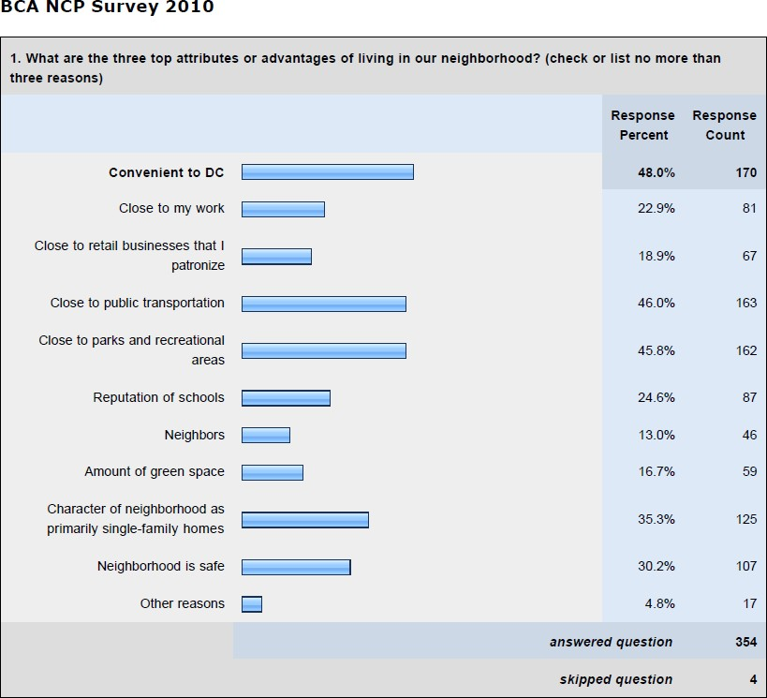

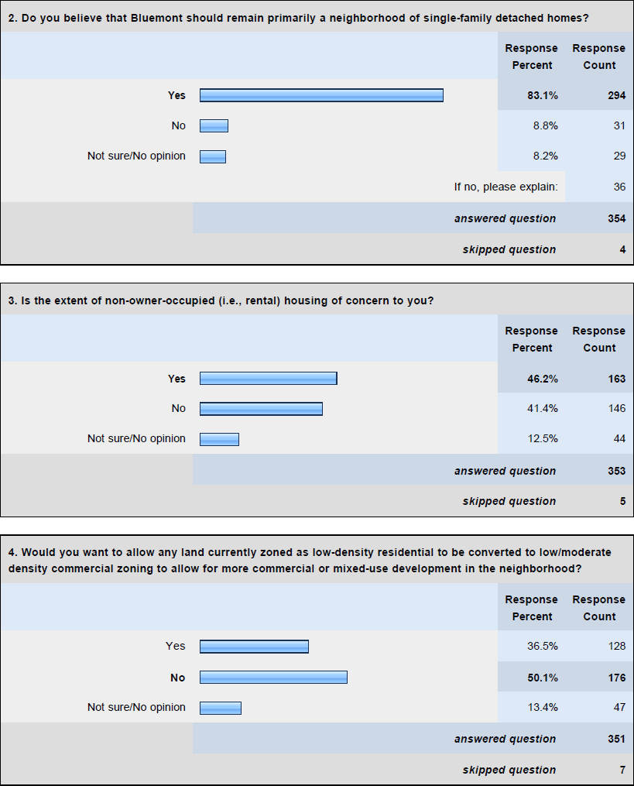

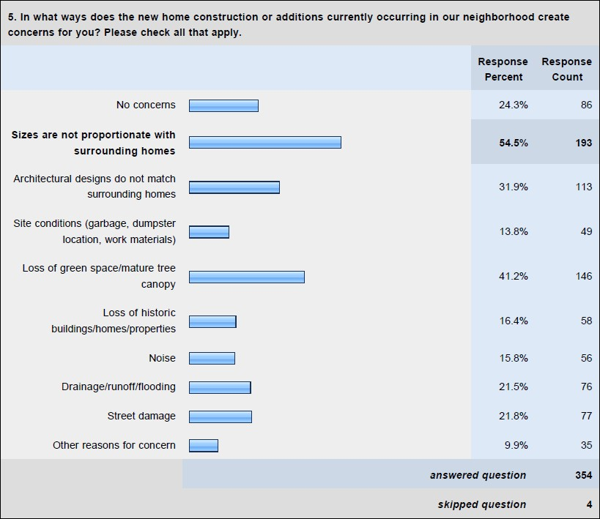

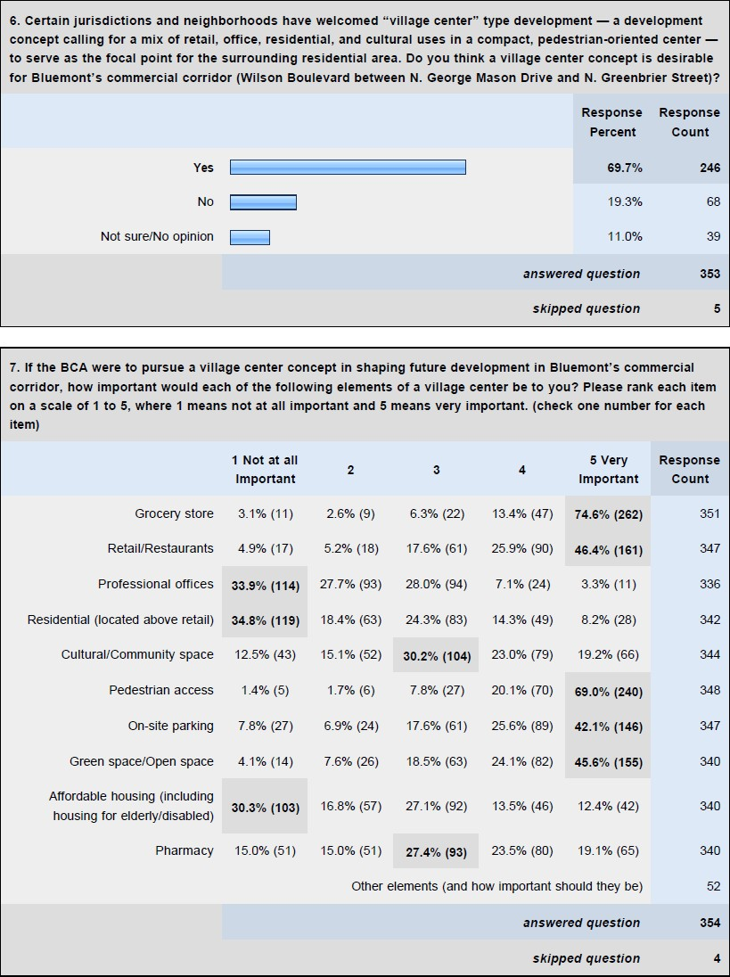

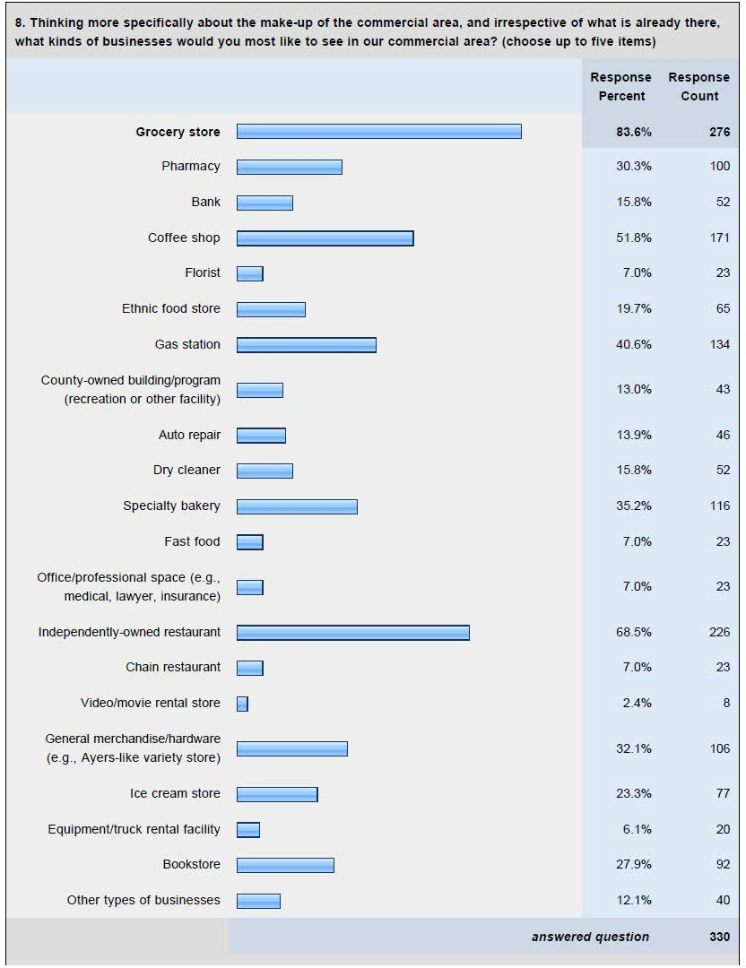

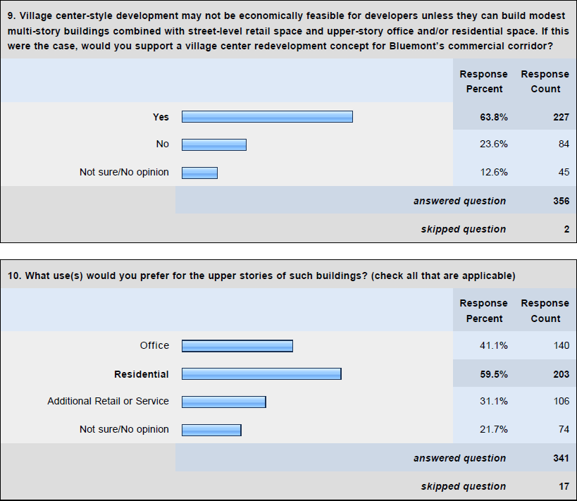

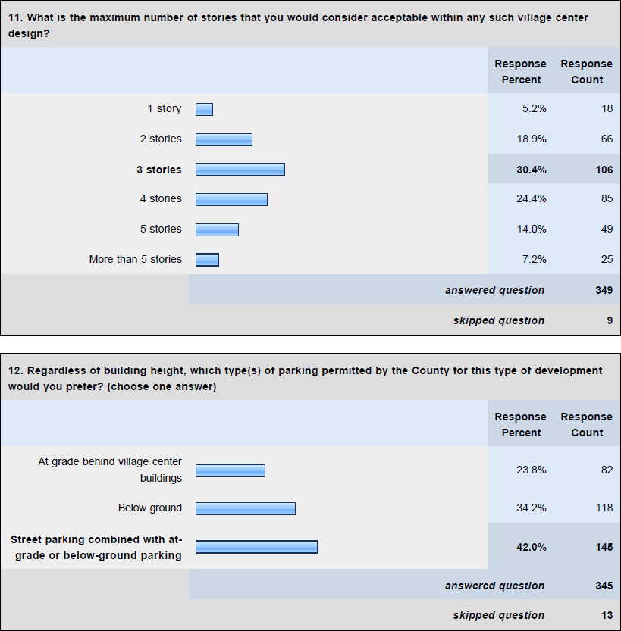

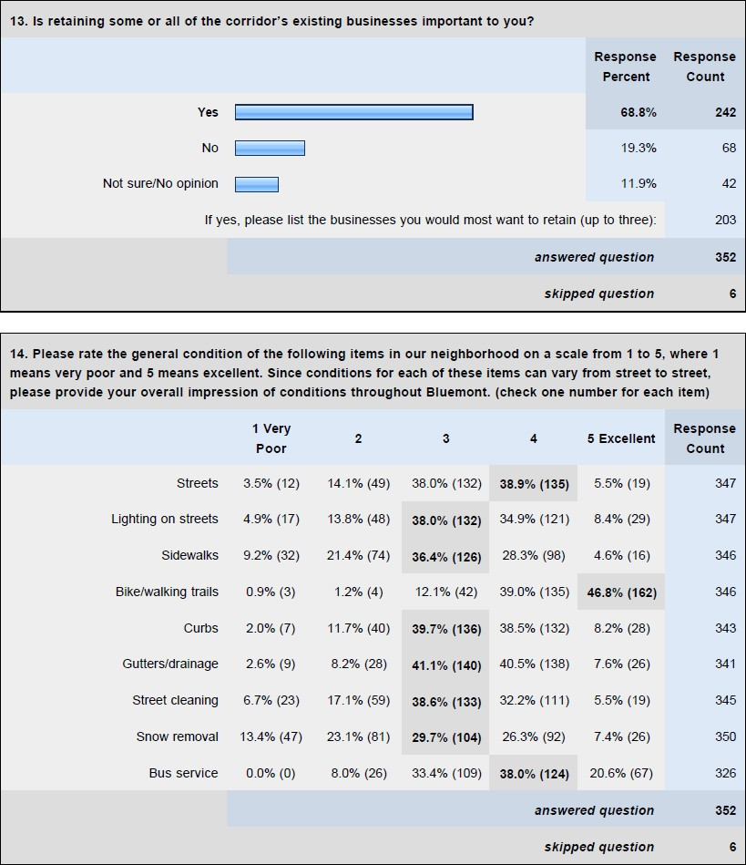

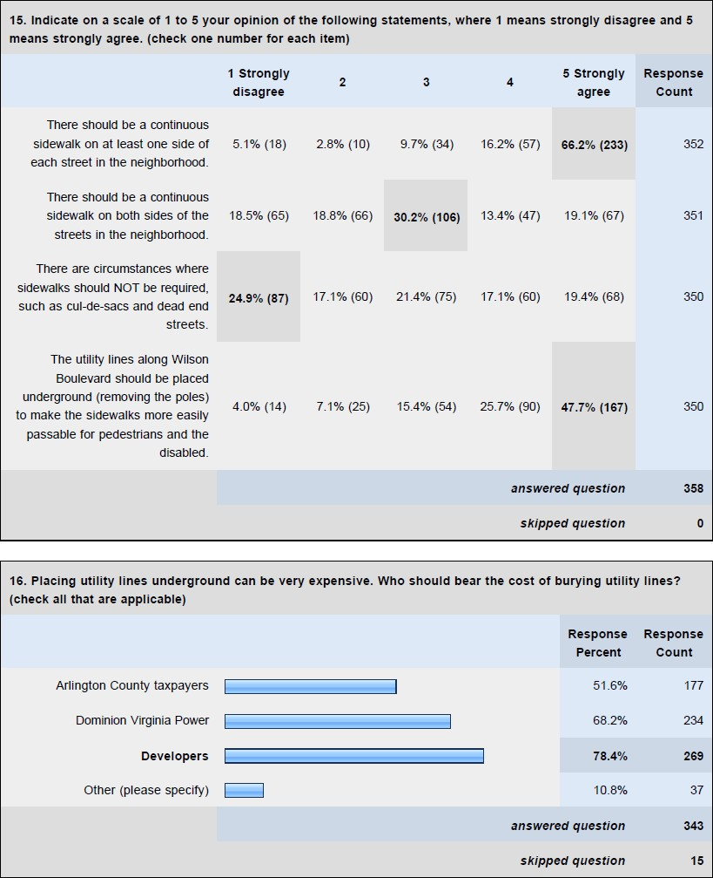

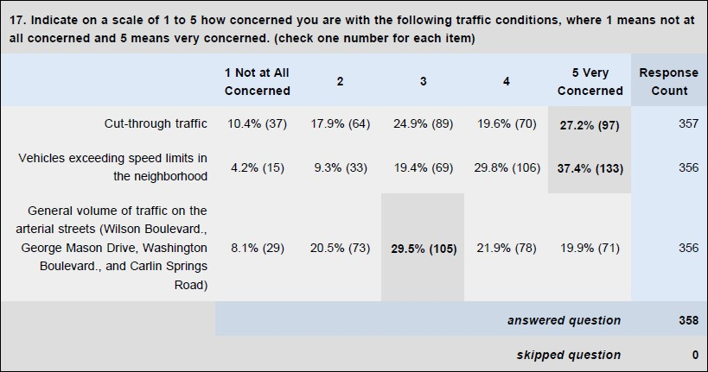

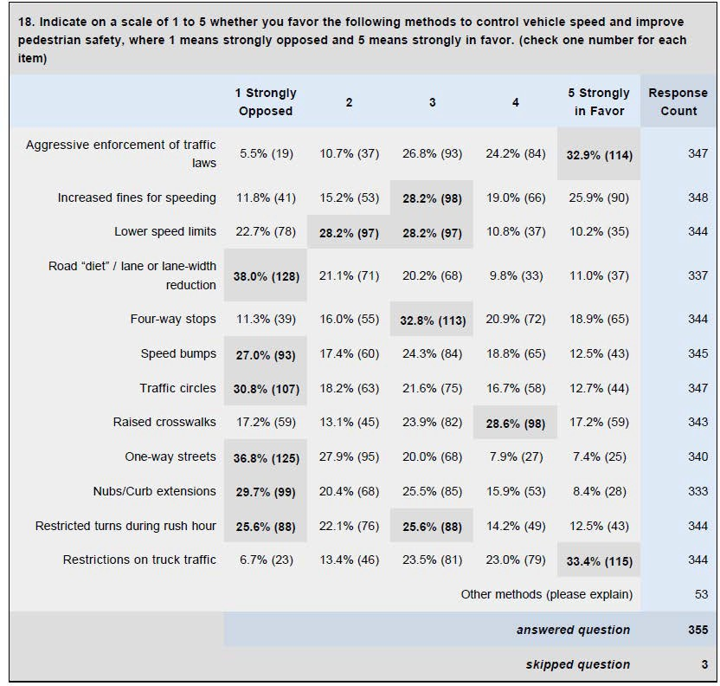

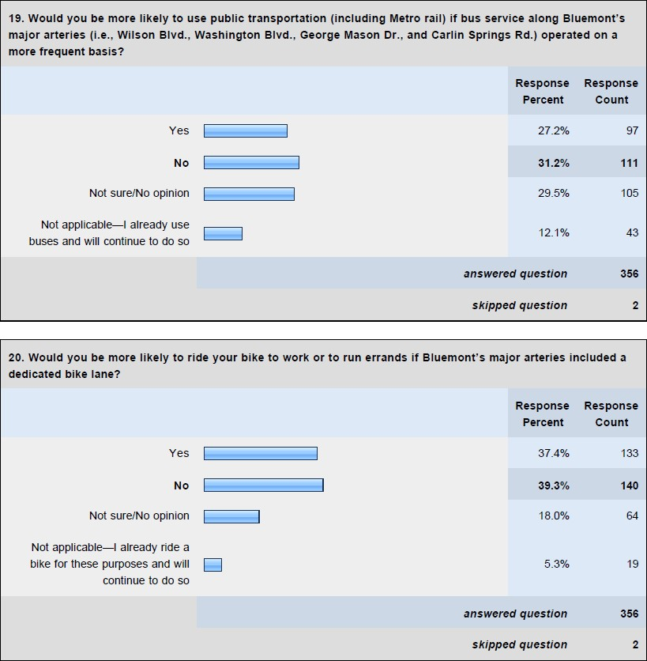

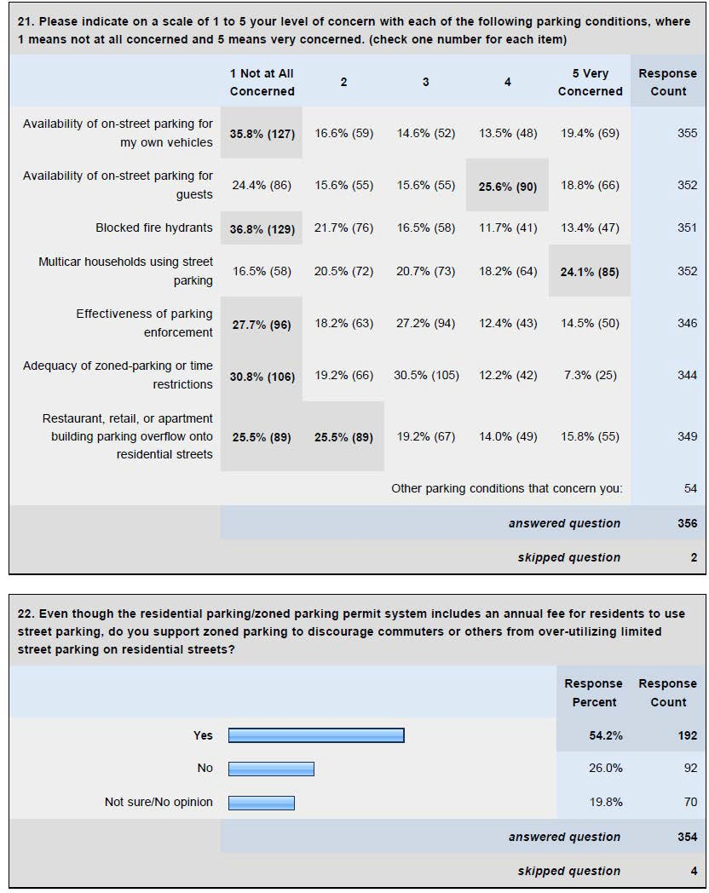

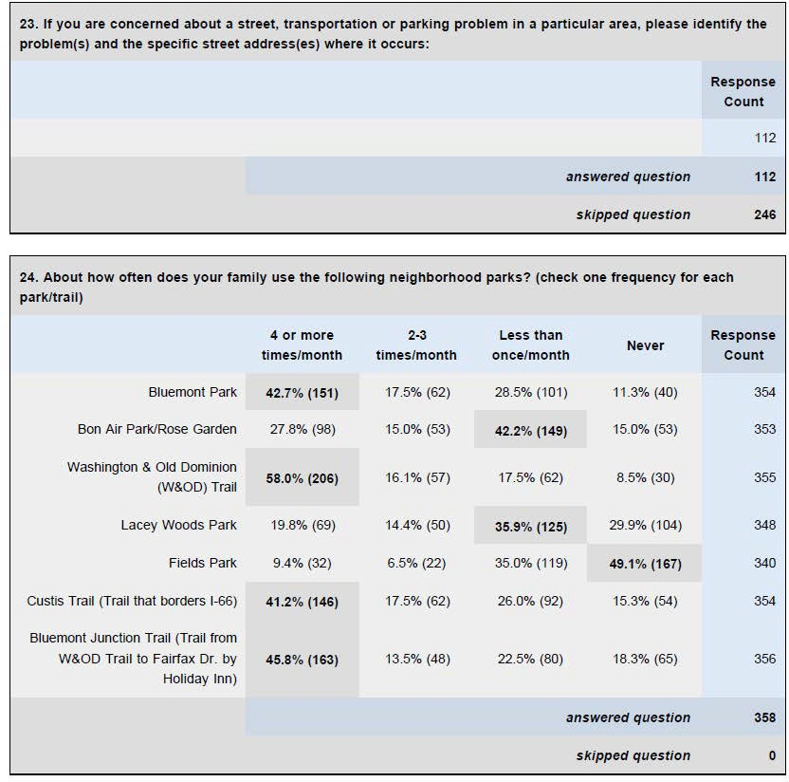

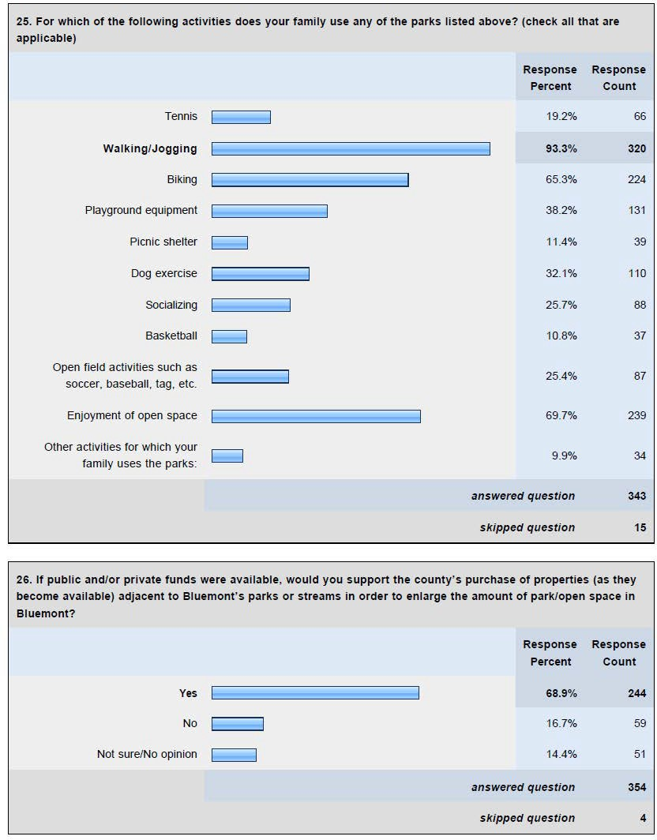

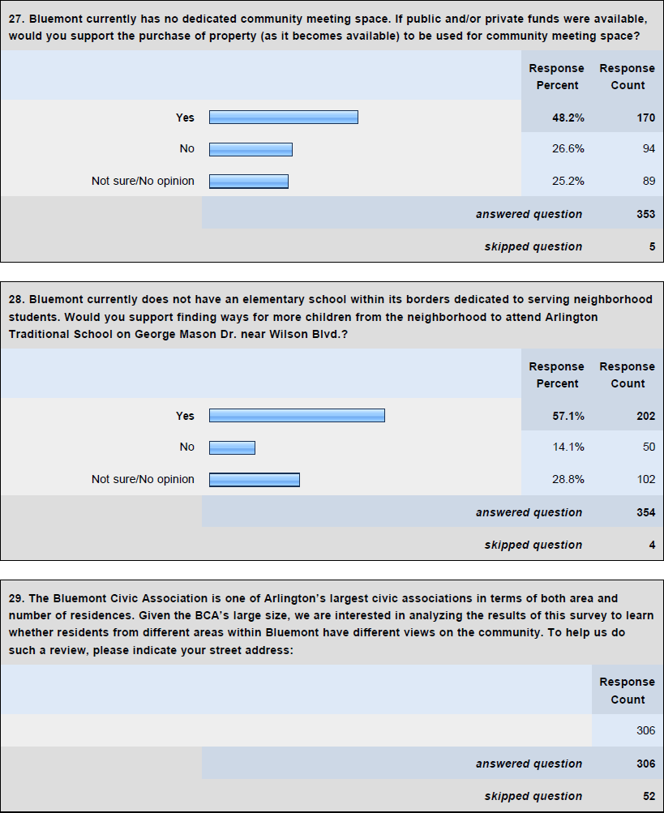

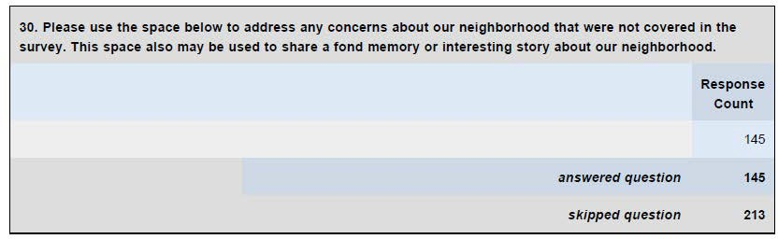

Appendix B – BCA NCP Survey 2010 (Narrative Responses) Survey Question I.1.
What are the three (3) top attributes or advantages of living in our neighborhood?

- Walkability on non-major streets. 5800 block of 11th St. N.
- Blue collarish (not as much as it used to be).N. Greenbrier St. & 5th St. N.
- Close to everything. 1100 block of N. Harrison St.
- Close to medical care. Close to church. No address given
- Walkable to so many things - a mall, gym, restaurants, the Metro. 800 block of N. Edison St.
- It offers the combination, for us, of living very close to urban amenities (i.e., Metro, restaurants, library) while also having some relatively rural qualities along with the opportunity to garden. 600 block of N. Vermont St.

Survey Question II.1.

Do you believe that Bluemont should remain primarily a neighborhood of single- family detached homes? If not, please explain:

- Townhomes and apartment buildings are just as right as single homes. I like the concept of open common spaces. 4th Rd. N.
- A limited amount of townhomes and/or condos should be allowed close to public transportation or where roads are capable of handling the extra density or if necessary to allow for good quality retail developments. 1000 block of N. Edison St.
- In areas east of George Mason Drive and all along Wilson Blvd., higher density residential housing should be encouraged to take advantage of the proximity to Metro and some of the recent redevelopment of the Ballston neighborhood. 4800 block of 9th St. N.
- People can afford to live in a detached home in Arlington, yet the jobs are in this area and it would be too much for them to endure the travel expenses coupled with low paying jobs. 5000 block of 6th St. N.
- Although I approve of low-density multi-family housing along the main thoroughfares. 700 block of N. George Mason Dr.
- I would like the BCA to consider area between Glebe and N. George Mason to be Bluemont. Please represent us as well to stay residential. No address given
- We don't need another Clarendon. 5200 block of 11th St. N.
- Duplex townhouses along Wilson would be fine. But this neighborhood can't support high-rises without major, unwanted changes. 700 block of N. Florida St.
- Primarily, yes, but we would be open to some mixed use on Wilson. 5600 block of 8th Road N.

- Actually, I think on a residential dimension it should be more of a blend given how close much of Bluemont is to the Metro and DC in general. 600 block of N. Vermont St.
- With provisions for low-income housing. 600 block of N. Tazewell St.
- But not McMansions. 5200 block of 5th St. N.
- Townhouse very acceptable, we live in one. 600 block of N. Abingdon St.
- I live in a town house in Bluemont. 4400 block of 7th St. N.
- More mix of housing choices and retail options would improve the neighborhood.
5500 block of 10th St. N.
- Low rise multi-family (3 - 4 stories max) along Wilson seems appropriate. 800 block of N. Frederick St.
- Having more select commercial businesses nearby would be a great benefit. 5600 block of 7th St. N.
- I do believe that Bluemont should remain primarily single-family detached homes, but I do not have a problem with multi-family dwellings on Wilson Blvd. 5200 block of 11th St. N.
- We live in a townhouse in Bluemont, and we do not believe our home should be eliminated. 4400 block of 7th St. N.
- It is not just single-family detached homes, there are townhomes at present in the neighborhood. 1600 block of N. Greenbrier St.
- I love the idea of a "village center" (a modern Westover) where even more shopping can be done on foot. 800 block of N. Frederick St.
- I think it's better to offer a sustainable mix of residential, retail, and commercial buildings to attract a diverse population. 7th Rd. N.
- I think a section of high density, especially near major intersections (e.g., Ballston and the intersection of George Mason Drive and Wilson) is good as it will provide multi-use. But I don't want to see the whole neighborhood turned into a multi- family area. I prefer single-family detached homes as the rule. That's why I think Westover is great. I don't want Bluemont turned into "Ballston West." 1100 block of N. Harrison St.
- I would prefer denser development, with more stores and townhouse buildings if necessary to support them. 800 block of N. Emerson St.
- However, I would rather see growth in Arlington than ugly sprawl in Loudoun County. 800 block of N. Florida St.
- I think it's good to have a mix--more people (i.e., condos or townhouses) brings in a larger tax base and more demand for public and private services. 5100 block of 9th St. N.
- I am receptive to the idea of a condo project for the obvious real estate value. However, I would not support further development of rental communities. Basically, I support what drives our values up - such as demand for our lots to build high rise condos, but not for those that drive our value down - such as demand for our lots to build dense rental structures. 5900 block of 9th St. N.
- I think we should have some higher density, but remain mostly single family homes. 700 block of N. Frederick St.

- I would love to see the space used for shops and restaurants...maybe the look and feel of Clarendon!! Wilson Blvd.
- I believe this should be primarily single-family home area. However, I am comfortable with adding a little bit more low/moderate density commercial zoning for more commercial and mixed use development. Adding just a little bit more could benefit our community more than ruin the beautiful single family atmosphere that we currently enjoy. 600 block of N. Illinois St.
- We live in a townhome and enjoy the mix of suburban feeling with the urban convenience of Metro, shopping and culture. Would not like to see huge high- rising condos but attached homes are nice. 600 block of N. Tazewell St.
- Not looking for more condos or townhomes, but new shops this side of Glebe Road towards George Mason would be nice. No address given
- East of George Mason Drive (Route 50 to Lee Hwy) should be allowed to become townhouses. 500 block of N. Wakefield St.
- But I also think that this shouldn't hinder development of the Safeway into a multi-use facility of some sort--apartments/parking/retail. 700 block of N. Frederick St.
- Single family on side streets, yes; detached not necessarily--townhouse rows a reasonable growth pattern for our growing urban setting. More robust but contained commercial areas would increase convenience and reduce need to travel by car for everyday chores. 5200 block of 5th St. N.
- I would let the market dictate what gets placed in the neighborhood. If the land makes more economic sense at a higher density level then a higher level is needed. 5700 block of 7th St. N.

Survey Question II.4.

In what ways does the new home construction or additions currently occurring in our neighborhood create concerns for you?

- Loss of lower-cost housing. 700 block of N. Edison St.
- Attracts high income people who are out of touch with reality. N. Greenbrier St. & 5th St. N
- Loss of affordable homes for middle-income families. 1100 N. Harrison St
- Violation of accessory dwelling - many people living in homes that are not of the same family. 5600 block of Wilson Blvd
- Houses are being renovated as boarding houses -- multi-tenant dwellings. 5600 block of 6th St. N
- Giant houses on tiny lots close together interfere with neighborhoods and communities that are established without paying taxes proportionate to the resources they consume. I also fear that in an economic downturn these properties may become rental properties used as group homes. 4800 block of 9th St. N.
- Street parking. 700 block of N. George Mason Dr.
- Parking congestion due to occupants of McMansions. 5300 block of 5th St. N.

- Parking problems. 500 block of N. Illinois St.
- Asbestos in old homes. 5700 block of 7th St. N.
- Leads to more overcrowding and traffic. 700 block of N. Albemarle St.
- Rentals to large groups of young people. 700 block of N. Florida St.
- I'm not sure the transportation system (not just the roads) is going to handle growth gracefully. 600 block of N. Vermont St.
- Blocking sun of neighbors. 5400 block of N. Four Mile Run Dr.
- Less parking available. 600 block of N. Jefferson St.
- Designs should match the "character" of the neighborhood rather than necessarily "match surrounding homes." 5200 block of 11th Road N.
- My concern is more with the many older homes that are in disrepair and detract from the quality of the neighborhood. There are many homes that are in need of significant renovation. 10th St. N.
- Density; multiple houses being placed on lots which previously had only one home. 12th St. N.
- Structures are too high; block sky and sunshine. No address given
- Large houses can be de facto small apartment buildings with 8 plus unrelated people living in them. 800 block of N. Frederick St.
- Large number of people in these huge homes. No address given
- The houses are built to be as big as the lot allows, rather than attractive or consistent with the character of Arlington. 800 block of N. Emerson St.
- Traffic disruption. 700 block of N. Albemarle St.
- The new houses on N. Florida St. look like office buildings. Maybe the houses are built to maximize space? They must be for indoor enthusiasts. 800 block of N. Florida St.
- The huge boxy houses that are being built in the 22203 neighborhood just east of ours are hideous. And there are certainly some houses in Bluemont that could use some exterior work. Generally, I like not having a homeowners association, but I do wish that everyone would be considerate of their neighbors. 5700 block of 8th St. N.
- Traffic. 600 block of N. Tazewell St.
- Corner of N. Harrison St. and Wilson Blvd is a safety hazard - standing water. No address given
- The McMansions the city lets people put up with 99% lot coverage are a disgrace and severely detract from the neighborhood charm. 5600 block of 9th St. N.
- How will taxes be affected? 5400 block of 9th Rd. N.
- Size increase is inevitable and of value; but some moderate control of architectural consistency, not necessarily to the past but looking forward, will lead to a more defined and desirable character for the neighborhood. 5200 block of 5th St. N.
- I have more concerns for the above with new construction, not additions or renovations. 1100 block of N. Harrison St.
- Lots are stripped, then remain empty, sometimes for years. 700 block of N. Jefferson St.

- If a NIMBY atmosphere takes off and renovations are curtailed, the ability to create a very nice, livable neighborhood will be lost. 5700 block of 7th St. N.
- Problems with temporary storage units being allowed for long periods (i.e., years) in front yards and driveways. 5300 block of 5th St. N.
- I really prefer ZERO on-street parking. The streets (George Mason Dr. between Arlington Blvd. to Wilson) are TOO congested with street parking. New home construction or additions should improve this situation NOT exacerbate this problem! 600 block of N. George Mason Dr.

Survey Question III.2.

If the BCA were to pursue a village center concept in shaping future development in Bluemont’s commercial corridor, what elements would be important to include or not include?

- Strongly disagree with "paved over" building, like that at Ballston with only a few token trees along sidewalk. It's unattractive and it creates a major drainage problem. 700 block of N. Buchanan St.
- Affordable housing for disabled. 1200 block of N. Illinois St.
- While it's not terribly important to me that a village center have a residential component, I do feel strongly that a portion of any such component should be made affordable. 700 block of N. Greenbrier St.
- Loss of affordable single family homes is very important; younger families are being forced to relocate. 1100 block of N. Harrison St.
- Moderately-priced establishments - we should be careful to offer places for people to relax that they can afford, not all high-end establishments. 5600 block of Wilson Blvd.
- Better to have businesses/services that address local residents' needs and not something that will attract traffic from far away. Important that rents be kept as low as possible to encourage/support small, independent businesses and not national chains. 5100 block of 8th Rd. N.
- Services and retail that are NOT restaurants. 4800 block of 9th St. N.
- We actually have a "village center" already, though it wasn't planned as such. Just keep future development focused on the idea. It doesn't need to be too cutesy, artificial. 700 block of N. George Mason Dr.
- Don't want people street-parking outside houses that aren't theirs, but also wouldn't want permit-parking for our streets. I love how easy it is to park outside Safeway and the other shops there right now, and just walk straight in and out with our kids. 600 block of N. Harrison St.
- Respect the rights of private property and business proprietors. 800 block of N. Abingdon St.
- Churches. 5600 block of 9th St. N.
- Venue for light music, restaurant with outdoor seating, cafe and wine bar. 400 block of N. Florida St.

- Existing businesses should be able to stay and not be priced out by neighborhood redevelopment. 800 block of N. Jacksonville St.
- Coffee shop. 5600 block of 8th St. N.
- Need a playground for children. 500 block of N. Illinois St.
- Keep low-key character of Wilson intact. 5200 block of 11th St. N.
- Small neighborhood stores or coffee shops; but no chains. 5600 block of 5th St. N.
- Something like Westover, but not high-rise condos over shops. 5700 block of 7th St. N.
- Safeway has a wonderful pharmacy staff. 700 block of N. Harrison St.
- Affordable retail. 700 block of N. Florida St.
- We need a good coffee shop. I miss the Pottery Store. No address given
- Wide sidewalks on Wilson Blvd. 5600 block of 5th St. N.
- I would like to see a more organized and less strip mall-like approach. Also, and I know this is huge and not likely, an additional Metro stop between Ballston and EFC would be a dream option as well. 5600 block of 8th Road N.
- Drug store. 4700 block of 7th Rd. N.
- Business support center, copier supply, fax, service. 800 block of N. Illinois St
- Public library. 5600 block of 6th St. N.
- I assume the question means how important would it be to include each of the above. I would feel it important to exclude professional offices and retail spaces that would increase vehicle traffic on neighborhood streets. I would favor green space, pedestrian traffic, and access by public transportation. I would oppose higher density residential zoning whether affordable or not. 5200 block of 11th Road N.
- Better bus service by ART and WMATA. 800 block of N. Frederick St.
- Important that a careful study of the demographics of the neighborhood and beyond be used to develop the correct blend of shops and residential that will become a self supporting entity. 800 block of N. Frederick St.
- Coffee Shop - Very Important ; Local Bar - Very Important. No address given
- Bookstore and café. 5600 block of 7th St. N.
- Gas station. 12th St. N.
- Traffic flow. How to ensure it doesn't become an unavoidable bottleneck like Clarendon Market community. 800 block of N. Jacksonville St.
- The BCA should not pursue a village center! 800 block of N. Abingdon St.
- Bike ways. 700 block of N. Edison St.
- Car repair, dry cleaners, an ABC store -- all weekly kind of quality of life retail.
5700 block of 4th St. N.
- Arlington has a bad history of building high density areas without making appropriate increases in the infrastructure (i.e., sewers, widening streets to accommodate increased traffic, providing sufficient parking and increase security). I will leave the area if it becomes like Clarendon; we are not on the Metro, we are a residential area. 700 block of N. Albemarle St.
- The center should be aesthetically pleasing by blending into the existing neighborhood with lots of greens, browns, and trees. 800 block of N. Florida St.

- It would be important to see a plan and potential tenants before anything like this were to happen. In general, I am supportive of the idea, but only in a way that modernizes the neighborhood. For instance, although Safeway is my regular store, the place is a dump on the outside. Similarly, the few surrounding strip malls are pretty bad, other than the recently renovated Panda Cafe-Super Pollo strip. Given that the Ballston Mall really can't attract much beyond third-rate retail, I'm skeptical that we could do it further out in our area. The idea would involve commitment from a reputable grocery store and a couple of moderate restaurants at the very least. 5900 block of 9th St. N.
- Do NOT follow the ridiculous Bethesda/Clarendon model of development. Severely restrict the height and design of the buildings to maintain the SUBurban nature of the area. Essentially Clarendon has been transformed into a city akin to Charlotte, N.C. that has maintained none of its heritage and appeal. Good job Arlington planning board! Hope you succeeded in increasing your tax base with those ugly condo mid-rises. BTW, question 9 is bogus. You should rephrase it to read: "may not be economically feasible for GREEDY developers." 800 block of
N. Abingdon St.
- I think it would be nice if there were a coffee shop within walking distance of our neighborhood. It would be a good place to meet other neighbors and would be more convenient than going to Ballston. The other daily essentials (groceries, pharmacy, etc.) are close enough already though. 5700 block of 8th St. N.
- This concept is not viable. Leave our neighborhood alone. Find a life! No address given
- Outdoor eating, an urban village with outdoor activity, water feature, etc.; green landscaping; a light at Wilson and Greenbrier, underground parking exiting on side street(s) with some ground parking. 5300 block of 5th St. N.
- Must make it safe for pedestrians; safer crossings with lights or arrows for safe passage for both vehicles and pedestrians. Very important. Look at the crossing at Glebe and Carlin Springs; very dangerous. 5300 block of N. Carlin Springs Road
- "Affordable housing" would be more of a priority if it were truly affordable. 700 block of N. Illinois St.
- I already use Mr. Lee as my pharmacist. No address given
- We are very SUPPORTIVE of LOCALLY OWNED and operated retail and restaurants. We are strongly OPPOSED to CHAIN restaurants and chain retails stores. An example of desirable commercial development would a small village center like Lee Heights. 700 block of N. Edison St.
- Wouldn't want to see the McDonald’s, Two Chefs or Panda Cafe go away. 600 block of N. Edison St.
- Impact on taxes? 5400 block of 9th Rd. N.
- Development should focus on day-to-day needs of a professional, commuting population who have little time for handling personal and family matters. 5200 block of 5th St. N.
- We already have plenty of restaurants. 1100 block of N. Harrison St.
- I wouldn't want the area to become like Ballston Common Mall (deserted of main stores, except for Macy’s). If there was retail/restaurant-type businesses, I'd rather see local places, like in Westover (Lost Dog Cafe, etc.). 5700 block of 8th Rd. N.

Survey Question III.3.

Thinking more specifically about the make-up of the commercial area, and irrespective of what is already there, what kinds of businesses would you most like to see in our commercial area?

- Craft store. 1200 block of N. Illinois St.
- Hair salon. 5600 block of N. 8th Place
- Barber. 400 block of N. Kensington St.
- Pub; teahouse. 600 block of N. Harrison St.
- Beauty shop; Nail and Spa Care shop. 1100 block of N. Harrison St.
- Either coffee shop or bookstore with a coffee shop - as long as it has wi-fi for hanging out and doing work while patronizing the establishment. 5600 block of Wilson Blvd.
- We need small/specialty retail and entertainment to draw foot traffic to them.
4800 block of 9th St. N.
- A place to get a beer -- like the Westover beer garden. 5200 block of 11th St. N
- Barber/hairdresser. 600 block of N. Harrison St.
- A larger and more modern Safeway. 600 block of N. Florida St.
- Love idea of creating a "Mini Westover" of our own. 5600 block of 5th St. N.
- Movie theater; Library; Organic grocery store; Busboys and Poets. 5600 block of 5th St. N.
- Deli. 4700 block of 7th Rd. N.
- Business support center. 800 block of N. Illinois St.
- Church and post office. 4400 block of 7th St. N.
- Barbershop. 800 block of N. Frederick St.
- Specialty retail (card/gift store, store like "A Place Called Home" currently at N. Frederick & Wilson). 800 block of N. Frederick St.
- Pizza restaurant. 5000 block of N. Washington Blvd.
- I think an organic food store and/or restaurant would fit the community, be welcomed, and probably profitable. 5700 block of 8th St. N.
- We love having a gas station and auto repair facility in the neighborhood, so we can get repairs and walk home. No address given
- Farmers market or farm-share outlet. 800 block of N. Jacksonville St.
- Independently owned retail antique or vintage shop (like existing No Place Like Home), card and gift shop, etc.; small chain retail- bird store, pet boutique, optical, etc. 5200 block of 11th St. N.
- Home and garden furnishings store. 5200 block of 12th St. N.
- Don't need other businesses. N. Bluemont Dr.
- My first thought whenever these big buildings go in with retail on the first floor is why oh why do we have another bank! We don't need any more. Really, in my opinion, after cleaning up the current strip malls almost anything will look and be better. Just include some green space, some nice landscaping, and retail. Almost

anything will look better and be a better use of space except for a parking lot (or another bank!). My favorite retail stores in Arlington are the Lee Heights shops. If we could have something similar, boy would that be great. Second is Westover.
What a nice mixed use of space, library, post office, restaurants, ice cream shop, and old fashioned hardware store! I prefer to leave the chains to Tysons Corner (or, sadly, Clarendon); but they aren't all bad and there are some needs met that might distinguish this village center from the others. 4600 block of N. Carlin Springs Rd.
- Laundromat. 5600 block of 9th Road N.
- Fitness center. 800 block of N. Buchanan St.
- Unique non-chain businesses. 612 N. Greenbrier St.
- Neighborhood sports bar. 5400 block of Wilson Blvd.
- What's a movie rental store? INDEPENDENT coffee shop, not a Starbucks or Caribou. 5700 block of 4th St. N.
- Pub, brasserie. 5200 block of 5th St. N.
- Outdoor eating with urban village environment. 5300 block of 5th St. N
- Any type of interesting retail store, preferably independent. 5200 block of 5th St. N.
- Should only develop area for residential construction, not commercial. 500 block of N. Wakefield St.
- Multi-faceted, family pub/restaurant with outdoor seating in the style of Westover Beer garden or Buzz Bakery. 700 block of N. Illinois St.
- Pharmacy within grocery store. 600 block of N. Illinois St.
- We already have any and every type of business we need there per above. We don't need another Starbucks, however! 1100 block of N. Harrison St.
- Bike Shop! 5600 block of N. 5th St.

Survey Question III.8.

If retaining some or all of the corridor’s existing businesses is important to you, list the businesses you would most want to retain (up to three):

- Grocery store. 700 block of N. Buchanan St.
- Pupatella, Two Chefs, Layalina. 700 block of N. Emerson St.
- Safeway, 7-11, Two Chefs. No address given
- Safeway, Layalina, Two Chefs. 700 block of N. Edison St.
- Professional offices, grocery, art store. 1200 block of N. Illinois St.
- Two Chefs, Safeway, Texaco. 500 block of 6 N. 8th Place
- Auto repair, Grocery, fast food. 400 block of N. Kensington St.
- Two Chefs, Grocery, Auto repair. 600 block of N. Harrison St.
- Texaco, Safeway, Arlington Pharmacy. No address given
- Layalina. No address given
- Safeway (remodeled would be nice), BP or Texaco. 5500 block of Fairfax Dr.
- Pupatella. 600 block of N. Vermont St.

- Safeway, Two Chefs. 700 block of N. Greenbrier St.
- Texaco, Safeway, McDonald’s. N. Greenbrier St. & 5th St. N.
- Safeway, BP Gas Station. 700 block of N. Vermont St.
- Two Chefs, McDonald’s, Safeway. No address given
- Texaco, Layalina. 600 block of N. Harrison St.
- Safeway, Nail and Spa Care, McDonald’s. 1100 block of N. Harrison St.
- Texaco, Safeway. 5400 block of 10th St. N.
- Restaurant, Grocery Store, Independently-owned businesses. 5600 block of 8th Rd. N.
- Arlington Pharmacy, Safeway, Texaco. 800 block of N. Harrison St.
- Pizza, grocery store, dry cleaning. 800 block of N. Kensington St.
- D&V auto repair, Safeway, Layalina restaurant. 5600 block of Wilson Blvd.
- Two Chefs restaurant, Covet store, Layalina. 600 block of N. Illinois St.
- I'm not to decide. I just don't like the idea of established small businesses being pushed out because of higher rents, like Clarendon, which has become boring and not particularly useful for its residents. 5100 block of 8th Rd. N.
- Two Chefs, Panda Cafe, Safeway. 600 block of N. Harrison St.
- Safeway, especially Safeway pharmacy; BP; Federal Lock and Safe; Hollywood Nails and barbershop. These businesses have remained in the neighborhood in tough times and deserve our support. 4800 block of 9th St. N.
- Safeway, 7-11, Two Chefs, gas station. No address given
- Barbershop, dry cleaner, Two Chefs. 700 block of N. George Mason Dr.
- Safeway, Texaco gas/automotive repair, barber. 600 block of N. Harrison St.
- D&V service station, McDonald’s, barber shop. 5700 block of Wilson Blvd.
- Texaco, Safeway, Safeway pharmacy. 5300 block of 5th St. N.
- D&V service station, Safeway, Panda Café. 800 block of N. Kensington St.
- D&V service station, George dry cleaner. 5600 block of 9th St. N.
- Safeway, McDonald’s, D&V service station. 800 block of N. Jacksonville St.
- It would be great if Safeway were a Whole Foods. 400 block of N. Florida St.
- Safeway, Texaco, Two Chefs. 800 block of N. Frederick St.
- Nail salon, Layalina, Vet office. 800 block of N. Harrison St.
- Safeway (EXTREMELY important to have a walkabout grocery store), Two Chefs, Super Pollo. 800 block of N. Edison St.
- Texaco, McDonald's, Two Chefs. 5600 block of 7th St. N.
- Two Chefs, Safeway, Texaco. 8th Rd. N.
- Safeway. 1100 block of N. Harrison St.
- Two Chefs, Grocery store other than Safeway, Arlington Pharmacy. 800 block of
N. Jacksonville St.
- Texaco, 7-11, Safeway. 5600 block of 8th St. N.
- Super Pollo, Two Chefs. No address given
- Texaco, Safeway, Two Chefs. 800 block of N. Greenbrier St.
- Safeway, Texaco, McDonald's. 600 block of N. Florida St.
- Safeway, Texaco, Restaurants. 5600 block of 9th Rd. N.
- Safeway, Texaco, restaurants. No address given

- Texaco, Barber, Safeway. Bluemont Dr.
- Two Chefs, Super Pollo, Texaco. 800 block of N. Greenbrier St.
- George's Valet, Various Ethnic Restaurants, Locksmith. 700 block of N. Vermont St.
- Grocery, gas station. 600 block of N. Florida St.
- All businesses contribute to the character of the corridor. 5200 block of 11th St. N.
- Gas station, Two-Chefs, Layalina. 800 block of N. Harrison St.
- Safeway, D&V, barber. 5100 block of 9th St. N.
- Gas station, Grocery store, Restaurant. 5th St. N.
- McDonalds...one of the nicest in Arlington; so many senior citizens go there. Safeway. 11th St. N.
- D&V Auto, No Place Like Home, Safeway. 5700 block of 7th St. N.
- Locally-owned businesses. 700 block of N. Albemarle St.
- Grocery store. Gas station. 800 block of N. Frederick St.
- Texaco, Restaurant. No address given
- Safeway, No Place Like Home. 700 block of N. Harrison St.
- Safeway, McDonald's, Texaco. 1100 block of N. Inglewood St.
- Layalina, Ballston Animal Hospital. 700 block of N. Florida St.
- Safeway, Ballston Animal Hospital. No address given
- Texaco. 5600 block of 5th St. N.
- Safeway, Texaco, Ballston Animal Hospital. 5200 block of 11th St. N.
- Safeway. No address given
- Safeway, All existing businesses. No address given
- There aren't many I would be concerned about, but La Union restaurant would be one. 5600 block of 8th Road N.
- Safeway, Hollywood Nails, a restaurant (several are good, so I couldn't pick just one). 800 block of N. Harrison St.
- Safeway Grocery, Layalina Restaurant. 600 block of N. Tazewell St.
- Gas station, restaurant, McDonald’s. 5400 block of N. 4 Mile Run Dr.
- Grocery, pharmacy, bank. 5200 block of 5th St. N.
- Safeway, D&V, Chinese Restaurant. 5200 block of 5th St. N.
- D&V, Safeway, Layalina. 4700 block of 7th Rd. N.
- Safeway, barber, nails. 600 block of N. Abingdon St.
- Safeway, La Union, Super Pollo. 800 block of N. Illinois St.
- D&V Texaco, Two Chefs, Clean-all. 600 block of N. Jefferson St.
- Grocery, gas station, restaurant. 5600 block of 4th St. N.
- Safeway, Two Chefs, Hollywood nails. 5600 block of 6th St. N.
- Safeway, Layalina, El Ranchero. N. Burlington St.
- Safeway, a gas station. 5200 block of 11th Road N.
- But, we do still need a grocery store. Just not necessarily the current Safeway.
5700 block of 8th Rd. N.
- George Valet, Pharmacy and Safeway. 4700 block of 4th St. N.
- Auto repair, grocery store, gas station. N. Greenbrier St.
- Safeway, sports and health, Macy's. 4400 block of 7th St. N.

- D&V and Safeway. No address given
- Grocery store, filling station, barbershop. 800 block of N. Frederick St.
- Grocery store, pharmacy, gas and auto repair. No address given
- Super Pollo. 5500 block of 10th St. N.
- Safeway, D&V Texaco. 700 block of N. Frederick St.
- Gas station, Super Pollo, McDonald’s. 500 block of N. George Mason Dr.
- Gas station, fast food, independent retail/service. 800 block of N. Frederick St.
- Safeway, Super Pollo. 700 block of N. Illinois St.
- McDonald’s, Grocery store. 800 block of N. Greenbrier St.
- Harris Teeter, BBT. 5700 block of 4th St. N.
- Restaurants. 5700 block of 9th Rd. N.
- Safeway, Pupatella shop, Gas station. 800 block of N. Harrison St.
- Layalina, El Ranchero. No address given
- China carry out, Super Pollo, Two Chefs. 5000 block of N. Washington Blvd.
- Grocery, Auto. 5700 block of 7th St. N.
- D&V Texaco, Safeway (with pharmacy), Layalina. 800 block of N. Harrison St.
- Two Chefs, Panda Cafe. 5700 block of 8th St. N.
- Large chain grocery store. 800 block of N. Frederick St.
- Safeway, D&V Auto Service. 5600 block of 7th St. N.
- Texaco, Safeway, Super Pollo. No address given
- Safeway, Texaco. 12th St. N.
- Grocery, Gas station. 616 N. Florida St.
- All of them; leave them as they are. No address given
- Safeway, 7-11, Super Pollo. 800 block of N. Jacksonville St.
- Ballston Animal Hospital, Two Chefs Restaurant, Super Pollo. 800 block of N. Abingdon St.
- D&V Texaco Service Center. 600 block of N. Illinois St.
- Ballston Animal Hospital, No Place Like Home, 7-11, Safeway, ONE gas station.
5200 block of 11th St. N.
- Nail salon, Super Pollo, McDonald’s. 5100 block of 9th St. N.
- Two Chefs, Texaco, Ballston Animal Hospital. No address given
- Safeway, Restaurants, gas station. 800 block of N. Frederick St.
- Safeway, gas station. 1600 block of N. Greenbrier St.
- Texaco. No address given
- Safeway, McDonald’s, Two Chefs. 800 block of N. Frederick St.
- Safeway, McDonald’s. N. Bluemont Dr.
- Super Pollo, Two Chefs, Hollywood Nails. 5600 block of 8th Rd. N.
- Grocery. No address given
- Grocery, 7-11, Texaco. 6th St. N.
- Texaco, Safeway, Restaurants. No address given
- Safeway, Two Chefs, Texaco. 5200 block of 8th Road N.
- Grocery. 800 block of N. Greenbrier St.
- Texaco, Safeway, Nail Salon. 5100 block of 10th St. N.
- Safeway, Texaco. 900 block of N. Frederick St.

- Two Chefs. No address given
- Two Chefs, 7-11, Layalina. 500 block of N. Greenbrier St.
- McDonald’s, Safeway. No address given
- D&V Auto Services, Super Pollo. 5600 block of 9th Road N.
- Layalina, Body Dynamics. 800 block of N. Buchanan St.
- Safeway. 5200 block of 8th Road N.
- Restaurants, gas, grocery. 700 block of N. Edison St.
- Two Chefs Restaurant, Panda Cafe. 600 block of N. Harrison St.
- Two Chefs, Grocery, Texaco. 600 block of N. Greenbrier St
- D&V Gas Station, Tailor, El Ranchero. No address given
- 1. Layalina; 2. McDonald's; 3. Ballston Pet Hospital. 5400 block of Wilson Blvd.
- Two Chefs has been here forever and deserves to stay. I'm in Safeway twice a week, though it could use an upgrade. Ethnic food is great. No more chain junk food outlets. (Would love to see McDonald's and 7-Eleven go. I haven't set foot inside either one in the 11 years I've lived 2 blocks from them!). 800 block of N. Frederick St.
- Safeway; gas station; small restaurants. 1300 block of N. Abingdon St.
- Super Pollo, Safeway. 7th Rd. N.
- Safeway, Texaco and its service station, the restaurants and shops next to Safeway. 5600 block of 7th St. N.
- D&V Service Center, El Ranchero Restaurant. 900 block of N. Kensington St.
- Super Pollo; the funky vintage stuff shop; Texaco (w/repair and rental). 5700 block of 4th St. N.
- La Union. 5700 block of 7th St. N.
- Two Chefs. 600 block of N. Emerson St.
- Super Pollo. 5100 block of 10th Rd. N.
- Super Pollo, Safeway, Barber Shop next Super Pollo. No address given
- Two Chefs. 600 block of N. Greenbrier St.
- Safeway, Super Pollo, Layalina. 5200 block of Wilson Blvd.
- Safeway, D&V Texaco. 5600 block of 8th St. N.
- Grocery, Two Chefs. 5100 block of 10th Road N.
- Two Chefs, Safeway. 5200 block of N. Bluemont Dr.
- Layalina, Safeway. 1200 block of N. Illinois St.
- Privately owned restaurants, a gas station, a new and updated Safeway. 700 block of N. Albemarle St.
- Grocery store. 5400 block of Wilson Blvd.
- Ballston Animal Hospital. No address given
- I would definitely want to keep a grocery store and the mom and pop restaurants.
5100 block of 9th St. N.
- Gas station, grocery store. 900 block of N. Emerson St.
- Safeway and gas station. 800 block of N. Jefferson St.
- Grocery, Gas Station, Restaurant. 5700 block of 8th St. N.
- D&V Auto, La Union, A grocery store (not necessarily Safeway). No address given

- Barbershop, Restaurants, Grocery (but updated). 700 block of N. George Mason Dr.
- I could do without any of the specific businesses, so long as there was a grocery store - preferably a nicer place. Even a Safeway, updated to match its newer stores, would be great. What I would not want to see are things like check cashing, cell phone stores, etc. I'm not a snob or anything, I just prefer that the area retail be something that generates broader interest in the community. Independent restaurants, bakeries, coffee, grocery, etc. Not things that would make it look like North Capitol Street. 5900 block of 9th St. N.
- Question 12 was well-designed if you are slanting your questionnaire toward respondents "preferring" below ground parking. I would like to see a combination of on-street and at-grade, but not below-ground. 800 block of N. Abingdon St.
- Layalina, Ballston Animal Hospital. 5700 block of 8th St. N.
- Just the Safeway, if it could be remodeled. 5900 block of 9th St. N.
- Safeway, Two Chefs, Super Pollo. 1100 block of N. Inglewood St.
- Safeway, Super Pollo, and McDonald’s. 1100 block of N. Inglewood St.
- ONLY if the Safeway is renovated! Everything else is outdated, tacky and old; it can all go! Wilson Blvd.
- Two Chefs, Layalina, Ballston Animal Clinic, 7-11. 5500 block of Fairfax Drive
- Texaco Gas and Service Station, 7 Eleven, McDonald’s. 600 block of N. Illinois St.
- Super Pollo, El Ranchero and Safeway (or similar grocery). 600 block of N. Tazewell St.
- Family owned restaurants. 700 block of N. Illinois St.
- Arlington pharmacy, Castros, Two Chefs. 800 block of N. Lexington St.
- Super Pollo, Family Restaurant. 4700 block of Wilson Blvd.
- With updated store fronts: Two Chefs, Castros, vet. BTW - we have too many gas stations on Wilson between George Mason and N. Harrison and the store front strip shopping centers are badly maintained and look terrible. Put in standards. 5300 block of 5th St. N.
- The grocery store is the only one that I would want to keep but it looks like a dump. It definitely needs a face lift. As for the other stores, they could all go. They don't fit the North Arlington look and feel. No address given
- Get rid of Safeway. 800 block of N. Harrison St.
- Grocery store, Robbie's gas station, No Place Like Home, 7-11, Two Chefs. 5600 block of 6th St. N.
- I don't have a desire to patronize any of the businesses in the corridor today. 5200 block of 5th St. N.
- Layalina, Two Chefs, Safeway (though not necessarily a Safeway). 600 block of
N. Abingdon St.
- Super Pollo, 7-Eleven, Two Chefs, Gas stations, Barber. 800 block of N. Buchanan St.
- D&V Service Center/Grocery Store/Restaurant. 600 block of N. Illinois St.
- No Place Like Home/Covet, D&V Texaco, Super Pollo. 700 block of N. Illinois St.

- Truck Rental. Mr. Lee’s Pharmacy. Getting rid of Safeway. No address given
- Two Chefs. 700 block of N. Edison St.
- Two Chefs. 5200 block of N. Bluemont Dr.
- Two Chefs, Barber Shop, Hollywood Nails. 600 block of N. Illinois St.
- Pharmacy, gas station, grocery store. 5426 11th St. N.
- Pupatella. 700 block of N. Frederick St.
- Safeway, gas station. 1100 block of N. Harrison St.
- Retaining as much of the corridor's existing businesses as possible is important to me: especially D&V Service Center. It is convenient for me to leave my car there and walk home while it is being worked on; the business owner has gone over and above to assist my family's vehicle needs, including renting a small truck when needed. I also love La Union restaurant. 1100 block of N. Harrison St.
- Grocery (Safeway); D&V gas station; Ballston animal hospital. 700 block of N. Jefferson St.
- Safeway, Texaco, Two Chefs. No address given
- Two Chefs, Safeway, and Texaco. 700 block of N. Edison St.
- Two Chefs, Layalina, Texaco station. No address given
- Safeway, current gas station, dry clean/alterations (work is quality). No address given
- Local mom & pop shops. Those shop run and owned by the local residents. Those shops that infuse a sense of community to the area. 600 block of N. George Mason Dr.
- Two Chefs, 7-11. 600 block of N. Edison St.

Survey Question IV.3.

Placing utility lines underground can be very expensive. Besides taxpayers, Dominion Virginia Power and developers, who should bear the cost of burying utility lines?

- Consumers wind up paying the costs in all situations. 4th Rd. N.
- No point in doing this unless you can get a wider sidewalk; it's not just power lines, it's signs, fire plugs, etc... 1500 block of N. Jefferson St.
- Costs should be shared. 5100 block of 8th Rd. N.
- Cable and phone companies. 4800 block of 9th St. N.
- For residential the developer should pay it all. For retail which everyone can share in there should be a combination of Arlington County taxpayers and the developer. 5000 block of 6th St. N.
- Developers primarily - but some taxes could be used. 5600 block of 6th St. N.
- Cable and telephone companies. 800 block of N. Abingdon St.
- The person who wants them. No address given
- A combination of all the above, including commercial property owners. 5500 block of 10th St. N.
- Developers plus neighborhood residents. 800 block of N. Frederick St.
- No one, it is a bad idea. 500 block of N. Jefferson St.

- People living in the area. 5000 block of N. Washington Blvd.
- State of Virginia funds. 5700 block of 4th St. N.
- Don't place lines underground. No address given
- All of the above. 5200 block of 11th St. N.
- All of these choices send the cost to the Arlington taxpayer either directly or through higher fees. No address given
- In the end we the tax payers will be paying for this...if not through taxes than through power bills...etc. 600 block of N. Greenbrier St.
- Getting access to land in Arlington is a privilege. They can help improve the area while benefiting from it. 800 block of N. Frederick St.
- I would be happy to "invest" in a fund to do this (e.g., our own sort of tax), if all Bluemont residents would comply - - - this on top of our normal taxes. 1100 block of N. Harrison St.
- Both the County and the power company have an interest. We, the tax payers, should help foot the bill if we demand the service. Similarly, Dominion should have a stake as well since they have a granted monopoly on our electric service. 5900 block of 9th St. N.
- Don't do this--waste of money. 5700 block of 8th St. N.
- BUT...the price of burying utility lines is not a show-stopper for our household. As an Arlington tax payer, I am willing to pay extra if renovations will lead to an increase in my overall property value. Wilson Blvd.
- I do not see the need to bury the poles, at an expense that will either be mine upfront or trickle down to me over time (such as Dominion Virginia Power increasing my bill), because I do not believe that the poles are creating obstacles on the sidewalks. 600 block of N. Illinois St.
- The developer mostly, along with curb and gutter and traffic controlling. 5300 block of 5th St. N.
- Business establishments in the area. No address given
- Combined projects when opportunities. 800 block of N. Harrison St.
- Whatever it takes to get it done! A temporary surcharge on power rates should be considered as well. 5200 block of 5th St. N.
- Those persons who mandate the placement of lines underground. 1200 block of N. Inglewood St.
- Bond measures. 5700 block of 8th St. N.
- Utility poles are all that stops pedestrians being hit by the buses on Wilson Blvd.
No address given
- It is too expensive to do this...not worth the money when racked against all the other needs we have in Arlington. 5600 block of 9th St. N.
- All of the above should contribute. 800 block of N. Jefferson St.
- The cost should be passed on to the end-user with an improvement fee. This should be paid by Comcast/Dominion Power/Verizon etc.'s customers. This question is unfair to single out just Dominion Power because multiple companies use their poles to wire the neighborhood. However, this could be a situation where Arlington County subsidizes the burial by timing the repaving/sidewalking of the street coincides with the burial of wires. 5700 block of 7th St. N.

- A combination of the above. 5600 block of N. 5th St.
- This is a silly question!! We should use all available means. In fact, if we were serious about this effort, we could have requisition TARP funding to offset cost or, at least, get us started. This should have been a "shovel-ready" project five years ago! 600 block of N. George Mason Dr.

Survey Question IV.7.

Other suggested methods to control vehicle speed and improve pedestrian safety:

- Left turn signals at all intersections. Dedicated crosswalk for pedestrians. Extend the walk time for pedestrians. 600 block of N. Harrison St.
- On-street parking; sidewalks with grass strips street-side. No address given
- Speed cameras. 600 block of N. Vermont St.
- Additional traffic lights on Wilson (maybe pedestrian lights). 600 block of N. Harrison St.
- Turn signal lights for all left turns at Wilson and George Mason intersection traffic calming and speed or pedestrian crossing triggered stop lights on George Mason. 4800 block of 9th St. N.
- I support whatever it takes to slow down cars and make our streets friendlier for people to walk and bicycle. 5200 block of 11th St. N.
- Fine pedestrians for crossing with ear buds and cell phones. 800 block of N. Abingdon St.
- More crosswalks with flashing lights. 400 block of N. Florida St.
- Children at Play signs. Deployable spike strips. 800 block of N. Greenbrier St.
- Placement of rumble strips near crosswalks so cars have to slow down. 700 block of N. Albemarle St.
- Mobile electronic speed indicators are very helpful. People often exceed the speed limit through inattention and the speed indicators remind them. I slow down for these. I far prefer them to being pulled over by a police officer. 800 block of N. Frederick St.
- No turn on red signs. 700 block of N. Florida St.
- One of my biggest issues is the poor choice to narrow Kensington AND add speed humps. One or the other would have done the job. Additionally, because of both, it is now dangerous to drive the road because they still allow parking on both sides of the street. I would be strongly in favor of limiting parking to one side of the street only. Cars now have to stop and pull over to let one another pass, and it's frustrating and unsafe. It happens daily, and should be corrected. 5600 block of 8th Road N.
- Mobile electronic speed indicators. 800 block of N. Harrison St.
- Each local intersection/roadway needs vary. Assess individually. 600 block of N. Tazewell St.
- Additional on street parking can also calm traffic. 5500 block of 10th St. N.
- Left turn lights at busy intersections. 700 block of N. Frederick St.

- Stop cramming more people into a finite space. Stop commercial construction on Wilson. 500 block of N. Jefferson St.
- Appropriate height for speed bumps especially where the bike/pedestrian trail crosses N. Kensington St. There is practically no speed hump/bump left and speeders drive by at an alarming speed especially during rush hours when drivers are cutting through the neighborhood. Very dangerous! 5700 block of 4th St. N.
- Please restrict the TRUCKS! One way streets is a very good idea! Please help restrict the cut through traffic on Kensington St.! 5700 block of 8th St. N.
- Narrowing the streets increases the chances that an animal or small child could appear suddenly from between parked cars and get hit. No address given
- Two lanes that are wider room for turns like on Washington Blvd. 800 block of N. Jacksonville St.
- Speeding is a serious issue in our neighborhood and should be a priority of BCA.
800 block of N. Greenbrier St.
- I think there are already good traffic controls in place. More controls will increase traffic congestion, confusion and frustration. The roads are already very slow. 4600 block of 7th Road N.
- Mobile electronic speed indicators. No address given
- Assign reasonable speed limits based on the number of lanes of traffic, divided streets, etc. 5600 block of 9th Road N.
- Coordinate traffic lights to allow cars to move smoothly on main streets so drivers are not tempted onto side streets. 700 block of N. Edison St.
- Mobile electronic speed indicators. 5400 block of Wilson Blvd.
- Speeding on Wilson Blvd., west of George Mason Dr., is a problem. 800 block of
N. Frederick St.
- Mobile electronic speed indicators. 900 block of N. Kensington St.
- More dead end streets. No address given
- I live on Harrison between Wilson and Washington where a lot of these methods have been attempted and while I HATE speed humps, I must admit they worked in our case. I am no longer opposed. In addition, I've seen other methods work that I was originally skeptical of. All that said, I don't want to turn us into Falls Church with the ridiculous restrictions on through traffic and left turns. 1100 block of N. Harrison St.
- The county has to give drivers SOMEWHERE to be able to drive. Restricting everywhere just leads to frustration and aggressive driving. How about ticketing people driving below the speed limit in the passing lane! That's a law and helps traffic move. Never seen anyone ticketed for that! 5700 block of 6th St. N.
- Widen the streets! For some reason the County just doesn't get that when you increase the building density that traffic is going to increase commensurately. Don't build it and they won't come! OR get smart and widen the streets to at the very least add a center turn lane. 700 block of N. Albemarle St.
- Traffic signals for pedestrian cross ways. 5400 block of Wilson Blvd.
- Strongly favor mobile electronic speed indicators. 700 block of N. George Mason Dr.

- Entirely cut off cut through between Carlin Springs and Wilson Blvd. through Kensington/ Jefferson Streets. 700 block of N. Jefferson St.
- George Mason Dr., between Wilson and Washington, should be reduced to one lane in each direction. Many homes are right on the street, and the multi-lane configuration allows many to speed. One lane would slow traffic near the school and our neighborhoods. 5900 block of 9th St. N.
- Left-hand turn signal at Wilson and George Mason (both east- and west-bound) is severely needed. Fixed metal signs with flashing lights turned on during rush hour to indicate the speed limit. 800 block of N. Abingdon St.
- We don't currently have this problem, but I would hate it if trucks started using our neighborhood as a cut-through from Wilson Blvd. to Rt. 50. 5700 block of 8th St. N.
- Well-timed lights at dangerous intersections (Harrison and Washington Blvd.).
700 block of N. Illinois St.
- My street is a major cut through (N. 5th at Greenbrier) from Carlin Springs to Wilson. NO ONE stops at the stop signs and they do not obey the speed limit. The stop sign in front of my house (N. Harrison and N. Illinois and 5th St. N. ) is badly placed: should have a triple stop. 5300 block of 5th St. N.
- Narrow auto lanes to include dedicated bike lanes. 5700 block of 6th St. N.
- There is no reason not to have speed bumps on every cross street that is primarily residential. 500 block of N. Wakefield St.
- Street-level crosswalk warning signs, lights, etc. to alert motorists. 700 block of N. Illinois St.
- If the rules are not enforced there is no point in having them. In the ten years I have lived in Arlington, I have never seen a police officer enforce pedestrian safety rules. No address given
- Expand I-66 to get single-person commuters to go there instead of through our neighborhoods. 5400 block of 9th Rd. N.
- Single side of street parking/not parking abutting sight lines of frequently used in- neighborhood could increase safety and easy of movement for residents moving toward arteries. While not a fan of barrier methods, I do realize this may be necessary for some internal routes which may ease cut-throughs. 5200 block of 5th St. N.
- What about a woonerf? No address given [ed note: A woonerf is a street area, primarily in the Netherlands, where pedestrians and cyclists have legal priority over motorists.] If the increased FINES were used SOLEY to fund improvements to the streets and infrastructure, I would gladly choose this option. Turing traffic lights; NO on-street parking. 600 block of N. George Mason Dr.
- I live near the intersection of Wilson and George Mason and I feel safe as a pedestrian, have not noticed an issue with speeding, feel there is not excessive traffic, and do not advocate spending money on any of the items above. Available funds would be better used for more sidewalks and removing power poles on Wilson. 600 block of N. Edison St.

Survey Question IV.10.

Other types of parking concerns:

- Households parking on sidewalk. 1200 block of N. Illinois St.
- Additional parking on side streets crowds the street too much. 1100 block of N. Harrison St.
- Overcrowding on street due to [illegal] multi-family, multi-tenant dwellings. 5600 block of 6th St. N.
- Parking along Washington Blvd. when large vans or SUVs block views for people trying to pull out of driveways. No address given
- Multiple resident (Group. House) parking where vehicles outnumber off-street parking two to one. 4800 block of 9th St. N.
- I absolutely do not support making this a zoned parking area, like Lyon Park. Even right across the street from the "village" we do not have a spillover problem. 700 block of N. George Mason Dr.
- Parking issues because of rental houses with more cars than owner-occupants.
5300 block of 5th St. N.
- Too much traffic going down street to Bon Air. 800 block of N. Kensington St.
- El Ranchero restaurant using County green space for parking. 800 block of N. Abingdon St.
- Our street seems to have gotten narrower over the years. 800 block of N. Jacksonville St.
- Development of commercial/residential areas does not seem to take into account true parking numbers. Please force developers to create adequate parking; this doesn’t seem to have been enforced in the past. 800 block of N. Greenbrier St.
- Parking on both sides of narrow streets making it almost impossible to drive or for snow plows. 5600 block of 9th Rd. N.
- No zone parking desired. 800 block of N. Greenbrier St.
- Landscaper-resident neighbor is parking his vehicles (two or three) on the street.
5600 block of 5th St. N.
- Rental properties with multiple renters parking on street and people on Wilson parking on side streets, such as Harrison. 800 block of N. Harrison St.
- Overflow of parking. Cars parked across sidewalks, N. 5th St. N
- Speeding. 5700 block of 7th St. N.
- Limit the number of cars per household, especially in the case of renters. 700 block of N. Albemarle St.
- Rental truck parking on N Frederick and N Fairfax Dr. 800 block of N. Frederick St.
- People park from other neighborhoods and stay for up to weeks without permits.
No address given
- More than one family in a home with three or four cars. During snow, multiple cars from one home parked on street, when they had driveway available. No address given

- Now that Kensington is narrowed, parking should be limited to one side only.
5600 block of 8th Road N.
- Related to parking, folks park on our street (Vermont) and then come back to their cars late at night and talk. It can be disturbing at times of one's slumber. 600 block of N. Vermont St.
- Parking on sidewalk. 5200 block of 5th St. N.
- Unused vehicles taking up street space. 4700 block of 4th St. N.
- There are too many surface parking lots and spaces, many of which are empty most of the time. Way too many curb cuts on Wilson near George Mason, which makes walking unsafe. 5500 block of 10th St. N.
- Rental truck parking taking up on street parking. 800 block of N. Frederick St
- Trucks. 800 block of N. Frederick St.
- Would like to see more zoned parking for many of our streets with older homes that do not have driveways. 800 block of N. Kensington St.
- Non-residents park at N. 10th & George Mason and walk to Metro. No address given
- Metaphysical Church needs larger lot or alternative parking versus street parking down 8th Road. 5700 block of 8th Road N.
- Metro commuters parking on residential streets. 5100 block of 10th St. N.
- Multi-family and multi-single rentals with 4+ autos using street parking. No address given
- Apartment buildings must provide at least one parking spot for each unit. 700 block of N. Edison St.
- Civic association overly involved in parking issues. 5100 block of 10th St. N.
- Trucks are parked continuously in 4-hour limited parking area (on N. Fairfax Dr., west of George Mason, adjacent to ATS grounds) so I can only assume that no tickets are being issued. If they were, either those trucks would get out of our neighborhood or it would be a cash cow for Arlington. 800 block of N. Frederick St.
- Single family houses rented to multiple individuals, resulting in 3-5 vehicles per house. 600 block of N. Emerson St.
- Parking is not currently an issue. Depending on the impact of any planned "village" I might re-rate some of these. 1100 block of N. Harrison St.
- Wilson Blvd. Texaco station parking commercial vehicles (Budget rental trucks) on residential streets and blocking lanes and sight lines to oncoming traffic. 700 block of N. Florida St.
- During the snowstorm, there was not enough street parking on our dead end. Two houses (including mine) have no driveway at all, so we rely on street parking. It's frustrating when neighbors have constant guests and do not respect others' parking needs. However, I don't think this is something the County needs to address. 5700 block of 8th St. N.
- Parking along Emerson makes it difficult to navigate with all the cut through traffic. 700 block of N. Frederick St.
- People regularly parking on my street who don't live there. 700 block of N. Illinois St.

- I would just prefer that people park their trucks and extra cars in front of their own houses rather than in front of mine, and have them registered to Arlington County. What's with that? Why do they think I want them parked in front of my house when they do not like them parked in front of their own? Self-centeredness, I guess. 5300 block of 5th St. N.
- We don't want to pay for extra parking passes to park on our own streets. We already have people parking on Carlin Springs to catch the bus to Ballston. 5300 block of N. Carlin Springs Road
- Abandoned cars. 800 block of N. Harrison St.
- Parking very close to corners, causing obstructed views while turning (e.g., 5th St.
N. and N. Frederick). 5200 block of 5th St. N.
- Police are not interested in checking streets for parking during M-F 9am-5pm.
500 block of N. Wakefield St.
- Renters tend to abuse on street parking and should be limited to number of cars that can eat up on street parking. No county sticker, no legal on street parking; if enforced that would solve the MD and DC renter on street parking issue. 5400 block of 11th St. N.
- Careful about limiting the parking too much. I think it would harm the retail establishments. 5400 block of 9th Rd. N.
- Neighbor's guests taking up "regular" parking an annoyance--especially when a single vehicle occupies more than one space. Line painting in some areas could encourage better use of the parking space we do have. More dramatic is fee- based, resident-only identified areas with escalating fees for exceeding some set vehicles per household as well as "credit" for those with driveway/parking on their own lots. 5200 block of 5th St. N.
- Tour buses parking on residential streets. 700 block of N. Jefferson St.
- IF you are concerned about parking, a lower density area of the Washington metropolitan area is for you. 5700 block of 7th St. N.
- Very concerned about blocking others, effective parking enforcement AND commuter parking. No address given

Survey Question IV.12.

If you are concerned about a street, transportation or parking problem in a particular area, please identify the problem and the specific street address where it occurs:

- Left turn from Eastbound Wilson to Northbound George Mason. No address given
- Crossing Wilson Blvd. should not be a death-defying act. Safeway parking lot should not be a truck pit stop. 1200 block of N. Illinois St.
- Neighbor with two vehicles parks to deliberately take what could be two spaces -- harassment. N. 8th Place and Jefferson St.
- Restrict guest parking. 5600 block of N. 8th Place

- Wilson Blvd. back-up at Glebe Rd. It will get much worse when the new office buildings are finished. We need left turn signals on Wilson turning onto George Mason. 1000 block of N. Edison St.
- I would like to bike more, however, I don't think dedicated bike lanes will be any safer than biking on the street. Bikes and cars are still in close proximity when bike lanes are simply a painted line on the street. I've seen drivers appropriate those lanes when they can get away with it (e.g., making turns around other stopped cars). The Custis Trail is a better prototype, although mixing walkers/runners and bikes is not fun! The bikers on the Custis act like they're in the Tour de France. They need to relax; Lance Armstrong, they are not. 600 block of N. Vermont St.
- Bus routes all go through Ballston Metro -- too time consuming and too much hassle to transfer -- for example, I can walk home from work faster than taking the bus. Straight cross-county buses on Glebe and George Mason would be helpful. N. Greenbrier St. & 5th St. N.
- People living on the street with out-of-state tags, taking up space and not paying county taxes (Illinois St.). No address given
- N. Harrison St.: parking and traffic is causing problems; street becomes too narrow in some sections. 1100 block of N. Harrison St.
- N. 10th and N. Jefferson has bad drainage; rain and melted snow pool at corner.
5400 block of 10th St. N.
- 6th St. N. -- between Kensington and Jefferson -- multiple "boarding" style dwellings with 4+ cars. 5600 block of 6th St. N.
- Too many trucks on Fairfax Drive by the school. 5100 block of 8th Rd. N
- Many elementary school children walk to the bus on 9th St. N. No sidewalks and a busy cut through on a one-lane street without speed bumps make this a tragedy waiting to happen. 4800 block of 9th St. N.
- There needs to be something done where George Mason meets 6th St. N. There are always many accidents that occur at that intersection. These many accidents have been going on for over 15 years. Something should be done. 5000 block of 6th St. N.
- 8th Road N. between Frederick and Greenbrier is very torn up/giant pot holes from winter storms. No address given
- Rental properties with many residents - each with cars that can cover the entire neighborhood - make it difficult at times for my elderly mom to park her car (she visits 2 x a week). Also, these cars tend to block our walkway in an effort to squeeze in (corner of N. Kensington and 6th St.). I think that the County should consider implementing a rule regarding the number of cars that can be parked on the street per house. Would stickers work? 5600 block of 6th St. N.
- I'd like to see new measures taken to make Wilson Boulevard more walk-able and bike-able. We should make it so it's like Westover or Clarendon. 5200 block of 11th St. N.
- I would visit Ballston Mall and use Ballston Metro MUCH more often with my young kids if I didn't have to park in the awful Mall Parking Garage where I can never work out which level to exit the elevator at with a stroller (all, except one (which one?) have stair access only in and out of the Mall). It adds too much time

and energy to our Metro trips. I can't face all that and then tour a museum with them too. So we just don't go. 600 block of N. Harrison St.
- N. 5th St. between Greenbrier and Harrison. 5300 block of 5th St. N
- Excessive non-residential traffic using Kensington, etc. 800 block of N. Kensington St.
- Investigate Marymount and George Mason students with parking passes. Purchased? 800 block of N. Abingdon St.
- Jacksonville. 800 block of N. Jacksonville St.
- Carlin Springs Rd. very busy with too many people speeding. Not enough parking and too few crosswalks. 400 block of N. Florida St.
- Streets immediately north of Wilson between N. Harrison and N. Lexington need to be cleared of sand, salt and chunks of asphalt remaining from snow removal. 800 block of N. Jacksonville St.
- Dangerous situation where bicycle path crosses Buchanan St. No address given
- Concerned that as Wilson Blvd. development continues residential street parking on N. Greenbrier will become overly congested/less available. 800 block of N. Greenbrier St.
- Jefferson St. north of Wilson is overparked. 5600 block of 9th Rd. N.
- Bluemont and Emerson along the bike path. Bluemont Dr.
- Concerned if limited parking or paid parking isn’t in new commercial development, then patrons will park on neighborhood streets. 800 block of N. Greenbrier St.
- Vermont St. 700 block of N. Vermont St.
- Reinforce stop sign for cars at N. 5th and N. Harrison. 500 block of N. Illinois St.
- People don't know how to park in cul-de-sacs. 600 block of N. Florida St
- Speeding on Frederick St. N. to St. Ann's School and Church. 5200 block of 11th St. N.
- 600 block of N. Greenbrier. 5th St. N.
- Emerson St. very narrow. 5700 block of 7th St. N.
- Lots of houses on N. Albemarle St. with 4 or 5 cars per house. 700 block of N. Albemarle St.
- Frequent red light running eastbound on Wilson at N. Edison. Traffic congestion on Wilson at N. Edison. Parked cars block hydrant and school bus stop at 8th Rd and N. Frederick St. Rental trucks driving through and parking in neighborhood. 800 block of N. Frederick St.
- Cars/trucks park too close to intersection of 8th Rd. and Harrison (cul-de-sac) and restrict visibility of cars leaving cul-de-sac. No address given
- 6th St. N. No address given
- Traffic circle on N. Harrison between Washington Blvd. and Wilson Blvd. Pedestrian crosswalks on George Mason on both sides of I-66. 5200 block of 11th St. N.
- Parking of motorcycle on streets, not driveway. 5400 block of 5th Road N.
- Intersection of N. Kensington St. at Wilson Blvd. has very poor storm drainage, especially the north side. Water flows down Wilson and pools at N. Kensington. No gutters or sidewalks either side of N. Kensington; very dangerous for

pedestrians when traffic turns onto N. Kensington. Water stands for days and debris collects. Glaze ice sheet forms across Kensington St. there in winter and lasts for days at a time. Also NO street lighting at the intersection makes for a pitch dark entrance to N. Kensington St. from Wilson Blvd. at night. 800 block of
N. Kensington St.
- Kensington St., a major cut through, should only allow parking on one side. 5600 block of 8th Road N.
- Sidewalks along Wilson with utility poles, etc., are a safety hazard especially since road is too busy to be safe for bicycles. 600 block of N. Tazewell St.
- Increased number of cars using N. Buchanan and 7th Rd. N as cut-through between Wilson and George Mason. They fly around the blind corner. 4700 block of 7th Rd. N.
- Above ground parking at Ballston around Mall, Metro and restaurants. 800 block of N. Illinois St.
- 5700 block, 7th St. N. 600 block of N. Jefferson St.
- The cut through traffic and speed at which these cars are traveling on 8th Rd. N.
5700 block of 8th Rd. N.
- Many neighborhood streets are too wide and lack sidewalks on both sides of the street. Solve both problems by adding sidewalks. 5500 block of 10th St. N
- N. Frederick gas station/truck rental issue, but it appears to have been solved. 800 block of N. Frederick St.
- Rental truck parking on N. Frederick St. 800 block of N. Frederick St.
- Drivers continue to ignore stop line on Wilson Blvd. at N. Vermont during rush hour. 800 block of N. Harrison St.
- The beginning of 4th St. N. where there are several very old trucks parked there on either side of the street marked "antique." They have flat tires and have items in the vehicles that stack up almost to the window level. Other parts of vehicles are in the front and side of the house next to some of these vehicles. 5700 block of 4th St. N.
- Cut through traffic on Kensington St. and people attempting to cut through Bluemont Park going down the 5700 block of N. 8th St. (a dead end). 5700 block of 8th St. N.
- Infrequency of buses departing Ballston station and heading west on Wilson. 800 block of N. Kensington St.
- Non-residents park at N. 10th & George Mason and walk to Metro. No address given
- Parking on both sides of Emerson St. 600 block of N. Florida St.
- Width, number of commercial driveways and general safety of sidewalks, including during snow. 800 block of N. Jacksonville St.
- 800 block of N. Abingdon and other streets in area being used as cut thorough by speeders trying to avoid light at Wilson and N. George Mason. 800 block of N. Abingdon St.
- 8th Rd. N., between Frederick and Edison. 1200 block of N. Harrison St.

- 8th Road by Greenbrier is a train wreck. The school buses are tearing it up, and it needs to be repaved. Add to that the lack of a continuous sidewalk leading into the commercial area, it is a hot mess. No address given
- Tazewell St. N., near Ballston Commons, receives a lot of overflow parking from the mall, often without regard to restrictions. 4400 block of 7th St. N.
- 8th Road N. 5700 block of 8th Road N.
- I live on Wakefield and with the increased traffic on our street, I would like the sidewalks to be continuous on one side of the street to allow for children and pedestrians to walk. Now there are places where you must walk in the street which is getting more and more dangerous. 4600 block of N. Carlin Springs Rd.
- Carlin Springs Road speeding. 5100 block of N. Carlin Springs Road
- Neighbors who have four cars but won’t use their garages. No address given
- 10th St. N. between N. Frederick and George Mason Drive. 5100 block of 10th St. N.
- Pedestrians crossing George Mason to get from one side of Fairfax to the other.
900 block of N. Frederick St.
- Very often cars cutting through from Carlin Springs to Wilson Blvd. drive down
N. Greenbrier St, and make unsafe, excessively fast turns doing so, at both ends of that stretch of Greenbrier (between N. 5th and N. Bluemont). We'd like to see those two intersections changed to three-way stops to eliminate this behavior. 500 block of N. Greenbrier St.
- Cut through problem between Wilson Blvd. and George Mason using N. Buchanan St. and Fairfax Dr. 800 block of N. Buchanan St.
- Sidewalks along Wilson between George Mason and Ballston Mall are not wide enough and are obstructed by poles and posts. 700 block of N. Edison St.
- Junk "antique" cars parked on street permanently on 4th St. N. 5700 block of 4th St. N.
- Excessive speed of traffic on 600-700 blocks of N. Wakefield in mornings cutting through between Carlin Springs Road and Wilson Blvd. 600 block of N. Abingdon St.
- Trucks are parked continuously in 4-hour limited parking area (on N. Fairfax Dr., west of Geo. Mason.) D&V Texaco station was using N. Frederick St. (just north of Wilson) to park their rental trucks. The zoning administrator recently succeeded in stopping that business from running but it would be awful for Bluemont if the business were permitted. The station does not have enough property to run a truck rental business so they were using the street as their parking lot. We cannot become a C-3 zoning area! 800 block of N. Frederick St.
- Heavy truck traffic and speeds need to be restricted and enforced on N. Carlin Springs Rd. 5100 block of N. Carlin Springs Rd.
- Numerous out of town (MD) tags on street parking on N. Frederick and N. 5th St.; Parked cars too close to the intersection. 5200 block of 5th St. N.
- Block of N. Emerson St., where multi-car group houses (some converted to 2-3 apartments) result in congested parking on a narrow and poorly lit street, which already suffers from considerable cut-through traffic. 600 block of N. Emerson St.

- N. Buchanan north of Bluemont Junction Trail, Fairfax Drive between Buchanan and George Mason. No address given
- 11th Rd. N. from N. Harrison to N. Inglewood Streets. Severe water damage and road surface damage; poor drainage; blind/unsafe for walking; unsafe intersections. 1100 block of N. Frederick St.
- Parking rules are not enforced by the police all over the area east of George Mason to Glebe; commercial vehicles allowed to park on neighborhood streets; many houses do not have a driveway and have multiple (sometimes 4 or more) cars parked on the streets (N. Albemarle, N. Buchanan, N. Abingdon, 7th St. N.). 700 block of N. Albemarle St.
- There should be a crosswalk with a light that must be manually activated on George Mason Dr. at Fairfax Dr. It is fairly dangerous to cross here, yet this is the most direct route for many from the neighborhood going to the Ballston Metro. 5100 block of 9th St. N.
- Wilson Blvd., Texaco station mentioned above. 700 block of N. Florida St
- Amount of traffic at Harrison St. and Wilson Blvd. Non-residents should be encouraged/required to use George Mason Blvd. for access between Washington Blvd. and Wilson Blvd. No address given
- We really need a speed bump on N. Emerson St. (which crosses the Bluemont Trail and is between Wilson and N. Carlin Springs). This street is used for school bus stops and other general pedestrian traffic, especially crossing to get to the other side of the trail. Drivers tend to speed on the street regardless of the fact that it is a residential neighborhood. 700 block of N. George Mason Dr.
- The intersection of N. Vermont and Carlin Springs and the intersection of N. Vermont/N. Park and George Mason - especially for pedestrians. 700 block of N. Vermont St.
- 600 block of Jefferson. One house has 5 or 6 cars making their overflow clutter the street. 700 block of N. Jefferson St.
- Our neighbor across the street constantly parks her second car so that the back half is sticking out into the street. We live on a dead end so I guess she feels like it's not dangerous to passing traffic. It is annoying though and is in the way of those of us who are trying to turn around on our own street. 5700 block of 8th St. N.
- Emerson St., as mentioned above. 700 block of N. Frederick St.
- On 10th St. N. near the intersection of George Mason. 1100 block of N. Inglewood St.
- Traffic on Fairfax Drive between Harrison and the park is WAY too fast. 5500 block of Fairfax Drive
- People regularly parking on my street (N. Illinois) who don't live there Need well timed light at Washington Blvd. and N. Harrison St. 700 block of N. Illinois St.
- There is very little enforcement of street parking violations on the side streets along Wilson Blvd. near the fire station (e.g., Buchanan). 4700 block of Wilson Blvd.

- I would be in favor of restricted parking if it included during the night. Arlington County needs to monitor and ticket the vehicles that night after night park on our streets and are not properly registered to the County. 5300 block of 5th St. N
- Cut through traffic on N. Harrison St. is a problem especially with cars speeding. I've actually encountered numerous times where cars will pass another car because they are going the speed limit. Four-way stops or restricting access/turns would hopefully cut down on traffic. 800 block of N. Harrison St.
- 5000 block of Carlin Springs Road. 5300 block of N. Carlin Springs Road
- Street behind Safeway. 800 block of N. Harrison St.
- Cars routinely park at the inner edge of N. 5th St. N. and N. Frederick intersection. This creates a severely obstructed view when turning from 5th St. onto N. Frederick or vice versa. 5200 block of 5th St. N.
- Drivers do not yield to pedestrians in the crosswalks on Wilson--especially in front of the Safeway. 5600 block of 8th Road N.
- 601 N. Wakefield St. - too many residents in a single family house. Same overcrowding at house on corner of N. Wakefield St. and Carlin Springs Rd. 500 block of N. Wakefield St.
- 4th and N. Kensington where bike trail crosses speed hump is worn down, cars barely slow down. I reported to the County. No response. 5700 block of 4th St. N.
- Inadequate street lighting at 636 N. Illinois St. - we run our front portico lights which helps but we foot the bill - not the County. It gets extremely hazardous when walking after dark on our uneven sidewalks causing several severe falls. 600 block of N. Illinois St.
- My problem is out-of-state renters who do not have Arlington County stickers or VA license plates. 5400 block of 11th St. N.
- Jacksonville St. is basically a one-way street due to cars lining both sides parked day and night. 5600 block of 9th St. N.
- Obviously, I only tend to see this on my own street, 5th between N. Fredrick & N. Harrison, and the route to Wilson. People have a right to have parties, and use the park on nice days, and I am actually opposed to heavily restricting this. The trick, of course, is to allow these activities while not making too heavy an impact on resident convenience and safety. Residents need to be understanding, too, no matter how temporarily annoyed I might be when a guest is in "my" space. I completely understand this is a tough one. Good luck. 5200 block of 5th St. N.
- 700 block of Wakefield St. is already the problem with lack of parking and lots of cut through traffic. Problem will be worse when Peck development is finished. 600 block of N. Wakefield St.
- I'm not sure I understand value to the neighborhood of having County vehicles parked in the parking lot overnight, every night. If County cars park in the dark lot overnight, why not everyone? One dark empty car is just like another. 800 block of N. Lexington St.
- The cul-de-sac on N. Kensington St. between 8th Rd. N. & Wilson. Multicar household on corner continuously narrows entrance causing dangerous conditions for others on cul-de-sac. No address given

- Horrible problem with cut through traffic on N. 5th and N. Jefferson. 5600 block of N. 5th St.
- Problems: 1. On street parking on George Mason Dr. between Arlington Blvd. to Wilson; 2. Inadequate sidewalks; sidewalks too narrow; 3. Driveway openings TOO narrow to enter / exit streets; 4. Obstructions, including electrical poles and light poles in the middle of the sidewalks; 5. Poor, inefficient, and lack proper turn lights on Wilson Blvd. and George Mason; 6. Poor drainage on George Mason and N. Pershing Dr. 600 block of N. George Mason Dr.
- I do not have any issues with the parking on my street. I very much support the zoned parking during business hours and do not mind paying the fee. 600 block of
N. Edison St.

Appendix C - Illustrated List of Street Condition Issues

Location | Problem | Picture
Illustration 1 Wilson Blvd. (between N. Glebe Rd. and N. George Mason Dr.) | Sidewalks on both sides are too narrow with utility poles, parking signs, bus signs and hydrants obstructing sidewalks. | 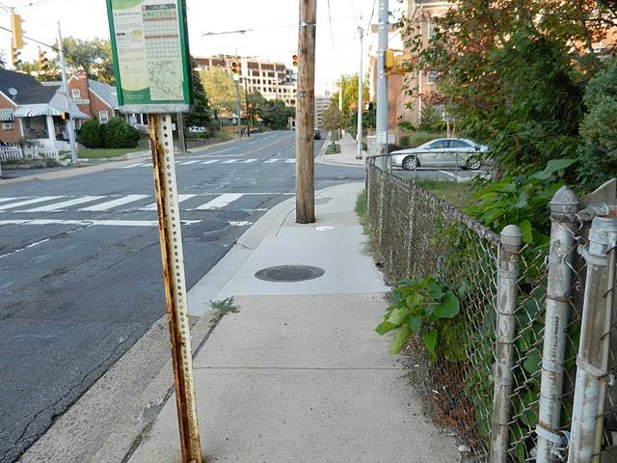
Illustration 2 Wilson Blvd. (between N. Glebe Rd. and N. George Mason Dr.) south side  Continued | Described above | 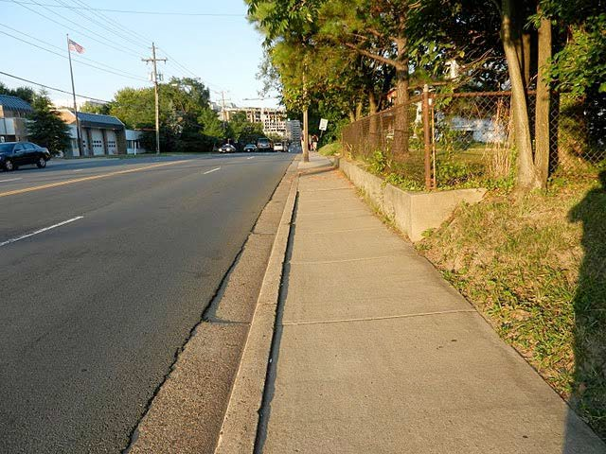
Illustration 3 Wilson Blvd. (between N. Glebe Rd. and N. George Mason Dr.) south side  Continued | Described above | 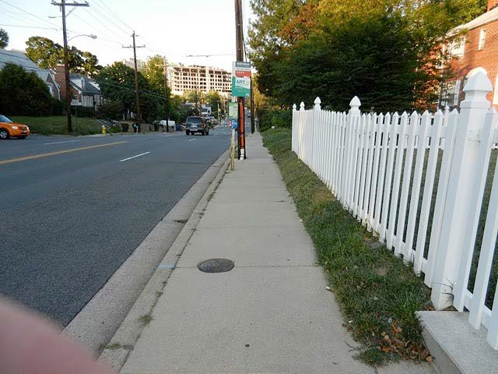

Illustration 4 Wilson Blvd. (between N. Glebe Rd. and N. George Mason Dr.) south side  Continued | Described above | 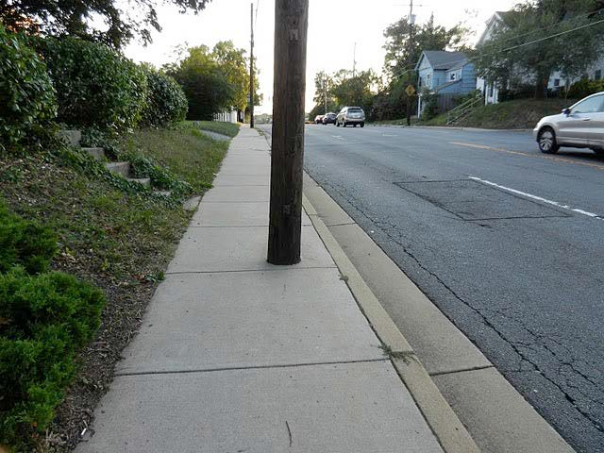
Illustration 5 Wilson Blvd. (between N. Glebe Rd. and N. George Mason Dr.) south side  Continued | Described above | 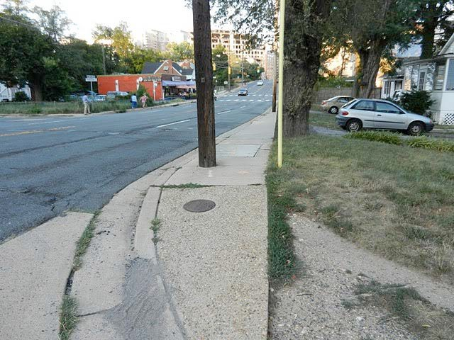
Illustration 6 Wilson Blvd. (between N. Glebe Rd. and N. George Mason Dr.) north side  Continued | Described above | 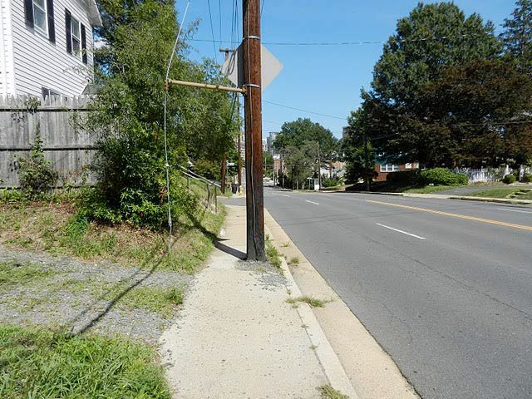

Illustration 7 Wilson Blvd. (between N. Glebe Rd. and N. George Mason Dr.) north side  Continued | Described above | 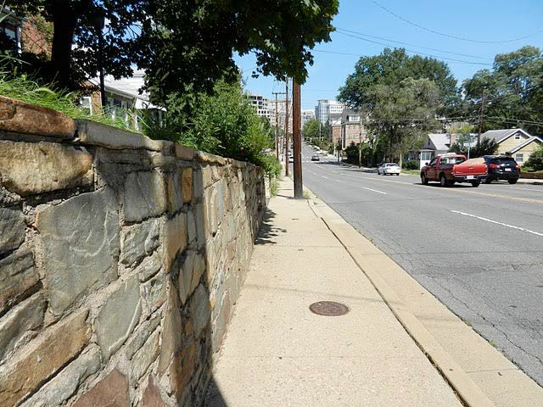
Illustration 8 Wilson Blvd. (between N. Glebe Rd. and N. George Mason Dr.) north side  Continued | Described above | 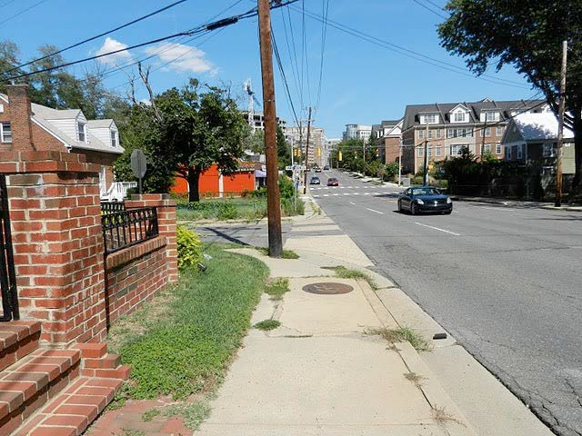

Illustration 9 Wilson Blvd. (between N. Harrison and N. Lexington Streets) north side  Continued | Described above | 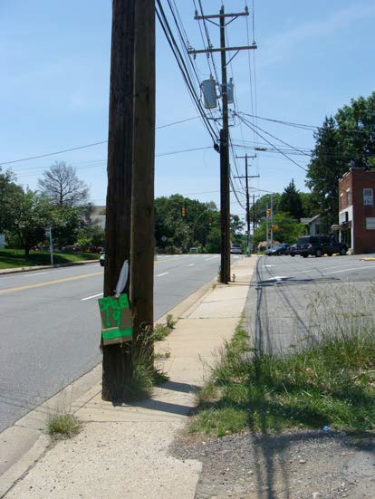
Illustration 10 Wilson Blvd. (between N. Harrison and N. Lexington Streets) north side  Continued | Described above | 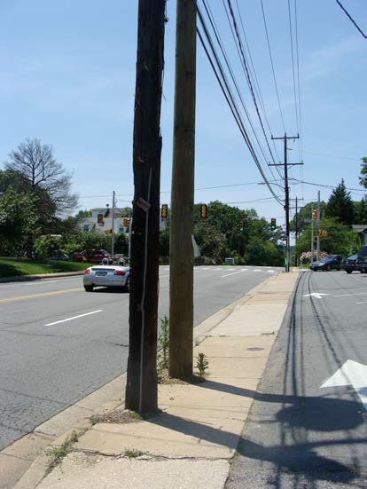

Illustration 11 Wilson Blvd. (between N. Harrison and N. Lexington Streets) north side  Continued | Described above | 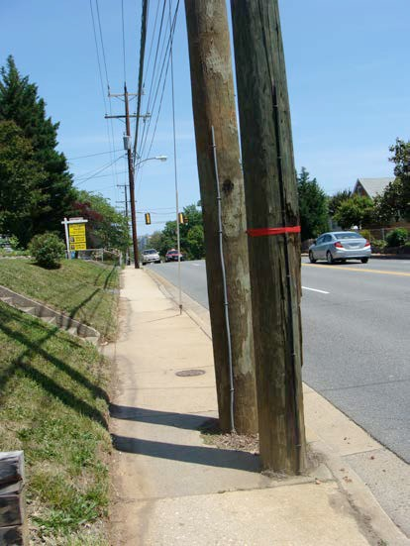
Illustration 12 Wilson Blvd. (between N. Harrison and N. Lexington Streets) north side  Continued | Described above | 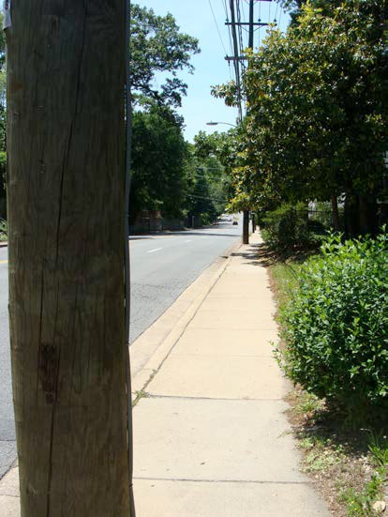

Illustration 13 Wilson Blvd. (between N. Harrison and N. Lexington Streets) north side  Continued | Described above | 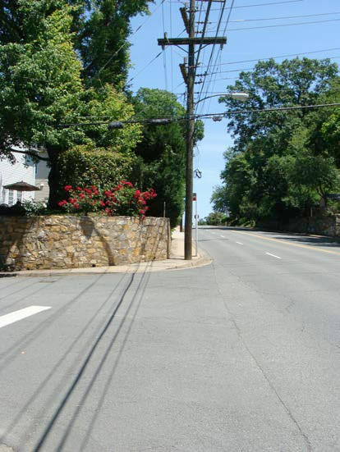
Illustration 14 Wilson Blvd. (between N. Harrison and N. Lexington Streets north side)  Continued | Described above | 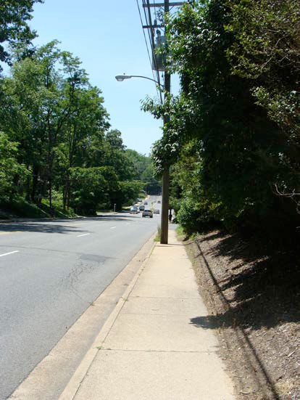

Illustration 15  N. George Mason Dr. (500-700 blocks) | Sidewalks on both sides of 500-700 blocks are intermittently narrow with utility poles, signage and hydrants blocking a number of places north of N. Carlin Springs Rd. up to Wilson Blvd. | 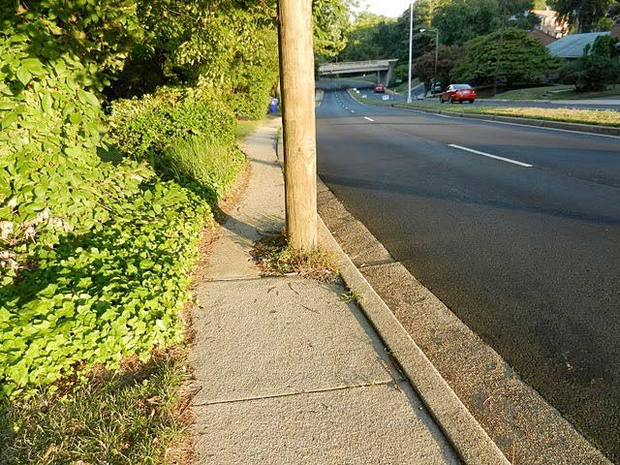
Illustration 16 George Mason Dr. (500-700 blocks) east side  Continued | Described above | 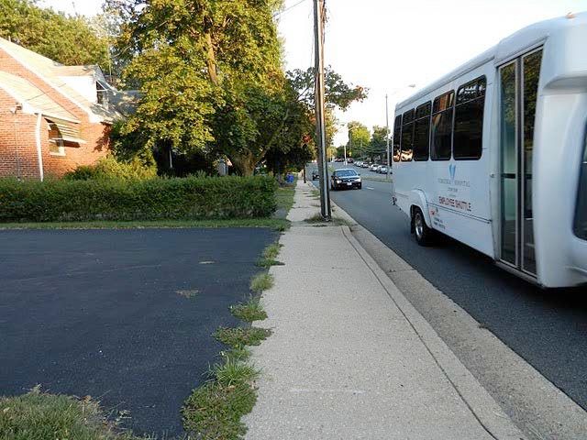
Illustration 17  N. George Mason Dr. (500-700 blocks) east side  Continued | Described above | 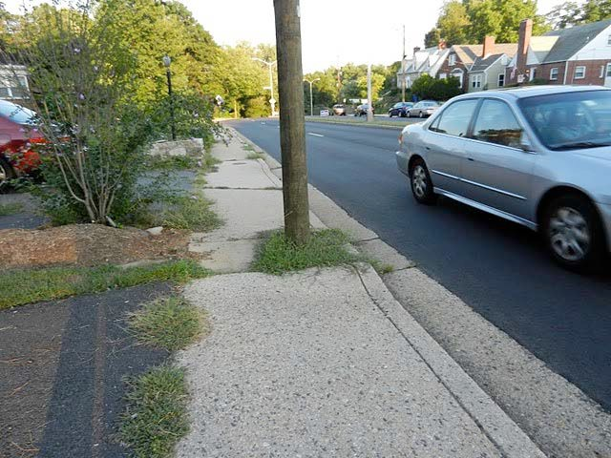

Illustration 18  N. George Mason Dr. (500-700 blocks) east side  Continued | Described above | 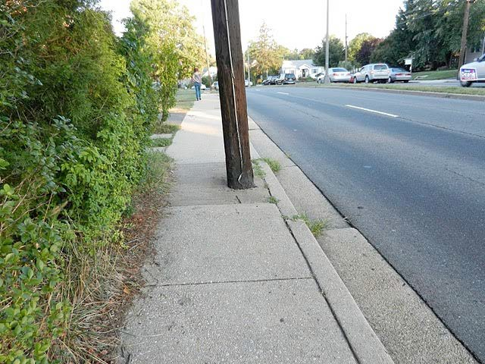
Illustration 19  N. George Mason Dr. (500-700 blocks) east side  Continued | Described above | 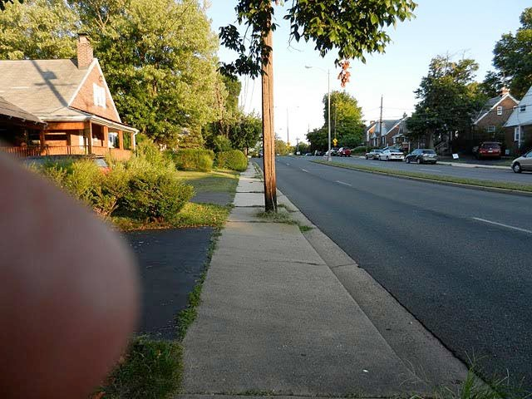
Illustration 20  N. George Mason Dr. (500-700 blocks) east side  continued | Described above | 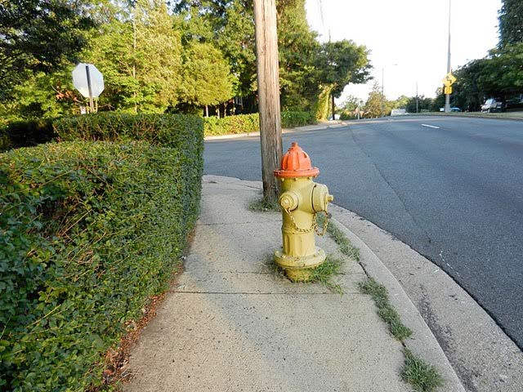

Illustration 21  N. George Mason Dr. (500-700 blocks) west side  Continued | Described above | 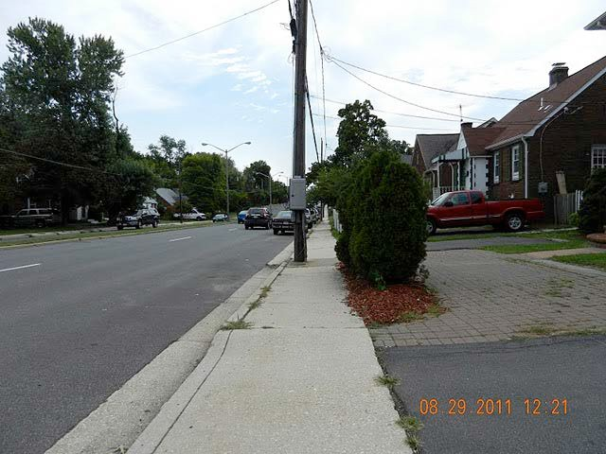
Illustration 22  N. George Mason Dr. (500-700 blocks) west side  Continued | Described above | 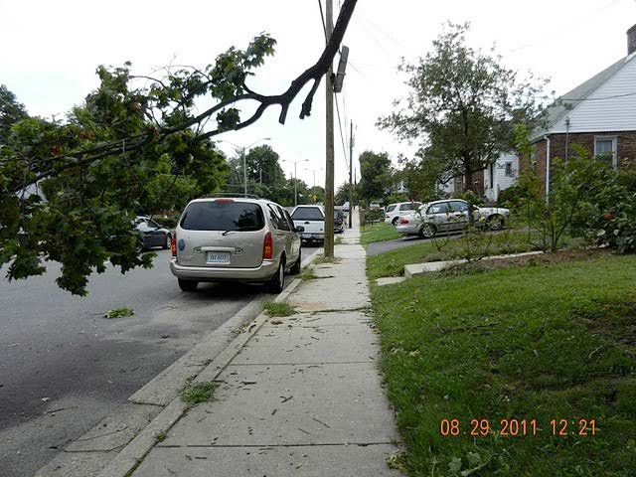

Illustration 23  N. Lexington Street (between Wilson Blvd and 8th Rd. N.) | Missing sidewalk on both sides of street (also depicted in Traffic Management Appendix as part of Jefferson/Lexington- Kensington cut- through; lack of sidewalk increases hazard to pedestrians) | 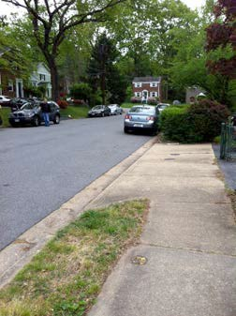
Illustration 24 8th Rd. N. (between N. Lexington and N.  Kensington Streets) | Described above | 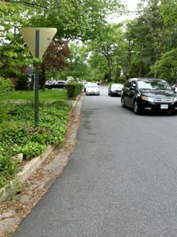

Illustration 25 Intersection of N. Lexington Street and 8th Rd. N. | Described above | 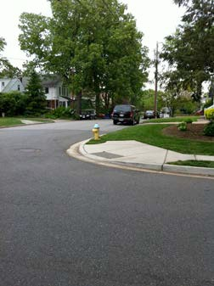
Illustration 26  Cul de sac west of  N. Kensington | Described above | 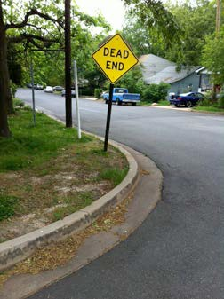

Illustration 27  N. Jefferson St. (1100- 1200 blocks; between N. Washington Blvd. and 11th St. N.) | Missing sidewalk on west side of street | 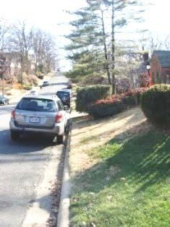
Illustration 28  N. Jefferson St. (800 block; between 8th Pl. N, and Wilson Blvd.) | Missing sidewalk on west side of street | 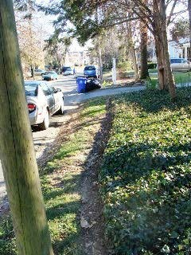

Illustration 29  N. Ivanhoe St. (1100 block; between Washington Blvd. and11th Rd. N.) | Missing sidewalk on east side of street | 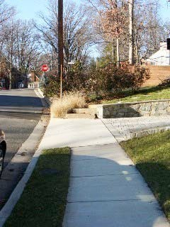
Illustration 30  N. Ivanhoe St. (1100 block; between Washington Blvd. and 11th Rd. N.)  Continued | Described above | 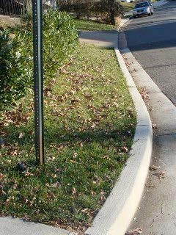

Illustration 31  N. Illinois St. (1100 and 1200 blocks; between N. Washington Blvd. and 11th St. N.) | Missing sidewalk on both east and west sides of street | 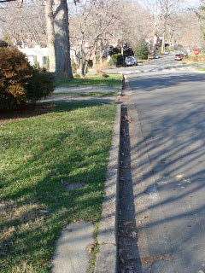
Illustration 32  N. Illinois St. (1100 and 1200 blocks; between N. Washington Blvd. and 11th St. N.)  Continued | Described above | 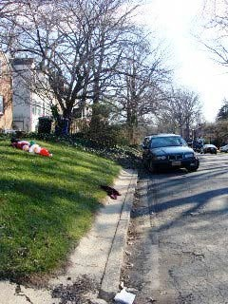

Illustration 33  N. Harrison St. (1000, 1100 and 1200 blocks; between N. Washington Blvd. and 10th St. N.) | Missing sidewalk on west side of street | 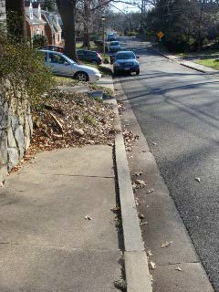
Illustration 34  N. Harrison St. (800 block; between 8th Rd. N. and Wilson Blvd.) | Missing sidewalk on west side of street | 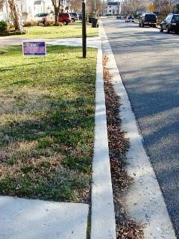

Illustration 35 | Missing sidewalk on | 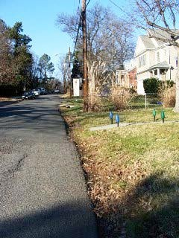
N. Greenbrier St. | west side of street;
(800 block; north | missing curb; road
of 8th Rd. N.) | surface itself is
 | deteriorating due to
 | heavy use by school
 | buses
Illustration 36 | No sidewalks or curbs | 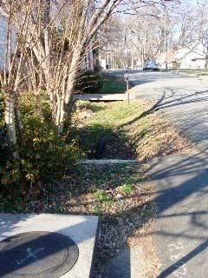
N. Edison St. (1000 | on either side of street
block; north of 10th
St. N.)

Illustration 37  N. Edison St. (1000 block; north of 10th St. N.)  Continued | Described above | 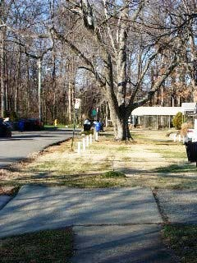
Illustration 38  N. Edison St. (800- 900 blocks; between Fairfax Dr. and Wilson Blvd.) | Missing sidewalk on west side of street (from survey - unverified) | 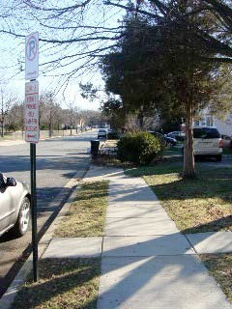

Illustration 39  Fairfax Dr. (4600 block; between N. Abingdon St. and  N. Glebe Rd.) (south side of street) | Substantial amount of standing water on south side of Fairfax Dr. after rainstorms; heightened hydroplaning danger for cars exiting I-66 eastbound at higher levels of speed | 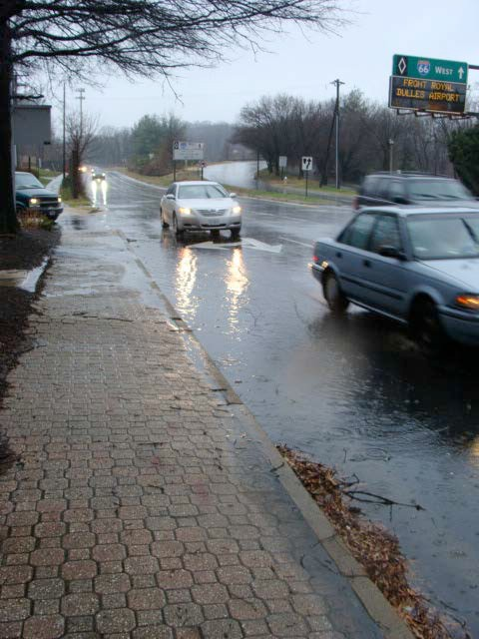
Illustration 40  Fairfax Dr. (4600 block; between N. Abingdon St. and  N. Glebe Rd.) (south side of street)  Continued | Described above | 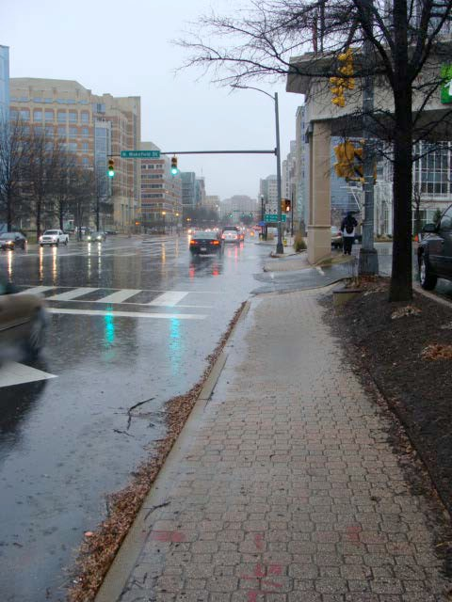

Illustration 41  Fairfax Dr. (4600 block; between N. Abingdon St. and  N. Glebe Rd.) (south side of street)  Continued | Described above | 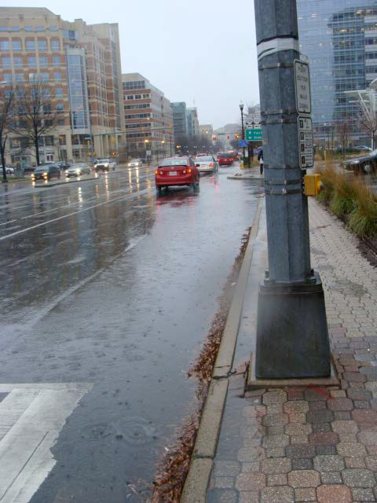
Illustration 42  Fairfax Dr. (4600 block; between N. Abingdon St. and  N. Glebe Rd.) (south side of street)  Continued | Described above | 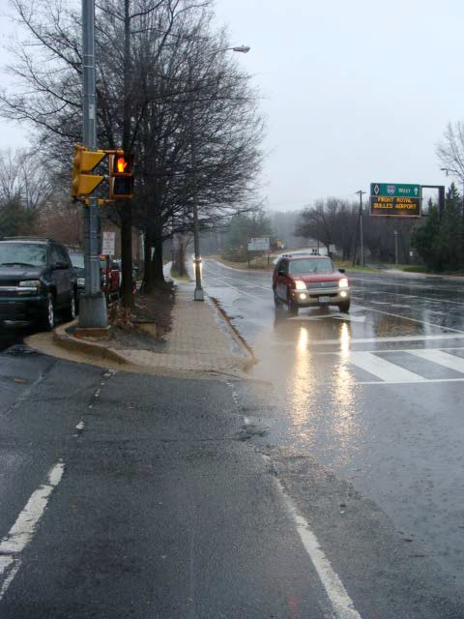

Illustration 43 | Substantial amount of | 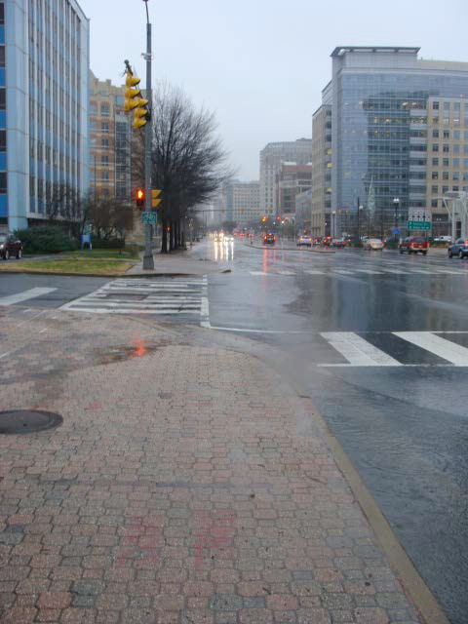
Fairfax Dr. (4600 | standing water on
block; between N. | north side of Fairfax
Abingdon St. and | Dr. after rainstorms
N. Glebe Rd.)
(north side of
street)
Illustration 44 | Sidewalks on the | 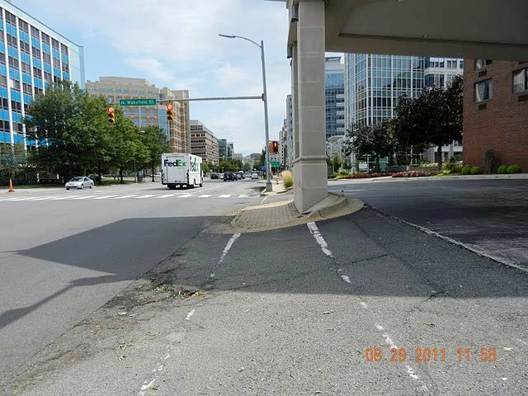
Fairfax Dr. (4600 | 4600 block in front of
block) | Holiday Inn are
 | intermittent and in
 | poor repair. Sidewalks
 | on the north side of
 | the 4600 block are
 | very narrow.

Illustration 45  Fairfax Dr. (4600 block)  Continued | Described above | 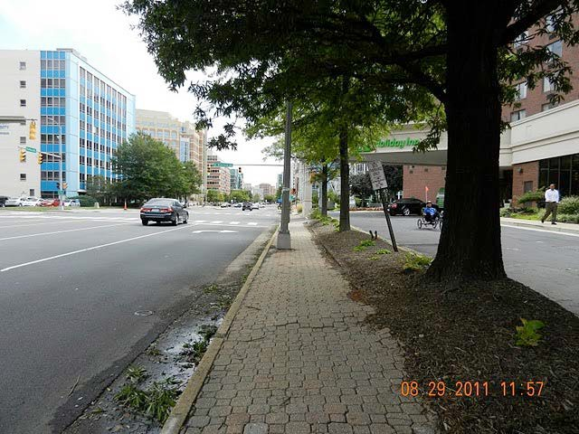
Illustration 46  Fairfax Dr. (4600 block)  Continued | Described above | 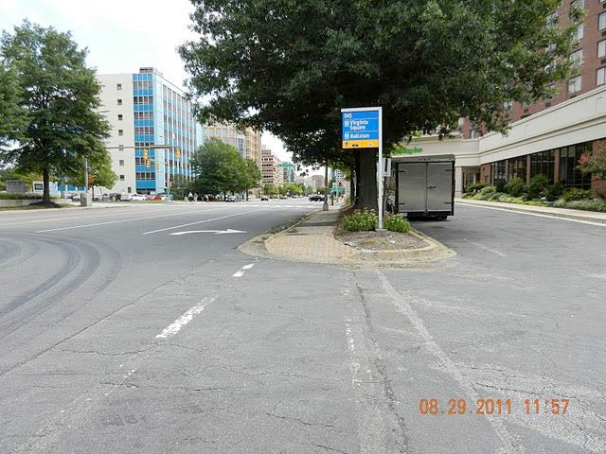

Illustration 47  12th St. N. (5200  block; between N. Frederick and N. Harrison Streets) | Partial sidewalk and missing curb | 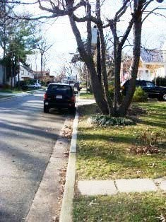
Illustration 48  11th Rd. N. (5200  block between N. Frederick and N. Harrison Streets) | Missing sidewalk on south side of street | 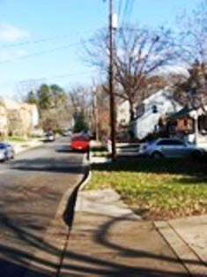

Illustration 49  11th Rd. N. (5400  and 5500 blocks; between N. Harrison and N. Inglewood Streets) | No sidewalk on either side of street; missing curb; severe water damage and road surface damage due to poor drainage | 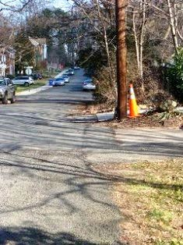
Illustration 50  11th Rd. N. (5400  and 5500 blocks; between N. Harrison and N. Inglewood Streets)  Continued | Described above | 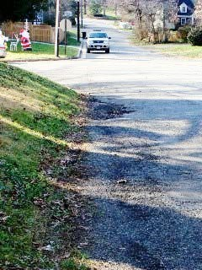

Illustration 51  11th Rd. N. (5400  and 5500 blocks; between N. Harrison and N. Inglewood Streets)  Continued | Described above | 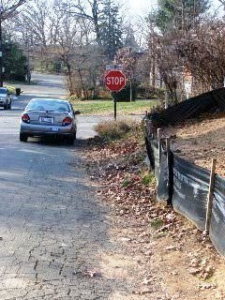
Illustration 52  11th St. N. (5200-  5500 blocks; between N. Frederick and N. Jefferson Streets) | Missing sidewalk on south side of street | 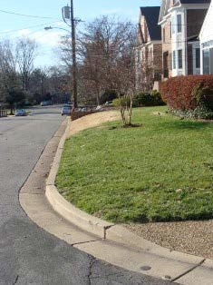

Illustration 53  10th St. N. (5400-  5500 blocks; between N. Harrison and N. Jefferson Streets) | Missing sidewalk on south side of street | 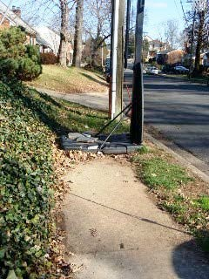
Illustration 54  9th Rd. N. (5400-  5500 blocks; between N. Harrison and N. Jefferson Streets) | Missing sidewalk on north side of street; missing curbs | 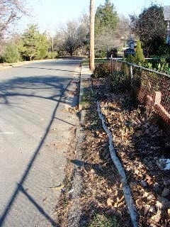

Illustration 55 | No sidewalk on either | 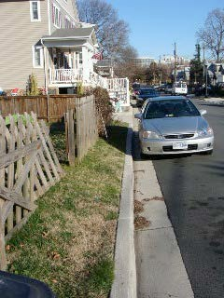
N. 9th St. N. (5100 | side of street; missing
block; between N. | curbs
Edison and N.
Frederick Streets)
Illustration 56 | Partial sidewalk | 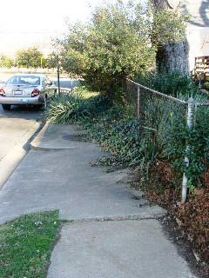
8th Rd. N. (5100 | (neither side has
block; between N. | complete sidewalk);
Edison and N. | missing curbs
Frederick Streets)

Illustration 57  8th Rd. N. (5100  block; between N. Edison and N. Frederick Streets)  Continued | Described above | 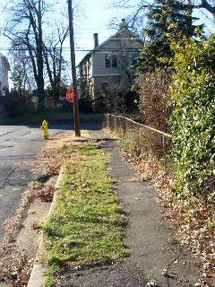
Illustration 58  8th Rd. N. (5100  block; between N. Edison and N. Frederick Streets)  Continued | Described above | 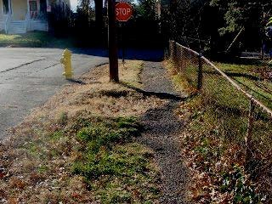

Illustration 59  8th Rd. N. (5200  block; between N. Frederick and N. Greenbrier Streets) | Partial sidewalk (neither side has complete sidewalk); missing curbs | 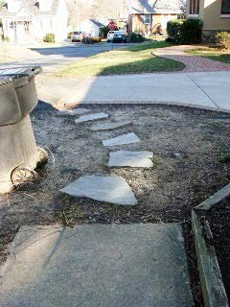
Illustration 60  8th Rd. N. (5200  block; between N. Frederick and N. Greenbrier Streets)  Continued | Described above | 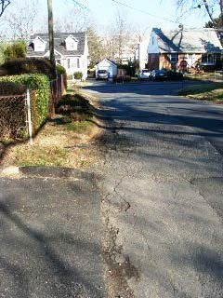

Illustration 61  8th Rd. N. (5200  block; between N. Frederick and N. Greenbrier Streets)  Continued | Described above | 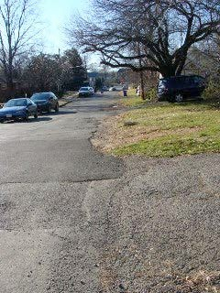
Illustration 62  8th Rd. N. (5200  block; between N. Frederick and N. Greenbrier Streets)  Continued | Described above | 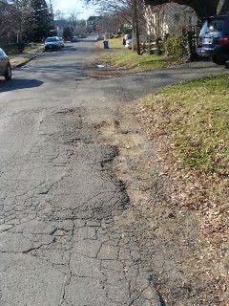

Illustration 63  8th Rd. N. (5200  block; between N. Frederick and N. Greenbrier Streets)  Continued | Described above | 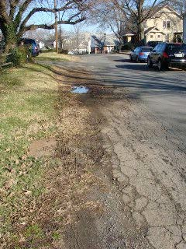
Illustration 64  N. Jefferson St. on the west side of Wilson to 9th Rd. N. | In the first block of N. Jefferson on the west side of Wilson on the south side of N. Jefferson, no curb, drain or sidewalk. | PICTURE STILL NEEDED
Illustration 65  7th Rd. N. (east of  N. Abingdon St.) | No sidewalks on either side north of 4600 block of 7th Rd. N., which is a cul-de- sac with a very narrow right-of-way. | 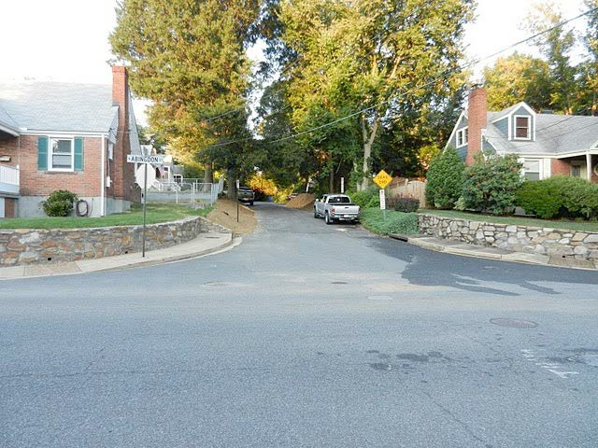

Illustration 66  7th St. N. (between cul-de-sac west of  N. Wakefield over to N. Vermont) | Sidewalks are intermittent on the 4500 block. | 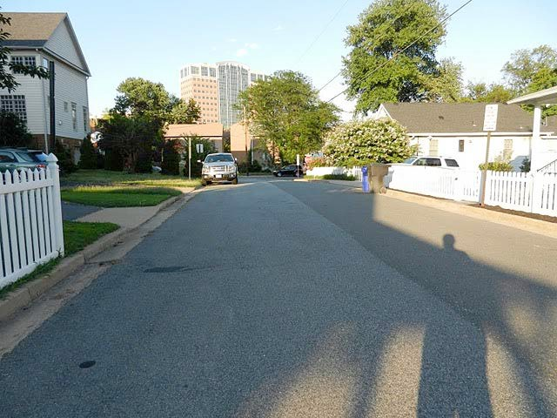
Illustration 67  7th St. N. (between cul-de-sac west of  N. Wakefield over to N. Vermont)  Continued | Described above | 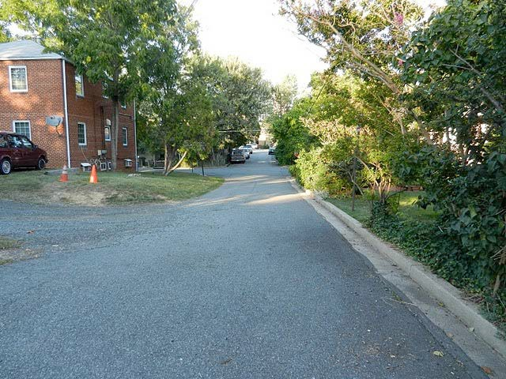
Illustration 68  7th St. N. (between  N. George Mason and N. Buchanan) | No sidewalks on south side of the 4900 block of 7th St. N. | 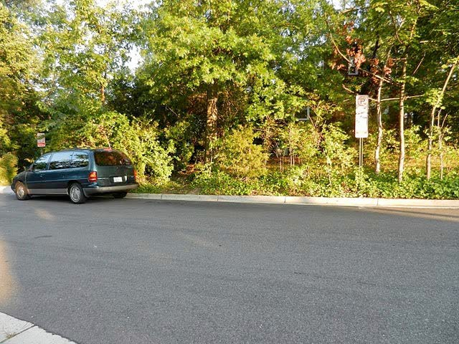

Illustration 69  8th Rd. N. (west of  N. Buchanan) | No sidewalks on either side of cul-de-sac with a very narrow right-of-way. | 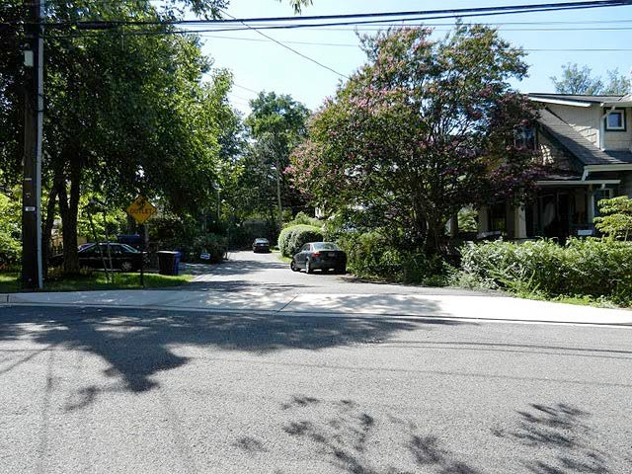
Illustration 70  8th Rd. N. (between  N. Buchanan and N. Abingdon) | Sidewalks are nonexistent on either side of this very narrow street. | 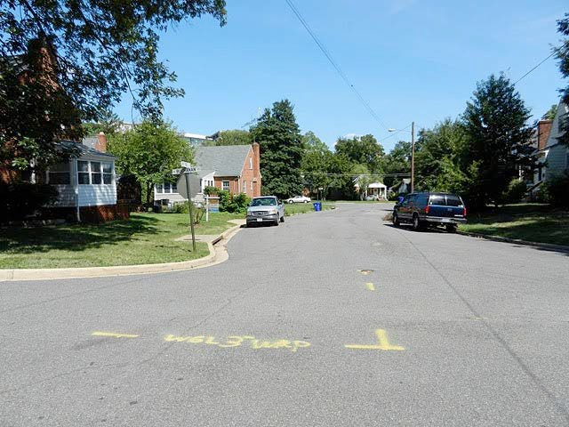
Illustration 71  9th St. N. (4800  block) | No sidewalks | 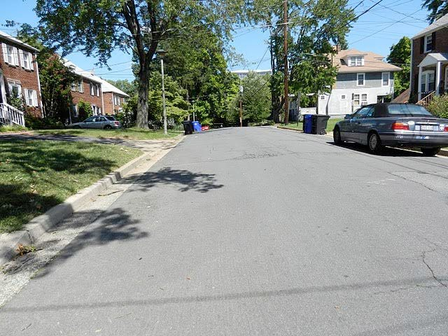

Illustration 72  9th St. N. (4800  block)  Continued | Described above | 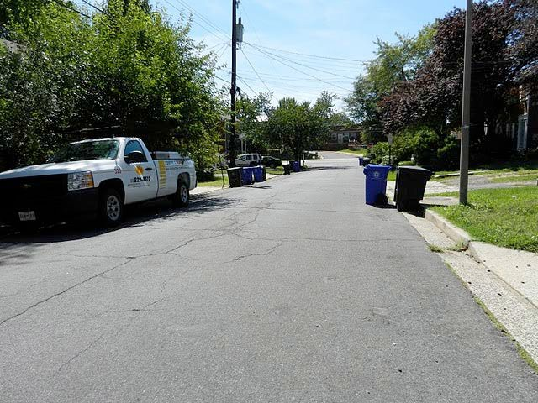
Illustration 73  N. Abingdon St. (700 block) | Sidewalks on west side extending south from Wilson Blvd. are narrow with utility poles presenting intermittent obstacles. | 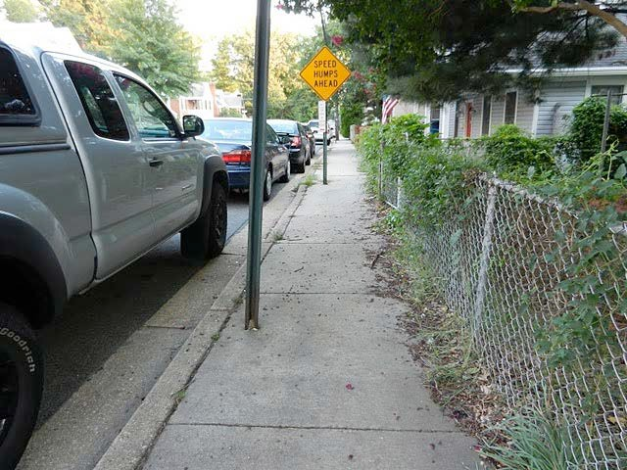
Illustration 74  N. Abingdon St. (700 block)  Continued | Described above | 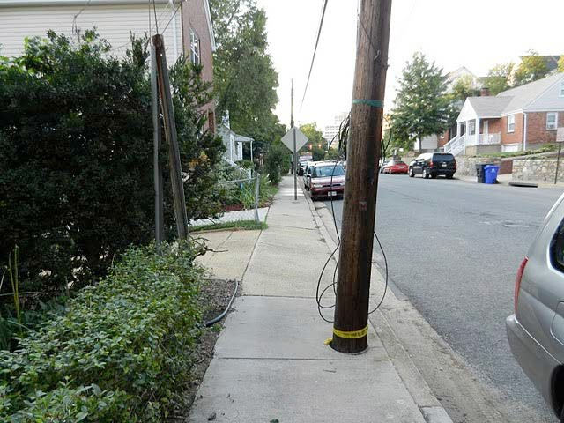

Illustration 75  N. Abingdon St. (800 block) | No sidewalks on either side of street. | 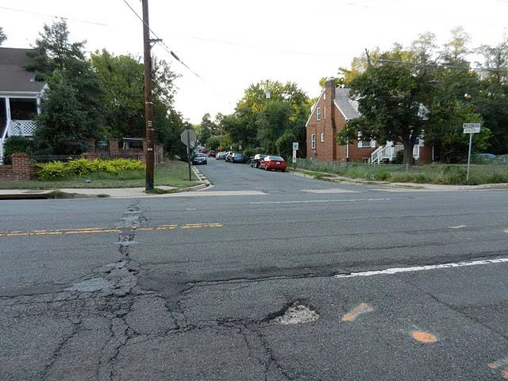
Illustration 76  N. Abingdon St. (800 block)  Continued | Described above | 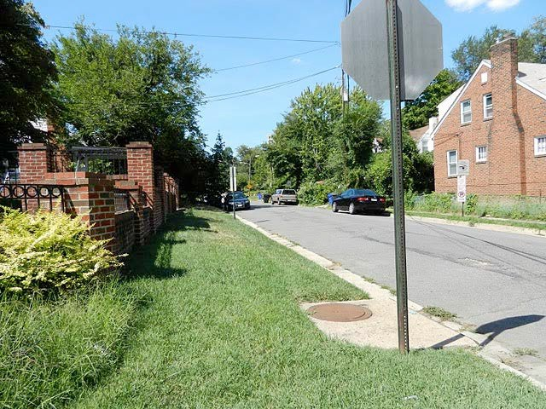
Illustration 77  N. Abingdon St. (800 block)  Continued | Described above | 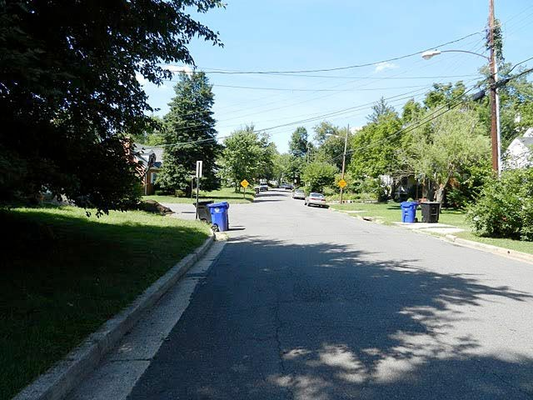

Illustration 78  N. Abingdon St. (800 block)  Continued | Described above | 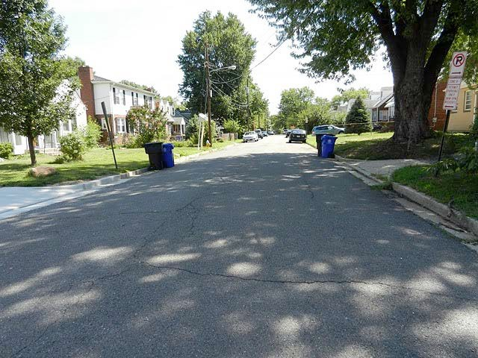
Illustration 79  N. Abingdon St. (800 block)  Continued | Described above | 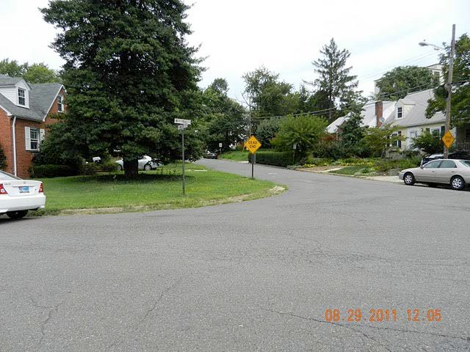
Illustration 80  N. Albemarle St. (700 block) | Missing sidewalk on east side for approximately 100 feet starting at Wilson Blvd. and extending south; existing sidewalks are very narrow | 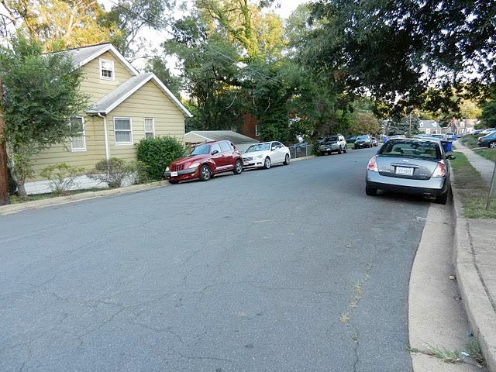

Illustration 81  N. Buchanan St. (700 block) | No sidewalk on the east side just north of 7th St. N. | 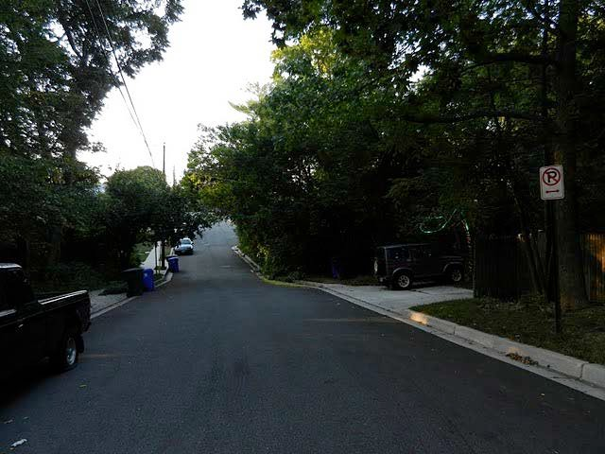
Illustration 82  N. Buchanan St. (800 block) | No sidewalks on either side north of 8th Rd. N. or south of 8th Rd. N. | 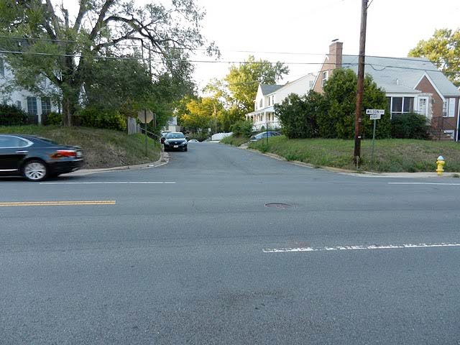
Illustration 83  N. Buchanan St. (800 block)  Continued | Described above | 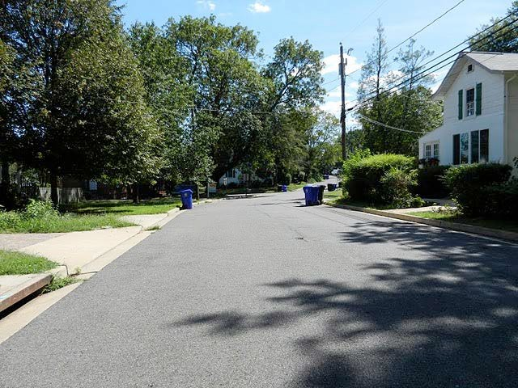

Illustration 84  N. Buchanan St. (800 block)  Continued | Described above | 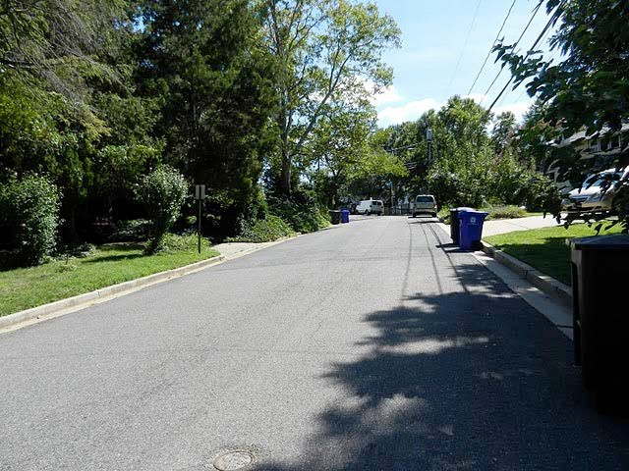
Illustration 85  N. Buchanan St. (800 block)  Continued | Described above | 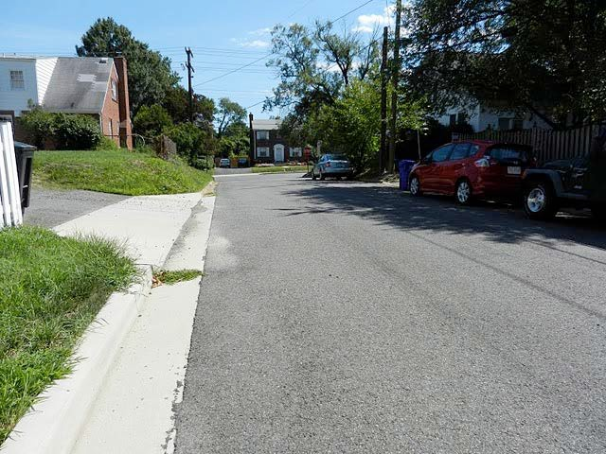
Illustration 86  N. Buchanan St. (800 block)  Continued | Described above | 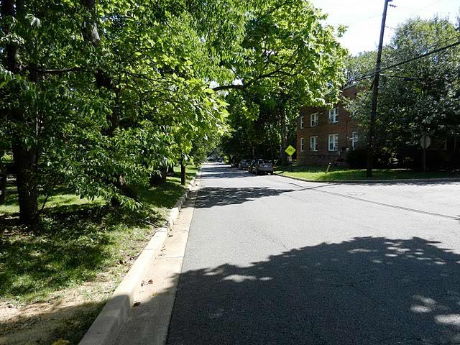

Illustration 87  N. Buchanan St. (800 block)  Continued | Described above | 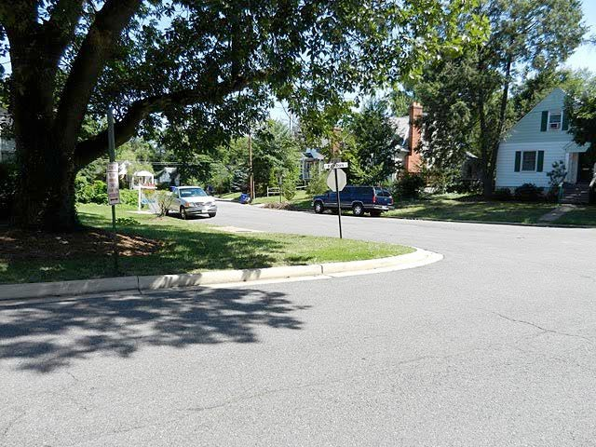
Illustration 88  N. Buchanan St. (800 block)  Continued | Described above | 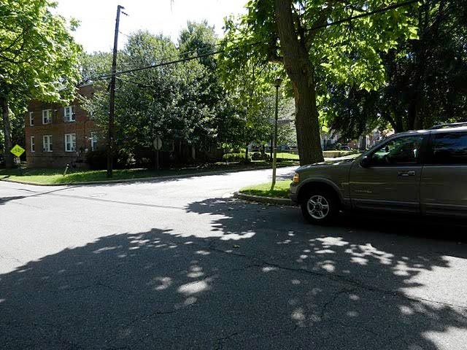
Illustration 89  N. Buchanan St. (900 block) | No sidewalks south of Fairfax Dr. | 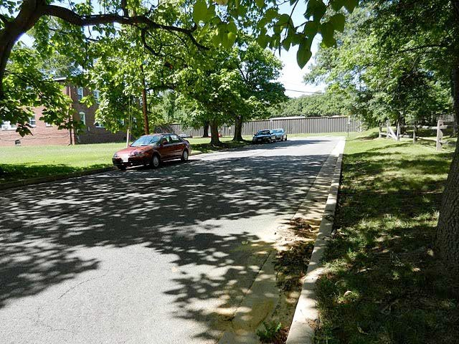

Illustration 90  N. Burlington St. (800 block) | No sidewalks | 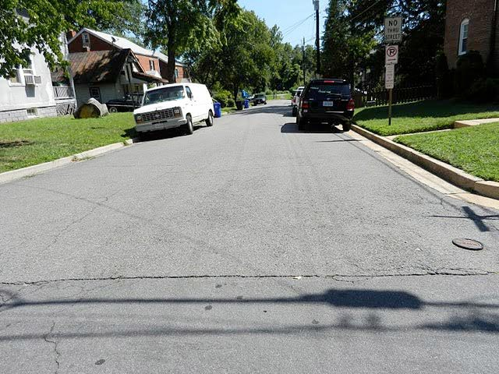
Illustration 91  Fairfax Dr. (4800 block) | Sidewalk on north side of street largely blocked from overgrown vegetation from public lands adjacent to I-66 sound barrier. | 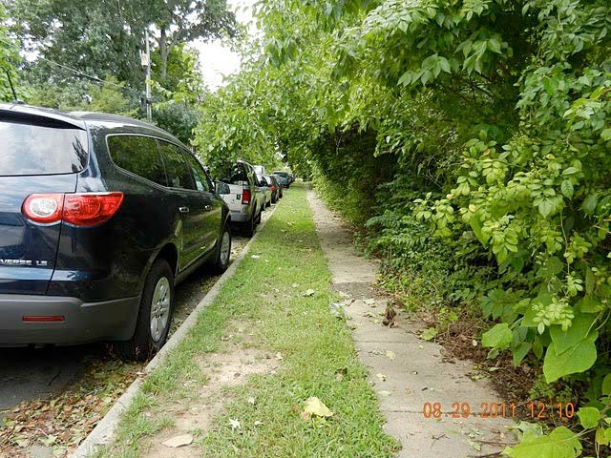
Illustration 92  Fairfax Dr. (4800 block)  Continued | Described above | 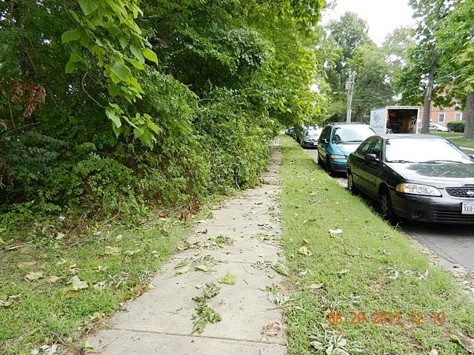

Illustration 93  N. Glebe Rd. (700 block) west side | Sidewalk on west side has utility poles blocking a number of places north of 7th St N. up to Wilson Blvd. | 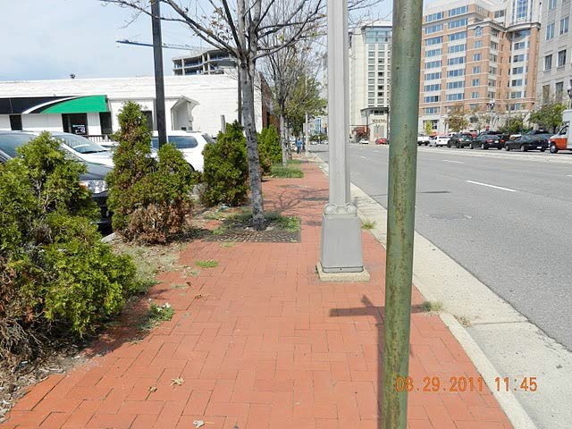
Illustration 94  N. Vermont St. (600 block) | No sidewalks on the west side of street | 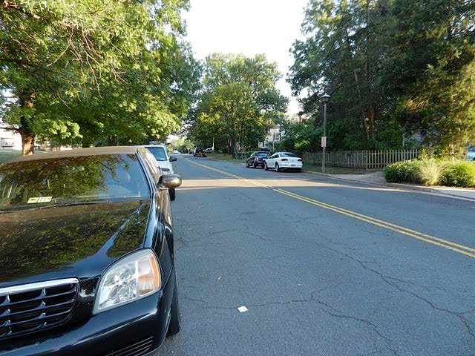

Illustration 95  N. Vermont St. (700 block) | No sidewalks on the west side of street | 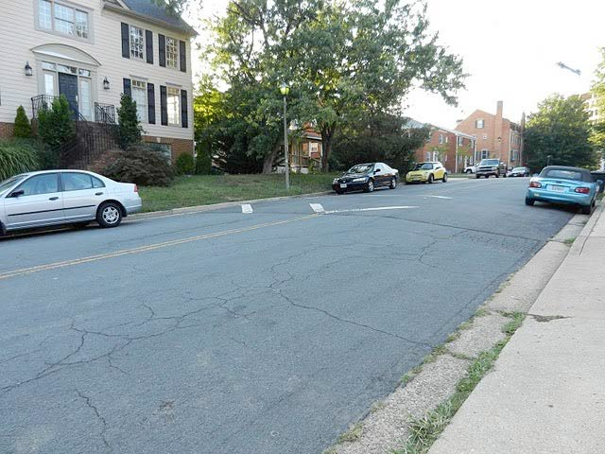
Illustration 96  N. Vermont St. (700 block)  Continued | Described above | 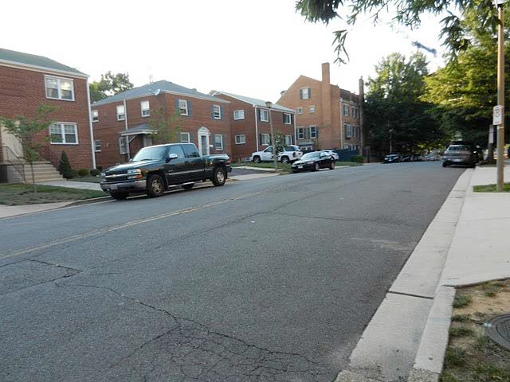
Illustration 97  N. Wakefield St. (600 block) | Sidewalks are intermittent on the east side and no sidewalks on the west side. | 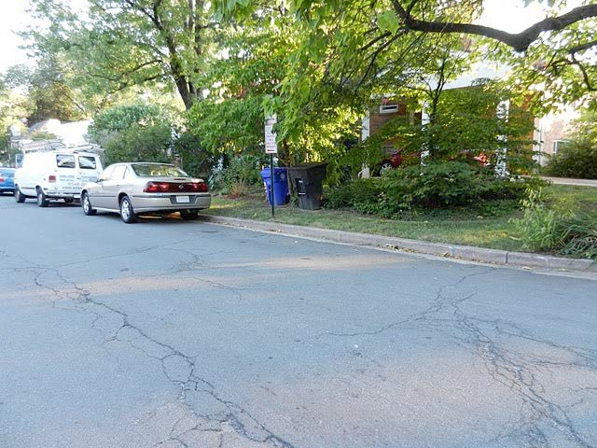

Illustration 98  N. Wakefield St. (600 block)  Continued | Described above | 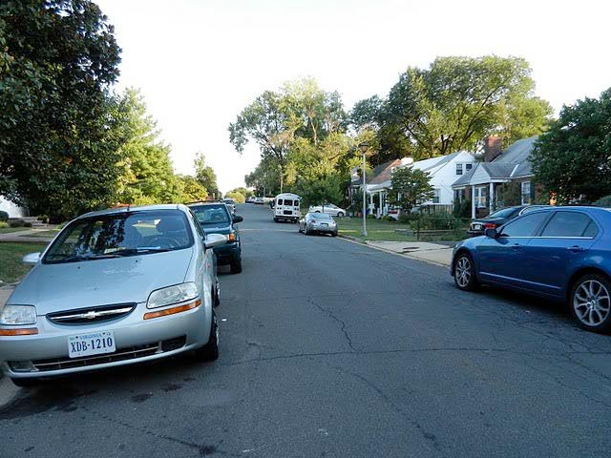
Illustration 99  N. Wakefield St. (600 block)  Continued | Described above | 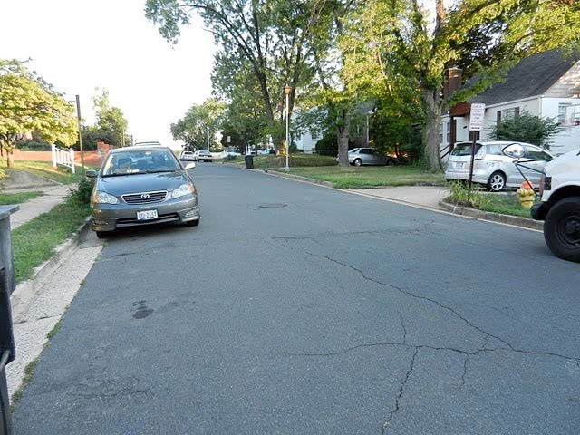
Illustration 100  N. Wakefield St. (700 block) | No sidewalks on either side of street | 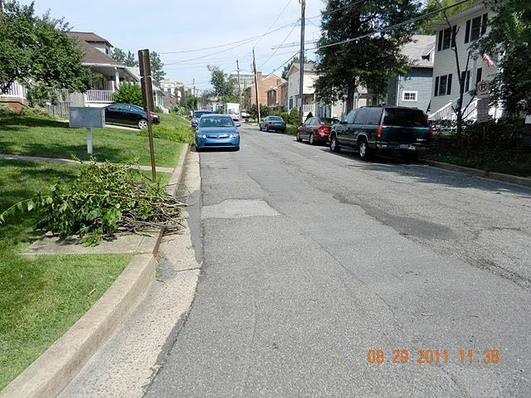

Illustration 101  N. Wakefield St. (700 block)  Continued | Described above | 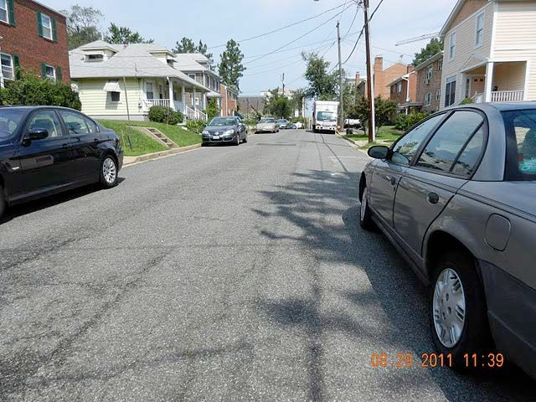
Illustration 102  N. Wakefield St. (800 block) | Ongoing development will probably install sidewalks on the east side; no sidewalks on the west side. | 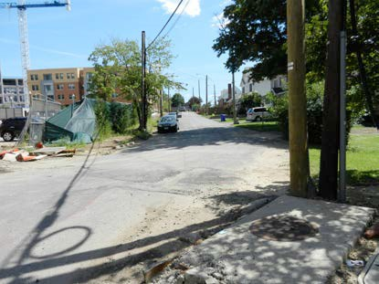
Illustration 103  N. Wakefield St. (900 block) | No sidewalks on the east side | 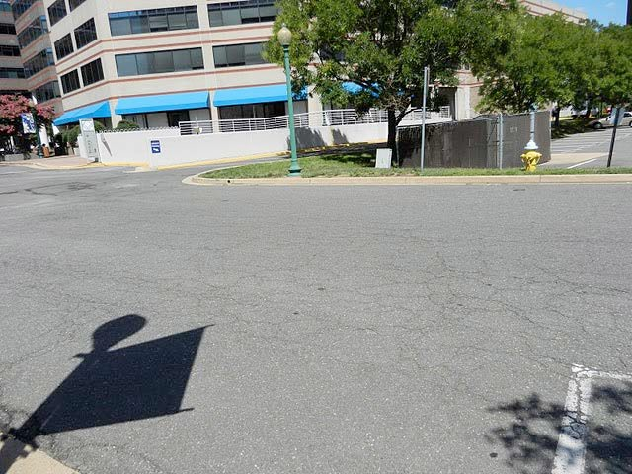

Illustration 104  N. Wakefield St. (900 block)  Continued | Described above | 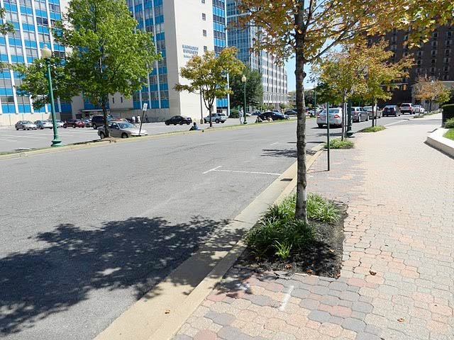
Illustration 105 Intersection of 10th St. N, and N. Jefferson St. | Frequent flooding due to very poor drainage | 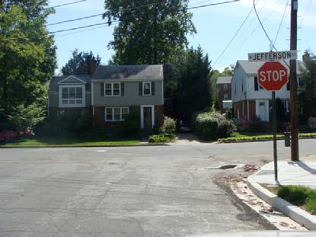
Illustration 106 Intersection of Wilson Blvd. and N. Kensington St. | Intersection has very poor storm drainage, especially the north side of Wilson; water flows down Wilson and pools at N. Kensington; freezes during winter. | 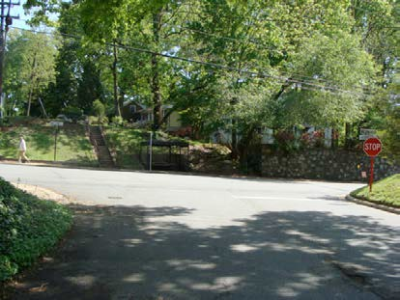

Illustration 107 Intersection of Wilson Blvd. and N. Kensington St. | No sidewalks on either side of N. Kensington makes it very dangerous for pedestrians when traffic turns onto N. Kensington from Wilson | 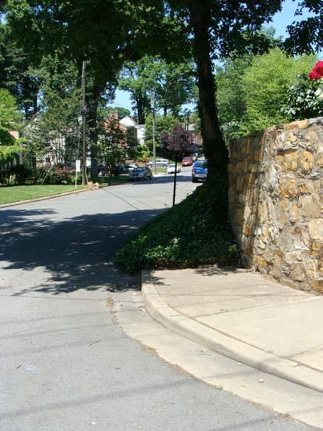
Illustration 108 Intersection of Wilson Blvd. and N. Kensington St. | Street light is out | 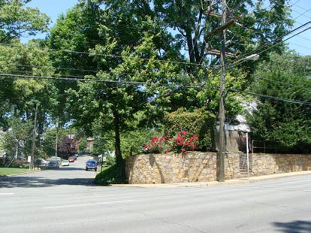

Illustration 109  N. Woodrow St. (800 block) | No sidewalks on east side of street (though ongoing development might result in installation of sidewalks). | 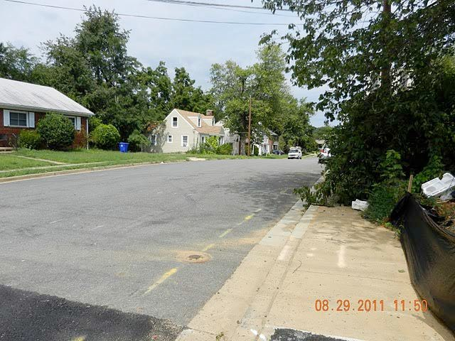
Illustration 110 Bluemont Dr. (between N. Frederick and N. Florida Streets) | No curb along bike path and cars frequently park on bike path grass | 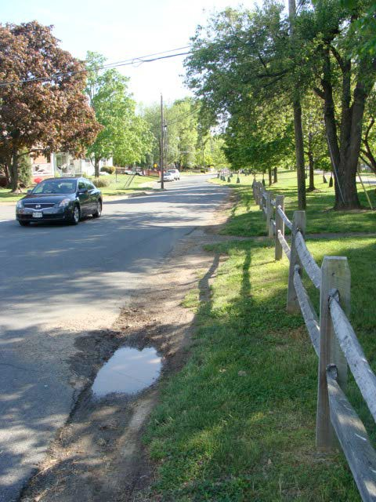

Illustration 111  Bluemont Dr (5200,  5300 and 5400  blocks) | Various segments of crumbling curbs and gutters | 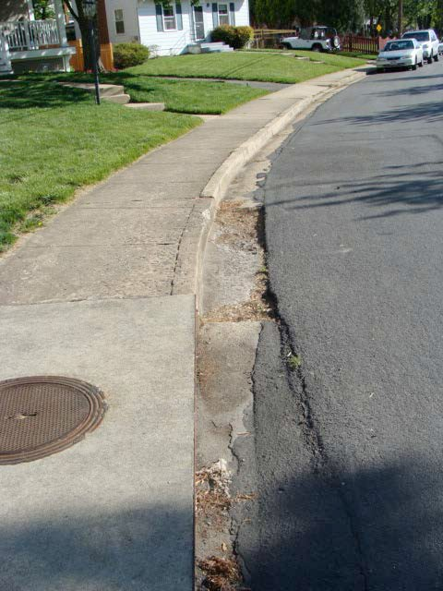
Illustration 112  Bluemont Dr (5300 block) | Missing curb | 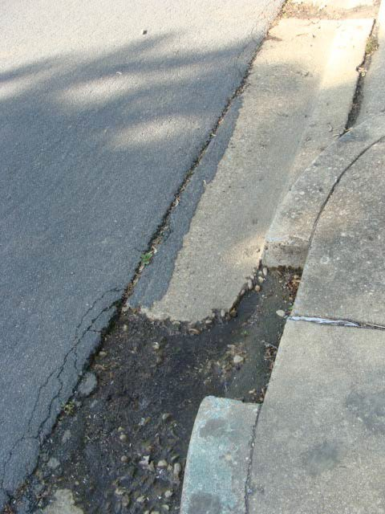

Illustration 113 Intersection of Bluemont Dr. and N. Frederick St. | Street light is out | 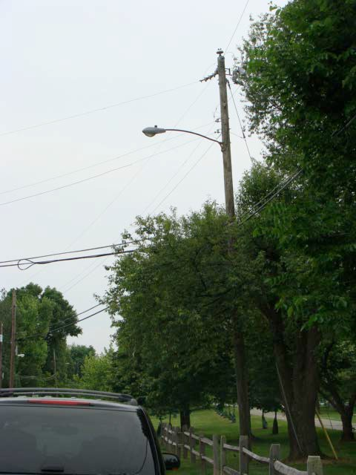
Illustration 114  N. Florida St. (600- 800 blocks) | Various segments of crumbling curbs and gutters | 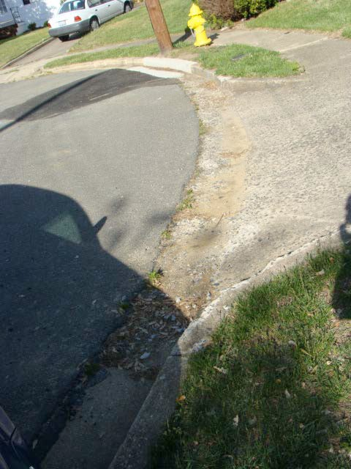

Illustration 115  N. Florida St. (600- 800 blocks) | Various segments of crumbling curbs and gutters | 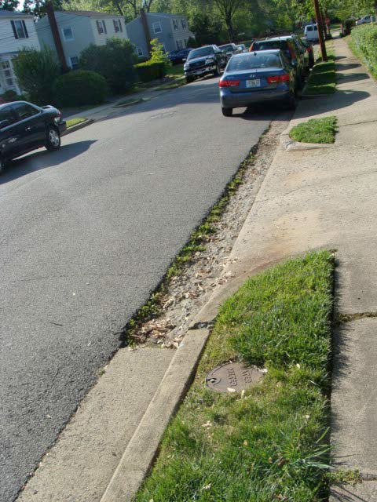
Illustration 116  N. Florida St. (700 block) | Sidewalk trip hazard | 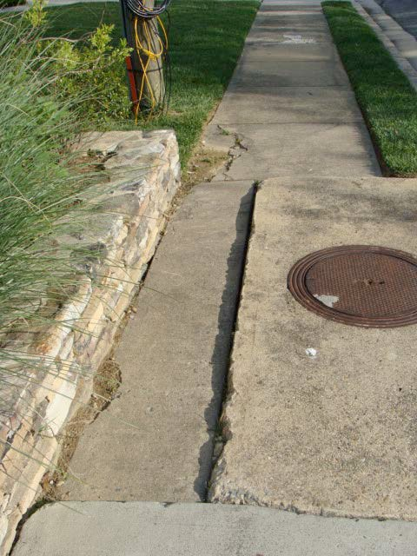

Illustration 117  N. Florida St. (700 block) | Poor drainage results in frequent standing water on street and sidewalk | 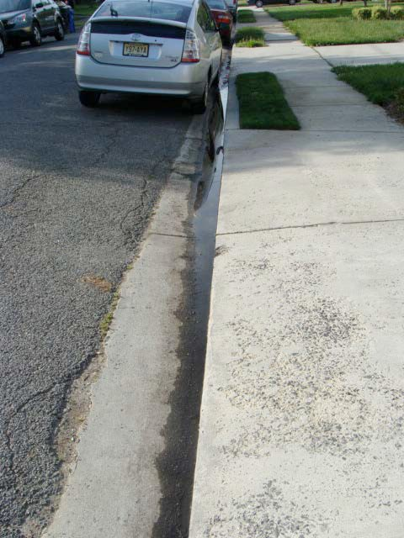
Illustration 118  N. Frederick St. (600-700 blocks) | Various segments of crumbling curbs and gutters | 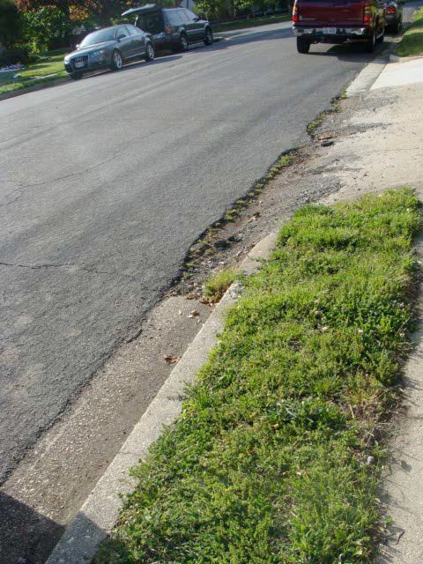

Illustration 119  N. Frederick St. (700 block) | Various segments of crumbling curbs and gutters; standing water due to poor gutter drainage | 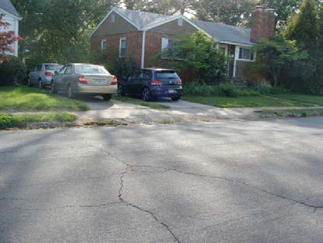
Illustration 120  N. Frederick St. (800 block) | No sidewalk at end of cul-de- sac | 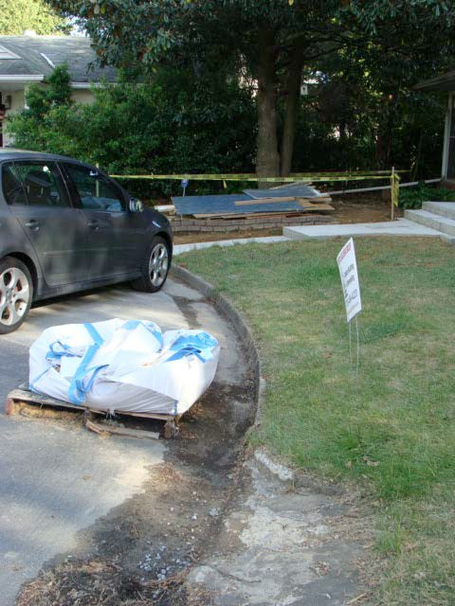

Illustration 121  N. Greenbrier St. (600-800 blocks) | Various segments of crumbling curbs and gutters | 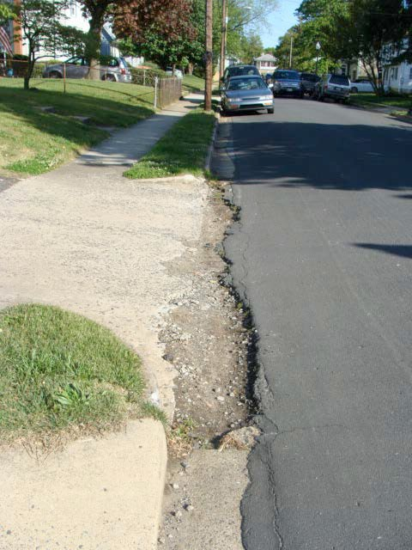
Illustration 122  N. Harrison St. (600 block) | Various segments of crumbling curbs and gutters | 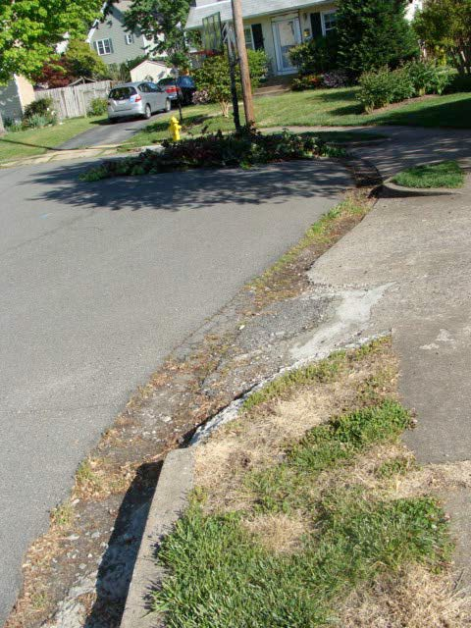

Illustration 123  N. Harrison St. (600 block) | Fire hydrant leak | 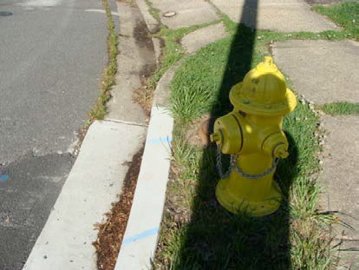
Illustration 124  N. Harrison St. (600 block) | Various segments of crumbling curbs and gutters; cracked and sinking sidewalk creates trip hazard | 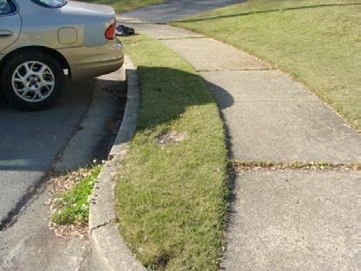
Illustration 125  N. Illinois St. (600- 800 blocks) | Various segments of uneven sidewalk surfaces, crumbling curbs and gutters | 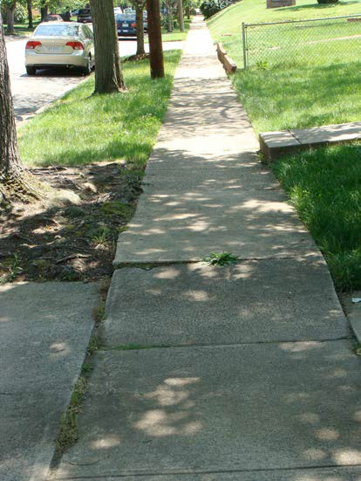

Illustration 126  N. Illinois St. (600- 800 blocks)  Continued | Described above | 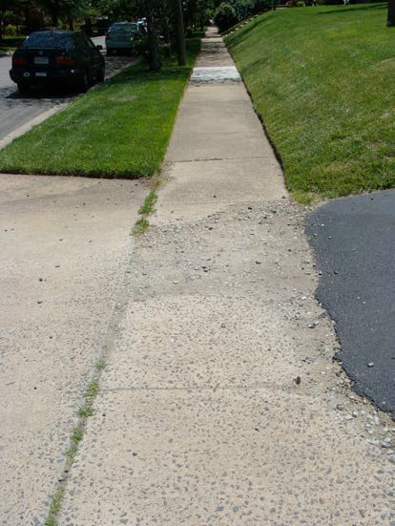
Illustration 127  N. Illinois St. (600- 800 blocks)  Continued | Described above | 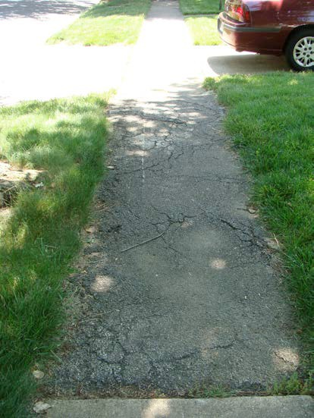

Illustration 128  N. Illinois St. (600- 800 blocks)  Continued | Described above | 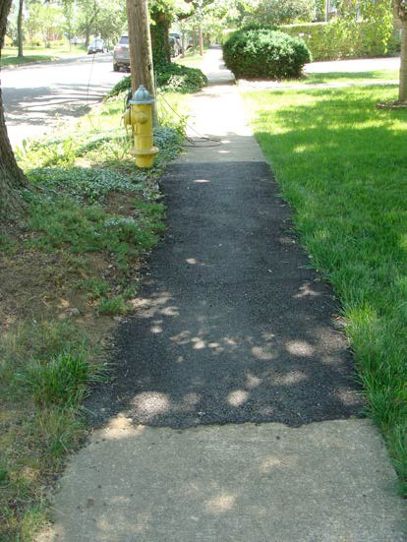
Illustration 129  N. Illinois St. (600- 800 blocks)  Continued | Described above | 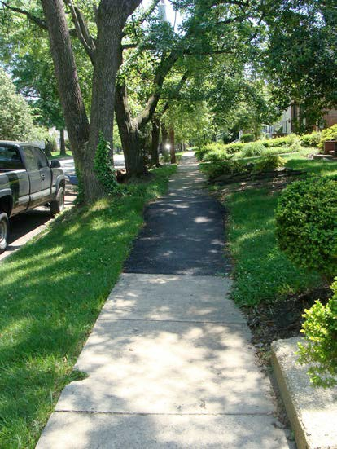

Illustration 130  N. Illinois St. (600- 800 blocks)  Continued | Described above | 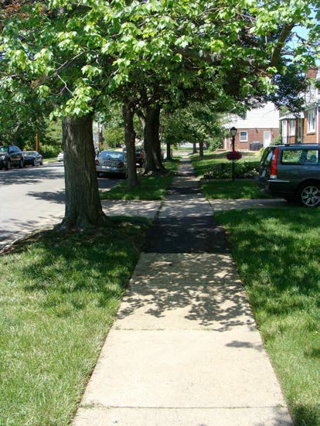
Illustration 131  N. Illinois St. (629) | Blocked raised gutter pipe floods street. | 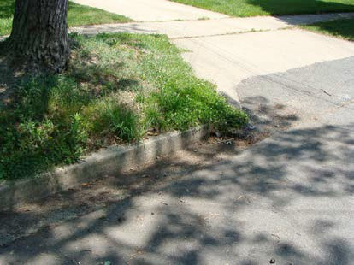
Illustration 132 Intersection of N. Illinois and 5th St. N. | Curb on corner is very steep and creates trip hazard | 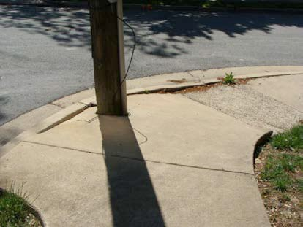

Appendix D - Illustrated List of Traffic Management/Transportation Issues

Location | Problem | Picture
Illustration 1 | Heavy traffic along | 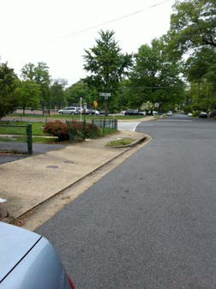
N. Lexington | Jefferson/Lexington-
St. (between | Kensington cut-
Wilson Blvd | through, combined
and 8th Rd. N.) | with general lack of
 | sidewalks, inadequate
 | traffic-calming
 | measures and heavy
 | pedestrian presence
 | due to bus stops and
 | nearby school and
 | parks, create very
 | hazardous conditions
Illustration 2 | Heavy traffic along
N. Lexington | Jefferson/Lexington-
St. (between | Kensington cut-
Wilson Blvd | through, combined
and 8th Rd. N.) | with general lack of
 | sidewalks, inadequate
 | traffic-calming
 | measures and heavy
 | pedestrian presence
 | due to bus stops and
 | nearby school and
 | parks, create very
 | hazardous conditions

Illustration 3 | Heavy traffic along
8th Rd. N. | Jefferson/Lexington-
(between N. | Kensington cut-
Lexington and | through, combined
N. Kensington | with general lack of
Streets) | sidewalks, inadequate
 | traffic-calming
 | measures and heavy
 | pedestrian presence
 | due to bus stops and
 | nearby school and
 | parks, create very
 | hazardous conditions
 | (note intermittent
 | sidewalks)
Illustration 4 | Heavy traffic along
Intersection of | Jefferson/Lexington-
N. Lexington | Kensington cut-
St. and 8th Rd. | through, combined
N. | with general lack of
 | sidewalks, inadequate
 | traffic-calming
 | measures and heavy
 | pedestrian presence
 | due to bus stops and
 | nearby school and
 | parks, create very
 | hazardous conditions
 | (note intermittent
 | sidewalks)

Illustration 5 | Heavy traffic along
Cul de sac west | Jefferson/Lexington-
of N. | Kensington cut-
Kensington | through, combined
 | with general lack of
 | sidewalks, inadequate
 | traffic-calming
 | measures and heavy
 | pedestrian presence
 | due to bus stops and
 | nearby school and
 | parks, create very
 | hazardous conditions
 | (note intermittent
 | sidewalks)
Illustration 6 | Need for raised | 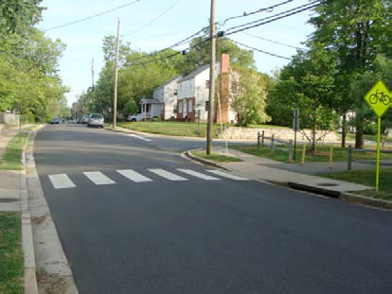
Intersection of | crosswalk and traffic
N. Emerson St. | calming measures;
and Bluemont | traffic using
Junction Trail | Emerson-Bluemont-
 | Greenbrier cut-
 | through is a hazard to
 | pedestrians, bicyclists
 | and bus stop users

Illustration 7 | Need for traffic
Bluemont Dr. | calming measures to
(between N. | slow speeding traffic
Emerson and N. | using Emerson-
Greenbrier) | Bluemont-
 | Greenbrier cut-
 | through
Illustration 8 | Install three-way stop | 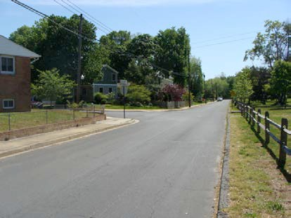
Intersection of | signs to slow down,
N. Greenbrier | deter traffic using
St. and | Emerson-Bluemont-
Bluemont Dr. | Greenbrier cut-
 | through
Illustration 9 | Install three-way stop | 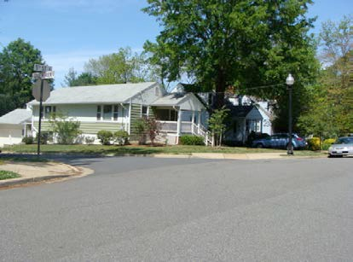
Intersection of | signs to slow down,
N. Greenbrier | deter traffic using
St. and 5th St. | Emerson-Bluemont-
N. | Greenbrier cut-
 | through

Illustration 10 800 block of N. Buchanan St. | Install traffic-calming measures to slow down, deter traffic using Buchanan- Fairfax cut-through | 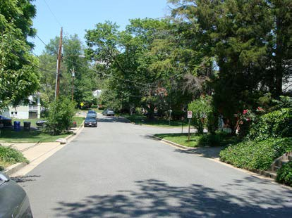
Illustration 11  N. Buchanan St. and Bluemont Junction Trail | Need for raised crosswalk and traffic calming measures; traffic using Buchanan-Fairfax cut-through is a hazard to pedestrians and bicyclists in this particular area | 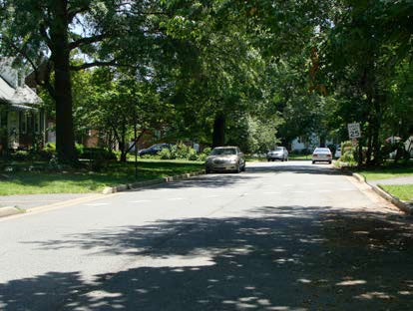
Illustration 12  4800 block of  N. Fairfax Dr. | Install traffic-calming measures to slow down, deter traffic using Buchanan- Fairfax cut-through | 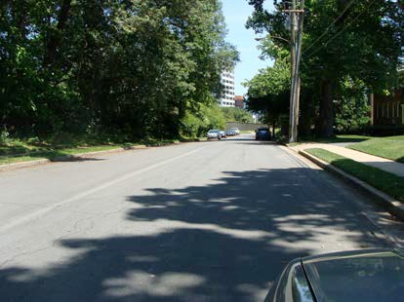

Illustration 13  Intersection of  N. Edison St. and 6th St. N. | Install traffic-calming measures to slow down, deter traffic using 6th St. – Edison St. Cut-Through | 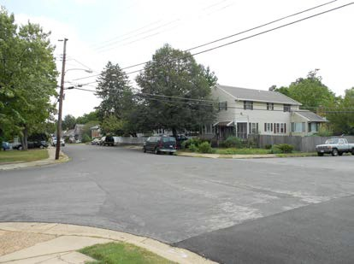
Illustration 14  5000 block of 6th St. N. | Install traffic-calming measures to slow down, deter traffic using 6th St. – Edison St. Cut-Through | 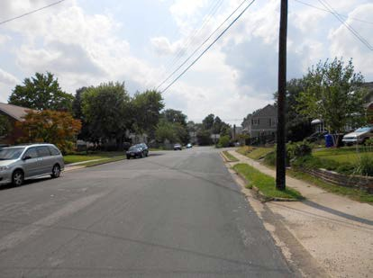
Illustration 15 Intersection of George Mason Dr. and 6th St. N. | Intersection is very prone to accidents (southbound George Mason traffic has problems navigating curve; northbound George Mason traffic turning onto 6th St. N. and 6th St. N. traffic turning onto northbound George Mason are blind to oncoming southbound George Mason traffic). | 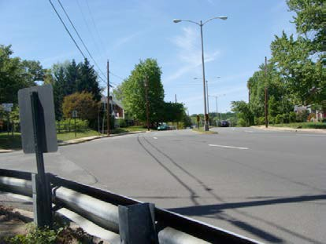

Illustration 16 | Pedestrian hazard due |  | 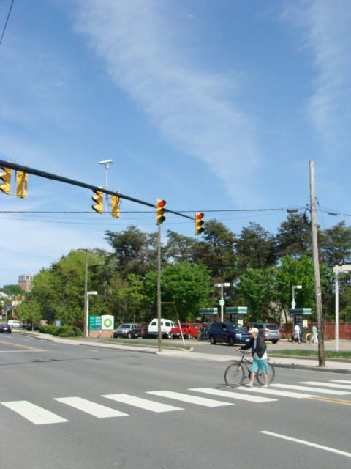
Intersection of | to frequent red light
Wilson Blvd. | running by eastbound
and N. Edison | Wilson Blvd. traffic
St.
Illustration 17 | Pedestrian hazard due |  | 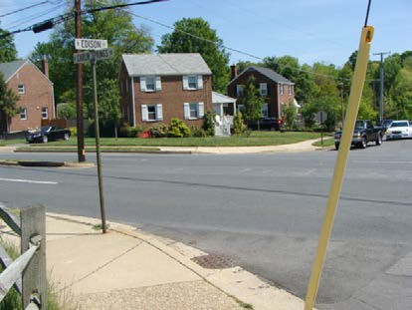
Intersection of | to high level of speed
Carlin Springs | on Carlin Springs Rd.
Rd. and N. | and lack of crosswalk;
Edison St. | heightened pedestrian
 | hazard due to high
 | level of persons trying
 | to reach Lubber Run
 | Amphitheater
Illustration 18 | Street is prone to | 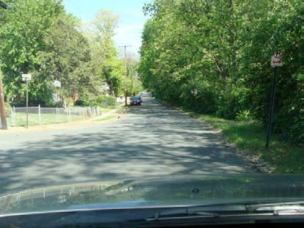
Fairfax Dr. | speeding traffic
(5500-5600 | which creates
blocks) | extreme danger for
 | bicycle and
 | pedestrian traffic
 | exiting from Custis
 | Trail to cross Fairfax
 | Dr. due to lack of
 | sidewalks on street’s

 | southside
Illustration 19 | Combination of | 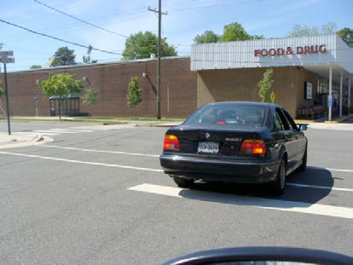
Intersection of | problems warrant
N. Emerson St. | traffic light to reduce
and Wilson | potential for
Blvd. | hazardous traffic and
 | pedestrian
 | conditions, including
 | (1) difficulty for
 | Emerson St. traffic
 | turning onto
 | westbound Wilson;
 | (2) traffic exiting
 | Safeway parking lot
 | frequently confused
 | as to appropriate
 | rights-of-way; and
 | (3) large number of
 | pedestrians leaving
 | Safeway.
Illustration 20 | Leading curb edge of | 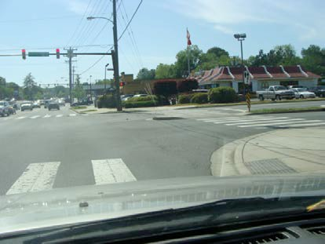
Intersection of | pedestrian medians
George Mason | in George Mason Dr.
Dr. and Wilson | needs to be painted
Blvd. | with yellow
 | reflective paint to
 | deter traffic from
 | running over curb
 | and posing hazard to
 | vehicles and
 | pedestrians

Illustration 21 Intersection of George Mason Dr. and Wilson Blvd. | Left turn from eastbound Wilson Blvd. to northbound George Mason Dr. is difficult and dangerous; suggest left-hand turning arrow | 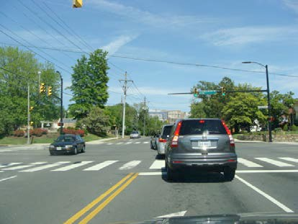
Illustration 22  Intersection of  N. Emerson and 6th St. N. | Blind corner creates traffic hazard; recommend installation of corner mirror | 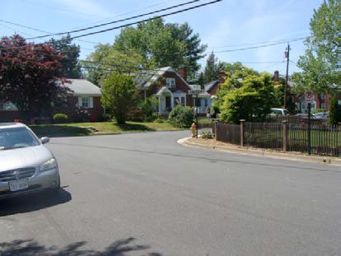
Illustration 23 | Cars routinely park at | 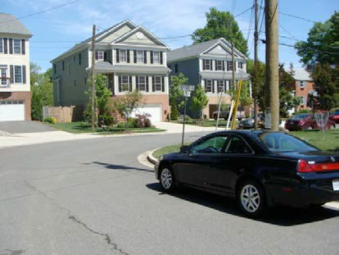
Intersection of | the inner edge of the
N. Frederick St. | N. 5th St. and
and 5th St. N. | Frederick St.
 | intersection, creating
 | a severely obstructed
 | view when turning
 | from 5th St. N. on to
 | N. Frederick or vice
 | versa; suggest that
 | there be parking
 | restrictions close to
 | this intersection

Illustration 24 | Right hand turn from | 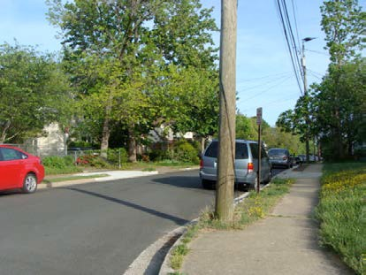
Intersection of | eastbound Bluemont
N. Emerson St. | onto southbound
and Bluemont | Emerson obscured by
Dr. | legal parking
 | permitted too close to
 | intersection
Illustration 25 | Eastbound Wilson | 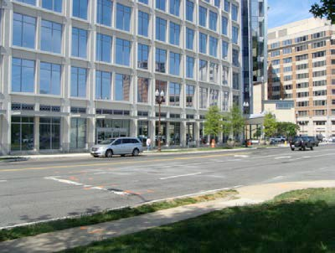
Intersection of | traffic ignores stop
Wilson Blvd. | line at intersection
and N. Vermont | during rush hour;
St. | stop line does not
 | extend across all
 | three lanes of
 | eastbound Wilson
 | Blvd.
Illustration 26 | Eastbound Wilson | 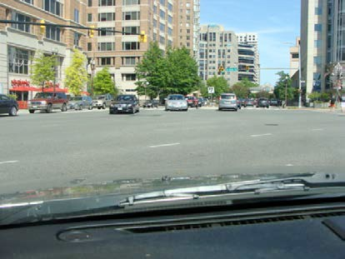
Intersection of | Blvd. traffic turning
Glebe Rd. and | left onto northbound
Wilson Blvd. | Glebe Rd. is subject
 | to extreme back-ups
 | which will be further
 | exacerbated by
 | increased traffic
 | resulting from new
 | office buildings

Appendix E – Illustrations of Representative Housing Stock

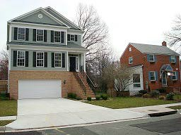

409 N. Frederick St. —Masonry with fiber cement siding, built 2011
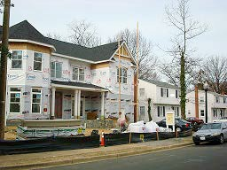

New Construction—N. Greenbrier St. & 5th St. N.

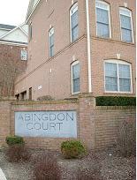

Abingdon Court Townhomes—Wilson Blvd. & N. Abingdon St.
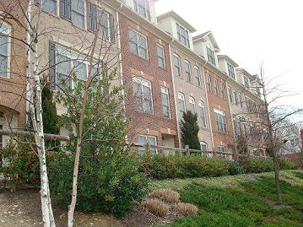

Abingdon Court Townhomes—brick, built 2005 Wilson Blvd. & N. Abingdon St., 4600-4640 Wilson Blvd.

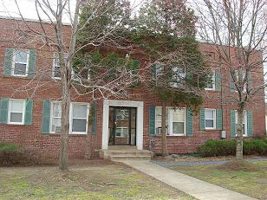

Low-Rise Apartments—9th St. N. & N. Buchanan St. 4800 9th St. N., Galanis Apartments, brick, built 1940

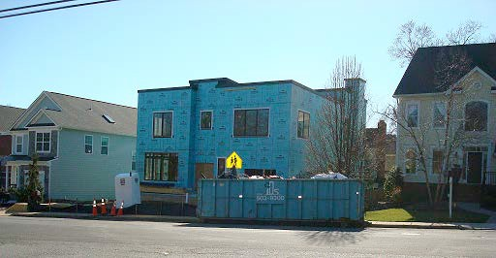

New Construction—N. Frederick St. & 10th Rd. N. 1000 block

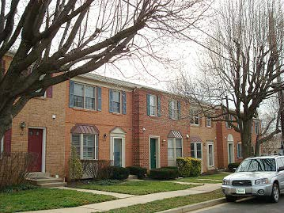

Two-Story Townhomes—841-843 N. Greenbrier St., masonry with brick veneer, built 1985

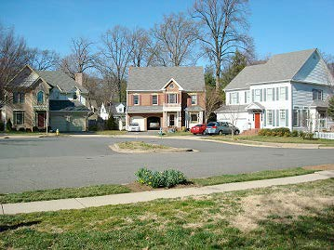

10th St. N. Cul de Sac—near St. Ann Catholic Church
900-908 N. Emerson St., masonry/fiber cement siding, built 1987

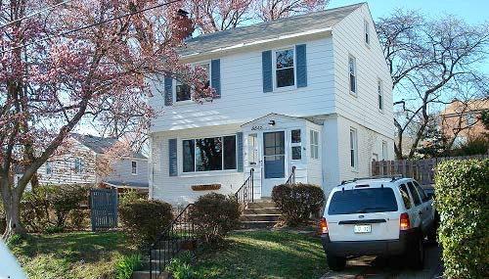

5543 10th St. N. —Two-story with attic, built 1948
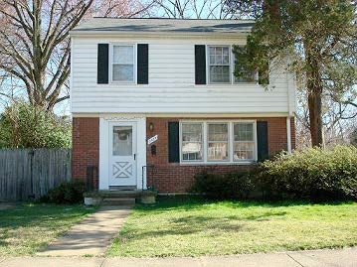

5520 10th St. N.—built 1948

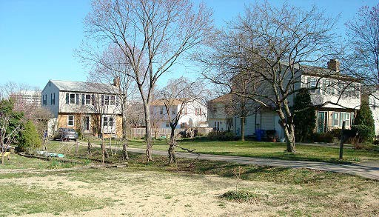

N. Edison St., 1000 Block

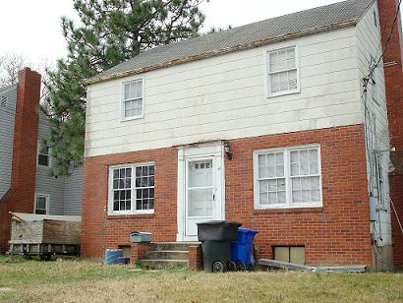

724 N. Emerson—Two story, built 1949

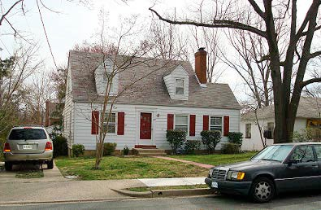

815 N. Harrison—1&1/2 story, aluminum siding, built 1948
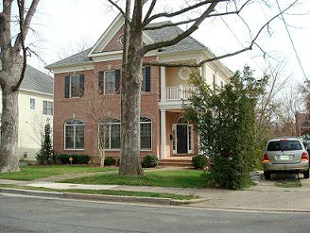

819 N. Harrison—Two-story, masonry, built 2007

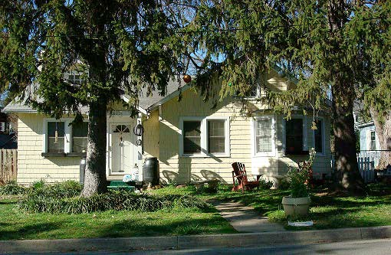

5231 11th St. N. —1 story, wood shingle & masonry, built 1920

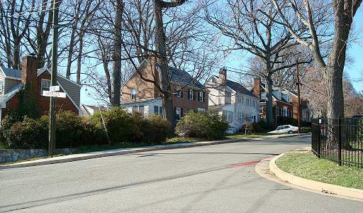

11th St. N. & N. Harrison
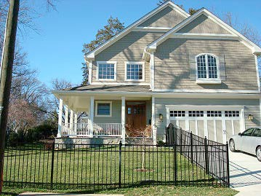

11th St. N. & N. Harrison 5235 11th St. N.
Two-story masonry/fiber cement siding, built 2010

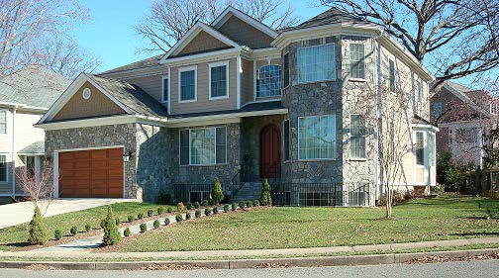

11th Rd. N. & N. Jefferson across from St. Michael’s Episcopal Church

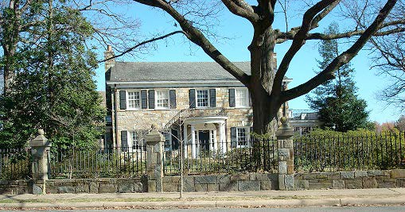

11th Rd. N. & N. Jefferson

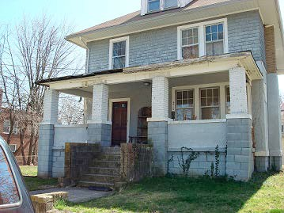

4810 9th St. N. —Two-story with attic, stucco, built 1920
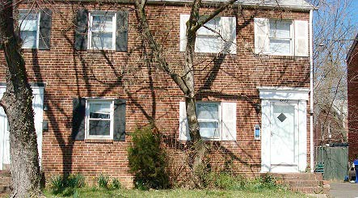

4843 9th St. N.—Duplex, brick veneer, built 1940

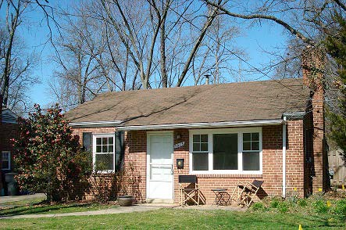

5615 8th St. N., —One-story, brick, built 1949
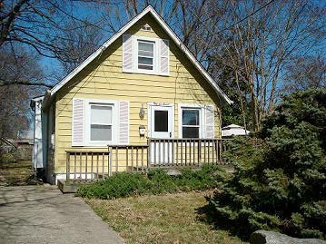
5611 8th St. N. —One-story with attic, masonry/aluminum siding, built 1938

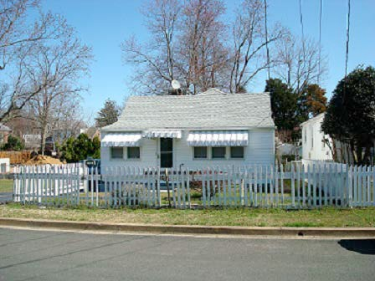

713 N. Jefferson—One-story, masonry/wood siding, built 1928
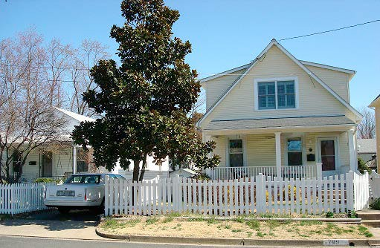

709 N. Jefferson St.—One-story with attic, masonry/vinyl siding, built 1928

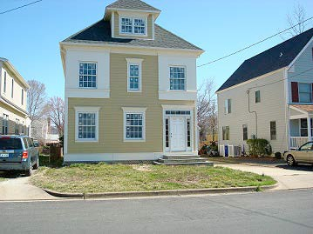

New Home Construction—N. Jefferson St.

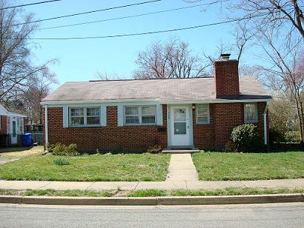

700 N. Florida St.—One-story, brick veneer, built 1950

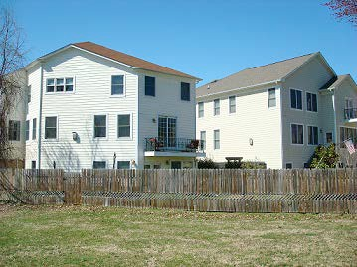

709 N. Florida St. —3-3/12 story, fiber cement siding, built 2004
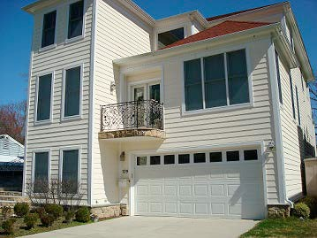

709 N. Florida St. —3-3/12 story, fiber cement siding, built 2004

Appendix F – Comments on Early Draft Versions and Responsive Revisions
The following is a list of comments submitted by Bluemont residents in response to prior draft versions of the individual chapters of the Neighborhood Conservation Plan (NCP). For these purposes, the comments have been made anonymous. Each comment is followed by an explanation of and/or a reference to any responsive changes that were made to the final version of the NCP.

Comment #1 (on Section VI. Traffic Management and Transportation):

“This draft captures many of the concerns of our neighborhood. However, a key and complicated cut-through has been left out: Carlin Springs/Edison-George Mason/North 6th Street-Wilson/Emerson. The employee shuttles from Virginia Hospital routinely use this short cut, as do other commercial vehicles as well as passenger vehicles throughout the day. It’s become quite a hazard, especially given that it’s also a very active bus route (there are heavily used stops at three of the corners at Edison and North 6th, as well as one at Emerson and the bike trail), sidewalks are missing and/or not always passable, elderly residents walk across the streets and would find it difficult to dodge traffic, Emerson is narrow, residents of all ages ride bikes, and the turn at Emerson/North 6th Street is very dangerous with little visibility. With the prospect of Safeway redeveloping, this cut-through will only become more popular and dangerous. Please add this cut- through to the plan with a recommendation for traffic calming measures — perhaps signs at all the arterial roads warning against cut-through traffic, a mini- traffic circle at the intersection of North 6th Street and Edison, and/or other measures. Thank you!”

Comment #1 Response:

See Section VI.A.1.d. and Recommendation VI-4 for responsive revision.

Comment #2 (on Section VI. Traffic Management and Transportation):

“I am incredibly concerned over the amount of traffic that has spilled over and often speeds through 6th St. N and Edison or Emerson as a shortcut or bypass between George Mason and Carlin Springs. Our community is a residential neighborhood with approx 25 school age children within a block’s radius without any speed humps or traffic circles. While I understand the short-term (too many years) necessity for a way to bypass the unsafe on-ramp; I think it is time to address the problem of Carlin Springs Rd. overpass of George Mason. The ramp is poorly constructed and is not used by county emergency vehicles and commercial vehicles. Our neighborhood had to push a fire truck through 6th and Edison in a few years back in the snow, since it couldn’t use the ramp. Since both George Mason and Carlin Springs are major thoroughfares; creating a safe, traffic lit and cross-walked solution to replace the overpass would aid the county’s

emergency vehicles, the growing automobile and pedestrian traffic and the neighborhood’s children, who like to walk and ride bikes. I believe if the George Mason and Carlin Springs intersection was properly constructed; the through- traffic in our residential community could be drastically reduced by the minimalist use of new speed humps and a traffic circle.”

Comment #2 Response:

See Section VI.A.1.d. and Recommendation VI-4 for responsive revision.

Comment #3 (on Section VI. Traffic Management and Transportation):

“As a long time family in the area and a person who works on transportation and air quality issues, I agree with the previous comments regarding the current use of “cut-throughs” by a growing number of businesses and many private vehicles who are trying to avoid using the elevated on-ramp from southbound George Mason to westbound Carlin Springs. Instead these vehicles use a cut through by turning right from southbound George Mason to 6th St. N then often speeding through neighborhood and the intersection of Edison and 6th St. (there is no stop sign on 6th St. N at the intersection with Edison St.) then turning left and heading south on Edison St. to the intersection of Carlin Springs and Edison as a shortcut to head south on Carlin Springs. This cut-through has several impacts upon individuals and families in the neighborhood in this section of Bluemont. There are households with young children who play in their yards, walk their dogs and other activities during which there is the potential for loose balls and pets to create a potentially dangerous environment between vehicles in a hurry and children at play. There are numerous pedestrians and bicyclist who use the streets and sidewalks in the neighborhood to access the Bluemont Junction bike/pedestrian pathway to Ballston, businesses along Wilson Blvd., schools in the area, commute to work by bike trails, as well as residential vehicles who now have to navigate increasingly congested neighborhood roads. This cut-through unnecessarily increases traffic and its associated safety and health hazards through an otherwise safe and pleasant family-friendly neighborhood which is already impacted by and squeezed between three highly congested principal arterial roadways: Wilson Blvd. to the north, George Mason to the East and Carlin Springs to the south.
There are several possible solutions including an outreach effort to businesses currently using this cut-through, signage posted that this is a family neighborhood with children at play. Posted lowered speed limit and four-way stop signs at the intersection of 6th St. N and Edison St. Traffic calming devices, such as elevated roadways - commonly called speed bumps - which may only have minimum benefits, or a traffic circle at the 6th St. N and Edison intersection which could also have storm water mitigation benefits as well as road dieting or reducing the

width of the affected intersection and roads. If a bike lane is being proposed as part of the redevelopment of the Carlin Springs bridge George Mason overpass then an extension of that bike lane from Carlin Springs through Edison St. to the Bluemont Junction bike and pedestrian trail would be one way to reduce the width of the cut-through impacted roads and have a minimum benefit of slowing some traffic but also benefit the growing number of bike commuters, families and others who walk through our neighborhood on their way to Ballston, Wilson Blvd. businesses, schools, activities at Lubber Run and home.”

Comment #3 Response:

See Section VI.A.1.d. and Recommendation VI-4 for responsive revision.

Comment #4 (on Section VI. Traffic Management and Transportation):

“This section is very well done. Here are a couple of comments. In the street conditions section there is a lot of content re: sidewalks and pedestrians, but bicyclists and bike lanes are mentioned only once. Yes, there is the bike path extension, but if you live north of Wilson Blvd. or south of Carlin Springs and want to ride your bike to Ballston via Wilson Blvd. or Carlin Springs Rd., you are basically taking your life in your hands. The sidewalks are narrow, obstructed with utility poles, and there are no bike lanes. If Wilson Blvd. and Carlin Springs Rd. were reduced from 4 lanes to 2 lanes (1 in each direction), there could be enough room for wider sidewalks, street parking, and a bike lane. Wilson Blvd would then be much more pedestrian and bike friendly, and be much more like the “Main Street” many residents want it to be. Reducing the lanes to one each way would also have a calming effect on traffic. Several examples of streets that have 2 lanes allowing for wider sidewalks, street parking and bike lanes are:
- Washington Blvd. west of N. George Mason Drive through the Westover area to N. McKinley Road
- N. George Mason Blvd, north of Lee Highway
- Nelly Custis Drive
- Military Road”

Comment #4 Response:

See Section V.B.2.a. and Recommendations V-1 and V-2 for responsive revision.

Comment #5 (on Section IX. Commercial and Business Areas):

“Thanks to all who worked on this chapter. I have comments (IN CAPS BELOW) on the following sections:
- Page 4 (bottom):
Although the residents’ survey did not directly solicit responses regarding problems within the Wilson Boulevard corridor, the comments and responses on related questions give the overall impression that there are no significant issues per se but rather a collective desire for general improvement to the retail offerings. Unlike the Glebe Road businesses, the small businesses along Wilson Boulevard (many of which are locally owned and serve the neighborhood) abut neighborhoods of single-family housing or parkland. Our survey indicates a growing concern among residents about the many opportunities for growth and change along Wilson Boulevard and the possibly adverse impact of development.
WHEN I READ THROUGH THE BACKGROUND MATERIALS ON THE WEBSITE (ELEMENTS OF VILLAGE CENTER), IT SEEMED CLEAR THAT RESPONDENTS WERE ALREADY CONCERNED ABOUT TRAFFIC, SPILLOVER PARKING, ETC. THAT SHOULD BE REFLECTED ABOVE.
- Page 5 (bottom):
A resounding 83% of survey respondents believe the single-family nature of the neighborhood should be retained, though only 50% were opposed to rezoning to allow for higher density development. Approximately 70% of the residents surveyed favored a village center concept and a slightly smaller percentage (64%) supported development that would include multi-story buildings. It’s important to note that this support of multi-story development is refined later in the survey with greatest support (30%) for a 3-story maximum height. Elements rated most important included inclusion of a grocery store, retail and restaurants, easy pedestrian access, on-site parking and green/open space.
IN FACT 54.5 PERCENT SAID 3 STORY MAXIMUM OR LESS. SINCE THIS IS THE “BY RIGHT” ALLOWABLE HEIGHT UNDER THE CURRENT C-1 ZONING, IT IS A MORE SIGNIFICANT FIGURE THAN THE MODE OF ‘30% FOR A 3-STORY MAXIMUM HEIGHT’ AND SHOULD BE INCLUDED IN THE TEXT.”

Comment #5 Response:

See Sections IX.A.2. and IX.A.3. for responsive revisions.

Comment #6 (General Comments):
“Nice job on capturing the demographics and summarizing the 2010 survey as well as the history of Bluemont! The Urban Forestry section looks good to me as well. Once other sections are in place I think we work to achieve consensus on a concise executive summary that includes a prioritized wish-list / call to action / policy recommendations for the community. This should probably be discussed as broadly as possible since the level of community engagement and BCA membership appear to have increased significantly since the 2010 survey.”

Comment #6 Response:

See Section XI. and list of NCP Recommendations; NCP to be voted on by Bluemont residents after neighborhood-wide notice.

Comment #7 (General Comments):

“A general, overall comment that would apply to all the documents: Just noticed that the WordPress page and some of the documents keep referring to the old NC Plan (and the new one) as the Bluemont Civic Association NC Plan. The old NC plan is not a BCA plan; it is the Bluemont Neighborhood Conservation Plan.
Recommendations in that plan came from Bluemont as a whole community (in coordination with the Civic Association), but it was not limited to BCA. That difference was intentional—it meant the plan was an inclusive, community-wide plan. I’m assuming that the updated plan’s focus will remain the same (which was the reason why we surveyed the WHOLE community and not just BCA members) and will not simply be a “civic association” plan even though our members are responsible for facilitating its drafting. I’d recommend correcting the language throughout all chapters (and the WordPress page) to reflect the community-wide nature of the plan by removing specific references to the Association as appropriate.”

Comment #7 Response:

Responsive changes made throughout NCP.

Comment #8 (on Section II. Executive Summary of Bluemont Survey):

“I am concerned that the language on pages 6 and 7 of the draft regarding the majority of respondents to the 2010 Survey supporting “modest multi-story buildings” contradicts our recent Option A recommendations to the county regarding the Safeway development that supports keeping the existing C-1 Zoning. On page 7 again the Survey supports a “maximum height acceptable” as “three to four stories. Things do change with time, but we should explain that current thinking is more along the lines of Option A.”

Comment #8 Response:

See footnote 14 for responsive revision.

Comment #9 (on Section VIII. Public Facilities and Services):

“ATS is currently slated for construction improvements to add classrooms and capacity to the school in the near future. When this capacity is added, Bluemont recommends that the School Board change the ATS lottery process so that preference is given to Bluemont children who apply for the ATS lottery. Such a policy will allow children who live closest to ATS to attend the school if they prefer and will help to alleviate overcrowding at Ashlawn and McKinley elementary schools.”

Comment #9 Response:

See Recommendation VIII-1 for responsive revision.

Comment #10 (on Section VIII. Public Facilities and Services):

“The County should complete the exhibit commemorating the site of the former Bluemont rail junction. The completed exhibit should illustrate the history of the County’s railroads and trolleys, should explain the significance of the junction to the development of the County and the Bluemont neighborhood, should fully expose the portion of the railroad‘s electrical substation that remains outside of the athletic field’s fence, and should interpret the historical features that remain on the site. The completed exhibit should contain maps, pictures and signage that are both outdoors and inside the caboose”

Comment #10 Response:
See Recommendation VIII-5 for responsive revision.

Comment #11 (on Section VI. Traffic Management and Transportation):

“Institute additional traffic calming measures on the Harrison St Cut-Through between Wilson and Washington Blvds. Install four-way stop signs on Harrison at the intersections of 8th Road N, 10th St N, and 11th St N, and 11th Rd N. Install traffic circles at the intersections of 11 St N. Also install a three-way stop sign on Fairfax Dr at Jefferson St. Consider three-way stops signs along Harrison at 9th Rd, Fairfax Dr, and 12th St N.”

Comment #11 Response:

Bluemont residents voted against adoption of suggested amendment at May 22, 2013, BCA general membership meeting.

Comment #12 (on Section IV. Land Use and Zoning):

“In order to help encourage the construction of ADA compliant sidewalks and bike lanes along Wilson Blvd. where narrowing the roadway or reducing the lanes may not be possible, Bluemont recommends changing the GLUP on both the North side and South side of Wilson Blvd. from “Low” to “Low Medium” and the zoning from R-5 and R-6 to R15-30T. This will help encourage Townhome development along Wilson Blvd. If and when Townhome developments are eventually proposed, then wider sidewalks, bike lanes and undergrounding of utility lines can be recommended as site plan conditions.”

Comment #12 Response:

Bluemont residents voted against adoption of suggested amendment at May 22, 2013, BCA general membership meeting.

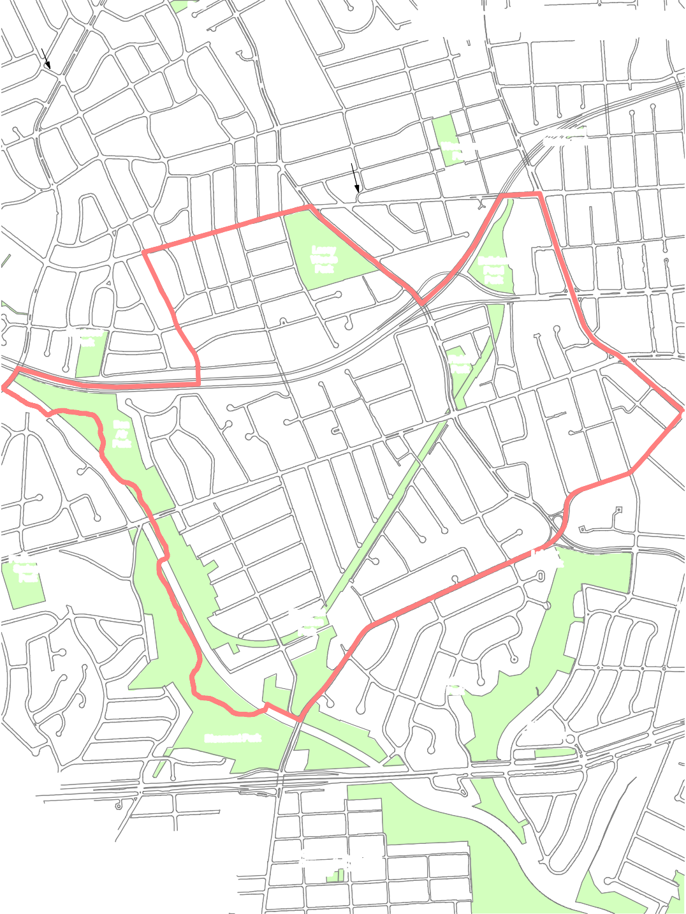Appendix G – Bluemont Area Map
ST
. SERVICE R

AGS. TA
UM N EO A
SN S TT
.-
S
R E T S E H C N
A 4TH
M
S. R
- I
R
H N. ST
N. W
.
O
O N. 16TH ST. N.
DS
T
0
1,125
Feet
/
Pursuant to Section 54.1-402 of the Code of Virginia, any determination of topography or contours, or any depiction of physical improvements, property lines or boundaries is for general information only and shall not be used for the design, modification, or construction of improvements to real property or for flood plain determination.
Aerial Photography flown February 2011
Map prepared by Arlington County GIS Mapping Center Produced and © October 2013

S .

11

10TH RD. N.

2ND
Legend
Civic Association Parks
Bluemont Civic Asssociation
S
Park
Clarenford Station Park
Woodlawn Park
Lacey Woods Park
Ballston Pond Park
Westover Park
Fields Park
Bon Air Park
Lubber Run Park
Powhatan Springs Park
H
Bluemont Junction Park
Edison Park
Arlington Forest Park
Bluemont Park
Carlin Hall Ball-Carlin
Community Cemetery
Center
O
N.
N. HARRISON ST.
N.
IN
ST.
Y
N
N

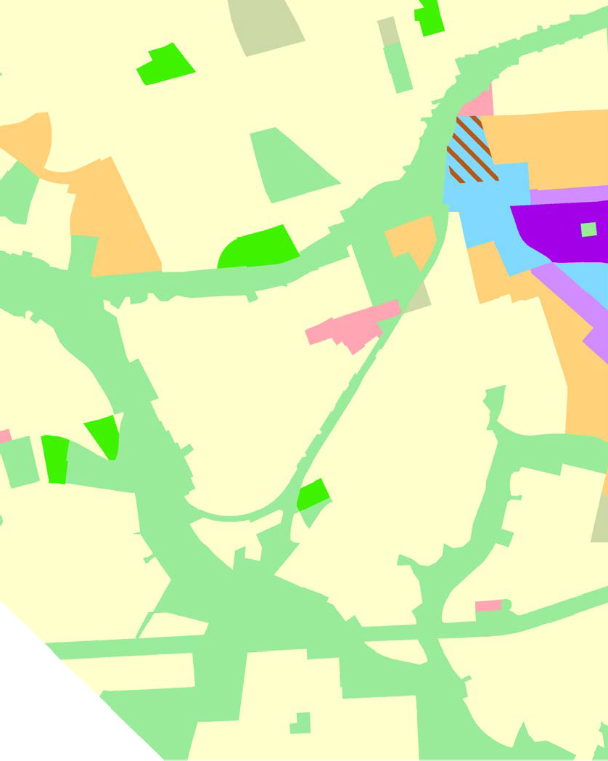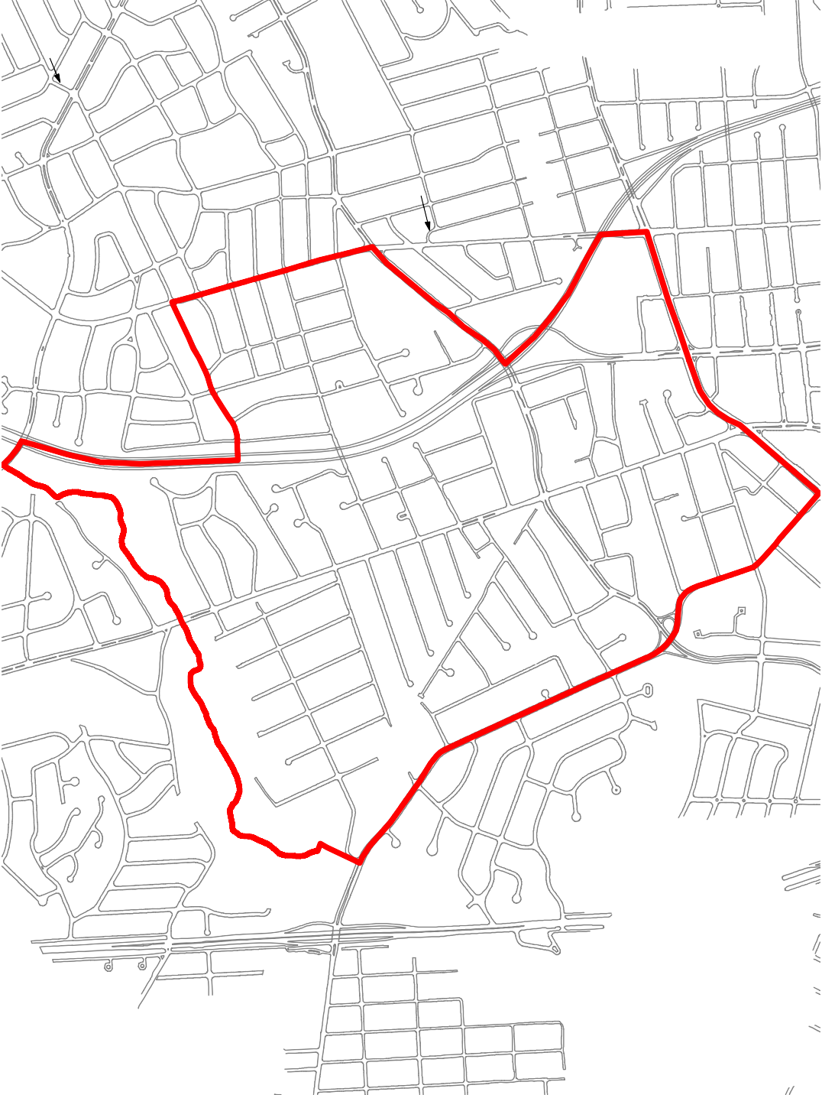Appendix H – Bluemont General Land Use Planning Map
S E
N K
O A
. D W
ST G .
BUS BI N
N
UM 1ST A
COL RD. N
.
N. N. N.
1STST.
1ST ST. N.

RVICE ROAD 1S

SERVICE ROAD
O S.R
S. 1ST ST. S. T. D
C N S T. O
O A N S WO
LU N E
M A . E N
B S. . R D O
U H D R D
S C ST K E G
ST BU PA B BI
R N
. A A
S. S. S.
4THST.
5THST.
S.
6THST
.S.
D-
S
R E T S E H C N
A 4TH
M
S. R
- I
R
N. ST
. W .
O
O N. 16TH ST. N.
DS
N. T
A O N.
B C
I K
NG S W
- T. A
0
1,125
Feet
/
Pursuant to Section 54.1-402 of the Code of Virginia, any determination of topography or contours, or any depiction of physical improvements, property lines or boundaries is for general information only and shall not be used for the design, modification, or construction of improvements to real property or for flood plain determination.
Aerial Photography flown February 2011
Map prepared by Arlington County GIS Mapping Center Produced and © October 2013
S .
11
10TH RD. N.
2ND

Legend
Civic Association
General Land Use Plan
Low Residential (1-10 units/acre) Low-Medium Residential Medium Residential
Service Commercial Public
Semi-Public
Gorvernment and Community Facitlities Low Office-Apartment-Hotel
Medium Office-Apartment-Hotel High-Medium Residential Mixed-Use
Coordinated Mixed-Use Development District
High-Medium Resid. 1/3 and Medium OAH 2/3
Bluemont Civic Association
GLUP
S
O
N.
N. HARRISON ST.
N.
IN
ST.
Y
N

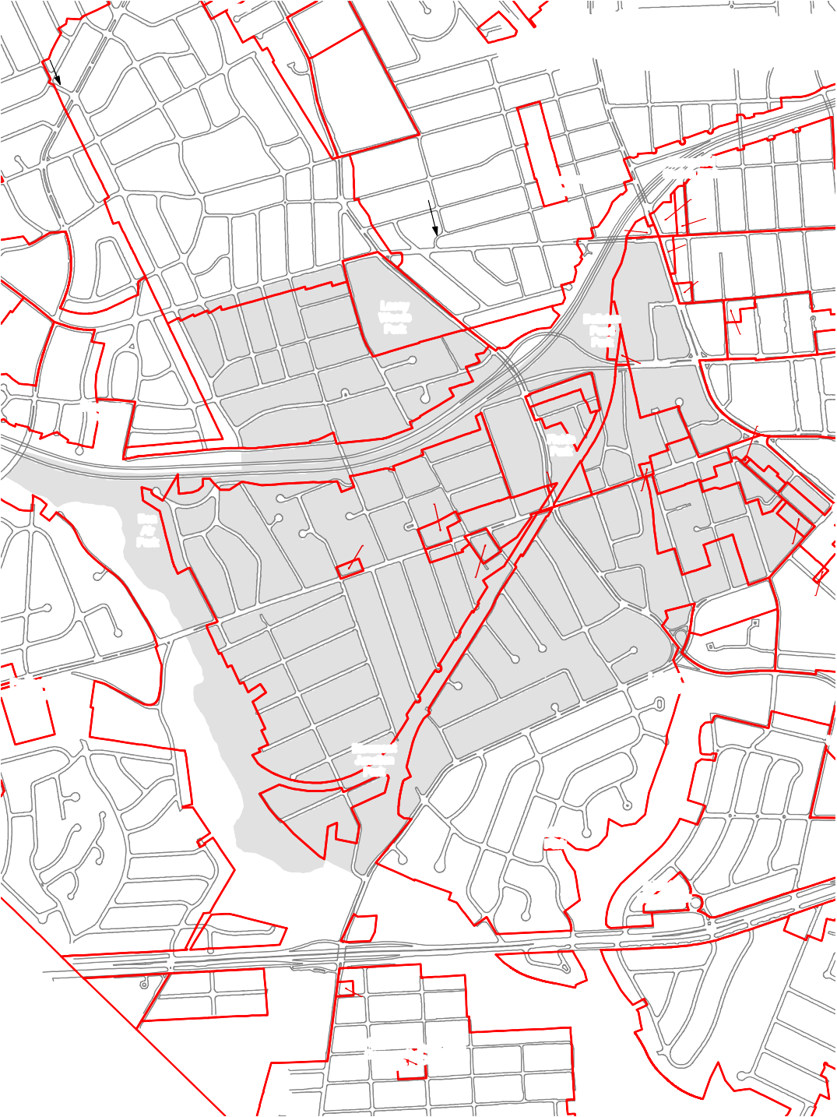Appendix I – Bluemont Zoning Map
S
T
. SERVICE R

AS T
G. A M N
RUO-1A
E
SN S TT
.-
S
R E T S
H S-3A
E
3
C N
A 4TH
M
S. R
- I
R
H S
N. T
.N. W
.
O
O N 16TH ST. N.
D
N S .
. T
A O N
^{B} ^{C} .
I K
N S W
G
- T. A
0
1,125
Feet
/
Pursuant to Section 54.1-402 of the Code of Virginia, any determination of topography or contours, or any depiction of physical improvements, property lines or boundaries is for general information only and shall not be used for the design, modification, or construction of improvements to real property or for flood plain determination.
Aerial Photography flown February 2011
Map prepared by Arlington County GIS Mapping Center Produced and © October 2013
S-3A
S .
S-D
R-5
R-8
R-6
C-2
RA14-26
C-O-1.5
C-O-1.0
C-2
R15-30T
C-2
S-3A
R
R-6
S-3A
RA14-26
11
C-O-2.5
C-2
R-5 RC
R-6
C-
R2-7
10TH RD. N.
S-3A
R-5
RA8-18
R2-7
C-O-1.0
C-1
R-5
C-1-R
R15-30T
C-O-1.0
R-6
R-6
R-10T
S-3A
S-3A
R-6
R-6
S-3A
R-6
R-6
S-

2ND
S-3A
S-3A
R-6
C-1
R-6
R-6
S-3A
R-6
0T
R-6
C-1-R
S-3A
S-3A
R-6
S-3A
Legend
Civic Association Zoning Boundary
Bluemont Civic Asssociation
Zoning
S
Park
Clarenford Station Park
Woodlawn Park
Lacey Woods Park
Ballston Pond Park
Westover Park
Fields Park
Bon Air Park
S-D
C
Lubber Run Park
Powhatan Springs Park
H
Bluemont Junction Park
Edison Park
Arlington Forest Park
Bluemont Park
Carlin Hall Ball-Carlin
Community Center
Cemetery
O
N.
N. HARRISON ST.
N.
IN
ST.
Y
N
N

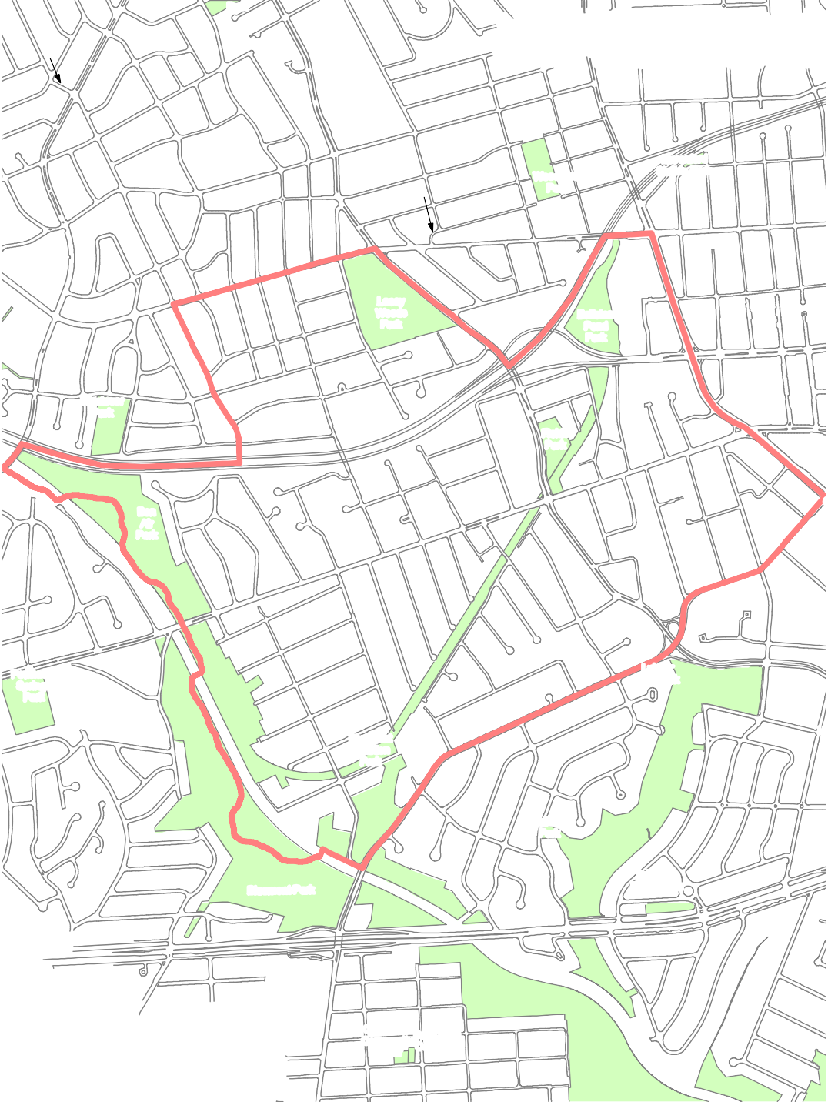Appendix J – Bluemont Parks Map
S
T
. SERVICE R

AS T
G. A UM N EO A
SN S TT
.-
S
R E T S E
H 3
C N
A 4TH
M
S. R
- I
R
H S
N. T
.N. W
.
O
O N 16TH ST. N.
D
N S .
. T
A O N
^{B} ^{C} .
I K
N S W
G
- T. A
0
1,125
Feet
/
Pursuant to Section 54.1-402 of the Code of Virginia, any determination of topography or contours, or any depiction of physical improvements, property lines or boundaries is for general information only and shall not be used for the design, modification, or construction of improvements to real property or for flood plain determination.
Aerial Photography flown February 2011
Map prepared by Arlington County GIS Mapping Center Produced and © October 2013

S .

11

10TH RD. N.

2ND
Legend
Civic Association Parks
Bluemont Civic Asssociation
Parks
S
Park
Clarenford Station Park
Woodlawn Park
Lacey Woods Park
Ballston Pond Park
Westover Park
Fields Park
Bon Air Park
Lubber Run Park
Powhatan Springs Park
H
Bluemont Junction Park
Edison Park
Arlington Forest Park
Bluemont Park
Carlin Hall Ball-Carlin
Community Center
Cemetery
O
N.
N. HARRISON ST.
N.
IN
ST.
Y
N
N

Appendix K - Arlington County Staff Comments on Draft Plan
Bluemont Civic Association Neighborhood Conservation Plan Update Recommendations Arlington County Staff Comments

REC | Civic Association Recommendation | Comment
Chapter IV: Land Use and Zoning
IV-1 | In order to preserve Bluemont as a predominantly residential neighborhood of detached homes, the County should work with the BCA to broadly maintain the prevailing land use and zoning patterns of the neighborhood. Bluemont residents particularly recommend that their views be given due consideration in adjudicating any rezoning request or zoning variance request that would allow additional commercial development or higher density development in the  neighborhood. | Rezoning requests, General Land Use Plan (“GLUP”) amendments and any special exception development applications are subject to established County processes, which include public processes and are ultimately subject to County Board approval. Community and neighborhood involvement is an integral component of the review process.
IV-2 | The County should work closely with the BCA in actively soliciting the opinions of Bluemont residents on prospective modifications to the Ballston Sector Plan that include any part of the Bluemont neighborhood. | At this time, a Ballston Sector Plan update is not on the Department of Community Planning, Housing and Development’s adopted work plan. Should such an update be undertaken in the future, however, the County would work very  closely with the BCA throughout the process.
IV-3 | Working with the BCA as appropriate, the County should be responsive to requests for enforcement of County ordinances on residential use, residential care, parking, noise, and other health and quality of life issues. In acting on such requests, the County should balance potential risks to health, safety, and welfare with the privacy rights of local residents. | Enforcement of ordinances is a legal process that ensures that potential violators are treated fairly and equitably. As a matter of course, staff is required to follow the protocols of Due Process during case investigations and prosecution. The County’s approach to investigate conditions affecting risks to health, life safety and welfare may be addressed by multiple agencies, including: Police, Code Enforcement, Zoning Enforcement, Inspection Services, Environmental Health, Child and Adult Protective Services, and the Rodent and Vector Bureau. Staff at enforcement agencies typically inventory complaints for case tracking purposes, but limit the detailed reporting on active investigations to ensure the efficiency of the enforcement process and protect the privacy of those involved. Balance is struck by the timely, efficient redress to issues of community  concern, when referenced to ordinance standards or laws.
Chapter V: Street Conditions
V-1 | Improve sidewalks on both sides of Wilson Blvd. throughout the Bluemont neighborhood so that they meet Arlington County and ADA design standards and generally manage Wilson Blvd. so that it is safe and comfortable for pedestrians, bicyclists, transit riders, motorists, and other users. County officials should work closely with the BCA’s Arterial Roads Task  Force in undertaking these efforts to ensure that | County staff will work with the Bluemont Civic Association to investigate the feasibility of rebalancing the allocation of County right of ways to support the process of better sidewalks, bike & transit facilities on Wilson Boulevard. This is potentially a very large-scale project that should be considered a part of the County’s CIP process.

Bluemont Neighborhood Conservation Plan Recommendations – Staff Comments

Bluemont Civic Association Neighborhood Conservation Plan Update Recommendations Arlington County Staff Comments

REC | Civic Association Recommendation | Comment
Chapter V: Street Conditions (continued)
V-1 | Continued  any work is responsive to the particular needs of Bluemont residents.
Added New V-2 | In the near term, implement the recommendations made in the BCA’s October 24, 2012 Resolution to reconfigure Wilson Boulevard west of George Mason Drive to make it safer and more accessible for all modes of transportation, with implementation in two phases: (1) Conversion of the existing four lanes to two through lanes and a two-way center turn lane (with dedicated turn lanes at intersections), and two bicycle lanes by restriping the pavement; and (2) Widening of sidewalks and planting/utility strips so as to meet ADA requirements and Arlington County  design guidelines. | Staff will study the implications of establishing the recommendations referenced here as they relate to signal and roadway capacity and available right-of-way. Phase 1, if warranted, could potentially be done in coordination with a regularly-scheduled resurfacing project requiring minimal or no impact to the existing right-of-way. Phase 2 would require a significant capital expenditure that makes it unlikely in the near term, but could be considered in the future as development occurs.
V-3  (Former V-2) | Improve sidewalks on both sides of N. George Mason Drive throughout the Bluemont neighborhood so that they meet Arlington County and ADA design standards and generally manage N. George Mason Drive so that it is safe and comfortable for pedestrians, bicyclists, transit riders, motorists, and other  users. | County staff is planning to implement some sidewalk enhancements on George Mason Drive as part of the Carlin Springs Road Bridge replacement project. The remainder of George Mason Drive could be evaluated as a future potential complete streets project funded through the Decal Fee or other appropriate  source.
V-4  (For- mer V- 3) | Install sidewalks on at least one side of the street on N. Jefferson St., N. Kensington St.,  N. Lexington St., 5th St. N., 6th St. N., 8th St. N., and 8th Road N. | County policy supports the provision of a sidewalk on at least one side of all streets. Those streets that currently lack a complete sidewalk could be good candidates for street improvement projects. Typically those projects for local streets are funded through the Neighborhood Conservation program based upon neighborhood priority and funding  availability.
V-5  (Former V-4) | The utility lines along Wilson Blvd. should be placed underground and the costs of this undergrounding should be primarily borne by developers and Dominion Virginia Power, along with Arlington County taxpayers if necessary. | Arlington County has achieved some utility undergrounding along Wilson Boulevard as part of private projects with site plan approvals. Due to extremely high costs, County-initiated undergrounding projects are typically limited to County properties or limited areas within high- density development districts. It is unlikely that  many utility lines will be undergrounded along Wilson Boulevard during the next 20 years.
Chapter VI: Traffic Management and Transportation
VI-1 | Install a four-way stop sign at the intersection of N. Kensington St. and 7th St. N.; create a crosswalk with stamped asphalt or a raised and stamped crosswalk; and provide signage along  N. Kensington informing motorists to yield to | There are established County warrants as to when multi-way Stop signs are to be installed. The Kensington and 7th Street intersection does not qualify under those warrants. The  County also has standards for installation of

Bluemont Neighborhood Conservation Plan Recommendations – Staff Comments

Bluemont Civic Association Neighborhood Conservation Plan Update Recommendations Arlington County Staff Comments

REC | Civic Association Recommendation | Comment
Chapter VI: Traffic Management and Transportation (continued)
VI-1 | Continued  pedestrians. If necessary, the County could consider the installation of traffic circles at several points along N. Kensington St. or restrictions on the usage of the street by non- residents during rush hours. | Continued  traffic circles. Kensington street after installation of speed humps does not meet those warrants. County policy is to not impose restrictions that limit use of public streets only to the street residents. Such restrictions are not  legal or enforceable.
VI-2 | Institute traffic calming measures along the Emerson-Bluemont- Greenbrier-5th-Harrison Cut-Through, including a raised crosswalk at  N. Emerson and Bluemont Junction Trail and appropriate stop signs at the Bluemont Drive-  N. Greenbrier and N. Greenbrier-5th  intersections. | County staff is willing to work with the community to identify sidewalk enhancements and traffic management measures that can improve the trail crossing at the Emerson street intersection. Stop signs are only installed where appropriate and are not used solely to  discourage vehicle use of local streets.
VI-3 | Institute traffic calming measures along the Buchanan-Fairfax Cut- Through, including a raised crosswalk at N. Buchanan and Bluemont Junction Trail and appropriate stop signs along  N. Buchanan. | County staff is willing to work with the community to identify sidewalk installation and traffic management measures that can improve the trail crossing at the Buchanan street intersection. Stop signs are only installed where appropriate and are not used solely to  discourage vehicle use of local streets.
VI-4 | Institute traffic calming measures along the 6th St.-Edison St. Cut- Through, including either a stop sign or traffic circle at the Edison-6th intersection. | The intersection does not meet established warrants for installation of a traffic circle or additional stop signs. Other measures such as street narrowing through sidewalk construction or addition of curb extensions could be  appropriate for a future capital project.
VI-5 | Institute traffic-calming measures at the intersections of the Bluemont Junction Trail and N. Buchanan, N. Emerson and N. Kensington Streets, such as raised cross- walks  and/or stop signs. | See responses to items VI-2 and VI-3. The trail crossing at Kensington street includes a raised crosswalk.
VI-6 | Institute speed-reduction measures on southbound George Mason Drive as it approaches the intersection with 6th St. N., including the installation of speeding fine  notice signs and/or speed display units. | Typical neighborhood traffic calming devices are not appropriate on an arterial street. (See response to V3).
VI-7 | Institute measures to sensitize Wilson Blvd. traffic to the presence of a traffic light at the Wilson Blvd.-N. Edison St. intersection, including the installation of a warning strobe or flashing light and periodic police presence. | The signal at N Edison St is clearly visible and does not need advance warnings intended for signals on horizontal or vertical curves with restricted visibility. The Police can verify whether red-light running is an issue and take  appropriate action.
VI-8 | Make pedestrian safety enhancements at the intersection of Carlin Springs Road and N. Edison St., such as the installation of a prominently painted crosswalk. | County staff agrees that pedestrian-related improvements are needed at this intersection and would like to work with the Bluemont and Arlington Forest communities to undertake a  project.

Bluemont Neighborhood Conservation Plan Recommendations – Staff Comments

Bluemont Civic Association Neighborhood Conservation Plan Update Recommendations Arlington County Staff Comments

REC | Civic Association Recommendation | Comment
Chapter VI: Traffic Management and Transportation (continued)
V-9 | Make the Custis Trail exits/entrances and/or warning signs along Fair- fax Drive more prominent. |  | Wayfinding signs for the Custis Trail were installed earlier this year. Additional signage near the Trail connection to Fairfax Drive is to be  installed after the construction currently taking place there is completed.
VI-10 | Consider the installation of a traffic light at the Wilson Blvd. and N. Emerson St. intersection, particularly in the event that the Safeway parcel is re-developed. |  | In order to install a signal, there are nationally standardized warrants that must be met. Staff has studied the intersection of Wilson Blvd and N Emerson St in the past and it does not meet these warrants. If conditions on the street or the roadside development were to change, staff would recommend a new study taking into  account these changes.
VI-11 | Install reflective markings on the leading edge of the pedestrian median in George Mason Drive at the north side of its intersection with Wilson  Blvd. |  | There is a plastic flex post installed on the leading edge of the median on the north approach of George Mason Drive at Wilson Blvd. Arlington  does not paint median noses.
VI-12 | Evaluate intersection of Wilson Blvd. and George Mason Drive for left-hand turning lights for eastbound and westbound Wilson Blvd. traffic, ensuring that there will still be enough time for pedestrians and bicyclists to use the  crossing. |  | The intersection of Wilson Blvd and George Mason Dr was studied to see if the westbound approach met the required warrants to install a left-turn phase. It did not meet those warrants. Staff will study the eastbound approach for a  potential left-turn phase.
VI-13 | Evaluate the intersection of N. Emerson St. and 6th St. N. for hazard- reducing measures, including installation of a corner mirror to  correct limited visibility, and installation of a sidewalk along the north side of 6th St. N. |  | County staff will work with the community on the design and installation of a sidewalk along Sixth street if the community pursues funding for such a project.
VI-14 | Establish parking restrictions along the inner edge of the intersection of N. Frederick St. and 5th St. N. |  | Staff will investigate the location for parking signage, but parking is prohibited by County code within 20 feet of an intersection with or without a  parking sign visible.
VI-15 | Establish parking restrictions along N. Emerson St. near the intersection of N. Emerson St. and Bluemont Drive. |  | Parking signs are existing on N Emerson St around the intersection with N Bluemont Drive. Staff will evaluate their locations. Parking is prohibited by County code within 20 feet of an intersection with or without a parking sign  visible.
VI-16 | Re-paint the stop line at the intersection of Wilson Blvd. and N. Vermont St. and have prominent signage warning eastbound Wilson  traffic to not block the intersection. |  | This location will be added to the pavement marking maintenance list for remarking. Staff will evaluate the Wilson Blvd & N Vermont St  intersection for potential signage.
VI-17 | The County should diligently monitor the congestion situation at the intersection of Glebe Road and Wilson Blvd. and take all necessary steps to ensure the smooth flow of traffic without compromising the safety of pedestrians who use the intersection on their way to and from Metro  and Ballston buildings. |  | Staff monitors the functioning of all traffic signals within the county and adjusts the timing as needed to keep traffic flowing while allowing for sufficient time for pedestrians to cross.
Bluemont Neighborhood Conservation Plan Recommendations – Staff Comments

Bluemont Civic Association Neighborhood Conservation Plan Update Recommendations Arlington County Staff Comments

REC | Civic Association Recommendation | Comment
Chapter VI: Traffic Management and Transportation (continued)
VI-18 | The County should give priority treatment to the completion of a western entrance to the Ballston-MU Metro station and any future development west of N. Glebe Road between  N. Carlin Springs Road and Washington Blvd. should be contingent upon acceleration of the timetable for such entrance. | Construction of the Ballston west entrance remains a priority for Arlington County. Currently the property needed for the new station entrance is privately owned and substantial additional funding is required. The County would like to have the station entrance built within the next ten years but does not feel that all new development west of Glebe Road should be delayed until after the new station  entrance is completed.
VI-19 | The County should maintain at least the current level of bus service enjoyed by Bluemont through both ART and WMATA buses. | The existing ART and Metrobus routes in Bluemont are expected to continue in the future. As County staff regularly reviews all routes to identify opportunities to improve service coverage and efficiency, changes could be implemented in the future. Public input will  be sought before any service changes are made.
VI-20 | The County should work with Capital Bikeshare to maintain the two bike-sharing stations already within Bluemont and consider additional Bluemont locations for stations, such as Bluemont and Bon Air Parks. | Arlington’s long-term plan for the Capital Bikeshare system calls for continued use of the existing Bluemont area stations and some additional expansion along the W&OD Trail corridor towards Bluemont and Bon Air parks. The County is willing to consider allowing  other locations if proposed by Capital Bikeshare.
Chapter VII: Housing
VII-1 | The BCA should remind Bluemont residents through its website and/or newsletter of the process for filing code-related complaints with the County and encourage them to do so, when  appropriate. | N/A
VII-2 | The BCA should educate residents about the sustainable landscape movement, encourage residents to adopt environmentally friendly gardening techniques, and re- mind residents of the differences between “neglected” yards and those that are intended to create havens for native plants. | Arlington county supports the planting of plants native to the county, and prioritizes the use of native plants where appropriate. Staff also supports the efforts of Virginia Cooperative Extension (VCE) and Master Gardeners. Both organizations are currently conducting outreach and education efforts that encourage environmentally sustainable landscape and  gardening practices.
VII-3 | Bluemont should work with the County to contribute to the realization of affordable housing targets as part of any future development of mixed-use space in the Wilson  Blvd. commercial corridor. | N/A
Chapter VIII: Public Facilities and Services
VIII-1  Added | ATS is currently slated for construction  improvements to add classrooms and capacity to the school in the near future. When this

Bluemont Neighborhood Conservation Plan Recommendations – Staff Comments

Bluemont Civic Association Neighborhood Conservation Plan Update Recommendations Arlington County Staff Comments

REC | Civic Association Recommendation |  | Comment
Chapter VIII: Public Facilities and Services (Continued)
VIII-1  Added | Continued  capacity is added, Bluemont recommends that the School Board change the ATS lottery process so that preference is given to Bluemont children who apply for the ATS lottery. Such a policy will allow children who live closest to ATS to attend the school if they prefer and will help to  alleviate overcrowding at Ashlawn and McKinley elementary schools. | The Civic Association should work directly with Arlington Public Schools.
VIII-2  Was 1 | As population density and development continues to increase, Bluemont residents urge the County to seek additional opportunities for land acquisition and easements to expand existing parks and open space. | Land acquisition will be considered as part of the next update of the Public Spaces Master Plan. The County partners with the Northern Virginia Conservation Trust to secure easements that support the recommendations in  the Natural Resource Management Plan.
VIII-3  Was 2 | The County should work with NVRPA and Dominion Power to implement an invasive species control plan to remove the existing infestation of invasive species in the power line right of way, to stop the rampant spread of new and existing invasive species, and to slow the destruction of the trees and the riparian vegetation. | Arlington County Parks and Natural Resource Division staff is currently coordinating with NVRPA, Dominion Virginia Power, and volunteers on an initiative to remove invasive plants and plant native species near power lines along the W&OD Trail. The current project is located along the W&OD Trail in Bon Air Park, between Wilson Boulevard and the Custis  Trail. Staff supports the concept of expanding such efforts as resources permit.
VIII-4  was 3 | The County should take steps to reduce the potential for motorist- bicyclist accidents at the I-66 eastbound exit ramp/Fairfax Drive near the Holiday Inn at 4610 Fairfax Drive. | The section of the Bluemont Junction Trail close to the Holiday Inn was recently widened. Further improvements are currently being made to the trail and the Fairfax Drive sidewalk in
VIII-5  Added | The County should complete the exhibit commemorating the site of the former Bluemont rail junction. The completed exhibit should illustrate the history of the County’s railroads and trolley, should explain the significance of the junction to the development of the County and the Bluemont neighborhood, should fully expose the portion of the railroad’s electrical substation that remains outside of the athletic field’s fence, and should interpret the historical features that remain on the site. The completed exhibit should contain maps, pictures and signage that are both outdoors and  inside the caboose. | The Historic Preservation Program staff agrees that this would be a worthwhile interpretive project. However, at the present time, the program does not have the staffing capabilities to complete such a project given other work priorities. It is recommended that the neighborhood consider adding this proposal to the future master planning efforts for Bluemont Park.
VIII-6  Was 4 | Prior to embarking on any future renovations or construction projects, the County should work to ensure that sensitive natural resources are not further damaged or compromised. | The position of Natural Resource Manager (NRM) was created with the adoption of the County’s Natural Resource Management Plan.  The NRM, along with staff from Parks and Natural Resources Division’s Forestry
Bluemont Neighborhood Conservation Plan Recommendations – Staff Comments

Bluemont Civic Association Neighborhood Conservation Plan Update Recommendations Arlington County Staff Comments

REC | Civic Association Recommendation | Comment
Chapter VIII: Public Facilities and Services (continued)
VIII-6  Was 4 | Continued | Continued  Section, reviews plans for park improvement and renovation projects for potential impacts to trees and other natural resources. Especially sensitive natural resources have been incorporated into a GIS mapping layer. Comments are submitted during the plan review process to avoid or minimize project impacts to sensitive  natural resources.
VIII-7  Was 5 | Local businesses are encouraged to develop and maintain attractive landscaping, especially in commercial areas adjacent to residential areas. County business development offices should encourage such practices even if not specifically required  by County ordinance. | The County enforces landscaping standards per the Zoning Ordinance for by-right projects. Site plan and use permit projects have landscaping requirements that are conditions of approval.
VIII -8  Former 6 | The County should not permit the installation of telecommunications towers or facilities in the neighborhood. | Telecommunications towers and facilities are allowed by the Arlington County Zoning Ordinance by Use Permit on private property. They are also allowed on public property under an Interim Policy adopted by the County Board. The County does not absolutely prohibit their installation, but any  applications will receive a public hearing.
Chapter IX: Commercial and Business Areas
IX-1 | The County should take steps to keep the heaviest commercial development contained to Ballston and let the Wilson Boulevard business district focus on local businesses that can directly serve the neighborhood.  The retail section of Wilson Blvd. in this | Land use policies, and more specifically retail policies, do not imply that Wilson Boulevard is a major commercial center as it continues west beyond its intersection with North Glebe Road. Rather, the commercial  area along Wilson Boulevard is envisioned
IX-2 | The County should ensure that the current Safeway site remain a grocery store, but with improved quality of service and outward appearance, without sacrificing parking or accessibility. | The County will continue to work to retain a grocery store at this location, in a form more compatible with a pedestrian friendly environment, recognizing that improvements or redevelopment will require additional height and density.  However, it is likely that, if Safeway is unable to meet its needs and goals as a private property owner, then it may opt to leave and/or sell the property. In this instance, the County does not have the authority to require that a particular use  must remain on private property.
IX-3 | The County should take steps to improve the overall quality and appearance of the  Wilson Boulevard business district, and to | County staff would like to work with the Bluemont Civic Association to investigate  the feasibility of instituting a “road diet”

Bluemont Neighborhood Conservation Plan Recommendations – Staff Comments

Bluemont Civic Association Neighborhood Conservation Plan Update Recommendations Arlington County Staff Comments

REC | Civic Association Recommendation | Comment
Chapter IX: Commercial and Business Areas - Continued
IX-3 | Continued  improve pedestrian access to the Wilson Boulevard businesses. Steps could include reducing Wilson Blvd. to one lane each way between Glebe Road and N. McKinley St. (the Falls Church line: similar to a comparable area of Washington Blvd. between Glebe Road and the Falls Church line). This would permit the widening sidewalks and allow for trees and on-  street parking similar to Westover or the Del- Ray neighborhood of Alexandria. | project on Wilson Boulevard and to develop concepts for a sidewalk improvement project. Where feasible, the County would include tree planting on Wilson Boulevard as part of the street and sidewalk project.
Recommendation with respect to problems identified in Appendices C and D
X-1 | The County should address all of the various problems identified and described in Appendix C (Illustrated List of Street Condition Issues) and Appendix D (Illustrated List of Traffic Management/Transportation Issues) to this document. | In regards to speeding complaints on residential streets, a speed classifier should be deployed to determine if it meets the threshold.  Most of the problems identified in Appendix C relate to missing or obstructed sidewalks. The County supports working with the Bluemont community on identifying the top priority locations for capital improvement projects and the funding and construction of those projects. Some of the proposed measures to address noted problems in Appendix D are not considered appropriate by County staff. The County will  review each location/issue to determine the appropriate responses.

Bluemont Neighborhood Conservation Plan Recommendations – Staff Comments

